2022 Prospect CAMP
Tuesday, JUNE 28TH, 2022
9AM-4PM
NO WALK UPS ACCEPTED
- Open to all current 7th-12th graders
- $200
- Greenwood Civic Center, 1610 HWY 72/221 East Greenwood, SC 29649
Camp Coordinators:
Glen Crawford - Head Coach
Maddie Gibbs – Asst. Coach
Rebecca Boesen – Asst. Coach

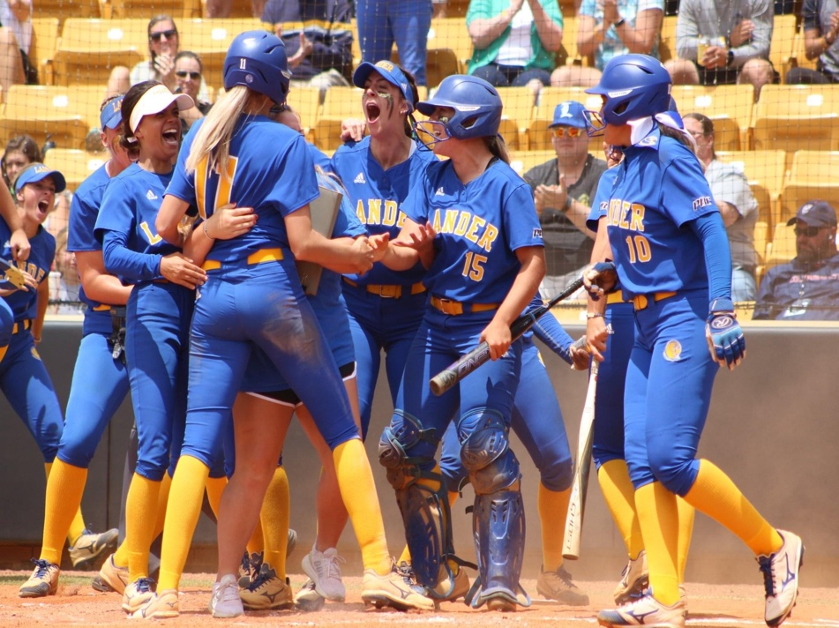
*No refunds within two weeks of the camp date
*Payment made out to CSA and sent to Lander Softball 320 Stanley Ave Greenwood, SC 29649
Insurance & Medical Information:
Player Name: _____________________________ Any Medications S.A. is taking: ___________________
Parent Name: __________________________ Medical Conditions to be aware of: __________________
Emergency Contact Name: ____________________________ Cell Phone #: _______________________
Medical Insurance Company: __________________________ Policy #: __________________________
Parent Signature: ______________________________________ Date: __________________________
Player Info:
Player Name: _________________________________ Age: ____________ Graduation Year: _________
Primary Position: __________________________ Secondary: __________________________
High School: ___________________________ Travel Team: _______________________________
Email: ___________________________ Cell Phone #: ___________________________
Address: ____________________________________________________________________

