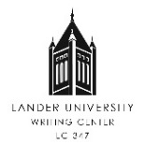 | Writing Center Referral Form

To be completed by referring faculty member:
Instructor Name | Signature:
Date: | Course Name & CRN:
Assignment: | Skills to Address in Conference:  - Responding to Instructor Feedback  - Responding to the Assignment  - Organization  - Argumentation (Developing & Supporting)  - Connections & Transitions  - Writing Process & Revision  - Textual Evidence (Sources & Citation)

To be completed by student before conference:
Student name:  L#: | Date:
Goal for conference: | Signature:

To be completed by tutor after conference:
Tutor name: | Date:
Accomplished in conference: | Signature:

