2014-2015 UNIVERSITY 101 YEAR-END SUMMARY REPORT

For the 2014/2015 academic year, the Division for Student Affairs was tasked with developing a freshman seminar or orientation class - University 101. This class was created and re-introduced for the 2014/2015 academic year. A freshman class of this nature has not been offered at Lander University since the 2005/2006 academic year. University 101 is a required course for graduation from Lander University. Students must earn a passing grade (C or better) in order to graduate from Lander. The course was required for all first time freshman with less than 24 hours. It met once a week for the semester and students earned one semester hour of credit. There were 27 sections taught for the Fall/2014 semester and 3 sections taught for the Spring/2015 semester. As stated in the class syllabus: “The purpose of University 101 is to provide first-year students with an understanding of the resources and tools available to them for making a successful transition from high school to college; to ensure that they become active, responsible members of the community; to help them acquire basic academic survival skills; to encourage active participation in student activities and campus recreation programs and to assist them in becoming a successful college student.” The objectives listed for the course in the syllabus were:
“University 101 will
- help the student academically, personally and socially to adjust to Lander University
- inform new students about the availability of services and programs
- assist new students in becoming familiar with the campus and local environment
- provide planned, intentional opportunities for new students to interact with fellow new students, as well as continuing students, faculty and staff members
- inform students about history/traditions, governance structure and campus culture to aid development of an identification with and integration into the university
- assist new students in becoming familiar with the wide range of electronic and information resources available and to review expectations of their use
- provide students with information about laws and policies regarding educational records and other protected information
- provide opportunities to understand academic and student life policies and procedures
- recognize the purpose and value of academic integrity and describe the key components related to the Lander University Honor Code
- describe and demonstrate principles of responsible citizenship within and beyond the campus community
- describe processes and resources related to overall wellness
- explain the implications of personal decisions for personal wellness”

In order to measure the effectiveness of the course, Lander University participated in the Educational Benchmarking Inc. (EBI) First-Year Seminar Assessment. This was the same assessment used for the similar course offered in 2005/2006. Attached in the Appendix is the explanation of the statistics and reliability of the assessment. Also, the Appendix (page 12) contains the lists of comparison institutions – the six institutions Lander University chose for comparison, the Carnegie list of institutions similar to Lander University and the list of all institutions using this assessment for 2015. This assessment measured 23 factors which targeted the objectives set for the course. The second factor around “Distance Learners: Online Environment” was not applicable to this course and was not measured. The benchmark comparisons of the means of each of these factors are listed below.

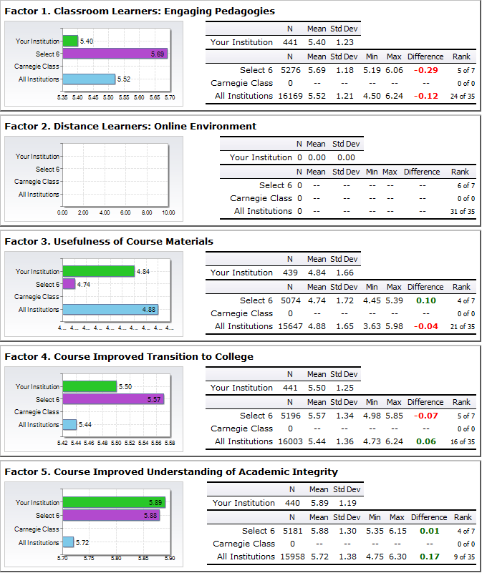

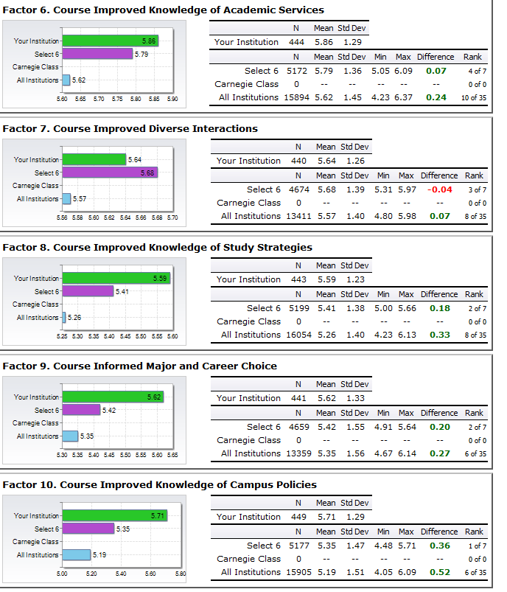

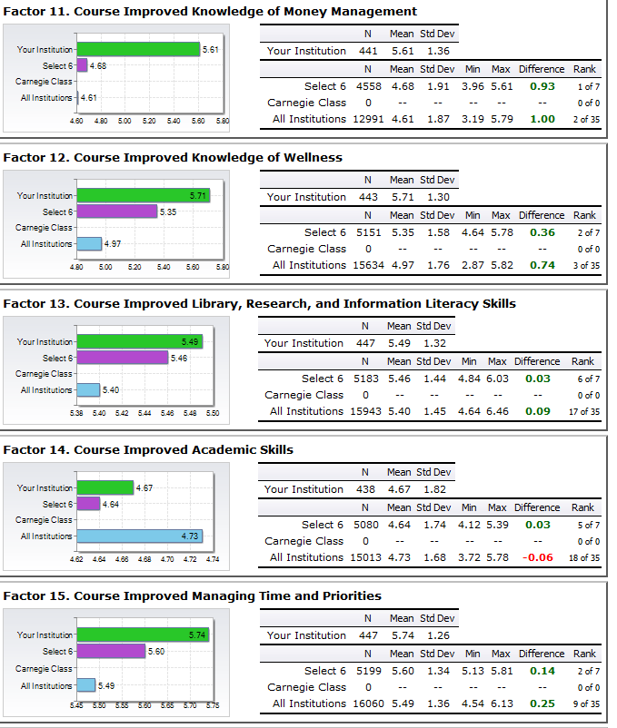

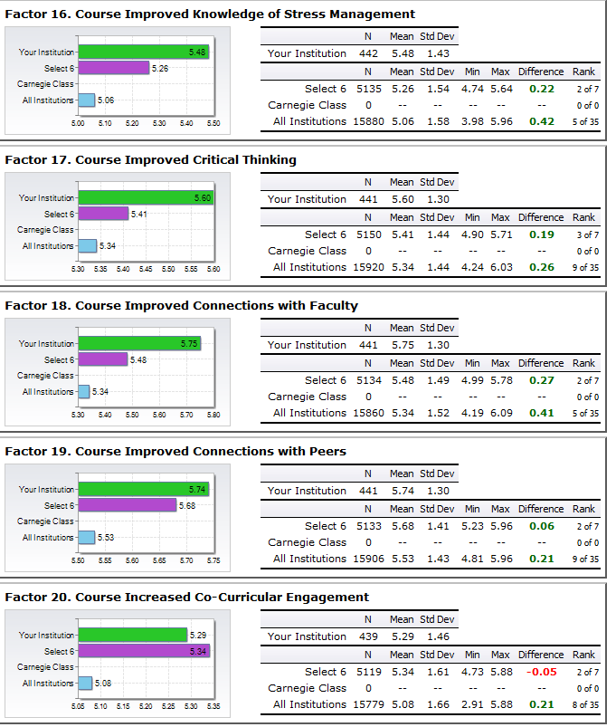

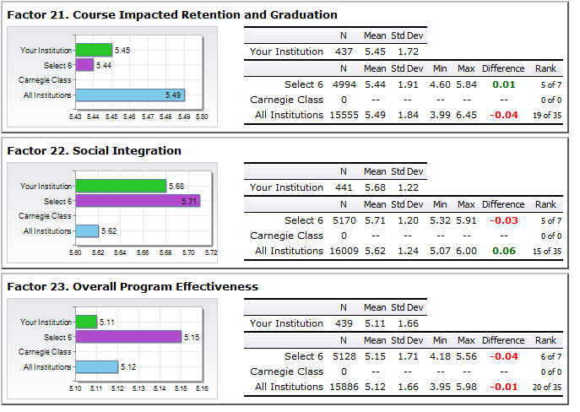

In summarizing the results, the data indicate that of the 22 factors measured, Lander University’s freshman seminar class – University 101 - scored with means above nine of the “select six” institutions and 13 of “all institutions”. In terms of being equal, Lander University scored with means equal to 12 of the “select six”, all of the “Carnegie class” (only 2 institutions), and eight of the peer institutions. The only factor which fell below the means of the “peer institutions” and “all institutions” was Factor 1-“Classroom Learners: Engaging Pedagogies”. The questions comprising this factor were around classroom environment. Student response means are compared in the following table for each of these questions:
Factor Description –Questions  To what degree did this course: | Lander University | Peer Institutions | Carnegie Class | All Institutions
A variety of teaching methods | 4.85 | 5.54 | ---------- | 5.23
Productive use of classroom time | 5.40 | 5.55 | ---------- | 5.41
Encouragement to speak in class | 5.72 | 6.03 | ----------- | 5.77
Encouragement for students to work together | 5.28 | 5.99 | ---------- | 5.75
Meaningful class discussions | 5.60 | 5.71 | ---------- | 5.57
Meaningful homework | 5.21 | 4.73 | --------- | 4.83
Interaction among classmates | 5.37 | 5.93 | ---------- | 5.75
Acceptance among classmates | 5.78 | 6.16 | ---------- | 6.02

The questions highlighted in red text will drive some of the changes made to the course curriculum for the 2015/2016 academic year. There were several other questions comprising some of the factors which scored below the comparison group means and these will also be considered in planning the curriculum for the next semester. These questions along with their performance are listed in the table below.

Factor Description –Questions  To what degree : | Lander University | Peer Institutions | Carnegie Class | All Institutions
Were the course materials interesting (Factor 3) | 4.37 | 4.47 | ---------- | 4.62
I better understand the transition from my previous educational experience to this current educational environment (Factor 4) (2nd Predictor) | 5.17 | 5.39 | ---------- | 5.26
The course improved my oral presentation skills (Factor 14) | 4.45 | 4.91 | ----------- | 4.87
Are you accepted by students at this college/university (Factor 22) | 5.79 | 5.95 | ---------- | 5.89
Would you recommend this course to other first-year students (Factor 23) | 4.89 | 5.15 | ---------- | 5.12

In addition, the data for the 2014/2015 academic year was compared with the data from the 2005/2006 academic year. The chart below demonstrates the comparison in terms of Overall Program Effectiveness:
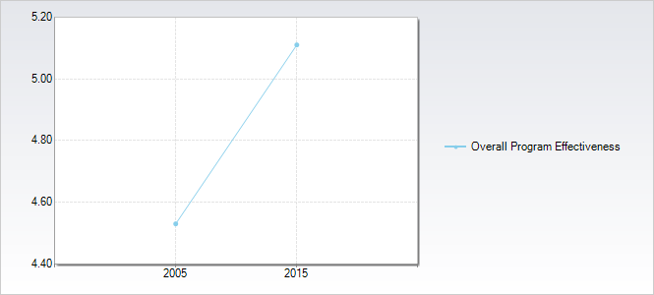

The longitudinal comparison of all the factors can be seen in the EBI Benchworks printed report located in the office area of Lander University’s Vice President for Student Affairs.

The EBI assessment report contains recommendations for improvement in terms of identifying high and low impact factors based on student satisfaction. EBI reports that “the lower the level of satisfaction, the greater the opportunity to make improvements”. Based on satisfaction levels, factors were ranked as predictors for change and improvement on factors used in measuring Overall Program Effectiveness. Below is the report containing the recommendations for improvement:
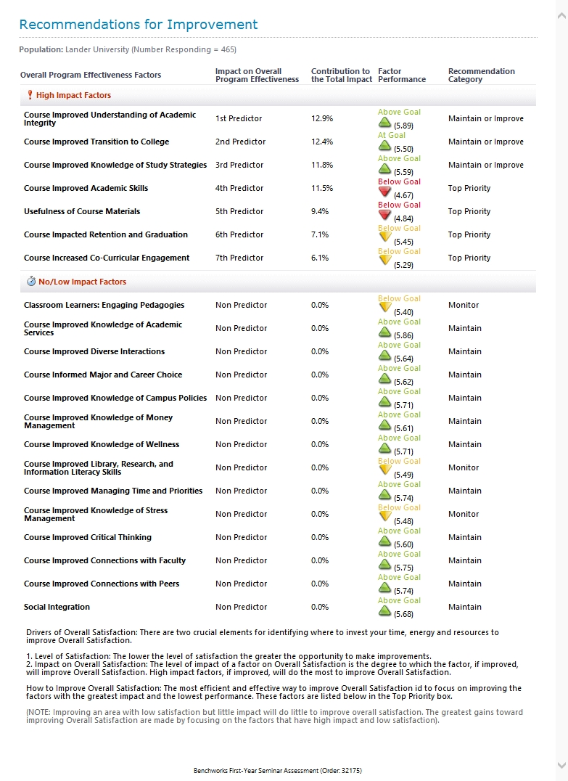

Based upon these results, two issues for discussion and possible change are incorporating additional information on improving academic skills and engaging students in developing and using more of these skills during the class and making efforts to improve the usefulness of course materials. Standard PowerPoint presentations were used in all classes along with the required textbooks of the Student Handbook and the Academic Catalog which are very usefulness and necessary to students in their academic endeavors. Students were also provided with Linda O’Brien’s book, How to Get Good Grades In College and Channing Bete Company, Inc.’s book titled, A Good Financial Start – Money Management for Young Adults. Two other factors that were ranked as more of a top priority of change for the course were the course impacting student retention and graduation from Lander University and the course increasing co-curricular engagement. Using standard PowerPoint presentations may have influenced the engagement of students in co-curricular activities. Next fall, the building of a co-curricular resume along with requiring student participation in at least one co-curricular event or activity might improve this performance in this factor. Instructors from University 101 will meet this summer to discuss these results and change the curriculum in an attempt to improve on these factors and the actual question responses on several of the factors which fell below comparison means.

University 101 required all students to attend four mandatory evening events. These events were targeted at providing the students with some educational information around Title IX issues (Theater Delta), substance use issues (Wasted…The Risks, The Realties, The Responses), motivational initiatives (Living College Life in the Front Row), and Lander University history (S. Lander – His Life & Legacy Documentary). All programs were evaluated by students and feedback gathered. The decision was made by the Vice President for Student Affairs to have students attend a specific number of FALS events or to participate in other ways on campus rather than attend these mandatory events. This was instituted for the three classes taught the Spring/2015 semester. Summaries of three of the program evaluations are presented in the tables below. The Samuel Lander film evaluation was a quiz format measuring knowledge gained rather than other facets of the presentation. The full evaluations are located in the office area of Lander University’s Vice President for Student Affairs.
Theater Delta (9/3/2014)
Statement | Strongly Agree | Agree | Disagree | Strongly Disagree
The scene & the characters were realistic. | 40% (227/568) | 54% (308/568) | 4% (24/568) | 2% (9/568)
The opportunity to interact with the characters enhanced the experience. | 37% (212/569) | 51% (288/569) | 11% (62/569) | 1% (7/569)
The post-performance conversation was thought-provoking & constructive. | 33% (185/559) | 50% (282/559) | 15% (83/559) | 2% (9/559)
The facilitators were effective in their roles. | 41% (233/570) | 46% (261/570) | 11% (64/570) | 2% (12/570)
I left this performance with more information than I came with. | 25% (142/574) | 48% (278/574) | 21% (122/574) | 6% (32/574)
This performance has impacted me in some way around these issues. | 22% (121/557) | 50% (280/557) | 23% (128/557) | 5% (28/557)
The performance has led me to reevaluate my opinions or ideas on these issues. | 19% (102/545) | 39% (211/545) | 34% (183/545) | 9% (49/545)
After experiencing this performance, I intend to change some of my behaviors around these issues. | 18% (101/557) | 42% (233/557) | 31% (170/557) | 9% (53/557)
Given the opportunity, I would attend another interactive performance by Theater Delta. | 27% (151/563) | 44% (249/563) | 23% (127/563) | 6% (36/563)
I would recommend to other people that they attend an interactive performance by Theater Delta. | 31% (179/570) | 48% (271/570) | 16% (94/570) | 5% (26/570)

Wasted…The Risks, he Realities, The Response (9/18/2014)
Statement | Strongly Agree | Agree | Disagree | Strongly Disagree
This presentation increased my knowledge/awareness of the subject. | 33% (126/381) | 48% (182/381) | 16% (62/381) | 3% (11/381)
The material presented will influence me to make positive changes in my behavior/choices. | 40% (152/380) | 46% (175/380) | 12% (46/380) | 2% (7/380)
The presenters communicated the information effectively. | 49% (187/380) | 43% (162/380) | 6% (22/380) | 2% (9/380)
The presenters were knowledgeable about the topic. | 51% (196/384) | 41% (159/384) | 6% (23/384) | 2% (6/384)
Overall, the presentation was worth my time. | 37% (139?381) | 36% (138/381) | 18% (69/381) | 9% (35/381)
This presentation impacted me in some way in regards to my thoughts about alcohol use. | 37% (140/374) | 43% (51/374) | 14% (51/374) | 6% (22/374)
This presentation caused me to reevaluate my ideas or opinions about using alcohol. | 33% (126/380) | 33% (127/380) | 27% (103/380) | 6% (24/380)
I would recommend this presentation to other people. | 38% (146/382) | 39% (149/382) | 19% (71/382) | 4% (16/382)

Living College Life in the Front Row (10/08/2014)
Statement | Strongly Agree | Agree | Disagree | Strongly Disagree
The content of this presentation was useful for me. | 53% (179/336) | 38% (128/336) | 5% (16/336) | 4% (13/336)
The presenter was effective in delivering the content of his presentation. | 61% (203/336) | 36% (122/336) | 1% (4/336) | 2% (5/336)
The content was presented in an engaging and organized manner. | 60% (201/336) | 36% (120/336) | 2% (7/336) | 2% (8/336)
I will use some of the presenter’s ideas, tips, and/or tools from the presentation. | 50% (169/336) | 42% (142/336) | 4% (12/336) | 4% (13/336)
Overall, The presentation was worth my time. | 50% (168/336) | 34% (114/336) | 7% (23/336) | 9% (31/336)

Responses to some open ended questions and comments are listed in the Appendix (pages 14-15).

APPENDIX
Description of the EBI Factors…………………………….. Page 10
Description of the EBI Statistical Analysis….…………….. Page 11
Description of the EBI External Benchmarking…………...Page 12
Description of the EBI Survey Response Rates...………......Page 13
Mandated Program Student Comments……....……………Page 14-15

Figure 1Nom

Non-factor Questions Question Numbers: 101 Reliability: N/A

Theater Delta - Student Additional Comments (9/3/2014):
- This might work better if split between girls & boys. (x2)
- Jungle juice is bad.
- Effective Performance.
- I found this to be a constructive group assembly.
- Rude comments ruined this experience for me.
- The host seemed very one-sided and you can’t be that way when you open the floor for discussion among college students.
- The situation was a gray area.
- Please tell the cast how sorry we are for the rude behavior.
- This should be required the first week of school for all freshmen.
- I may be interested in seeing someone to talk about my issues.
- This should not be played for immature freshman or they should be asked to leave, I found it offensive and very uncomfortable.

Wasted….The Risks, The Realties, The Response- Student Comments (9/3/2014):
- I learned that -
  - You should never drink & drive. (x57)
  - Choices will affect more than just you. (x36)
  - Drinking and driving put more people at risk than just yourself. (x31)
  - Nothing new. (x29)
  - Alcohol related accidents happen more common than I thought. (x24)
  - Be responsible. (x19)
  - Alcohol is very dangerous. (x16)
  - Don’t let friends drink and drive. (x14)
  - I need to be more aware of consequences. (x9)
  - Underage drinking is dangerous. (x9)
  - Drinking and driving is a serious matter. (x8)
  - A majority of college accidents are alcohol related/involved. (x4)
  - What could happen “jail wise” if you drink underage. (x3)
  - We are not invincible. (x2)
  - You shouldn’t drive angry.
  - Distracted driving is the same as drunk driving.
  - You can have fun without drinking.
  - Being yourself will get you more respect.
  - Alcohol can mess with your mind.
  - Not all diseases are curable.
  - Lander is a dry campus.
- It impacted me because –
  - The lady shared a personal story about her son. (x61)
  - Personal experience. Friends/loved ones have died/been injured due to drinking and driving. Relatable. (x56)
  - Not impacted. (x29)
  - Made me more aware of the realities of tragedy around alcohol. (x22)
  - I don’t want myself or loved ones to be injured by a drunk driver. (x19)
  - I don’t use alcohol, it made me want to continue not to drink. (x14)
  - I will not drink & drive. (x13)
  - It made me not want to drink at all. (x13)
  - Mistakes can turn very bad even if we don’t mean for them to. (x11)
  - It made me think of my future. (x9)
  - I don’t want to die/it could happen to me. (x7)
  - Made me realize I need to wait until I’m of drinking age. (x4)
  - I shouldn’t give into drinking temptations. (3)
  - We have the same presentation at my high school/seen before. (x2)
- I intend to –
  - Never drink & drive. (x58)
  - Think before I act, make smart decisions/be responsible. (x29)
  - Continue what I’ve been doing and not drink. (x28)
  - Wait until I’m 21. (x27)
  - Continue what I’ve been doing, I am smart with my drinking. (x23)
  - Don’t participate in underage drinking, it’s not worth it. (x23)
  - Just not drink. (x22)
  - Always find a DD. (x21)
  - Look out for my friends/others. (x19)
  - Be safe – know my surroundings. (x17)
  - Stay away/avoid alcohol. (x8)
  - Limit/Watch my drinking and either have some place safe to stay or a sober driver to take me home. (x5)
  - Reevaluated my opinion on alcohol.
  - Not go to a party and get a girl drunk just to have sex.
  - Not drink because it can be addicting and make a mess out of your life.
  - I hate the tastes of alcohol but should I decide to consume it, I will do so responsibly.
- Additional Comments –
  - The lady who spoke about her son was great/moving. (x5)
  - The part where the cops spoke was not effective, no one was paying attention. (x4)
  - Cops at the beginning to be more adamant, they acted like it was not really a big deal. (x2)
  - It was informative. (x2)
  - The faculty need to be stricter on the ignorant people, it is not a laughing matter and needs to be taken seriously.
  - I pray for the family.
  - I disagree because my values were not changed, I wanted to hug the mother though.
  - Monotone and boring.
- Other Programs You Would Like to see –
  - More stories based on personal experience. (x2)
  - Programs about peer pressure.
  - Movies about this topic.
  - Something more uplifting.
  - Programs about texting and driving.
  - UFC Fight Night.

Living College Life in the Front Row (10/08/2014):
- Please Share the Tools/Tips You Plan to Live Life on the “Front Row”-
  - Treat everyone like a rockstar. (x37)
  - Don’t judge someone before you know them/never judge a book by its cover. (x23)
  - Be more active and get involved. (x21)
  - Be outgoing. (x18)
  - Get involved around campus/join organizations. (x18)
  - Be an active citizen. (x13)
  - Talk to people more. (x13)
  - Don’t be shy/get out there. (x11)
  - Be a leader. (x11)
  - “Live uncomfortable”. (x9)
  - Make friends. (x9)
  - Try new things. (x7)
  - Don’t live in fear. (x5)
  - Get pumped about class. (x4)
  - How to push myself through college.
  - Live life and have fun.
  - More videos.
  - Take every opportunity I can.
- Additional Comments –
  - I liked this program. (x22)
  - These are stupid/pointless/do not have anything to do with class. (x14)
  - These should not be mandatory/we should not be forced to come to these. (x11)
  - I’m glad this program wasn’t so downing/was more upbeat. (x2)
  - I wish the programs were offered earlier in the day.
  - This is cutting in on my study time.
  - Best one yet.
  - This should be the only presentation we are required to come to.
  - This was fun and entertaining.
  - I want to be like him when I grow up.
  - I don’t think this was all that useful.
- What Other Programs Would You Like to See as Part of the University 101 Class –
  - More motivational speakers/like this one. (x27)
  - None/we’ve had platy/this should be the last one. (x17)
  - Comedians. (x7)
  - A production/theater performance. (x6)
  - How to succeed after college. (x3)
  - Anything not sad or depressing. (x3)
  - A magic show. (x 2)
  - Safe sex/Sex talk/Not just rape talk. (x2)
  - Something about coping with college.
  - Movie night/Something about love/Violence/Art stuff.
  - How to defend myself.
  - Mock study sessions where University 101 teachers and classmates can offer help.
  - You should show a program on prison because that is probably where most of my classmates will end up.

