BANNER FINANCE

TRAINING GUIDE

FOR

GENERAL INQUIRY

AND

NAVIGATION

Revised: July 24, 2013
TABLE OF CONTENTS

Introduction……………………………………………………………………………………………2

Account Codes…………………………………………………………………………………….2 – 6

Maneuvering in Banner…………………………………………….……………………………...7 – 9

SECTION I

Budget General Query…………………………………………….……….……………10 – 15

Download to Microsoft Excel………………………………………..………………….16 – 17

Add Additional Column for Queries……………………………………….……………18 – 19

SECTION II

View Documents………………………………………………………………………...20 – 23

INTRODUCTION

Welcome to Banner Finance. The Finance modules found within Banner contain detailed information about expenditures and charges that post against an individual budget. Banner uses an accounting string called “FOAPAL” for assigning costs to its proper organizational unit. This acronym stands for:
F Fund
O Organization
A Account
P Program
A Activity
L Location

Each numeric combination of the FOAPAL is identified by 6 individual characters. Six characters for the Fund, six characters for the Organization and so on. Every financial transaction in Banner requires at least the F (Fund), O (Organization), A (Account) and P (Program). However, a six digit I (Index) has been created which will default the F (Fund), O (Organization) and P (Program) for ease of data entry. End users need only to know their I (Index) and corresponding A (Account) codes when the FOAPAL is called for. Indexes should minimize posting errors.

Account Codes

Account codes identify the type of expenditure being charged to the appropriate department and funding source.

 |  |  | DATA |  | POOL
TYP | ACCOUNT | DESCRIPTION | ENTRY | STATUS | ACCT
70 |  | Expenditures
71 |  | Supplies/Services
 | 710000 | Supplies & Services Budget Pool | B | A | 700000
 | 710390 | Lease Buy Out | Y | A | 700000
 | 711000 | Administrative Supplies | Y | A | 700000
 | 711010 | Advertising/Printing | Y | A | 700000
 | 711020 | Auxiliary Chargeback | Y | A | 700000
 | 711030 | Bank/Credit Card Fees | Y | A | 700000
 | 711040 | Contractual Services | Y | A | 700000
 | 711045 | State Owned Lease Vehicle | Y | A | 700000
 | 711050 | Cost of Goods Sold | Y | A | 700000
 | 711060 | Dues/Memberships | Y | A | 700000
 | 711070 | Insurance | Y | A | 700000
 | 711080 | Maintenance Supplies | Y | A | 700000
 | 711090 | Moving Expenses | Y | A | 700000
 | 711100 | Postage/Freight/Delivery | Y | A | 700000
 | 711110 | Purchases for Resale | Y | A | 700000
 | 711115 | Internet Band Width | Y | A | 700000
 | 711120 | Telephone | Y | A | 700000
 | 711125 | Cable | Y | A | 700000
 | 711130 | Credit Memos | Y | A | 700000
 | 711135 | Write Off | Y | A | 700000
 | 711140 | Bad Debt | Y | A | 700000
 | 711145 | Bad Debt-Park Hook | Y | A | 700000
 | 711150 | Furniture | Y | A | 700000
 | 711155 | Computer Hardware/Software | Y | A | 700000
 | 711157 | Centennial Emergency Project | Y | A | 700000
 | 711160 | Non-Capital Equipment | Y | A | 700000
 | 711170 | Police Uniforms | Y | A | 700000
 | 711180 | Taxes and Fees | Y | A | 700000
 | 711190 | City of Gwd - False Alarm Fines | Y | A | 700000
 | 711200 | Lease of Property | Y | A | 700000
 | 711210 | Honorarium | Y | A | 700000
 | 714998 | Internal Charge Back | Y | A
 | 71NPHD | Nursing PHD Reimbursements | Y | A | 700000
 | 714900 | Year End Cost Pool | B | A
 | 714999 | Year End Cost Allocation | Y | A | 714900
 | 715000 | Educational Materials | B | A
 | 715010 | Audiovisuals | Y | A | 715000
 | 715020 | Back Issues-Periodicals | Y | A | 715000
 | 715030 | Book Binding | Y | A | 715000
 | 715040 | E-Books | Y | A | 715000
 | 715050 | Electronic Full-Test Periodicals | Y | A | 715000
 | 715060 | Electronic Journals | Y | A | 715000
 | 715070 | Electronic Resources | Y | A | 715000
 | 715080 | Inter-Library Loans | Y | A | 715000
 | 715090 | Library Books | Y | A | 715000
 | 715100 | Library-LH | Y | A | 715000
 | 715110 | Library-LS | Y | A | 715000
 | 715120 | Microfilm | Y | A | 715000
 | 715130 | Music | Y | A | 715000
 | 715140 | Non-Permanent Serials | Y | A | 715000
 | 715150 | Payments for Lost Books | Y | A | 715000
 | 715160 | Periodicals | Y | A | 715000
 | 715170 | Permanent Serials | Y | A | 715000
 | 715180 | Standing Orders/Books | Y | A | 715000
 | 716000 | Athletics | B | A
 | 716050 | Game Day | Y | A | 716000
 | 716080 | Medical | Y | A | 716000
 | 716090 | Officials | Y | A | 716000
 | 716120 | Uniforms/Other | Y | A | 716000
 | 717000 | Animal Supplies/Services | B | A
 | 717010 | Hay | Y | A | 717000
 | 717020 | Feed/Supplements | Y | A | 717000
 | 717050 | Veterinary Charges | Y | A | 717000
 | 717060 | Farrier Charges | Y | A | 717000
 | 717070 | Boarding Charges | Y | A | 717000
 | 717080 | Animal Charges | Y | A | 717000
 | 717090 | Animal Waste Disposal | Y | A | 717000
 | 717100 | Stall Bedding | Y | A | 717000
72 |  | Utilities
 | 720000 | Utility Budget Pool | B | A
 | 720010 | Utilities, Trash Service | Y | A | 720000
 | 720020 | Utilities, Electricity | Y | A | 720000
 | 720030 | Utilities, Natural Gas | Y | A | 720000
 | 720040 | Utilities, Water | Y | A | 720000
 | 720050 | Utilities, Sewer | Y | A | 720000
73 |  | Travel
 | 730000 | Travel Budget Pool | B | A
 | 730005 | Athletic Team Registration | Y | A | 730000
 | 730010 | Non-State Employee Travel | Y | A | 730000
 | 730015 | Clinical Travel | Y | A | 730000
 | 730030 | Recruiting | Y | A | 730000
 | 730040 | One-day Meals | Y | A | 730000
 | 739000 | Year End Travel Allocation | Y | A | 730000
 | 730100 | Travel In-State | Y | A | 730000
 | 730110 | Mileage In-State | Y | A | 730000
 | 730120 | Lodging In-State | Y | A | 730000
 | 730130 | Meals In-State | Y | A | 730000
 | 730140 | Registrations In-State | Y | A | 730000
 | 730150 | Rental Car In-State | Y | A | 730000
 | 730160 | Other Transportation Costs In-State | Y | A | 730000
 | 730200 | Travel Out-Of-State | Y | A | 730000
 | 730210 | Mileage Out-Of-State | Y | A | 730000
 | 730220 | Airfare Out-Of-State | Y | A | 730000
 | 730230 | Lodging Out-Of-State | Y | A | 730000
 | 730240 | Meals Out-Of-State | Y | A | 730000
 | 730250 | Registrations Out-Of-State | Y | A | 730000
 | 730260 | Rental Car Out-Of-State | Y | A | 730000
 | 730270 | Other Transport Costs Out-Of-State | Y | A | 730000
 | 730300 | Travel Foreign | Y | A | 730000
 | 730310 | Airfare Foreign | Y | A | 730000
 | 730320 | Lodging Foreign | Y | A | 730000
 | 730330 | Meals Foreign | Y | A | 730000
 | 730340 | Registrations Foreign | Y | A | 730000
 | 730350 | Rental Car Foreign | Y | A | 730000
 | 730360 | Other Transportation Costs Foreign | Y | A | 730000
74 |  | Perkins
 | 740000 | Cost Prin & Int Pool | B | A
 | 740005 | Cost Prin & Int Can 15% After Teach | Y | A
 | 740010 | Cost Prin & Int Can 20% After Teach | Y | A
 | 740020 | Cost Prin & Int Can 30% After Teach | Y | A
 | 740030 | Cost Of Prin. & Int. Can. Death | Y | A | 740000
 | 740040 | Cost of P&I Can. Disability | Y | A | 740000
 | 740050 | Cost of P&I Can. Bankruptcy | Y | A | 740000
 | 740060 | Other Collection Costs | Y | A | 740000
 | 740070 | Administration Expense | Y | A | 740000
 | 740080 | Perkins Share Due to Federal Govern | Y | A | 740000
 | 740090 | Cost of P&I Can Law11/90&Aft 15% | Y | A | 740000
 | 740100 | Cost of P&I Can Law11/90&Aft 20% | Y | A | 740000
 | 740110 | Cost of P&I Can Law 11/90&Aft 30% | Y | A | 740000
 | 740120 | Cost P&I Nur/Med Can 7/22/92 15% | Y | A | 740000
 | 740130 | Cost P&I Nur/Med Can 7/22/92 20% | Y | A | 740000
 | 740140 | Cost P&I Nur/Med Can 7/22/92 30% | Y | A | 740000
 | 740150 | Cost of P&I Can High Risk 15% | Y | A | 740000
 | 740152 | Cost of P&I Can High Risk 20% | Y | A | 740000
 | 740154 | Cost of P&I Can High Risk 30% | Y | A | 740000
 | 740160 | 15% Cost of PrinTeach Short 7/92 | Y | A | 740000
 | 740170 | 20% Cost of PrinTeach Short 7/92 | Y | A | 740000
 | 740180 | 30% Cost of PrinTeach Short 7/92 | Y | A | 740000
 | 740190 | Cost of Mil Canc Act Duty Host Area | Y | A | 740000
 | 740200 | Cost Prin & Int Can US Dept of Ed | Y | A
 | 740210 | Cost P&I State Lic Pre-K | Y | A
75 |  | Capital Acquisitions
 | 750000 | Capital Equipment Budget Pool | B | A
 | 750010 | Vehicles | Y | A | 750000
 | 750020 | Machinery, equip., & other | Y | A | 750000
 | 750030 | Intangibles | Y | A | 750000
 | 750040 | Buildings & improvements | Y | A | 750000
 | 750050 | Land improvements | Y | A | 750000
 | 750060 | Land & improvements | Y | A | 750000
76 |  | Notes/Bonds Expense
 | 760000 | Principle | Y | A | 700000
 | 760010 | Interest | Y | A | 700000
 | 760020 | Fees | Y | A | 700000
77 |  | Amortization/Depreciation
 | 779999 | Amortization/Depreciation | Y | A | 700000
78 |  | Indirect Cost Recovery
 | 788888 | Indirect Cost Recovery | Y | A | 700000
79 |  | Scholarships
 | 790000 | Scholarship Budget Pool | B | A
 | 790010 | Scholarships Paid | Y | A | 790000
 | 790020 | Fee Waivers | Y | A | 790000
 | 790021 | Tuition Prepayment Fee Waiver | Y | A | 790000
 | 790025 | Portal Waivers | Y | A | 790000
 | 790030 | Summer Smart Waivers | Y | A | 790000
 | 790040 | Men's Baseball Scholarship | Y | A | 790000
 | 790050 | Men's Basketball Scholarship | Y | A | 790000
 | 790060 | Men's Golf Scholarship | Y | A | 790000
 | 790070 | Men's Soccer Scholarship | Y | A | 790000
 | 790080 | Men's Tennis Scholarship | Y | A | 790000
 | 790090 | Women's Basketball Scholarship | Y | A | 790000
 | 790100 | Women's Cross Country Scholarship | Y | A | 790000
 | 790110 | Women's Soccer Scholarship | Y | A | 790000
 | 790120 | Women's Softball Scholarship | Y | A | 790000
 | 790130 | Women's Tennis Scholarship | Y | A | 790000
 | 790140 | Women's Volleyball Scholarship | Y | A | 790000
 | 790145 | Women's Golf Scholarship | Y | A | 790000
 | 790150 | Police/Fireman-Free | Y | A | 790000
 | 790160 | Veterans Admin.-Free | Y | A | 790000
 | 790165 | LU Out of State Scholarship | Y | A | 790000
 | 790170 | Out of State Abatement | Y | A | 790000
 | 790180 | Out of State-Sister St.-Abatement | Y | A | 790000
 | 790190 | Fees-Gov. Essay Abatement | Y | A | 790000
 | 790200 | International Dorm Grant | Y | A | 790000
7A |  | Expenditure Pool
 | 700000 | Expenditure Budget Pool | B | A
 | 700100 | Contingency | B | A
7B |  | Internal Expenditures
 | 799995 | Annual Leave | Y | A | 700000
 | 799997 | Bus Useage Charge | Y | A | 700000
 | 799998 | Reimbursements | Y | A | 700000
 | 799999 | Internal Expenses | Y | A | 700000

Maneuvering in Banner

Users will access Banner Finance through a feature called “Self Service” renamed “Bearcat Web”.

Navigate to your MyLander Campus Portal https://mylander.lander.edu/cp/home/displaylogin

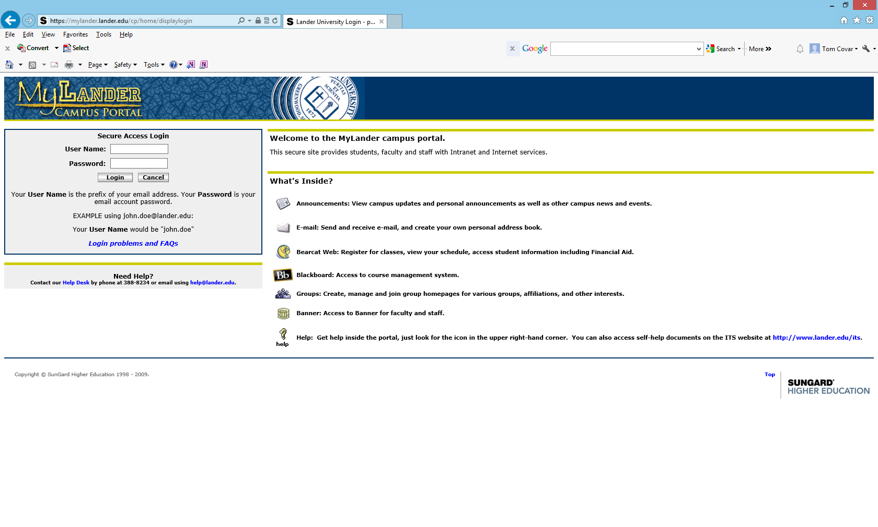
Enter your User Name and Password as if you are logging onto your computer for the first time for the day.

Enter:
User Name and
Password
Choose “Login”

On the upper right side of your MyLander homepage, choose the Bearcat Web (Banner Self-Service) folder to access your Bearcat Web authorizations.

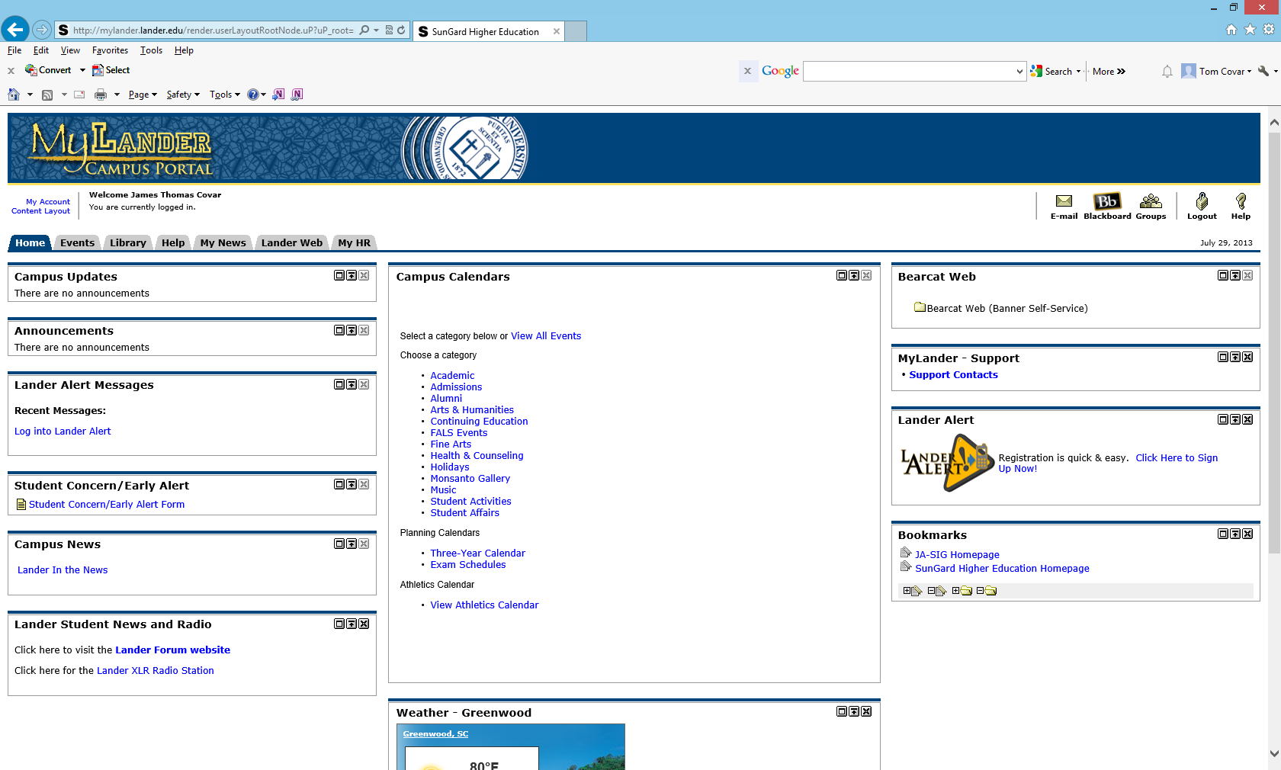
Choose Bearcat Web (Banner Self-Service)

Depending on your authorization criteria, your folder options may vary. For Budgeting, choose the Finance folder.
Choose the Finance folder
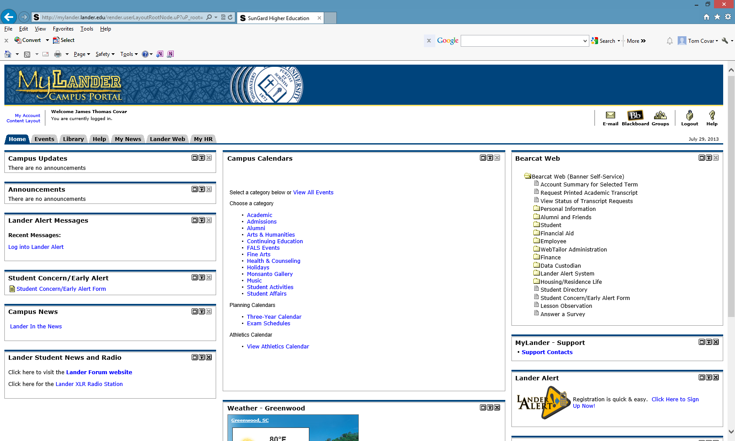

SECTION I

Budget General Query

Notice, two options will appear, Budget Queries and View Document. Choose Budget Queries.

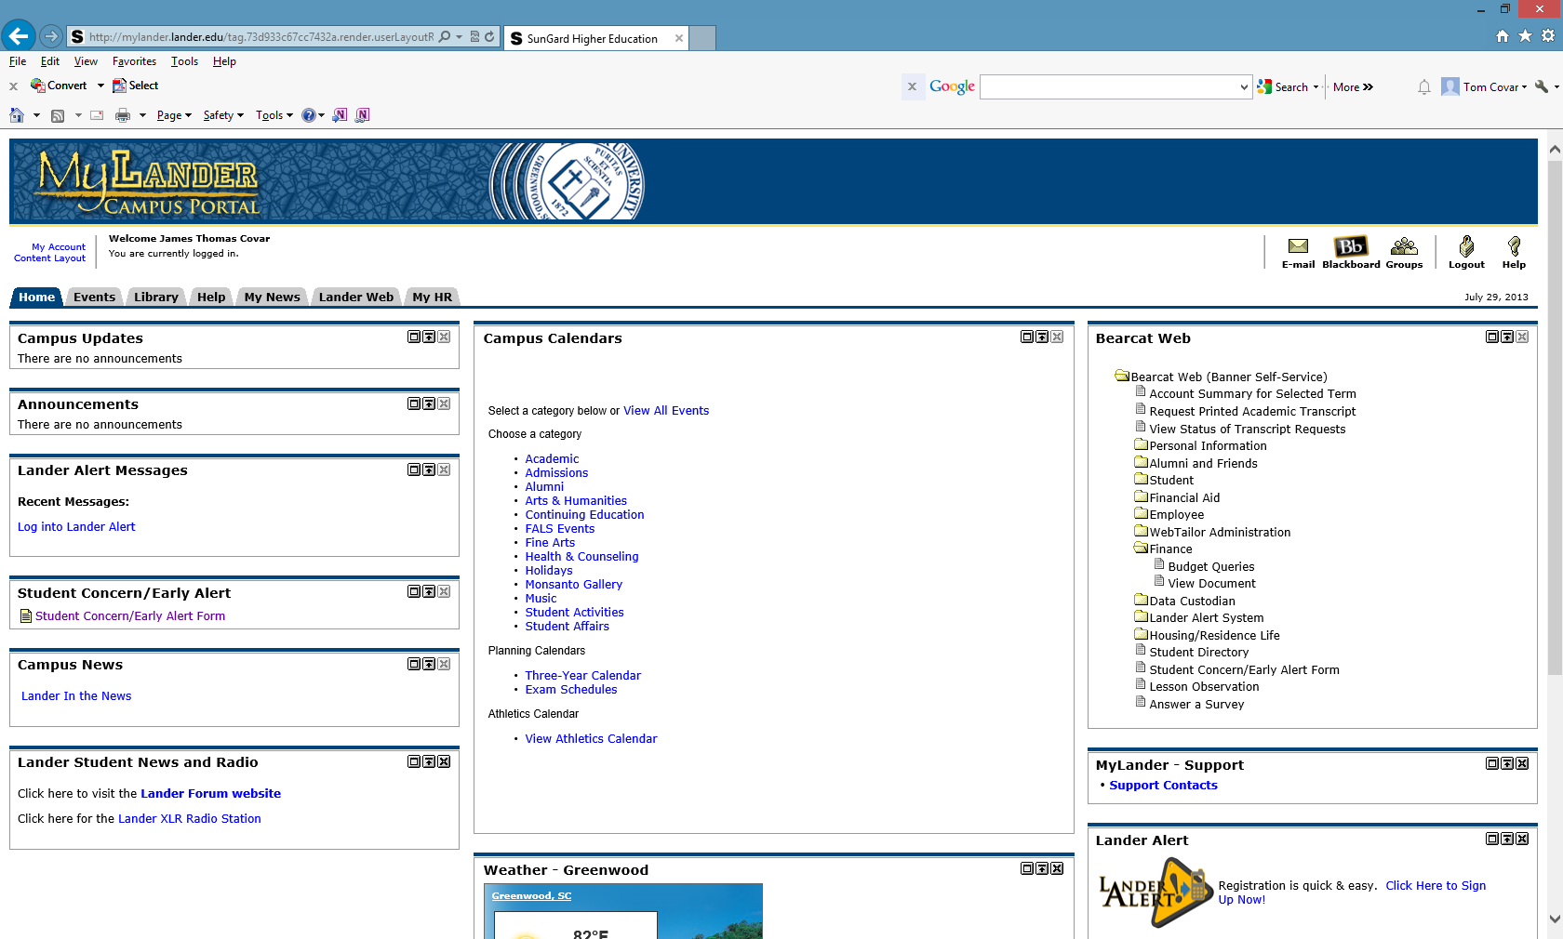
Choose Budget Queries

- Budget Queries will be used to inquire into individual FOAPALs.

- View Document will be used to inquire into a specified accounting document such as a Purchase Order, Travel Authorization, Requisition, etc.

Using your drop down box for “Retrieve Existing Query,” choose General Inquiry (Shared).

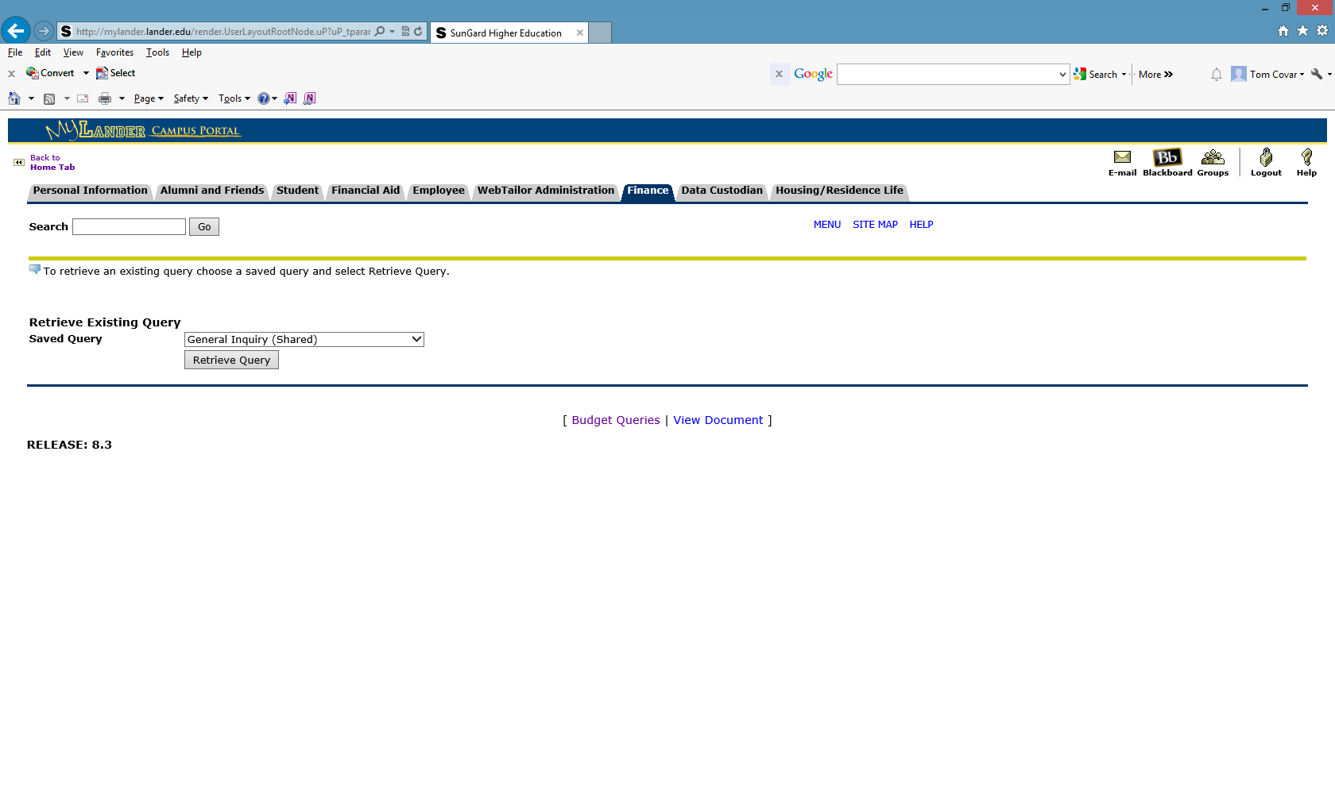 Choose Retrieve Query.
Retrieve Query

The appropriate report criteria are automatically selected.

Choose Continue to advance to next page.

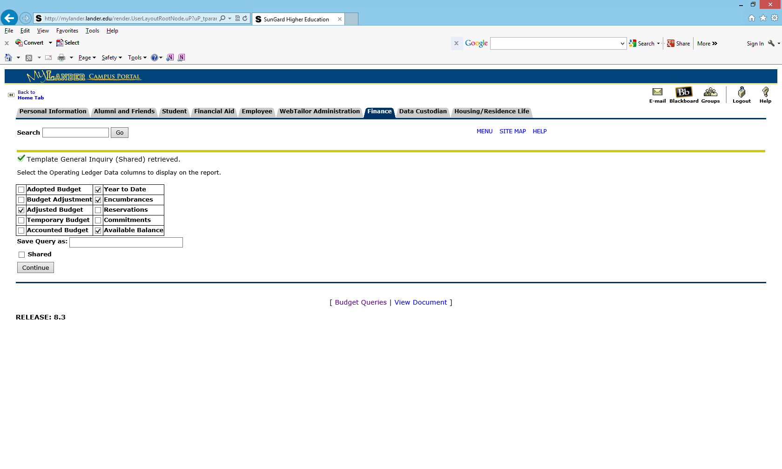
Continue

Note Fiscal Year and Fiscal Period have been pre-populated. Enter your index number in the Index field.

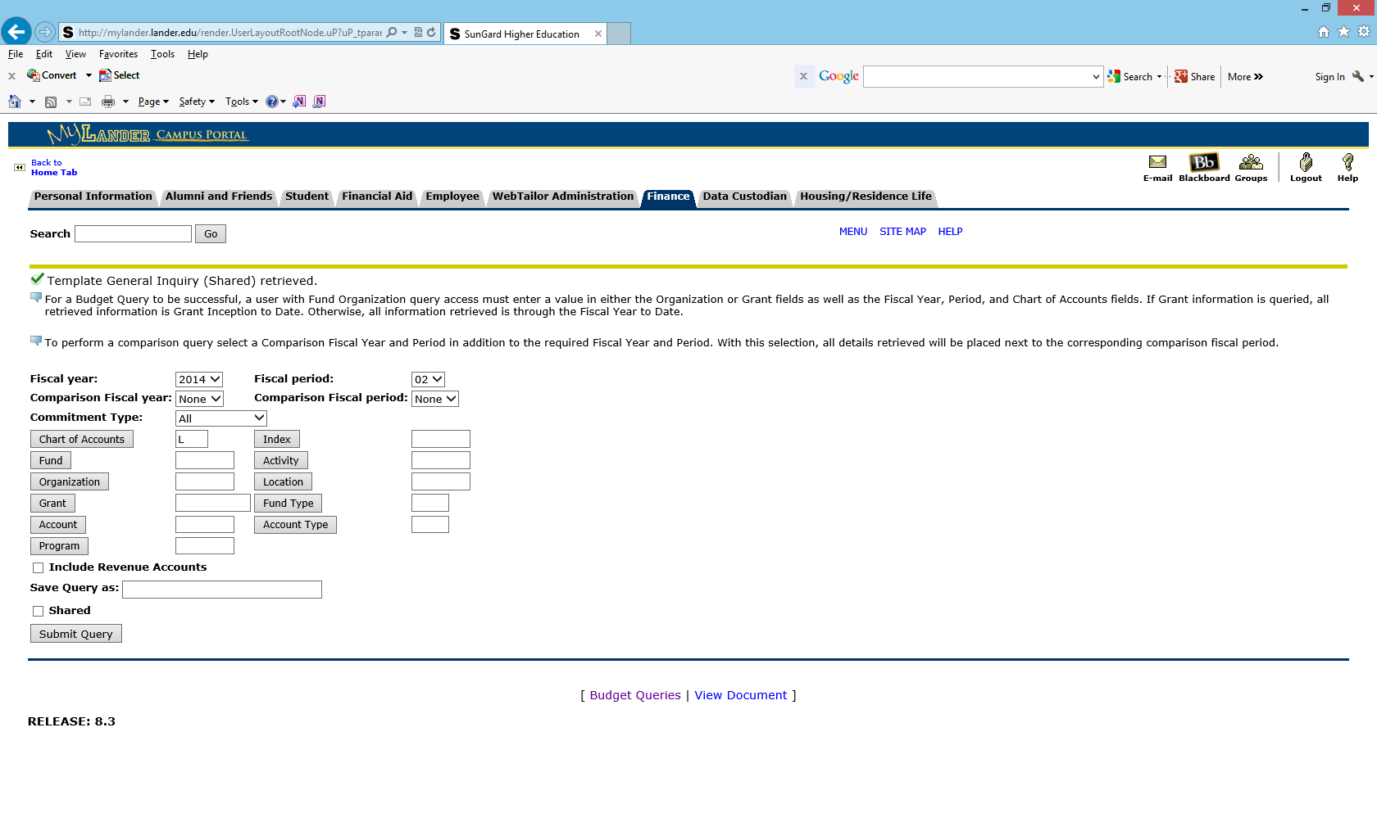
Submit Query
Enter the index number you wish to query.

Choose Submit Query.

Notice that your Fund, Organization and Program Codes have now been populated.
Submit Query

Notice that the Fund, Organization and Program codes have defaulted into their appropriate fields.

Press the Submit Query Button again to view your data output.

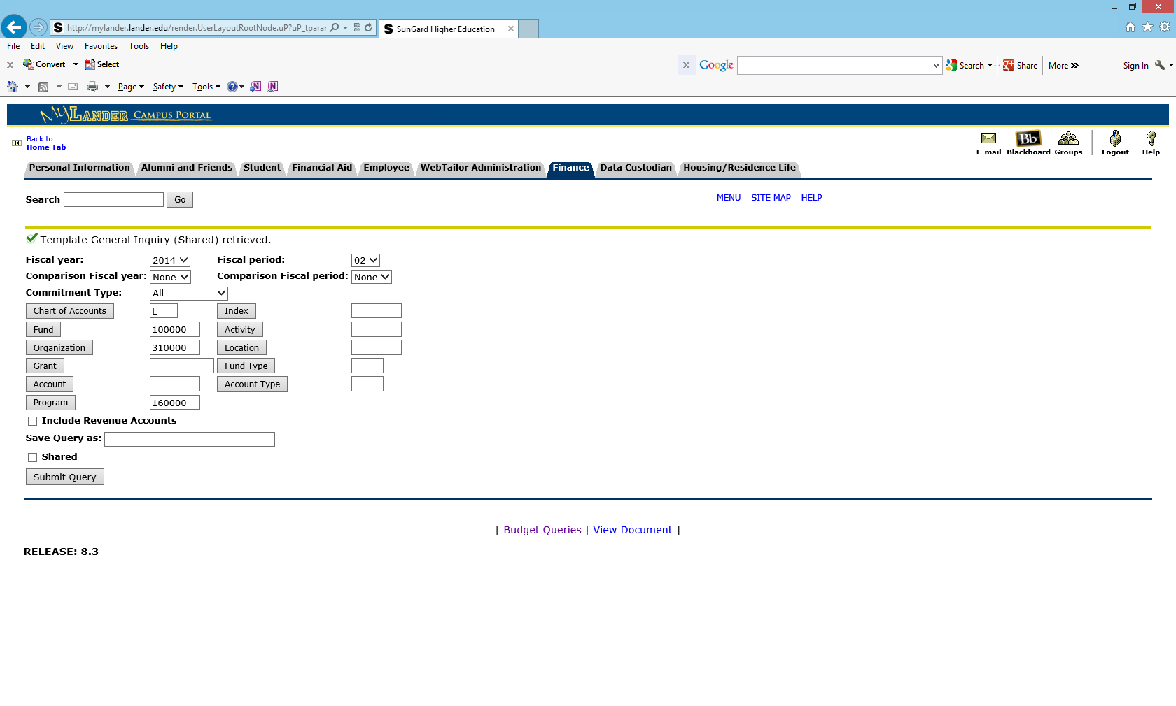
Notice that your Fund, Organization and Program Codes have now been populated
Submit Query

Data Output:

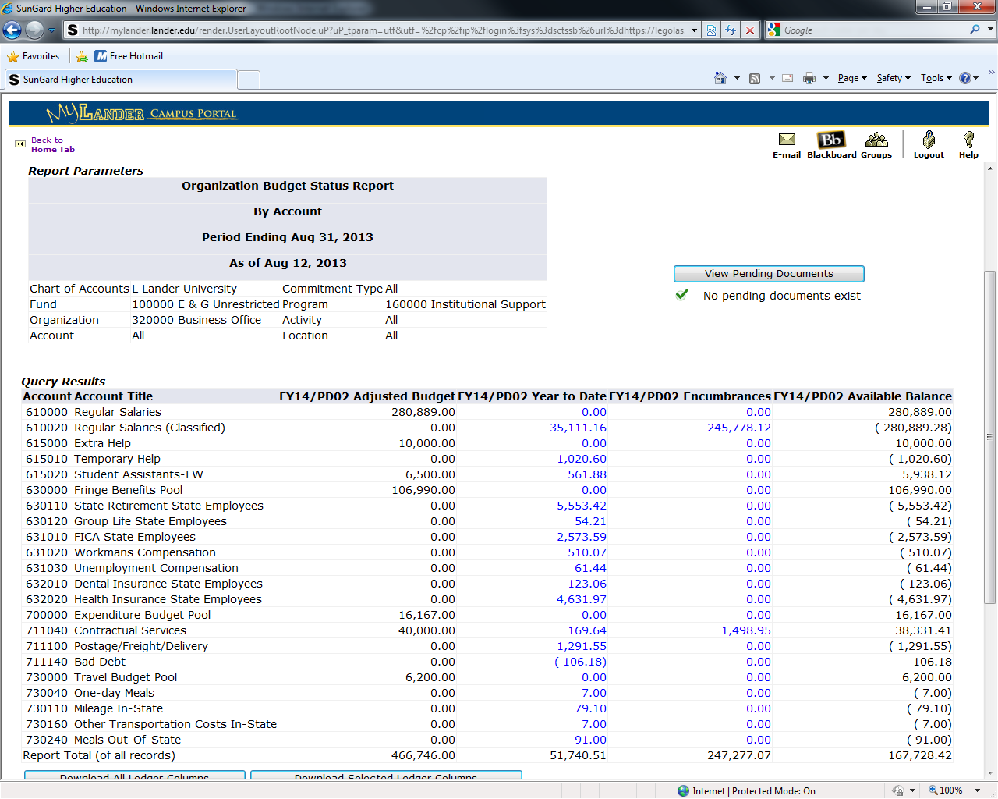

Download to Microsoft Excel

Another feature offered by Banner Finance is the ability to download financial data retrieved by the query into a Microsoft Excel spreadsheet.

Choose the “Download Selected Ledger Columns.”

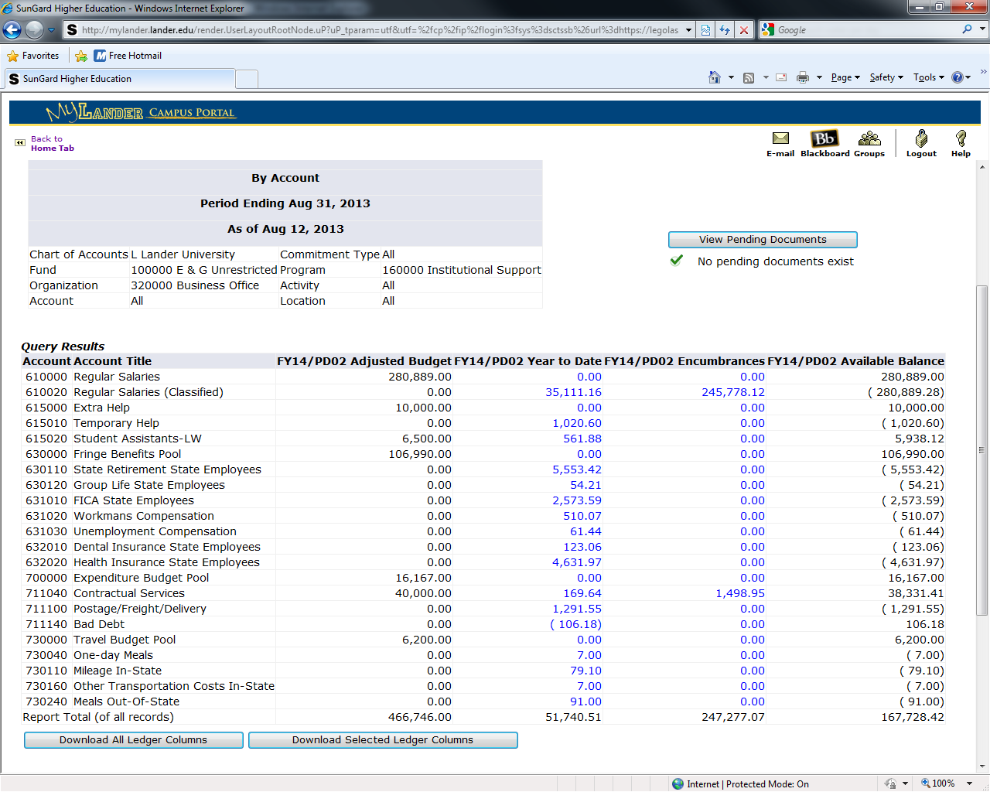

Download Selected Ledger Columns

Notice that the queried results have now been downloaded into a Microsoft Excel format. Microsoft Excel features can be used to add, delete, or rearrange the data to accommodate the needs of the user.

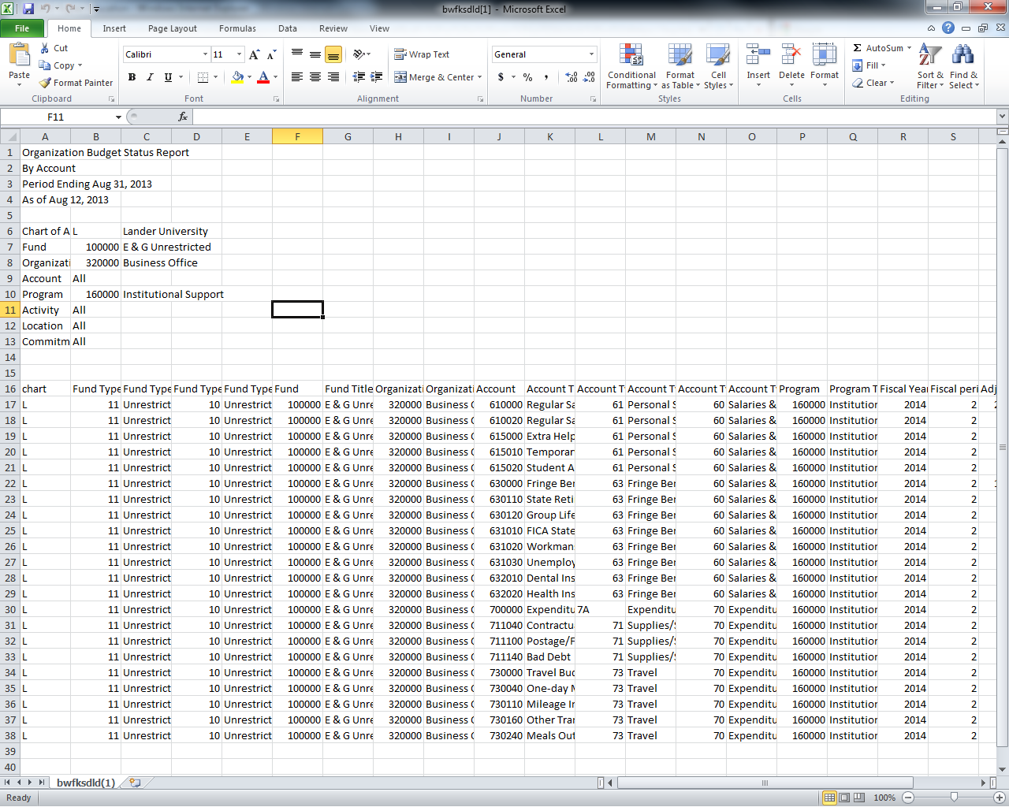

Add Additional Column for Queries

An additional feature of Banner Finance is the ability to add a calculated field to an executed query.

Use the drop down boxes to choose a calculation to perform and its placement on the results screen.

Press the Perform Computation button.

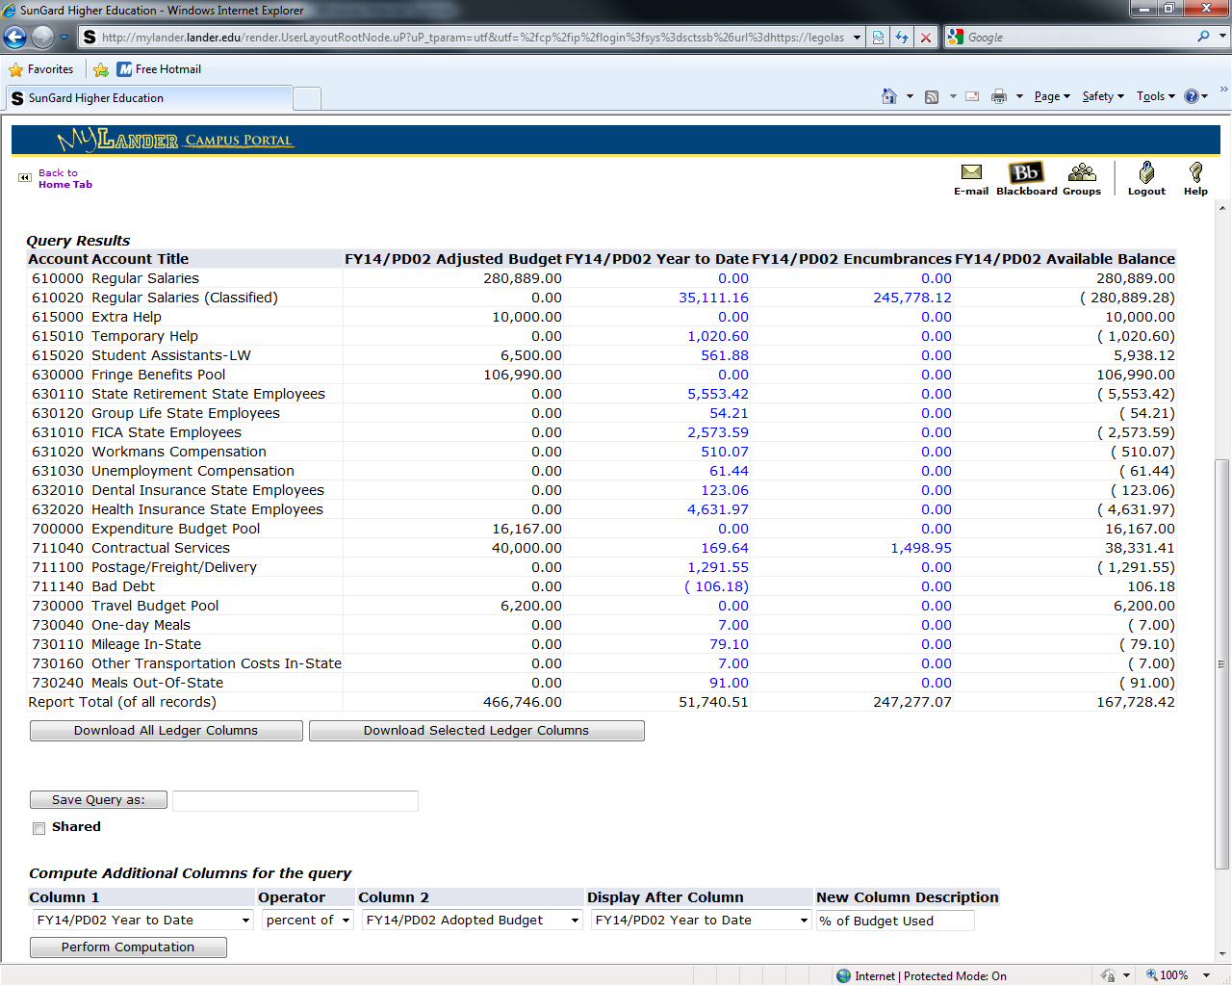

Perform Computation

Notice that “% of Budget Used” has been inserted after the Year to Date Column. Should the user utilize the Download Selected Ledger Columns feature, the Microsoft Excel spreadsheet will NOT include the “% of Budget Used” as it is a temporary calculated field.

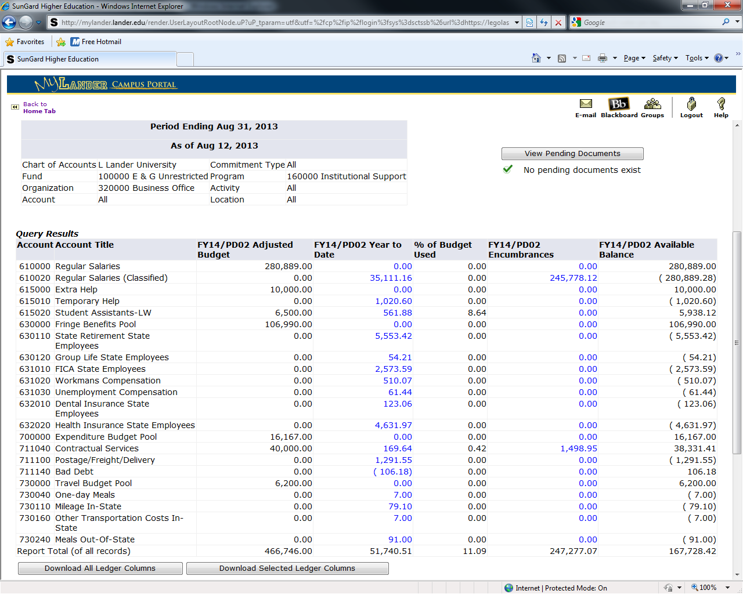

SECTION II

View Documents

Banner Finance also enables the user to view a specific document provided the document number is known. Also be aware that the data retrieved through the View Document menu is also available by drilling down in the Budget Queries menu.

Choose the View Document option as indicated by the circled selection below if the document number is known.

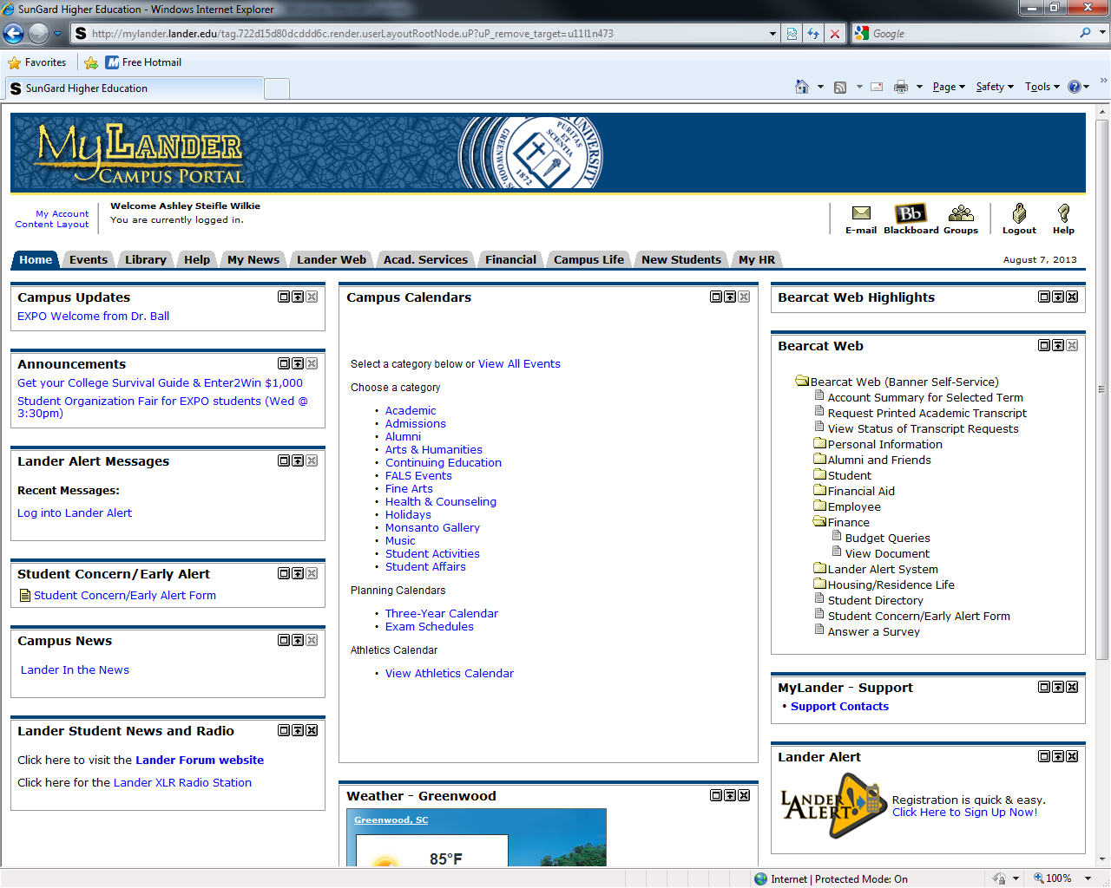
Choose View Document

Using the drop down dialog box, indicate the type of document by choosing the Requisition, Purchase Order, Invoice, Journal Voucher, Encumbrance, or Direct Cash Receipt.

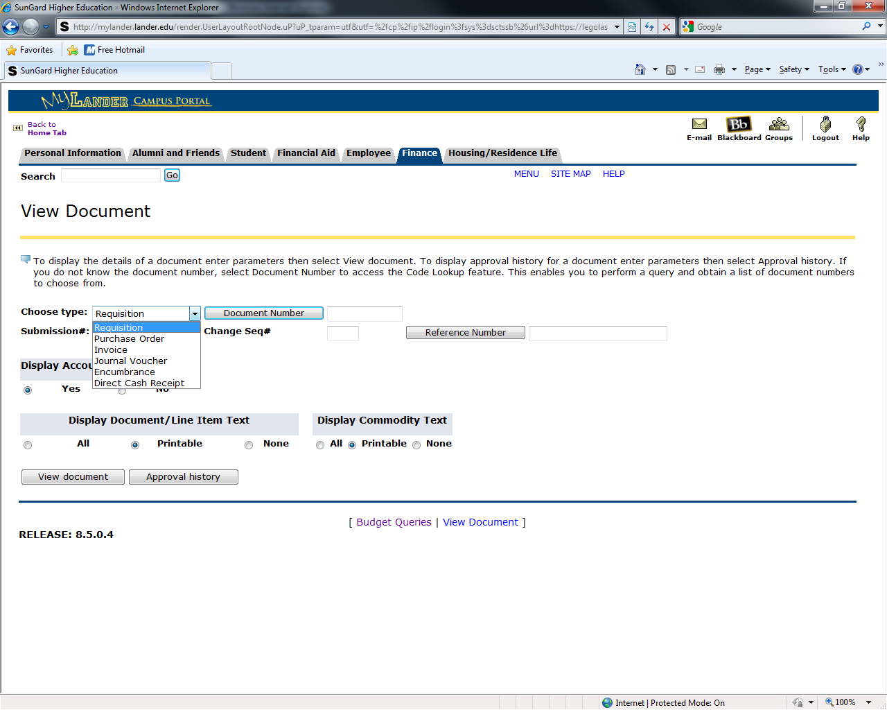

In this example choose “Invoice” from the drop down dialog box as indicated by the circled selection below. Key the appropriate document number into the Document Number field and press the View Document button.

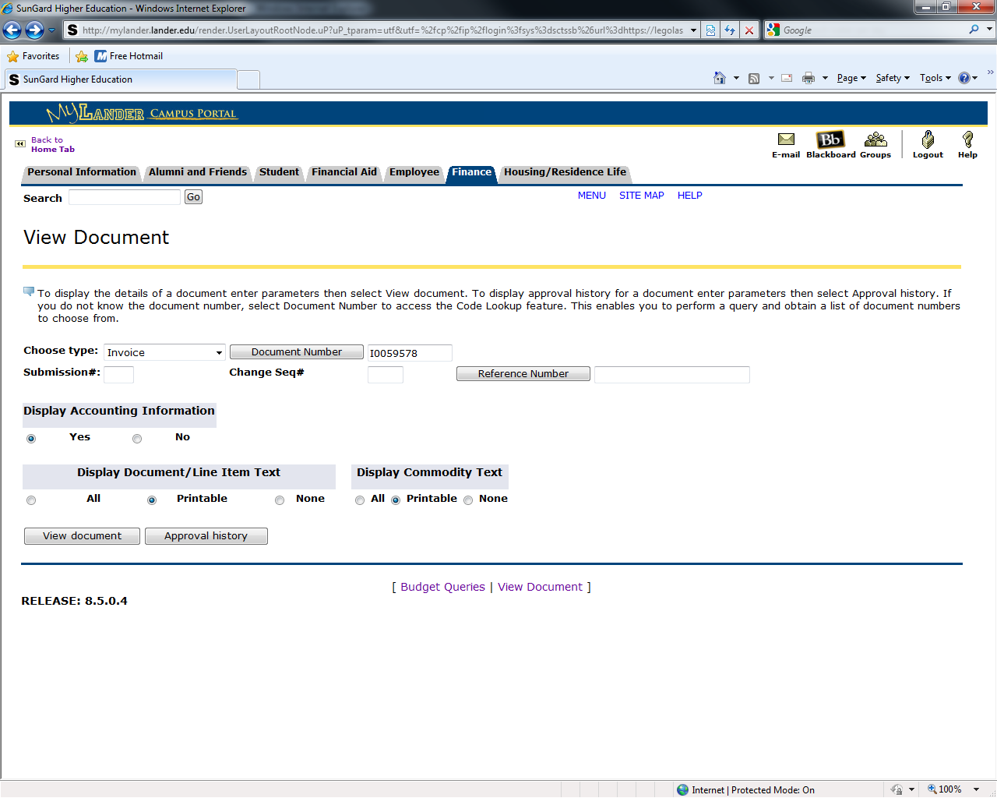
View Document

The data shown is the document.

