DESIGN-BUILD REQUEST FOR PROPOSAL

Lander University
Outdoor Pool Demolition and Construction

State Project # H21-N069-CB

July 01, 2021

Proposals Due: August 03, 2021 by 3:00 PM

TABLE OF CONTENTS

- INTRODUCTION Page 3
1.1 Competitive Sealed Proposal Page 3
  - Request for Proposal Page 3
  - For Shortlisted Firms Only Page 3
  - Pre-Proposal Conference and Site Visit Page 3

- WRITTEN TECHNICAL PROPOSAL—SUBMISSION FORMAT AND REQUIREMENTS PAGE 3
  - Proposal Format Page 3
  - Evaluation of Shortlisted Firms Page 4
  - Response to Criteria Page 5
  - Additional Conditions Page 6

- INTERVIEW, FEE PROPOSAL, & FINAL EVALUATION PAGE 7
  - Proposal Presentation and Interview Format Page 7
  - Questions Page 7
  - Who Should Attend? Page 7
  - Intent of Interview Page 7
  - Final Evaluation Ranking Page 7
  - Fee Proposal Evaluation Page 7

- ADDITIONAL INFORMATION
  - Right to Withdraw or Reject Page 7
  - Rejection of Submittals Page 8
  - Apparent Successful Firm Page 8
  - Waiver of Minor Irregularities Page 8
  - Submittals Property of Owner Page 8
  - Owner’s Right to Concepts Page 8
  - Special Considerations Page 8
  - Discussions and Negotiations Page 8
  - Criminal Background Checks Page 9
  - Certification Regarding Debarment and Other Responsibility Matters. …….Page 9
  - Ethics Certificate Page10
  - Restrictions Applicable to Offerors & Gifts Page 10
  - Non-Resident Taxpayer Registration Affidavit Income Tax Withholding Page 10
  - Submitting Confidential Information Page 11
  - Solicitation Information from Sources Other Than Official Source Page 12
  - Tax Credit for Subcontracting with Minority Firms Page 12
  - Clarification Page 12
  - Discussions & Negotiations Page 12
  - Open Trade Representation Page 12

Exhibit A - Fee Proposal Form Page 13
Exhibit B – Agency Provided Reference – Pool Location Page 14
Exhibit C - Agency Provided Reference – Existing Pool Drainage Page 15
Exhibit D – Agency Provided Reference - Restroom Facility Location ..…………………………...Page 16
Exhibit E – Agency Preferred Design Criteria……………………………………………………….Page 17

- INTRODUCTION
1.1 Final Selection of the Deign-Build (DB) firm for this project shall be made using the Competitive Sealed Proposal method according to South Carolina Code of Laws, Section 11-35-1530 – Competitive Sealed Proposals.
1.2 Lander University will be utilizing a Single-Phase SCBO solicitation for this Request for Proposals (RFP
1.3 The RFP is offered only to Design Build firms that respond to the SE-710, Invitation for Professional Services, SCBO solicitation.
1.4 Lander University will be hosting a pre-proposal meeting. The meeting will be held on the project site. The purpose of the visit is to acquaint interested Design Build Teams with the construction area and the existing conditions. You can gain early access to the project site by scheduling an appointment with the Agency Project Manager, Jeff Beaver at (864) 388-8208, jbeaver@lander.edu. By submitting the RFP, the DB Team acknowledges that they are familiar with the site and existing conditions as ascertained through the site visit. All questions shall be documented, via email, to the Project Manager, Jeff Beaver.

2. WRITTEN TECHNICAL PROPOSAL – SUBMISSION FORMAT AND REQUIREMENTS
(Response to Request for Proposal or RFP) – Physical Submittal
2.1 Interested Design Build firms, who receive the Design Build RFP, will be able to submit proposals describing their ideas and approach to the project. The format shall be according to the evaluation criteria order dictated in Section 2.2.1.
2.1.1 Five (05) printed copies shall be submitted. Each submittal shall be identical and include a transmittal letter. The transmittal letter does not count toward the page limit. No stipend is provided; therefore, the Submitter’s cost incurred in responding to the RFP is the submitter’s alone.
2.1.2 Responses are limited to no more than thirty (30) printed pages using a minimum of a 11-point Times New Roman font and one-inch margins. A page means a display of information on a side of a sheet of paper (printing on a single side of paper is one page; printing on both side of the same sheet of paper is two pages). Submitted document shall be 8 ½” x 11” in surface area, not including its binder. Charts and Drawings can be submitted on 8 ½” x 17” page (Z – folded). Pages should be numbered consecutively. A table of contents, with corresponding tabs in the body of the proposal, must be included as well to identify each section. Placing multiple tabs on the same page is acceptable. If more than one item in the table of contents can be started on a single page, you may do so and place all corresponding tabs on that page. Any affidavits, certifications or signed statements called for may be included an in appendix and will not count toward the page limit. The transmittal letter, cover and table of contents do not apply toward the page limit.
2.1.3 The deadline for submission of the RFP is listed on the SE-710, Invitation for Design – Build Services and the RFP’s cover page. This is a firm deadline. The Agency is not responsible for the proper or timely delivery of submittals. Failure to meet the deadline for receipt of submittals will result in refusal of the submittal. Submittals received after the deadline will not be considered whether delayed in transit or for any other cause whatsoever. The SE-710 provided for three methods of delivery of the RFP response: US Mail, Commercial Currier, and a Hand-Deliver Address. Each firm is solely responsible for the accuracy and completeness of its submittal. Errors and omissions may constitute grounds for rejection.
2.1.4 Costs to Prepare Responses: The Agency assumes no responsibility or obligation to the respondents and will make no payment for any costs associated with the preparation or submission of proposals.
2.1.5 In order to limit the cost incurred by responding to this solicitation, proposers are encouraged to be brief. Firms should devote the majority of the written proposal and the interview time to creative ideas and special qualifications pertinent to this project. Emphasis should be placed on responding to the evaluation criteria, understanding the project requirements and the project goals. If there are multiple firms proposed as one team, each component firm should describe its relevant experience but the total number of pages must be adhered to for the submission.
2.1.6 Firms should deliver their RFP submissions in a sealed package. The name and address of the firm should appear on the outside of the package and the package should reference the project. Do not include a fee proposal with the technical proposal. The Fee Proposal is submitted separately as outlined in Section 3.
2.1.7 Submit technical proposal only to the Project Manager / Procurement Officer at the following address:
Jeffrey S. Beaver
Lander University
Director – Office of Engineering Services and Facility Operations
US Mail Currier
320 Stanley Avenue 204 West Henrietta Ave1205 Main Street
Greenwood, South Carolina 29649 Greenwood, SC 29649
Phone: 864-388-8208
Email: jbeaver@lander.edu
2.1.8 All questions during the proposal phase should be submitted in writing and those responses will be posted in an addendum to the website at jbeaver@lander.edu. Questions should be submitted to Jeff Beaver – contact information in section 2.1.7 above.
2.2 Evaluation of Interested Firms
2.2.1 The Selection Committee will evaluate the content of the written technical proposals, the interviews and the fee proposals based upon the criteria listed in the table below. As the services being sought are considered professional in nature, the evaluation will be based upon consideration of the demonstrated qualifications and capabilities of the proposers. The criteria are listed in no particular order.

RFP CRITERIA
Major Category | Criteria Elements
Project Approach, Execution, and Project Timeline | - Proposed approach for the design process, permitting, developing cost information, developing construction-scheduling information, selecting subcontractors, and managing the construction, including working through issues that may arise during the construction process.
Qualifications and Experience of the proposed D-B Team | - Experience in managing and constructing similar size and scope of projects.  - Experience of their project team directly working on this project.  - Quality of references for the proposed team.  - Three examples, with pictures, of similar projects including the project name, the names and roles of key members of the D-B Design Team that participated in the project.  - Names of the design firms and the project general scope of work, construction costs, location, and a client point of contact. Provide a comparison of the initial scope of work, initial cost and initial schedule versus the file scope of work, final actual cost and final actual schedule, including an explanation for any differences between each category.
Project Cost Proposal | - Provide an itemized list of project costs:  Demolition of the existing pool  Design Fees : Schematic Design Phase  Design Development Phase  Construction Phase  Construction of the new pool, to include infrastructure  Construction of the restroom facility  Bonding, Insurance, Fees, all other tangible cost  10% construction contingency
Design Creativity | - Lander University has provided great flexibility on the design parameters. This section should illustrate your interpretation of creativity in developing an attractive, modern, functional venue. Creativity shall be accomplished without sacrificing quality, design integrity, or standard engineering /construction
Equipment and Construction Warranties  (Submit Separately – See Section 3) | - Lander University is aware the manufacturers of equipment (pumps, filtration, etc…) offer factory warranties. Please provide the proposed equipment warranties.  - Lander University is interested in the warranty on work, technique and materials that the contractor is willing to provide the university regarding general construction failures, other than equipment warranties, such as, but not limited to cracking pool walls, pool loss of water, drainage issues, etc.
Clarity of Submittal | - Extent to which the instructions in the RFP were followed and information is clearly presented.
2.3 Response to Criteria
2.3.1 Project Approach, Execution, and Timeline – As part of the criteria submission, DB Teams shall address all relevant subjects as it perceives them, including but not limited to:
  - Describe design approach and how it provides a cost-effective, well-designed, operable and maintainable project that meets the projects requirements: Swimming Pool and Restroom Facility
  - Include design information like permitting, review by client, OSE, and Independent Peer Reviewer (IPR), cost estimate checks, shop drawings and submittals review, major inspections.
  - Discuss the choice of water disinfection system and equipment and the effect of those choices for maintenance, operational ease, costs, and eventual discharge.
  - Discuss the SC DHEC compliance responsibilities
  - Describe the expected operational life of the water flow loop equipment
  - Provide a list of all permits and approvals necessary to complete the project.
  - Provide water flow and treatment processes diagram of proposed water loop.
  - Provide a site plan including lay down area, and safety/security control to the job site.
  - Provide a graphical expected timeline of the respective project phases, assuming project weather is not an obstacle
  - Discuss
  - Acknowledge that the following items are also included in your proposal:
    - Security fencing temporary and final
    - Procurement and management of all subcontractors, vendors and suppliers.
2.3.2 Qualifications and Experience of the Proposed Project Design Team – As part of the criteria submission, DB Teams shall address all relevant subjects as it perceives them, including but not limited to:
  - Provide confirmation that all members of the Design –Build Design Team are legally licensed in the State of South Carolina.
  - Provide confirmation that all sub-contractors being contracted with are legally licensed in the State of South Carolina and possess the level of contractor’s license for the value of project work they are to perform
  - Ensure compliance that all contractors and sub-contractors possess a City of Greenwood, SC Business License
  - Provide information about the Design-Build team members and their proper experience with similar projects.
  - Provide like-project related references on three prior project
  - Acknowledge an understanding of the Independent Peer Review process, IPR. Lander University will be procuring and providing the respective professionals to conduct the review

2.3.3 Project Cost Proposal Project Cost Proposal – As part of the criteria submission, DB Teams shall address all relevant subjects as it perceives them, including but not limited to:
  - Provide breakdown of design, permitting and construction costs for the new swimming pool, Filtration / Pump Building, restroom facility, 5% for third party inspections, and a 10% construction contingency.
  - Provide your best design-build proposal at a cost within budget.

2.3.4. Design Creativity – Present insight into the design process and pool amenities that are intended to create a uniqueness factor and an enjoyable pool experience, where swimming is not the only offer.
- Non-institutional appearance
- Irregular perimeter shape
- Max depth of less than 5 feet, with a varying depth concept
- Wheelchair entry autonomy
- In-pool seating ledges
- Pool lighting to create a night-time wow factor
- Restroom facility architecture
- SC DHEC required perimeter safety fencing
- Application of an automated bottom cleaning system / device

2.3.5. Equipment and Construction Warranties
- Manufacturer’s Warranties on all pool and restroom equipment
- Contractor’s Warranties on construction work

2.3.6 Clarity of Submittal – As part of the criteria submission, DB Teams shall address all relevant subjects, as it perceives them, including but not limited to:
  - Conforms with the format instructions as listed above.
  - Provides information listed in the Response to Criteria.
  - Provides relevant information in a clear and concise manner that demonstrates your DB Team’s understanding of the project and their solution to performing the project..

  - Additional Conditions
2.4.1 The Selection Committee members will receive, and independently review, score, and rank the RFPs that were submitted. The Committee will consolidate and summarize the individual evaluations into a comprehensive score and ranking of the design teams’ submittals. Committee will review the submittals and invite the top three ranked, qualified teams, for interviews with the Selection Committee, using the criteria established in the RFP. However, should the review of a technical proposal from a firm convince the Selection Committee that a firm is not appropriate for this project, the interview will be cancelled and the firm will not advance further in the process.
2.4.2 The Agency reserves the right to reject any or all responses received. The Agency is not obligated to request clarifications or additional information but may do so at its discretion. The Agency reserves the right to extend the deadline for submittals.
2.4.3 The Agency reserves the right to check references of proposed personnel on the project team and to request substitutions of personnel if it deems such action is in the Agency’s best interests. Moreover, the Agency reserves the right to check any reference that it may become aware of in addition to the references given by the proposer.
2.4.4 Equal Employment Opportunity: During the performance of this Contract, the DB Team agrees as follows: The DB Team will not discriminate against any employee or applicant for employment because of race, creed, color, sex, age, national origin, place of birth, or physical handicap. The DB Team must have a history of being non-discriminating and will not discriminate on the basis of race, creed, color, sex, or national origin in any of its employment practices, or procurement practices with respect to the workforce of the firm, or procurement services in connection with this project.
2.4.5 It is a specific requirement that the selected firm certify that it operates a drug-free workplace and that it will remain that way throughout the duration of the project in order to satisfy South Carolina Statute 44-107-30.
2.4.6. Lander University is a tobacco product free campus. The Design Build Team is to ensure compliance
2.4.7 Lander University has a zero tolerance standard for allegation that contractor personnel acted in ways considered un-becoming to the university, have partaken in activity including, but not limited to, harassment, intimidation, cat-calling, threatened, and/or undertaken an unwelcomed approach towards university faculty, staff, students, and camp attendees.

3. INTERVIEW, FEE PROPOSAL, & FINAL EVALUATION
3.1 The time allotted to each firm for the presentation and interview will not exceed 45 minutes (30 minutes for presentation, 15 minutes for questions and discussion). The format of the firm’s presentation during the interview session is at the discretion of the firm. All members of the Selection Committee will be present during the formal interview.
3.2 Firms must address any questions related to the interview to the Project Manager, Jeff Beaver. Firms must not contact any other members of the Selection Committee before or after the interview until after a contract has been executed.
3.3 The number of representatives of the DB team is limited to a maximum of seven (7) individuals, and shall include at least the DB’s Project Manager, Construction Manager and Design Manager, and those key people with whom the Owner will interact regularly.
3.4 The intent of the formal interview process is to provide the Selection Committee with an elaboration of the written proposal’s information in order to help the Selection Committee make a final selection of the firm that in the sole discretion of the selection committee best meets the requirements for this project.
3.5 Based on a combination of the scores received on the written submission and the formal interview, the Committee will rank the firms in order of qualification. The Selection Committee will use only those criteria published in this RFP in making their determinations. Upon the Selection Committee’s completion of the evaluation process, public notice of the competition's results will follow, first to the shortlisted firms, after a contract has been executed.
3.6 The price hall include one proposal which shall include the total cost of the project, including fees, design, permitting, overhead, profit, and construction cost, etc. See Exhibit –A- Fee Proposal form for more detail. The price proposal shall be conveyed in the form of a stipulated lump sum price. The proposal price may become the Contracted Price, or negotiations may occur that would result in a Contracted price that is different from the proposed price. Any cost savings between the proposed lump sum price and the Contracted Price will be accrued to the Owner. Once a contract is signed, any revisions to the Contract price are to be based on cost reductions only, unless the owner modifies the scope of work. Any savings as a result of “value engineering”, final design pricing from the vendors and subcontractors, etc. will result in a shared savings between the owner and the Design/ Build Firm. The percentage of that sharing between the Owner and the Design/ Build firm will be negotiated prior to entering a contract. The price proposal will not include the Independent Peer Reviewer fees and reimbursable. The Agency will procure and pau for Chapter 01 and Chapter 17 inspections as required by the International Building Code, using a third party inspector chosen from the OSE approved list. Re-inspections and lost time from not being ready for inspections will be paid by the Design/ Build Team.
3.7 Each shortlisted firm invited to interview shall prepare and deliver a fee proposal to the Selection Committee Chair at the time of their interview. After all the interviews have ended, the Selection Committee Chair will open all of the fee proposals with the Project Manager. These fee proposals will be part of the selection evaluation. The highest-ranked Offeror’s fee proposal will be part of the basis for initial contract negotiations subsequently conducted. If negotiations with the highest-ranked Offeror are not successful, the Agency will then invite the second-ranked Offeror to negotiate, and so on. The Committee will evaluate the level and quality of professional services pledged relative to the costs proposed for Design-Build services.
3.8 Offeror agrees that from the compensation to be paid, the owner shall retain as Liquidated Damages the sum of $100 per day for each calendar day the actual construction time to achieve Substantial Completion exceeds the specified or adjusted time for Substantial Completion as provided in the contract documents. This sum is intended by the parties, as the predetermined measure of compensation for actual damages, not as a penalty for nonperformance.

- ADDITIONAL INFORMATION
4.1 The Agency reserves the right to withdraw this RFP or to reject any and all submittals at any time and cancel the project if, in the sole discretion of the Agency, continuation is deemed not to be in the best interest of the State.
4.2 In addition to the Agency’s general right to reject all submittals, a submittal may be rejected if the submittal contains false or misleading statements or references that, in the sole judgment of the Selection Committee, do not support an attribute or condition contended by the firm and, in the sole judgment of the Selection Committee, such statements were intended to mislead the Selection Committee in its evaluation of the submittal.
4.3 All submittals, together with any supporting material submitted by the firm, become the property of the Agency and may be retained, destroyed, or otherwise disposed of at the convenience of the Agency. All submittals, if retained by the Agency, become a matter of public record when final negotiations are completed. The submittal received from the selected firm will become part of the agreement reached by the Agency and the firm.
4.4 By providing a submittal, each firm agrees that the Agency will have the right to use any or all ideas or concepts presented in any submittal without restriction and without compensation to the firm.
4.5 By submitting a proposal, the Design Build Team agrees to the OSE’s “Clauses for Use in Design-Build Contracts” (Exhibit B) and will be a part of the contract documents.
4.6 DISCUSSIONS & NEGOTIATIONS : Submit your best terms from a cost or price and from a technical standpoint. Your proposal may be evaluated and your offer accepted without any discussions, negotiations, or prior notice. Ordinarily, nonresponsive proposals will be rejected outright. Nevertheless, the State may elect to conduct discussions, including the possibility of limited proposal revisions, but only for those proposals reasonably susceptible of being selected for award. If improper revisions are submitted, the State may elect to consider only your unrevised initial proposal. [11-35-1530(6); R.19-445.2095(I)] The State may also elect to conduct negotiations, beginning with the highest ranked offeror, or seek best and final offers, as provided in Section 11-35-1530(8). If negotiations are conducted, the State may elect to disregard the negotiations and accept your original proposal.
4.7 All companies, including but not limited to, the Design Build, design professionals, vendors, suppliers, consultants, general contractors of any trade, and their subcontractors, that bring one or more of its employees on to the Agency’s property in order to fulfill the terms of this agreement, must ensure the person(s) are in good legal standing and will not pose a threat to property, students, faculty, staff, and visitors of Lander University. Lander University reserves the right to have individuals suspected of illegal and/or inappropriate behavior removed from the university grounds. Lander University reserves the right to press legal charges, as appropriate, to individuals suspected of illegal and/or inappropriate behavior
4.8 Disclosure of Conflicts of Interest or Unfair Competitive Advantage (2011): You warrant and represent that your offer identifies and explains any unfair competitive advantage you may have in competing for the proposed contract and any actual or potential conflicts of interest that may arise from your participation in this competition or your receipt of an award. Without limitation, an unfair competitive advantage exists where a contractor competing for award possesses either proprietary information that was obtained from a government official without proper authorization or source selection information (as defined in SC Regulation 19-445.2010(C)) that is relevant to the contract but is not available to all competitors, and such information would assist that contractor in obtaining the contract. If you have an unfair competitive advantage or a conflict of interest, the state may withhold award. Before withholding award on these grounds, an offeror will be notified of the concerns and provided a reasonable opportunity to respond. Efforts to avoid or mitigate such concerns, including restrictions on future activities, may be considered.

  - Certification of Independent Price Determination: GIVING FALSE, MISLEADING, OR INCOMPLETE INFORMATION ON THIS CERTIFICATION MAY RENDER YOU SUBJECT TO PROSECUTION UNDER SC CODE § 16-9-10 AND OTHER APPLICABLE LAWS.
- By submitting an offer, the offeror certifies that—
- The prices in this offer have been arrived at independently, without, for the purpose of restricting competition, any consultation, communication, or agreement with any other offeror or competitor relating to—
- Those prices;
- The intention to submit an offer; or
- The methods or factors used to calculate the prices offered.
- The prices in this offer have not been and will not be knowingly disclosed by the offeror, directly or indirectly, to any other offeror or competitor before bid opening (in the case of a sealed bid solicitation) or contract award (in the case of a negotiated solicitation) unless otherwise required by law; and
- No attempt has been made or will be made by the offeror to induce any other concern to submit or not to submit an offer for the purpose of restricting competition.
- Each signature on the offer is considered to be a certification by the signatory that the signatory—
- Is the person in the offeror’s organization responsible for determining the prices being offered in this offer, and that the signatory has not participated and will not participate in any action contrary to paragraphs 1.A through 1.C of this certification; or
- (a) Has been authorized, in writing, to act as agent for the offeror's principals in certifying that those principals have not participated, and will not participate in any action contrary to paragraphs 1.a through 1.c of this certification [As used in this subdivision 2.b.i, the term "principals" means the person(s) in the offeror’s organization responsible for determining the prices offered in this bid];
- As an authorized agent, does certify that the principals referenced in subdivision 2.b.i of this certification have not participated, and will not participate, in any action contrary to paragraphs 1.a through 1.c of this certification; and
- As an agent, has not personally participated, and will not participate, in any action contrary to paragraphs 1.a through 1.c of this certification.
- If the offeror deletes or modifies paragraph 1.b of this certification, the offeror must furnish with its offer a signed statement setting forth in detail the circumstances of the disclosure.

  - CERTIFICATION REGARDING DEBARMENT AND OTHER RESPONSIBILITY MATTERS:
- By submitting an Offer, Offeror certifies, to the best of its knowledge and belief, that-
- Offeror and/or any of its Principals-
- Are not presently debarred, suspended, proposed for debarment, or declared ineligible for the award of contracts by any state or federal agency;
- Have not, within a three-year period preceding this bid, been convicted of or had a civil judgment rendered against them for: commission of fraud or a criminal offense in connection with obtaining, attempting to obtain, or performing a public (Federal, state, or local) contract or subcontract; violation of Federal or state antitrust statutes relating to the submission of bids; or commission of embezzlement, theft, forgery, bribery, falsification or destruction of records, making false statements, tax evasion, or receiving stolen property; and
- Are not presently indicted for, or otherwise criminally or civilly charged by a governmental entity with, commission of any of the offenses enumerated in paragraph 1.a.(i)(b) of this provision.
- Offeror has not, within a three-year period preceding this bid, had one or more contracts terminated for default by any public (Federal, state, or local) entity.
- "Principals," for the purposes of this certification, means officers; directors; owners; partners; and, persons having primary management or supervisory responsibilities within a business entity (e.g., general manager; plant manager; head of a subsidiary, division, or business segment, and similar positions).
- Offeror shall provide immediate written notice to the Procurement Officer if, at any time prior to contract award, Offeror learns that its certification was erroneous when submitted or has become erroneous by reason of changed circumstances.
- If Offeror is unable to certify the representations stated in paragraphs 1.a., Offer must submit a written explanation regarding its inability to make the certification. The certification will be considered in connection with a review of the Offeror's responsibility. Failure of the Offeror to furnish additional information as requested by the Procurement Officer may render the Offeror non-responsible.
- Nothing contained in the foregoing shall be constructed to require establishment of a system of records in order to render, in good faith, the certification required by paragraph (a) of this provision. The knowledge and information of an Offeror is not required to exceed that which is normally possessed by a prudent person in the ordinary course of business dealings.
- The certification in paragraph 1 of this provision is a material representation of fact upon which reliance was placed when making award. If it is later determined that the Offeror knowingly or in bad faith rendered an erroneous certification, in addition to other remedies available to the State, the Procurement Officer may terminate the contract resulting from this solicitation for default.

  - ETHICS CERTIFICATE: By submitting a offer, the offeror certifies that the offeror has and will comply with, and has not, and will not, induce a person to violate Title 8, Chapter 13 of the South Carolina Code of Laws, as amended (ethics act). The following statutes require special attention: SC Code § 8-13-700, regarding use of official position for financial gain; SC Code § 8-13-705, regarding gifts to influence action of public official; SC Code § 8-13-720, regarding offering money for advice or assistance of public official; SC Code §§ 8-13-755 and 8-13-760, regarding restrictions on employment by former public official; Section 8-13-775, prohibiting public official with economic interests from acting on contracts; SC Code § 8-13-790, regarding recovery of kickbacks; SC Code § 8-13-1150, regarding statements to be filed by consultants; and SC Code § 8-13-1342, regarding restrictions on contributions by contractor to candidate who participated in awarding of contract. The state may rescind any contract and recover all amounts expended as a result of any action taken in violation of this provision. If contractor participates, directly or indirectly, in the evaluation or award of public contracts, including without limitation, change orders or task orders regarding a public contract, contractor shall, if required by law to file such a statement, provide the statement required by SC Code § 8-13-1150 to the procurement officer at the same time the law requires the statement to be filed.

  - RESTRICTIONS APPLICABLE TO offerorS & GIFTS: Violation of these restrictions may result in disqualification of your bid, suspension or debarment, and may constitute a violation of the state Ethics Act.
- After issuance of the solicitation, offeror agrees not to discuss this procurement activity in any way with the Owner or its employees, agents or officials. All communications must be solely with the Procurement Officer. This restriction may be lifted by express written permission from the Procurement Officer. This restriction expires once a contract has been formed.
- Unless otherwise approved in writing by the Procurement Officer, offeror agrees not to give anything to the Owner, any affiliated organizations, or the employees, agents or officials of either, prior to award.
- Offeror acknowledges that the policy of the State is that a governmental body should not accept or solicit a gift, directly or indirectly, from a donor if the governmental body has reason to believe the donor has or is seeking to obtain contractual or other business or financial relationships with the governmental body. SC Regulation 19-445.2165(C) broadly defines the term donor.

  - NONRESIDENT TAXPAYER REGISTRATION AFFIDAVIT INCOME TAX WITHHOLDING (IMPORTANT TAX NOTICE - NONRESIDENTS ONLY):
- Withholding Requirements for Payments to Nonresidents: SC Code § 12-8-550 requires persons hiring or contracting with a nonresident conducting a business or performing personal services of a temporary nature within South Carolina to withhold 2% of each payment made to the nonresident.
- The withholding requirement does not apply to:
- payments on purchase orders for tangible personal property when the payments are not accompanied by services to be performed in South Carolina,
- nonresidents who are not conducting business in South Carolina,
- nonresidents for contracts that do not exceed $10,000 in a calendar year, or
- payments to a nonresident who
- registers with either the S.C. Department of Revenue or the S.C. Secretary of State and
- submits a Nonresident Taxpayer Registration Affidavit - Income Tax Withholding, Form I-312 to the person letting the contract.
- For information about other withholding requirements (e.g., employee withholding), contact the Withholding Section at the South Carolina Department of Revenue at 803-898-5383 or visit the Department's website at: www.sctax.org.
- This notice is for informational purposes only. This Owner does not administer and has no authority over tax issues. All registration questions should be directed to the License and Registration Section at 803-898-5872 or to the South Carolina Department of Revenue, Registration Unit, Columbia, S.C. 29214-0140. All withholding questions should be directed to the Withholding Section at 803-898- 5383.
- Please see the "NONRESIDENT TAXPAYER REGISTRATION AFFIDAVIT INCOME TAX WITHHOLDING" form (Form Number I-312) located at: http://www.sctax.org/forms/withholding/i-312-form

  - SUBMITTING CONFIDENTIAL INFORMATION:
- For every document Offeror submits in response to or with regard to this solicitation or request, Offeror must separately mark with the word "CONFIDENTIAL" every page, or portion thereof, that Offeror contends contains information that is exempt from public disclosure because it is either
- a trade secret as defined in SC Code § 30-4-40(a)(1), or
- privileged & confidential, as that phrase is used in SC Code § 11-35-410.
- For every document Offeror submits in response to or with regard to this solicitation or request, Offeror must separately mark with the words "TRADE SECRET" every page, or portion thereof, that Offeror contends contains a trade secret as that term is defined by SC Code § 39-8-20 of the Trade Secrets Act.
- For every document Offeror submits in response to or with regard to this solicitation or request, Offeror must separately mark with the word "PROTECTED" every page, or portion thereof, that Offeror contends is protected by SC Code § 11-35-1810.
- All markings must be conspicuous; use color, bold, underlining, or some other method in order to conspicuously distinguish the mark from the other text. Do not mark your entire bid as confidential, trade secret, or protected! If your bid or any part thereof, is improperly marked as confidential or trade secret or protected, the State may, in its sole discretion, determine it nonresponsive. If only portions of a page are subject to some protection, do not mark the entire page.
- By submitting a response to this solicitation, Offeror
  - agrees to the public disclosure of every page of every document regarding this solicitation or request that was submitted at any time prior to entering into a contract (including, but not limited to, documents contained in a response, documents submitted to clarify a response, & documents submitted during negotiations), unless the page is conspicuously marked "TRADE SECRET" or "CONFIDENTIAL" or "PROTECTED",
  - agrees that any information not marked, as required by these bidding instructions, as a "Trade Secret" is not a trade secret as defined by the Trade Secrets Act, and
  - agrees that, notwithstanding any claims or markings otherwise, any prices, commissions, discounts, or other financial figures used to determine the award, as well as the final contract amount, are subject to public disclosure.
- In determining whether to release documents, the State will detrimentally rely on Offeror’s marking of documents, as required by these bidding instructions, as being either "Confidential" or "Trade Secret" or "PROTECTED".
- By submitting a response, Offeror agrees to defend, indemnify & hold harmless the State of South Carolina, its officers & employees, from every claim, demand, loss, expense, cost, damage or injury, including attorney’s fees, arising out of or resulting from the State withholding information that Offeror marked as "confidential" or "trade secret" or "PROTECTED".
  - SOLICITATION INFORMATION FROM SOURCES OTHER THAN OFFICIAL SOURCE: South Carolina Business Opportunities (SCBO) is the official state government publication for State of South Carolina solicitations. Any information on State agency solicitations obtained from any other source is unofficial and any reliance placed on such information is at the offeror’s sole risk and is without recourse under the South Carolina Consolidated Procurement Code.
  - TAX CREDIT FOR SUBCONTRACTING WITH MINORITY FIRMS: Pursuant to SC Code § 12-6-3350, taxpayers, who utilize certified minority subcontractors, may take a tax credit equal to 4% of the payments they make to said subcontractors. The payments claimed must be based on work performed directly for a South Carolina state contract. The credit is limited to a maximum of fifty thousand dollars annually. The taxpayer is eligible to claim the credit for 10 consecutive taxable years beginning with the taxable year in which the first payment is made to the subcontractor that qualifies for the credit. After the above ten consecutive taxable years, the taxpayer is no longer eligible for the credit. The credit may be claimed on Form TC-2, "Minority Business Credit." A copy of the subcontractor's certificate from the Governor's Office of Small and Minority Business (OSMBA) is to be attached to the contractor's income tax return. Taxpayers must maintain evidence of work performed for a State contract by the minority subcontractor. Questions regarding the tax credit and how to file are to be referred to: SC Department of Revenue, Research and Review, Phone: (803) 898-5786, Fax: (803) 898-5888. The subcontractor must be certified as to the criteria of a "Minority Firm" by the Governor's Office of Small and Minority Business Assistance (OSMBA). Certificates are issued to subcontractors upon successful completion of the certification process. Questions regarding subcontractor certification are to be referred to: Governor's Office of Small and Minority Business Assistance, Phone: (803) 734-0657, Fax: (803) 734-2498. Reference: SC Code § 11-35-5010 – Definition for Minority Subcontractor & SC Code § 11-35-5230 (B) – Regulations for Negotiating with State Minority Firms.
4.17 CLARIFICATION (NOV 2007): Pursuant to SC Code § 11-35-1520(8), the Procurement Officer may elect to communicate with you after opening for the purpose of clarifying either your offer or the requirements of the solicitation. Such communications may be conducted only with offerors who have submitted an offer which obviously conforms in all material aspects to the solicitation. Clarification of an offer must be documented in writing and included with the offer. Clarifications may not be used to revise an offer or the solicitation. [SC Code § 11-35-1520(8); SC Reg.19-445.2080]
4.18 DISCUSSIONS & NEGOTIATIONS (NOV 2007): Submit your best terms from a cost or price and from a technical standpoint. Your proposal may be evaluated and your offer accepted without any discussions, negotiations, or prior notice. Ordinarily, nonresponsive proposals will be rejected outright. Nevertheless, the State may elect to conduct discussions, including the possibility of limited proposal revisions, but only for those proposals reasonably susceptible of being selected for award. If improper revisions are submitted, the State may elect to consider only your unrevised initial proposal. [SC Code § 11-35-1530(6); SC Reg 19-445.2095(I)] The State may also elect to conduct negotiations, beginning with the highest ranked offeror, or seek best and final offers, as provided in SC Code § 11-35-1530(8). If negotiations are conducted, the State may elect to disregard the negotiations and accept your original proposal.
4.19 OPEN TRADE REPRESENTATION (JUN 2015): By submitting an Offer, Offeror represents that Offeror is not currently engaged in the boycott of a person or an entity based in or doing business with a jurisdiction with whom South Carolina can enjoy open trade, as defined in SC Code § 11-35-5300.

[END OF REQUEST FOR PROPOSALS]

(Exhibit A)
PROPOSAL FORM
Outdoor Pool Demolition and Construction
State Project Number: H21-N069-CB

TOTAL PROJECT DESIGN-BUILD COST OF:
Fee: For the Design-build services provided by DB Team, including but not limited to design basic services, design additional services, permitting, bonds, insurance, construction, inspection/testing, and independent peer review services, fee is all inclusive and is as noted below:
TOTAL DESIGN-BUILD FEE (in dollars) | $

PROPOSED TEAM
Project Executive:
Lead Project Manager:
Lead Design Manager:

Respectfully submitted this day of , 2021.

Legal Name of Respondent:

By (Name/Signature):

Printed Name:

Title/Position with the Firm:
State of: County of:
Subscribed and sworn to before me this day of
Notary Public:
My commission Expires:

(Exhibit B)
Project Site
Outdoor Pool Demolition and Construction
State Project Number: H21-N069-CB

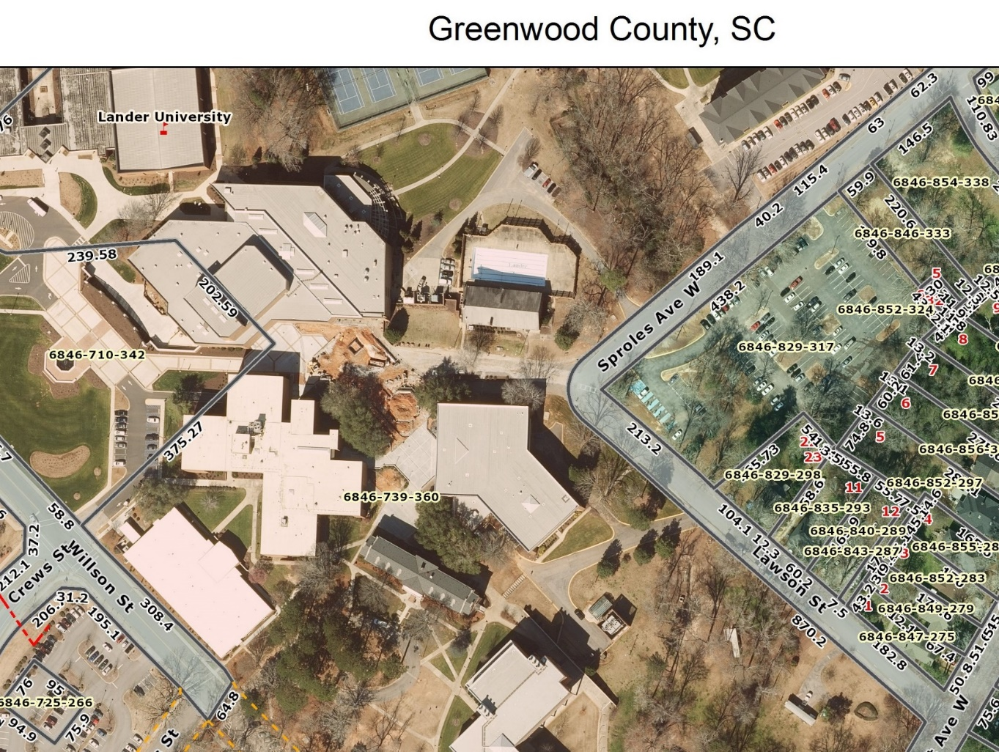
Outdoor
Pool Location
Campus Outdoor Pool Location

(Exhibit C)
Pool Drainage
Outdoor Pool Demolition and Construction
State Project Number: H21-N069-CB

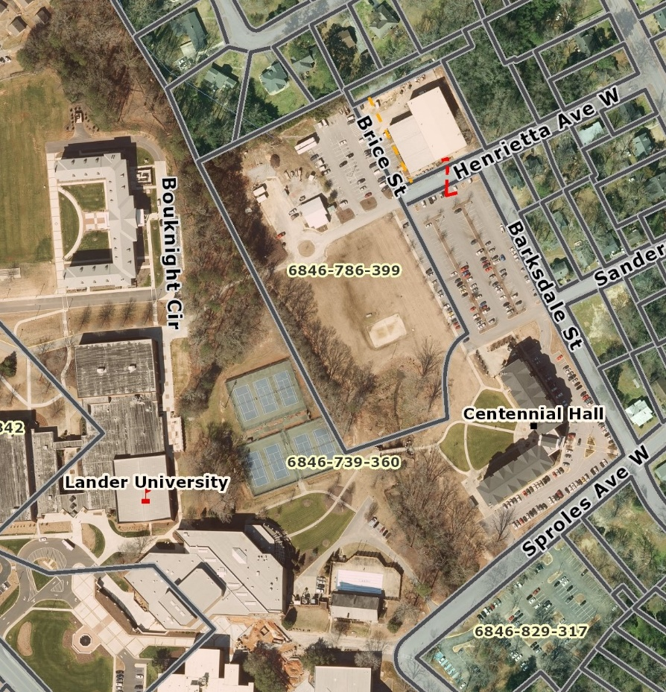
Existing Pool Drainage
Current underground overflow from the retention pond, piped to another receiving stream
Pool
Location
Current, pool drainage discharge
Current, retention pond

(Exhibit D)
Restroom Location
Outdoor Pool Demolition and Construction
State Project Number: H21-N069-CB

Proposed Location of Restroom Facility Construction
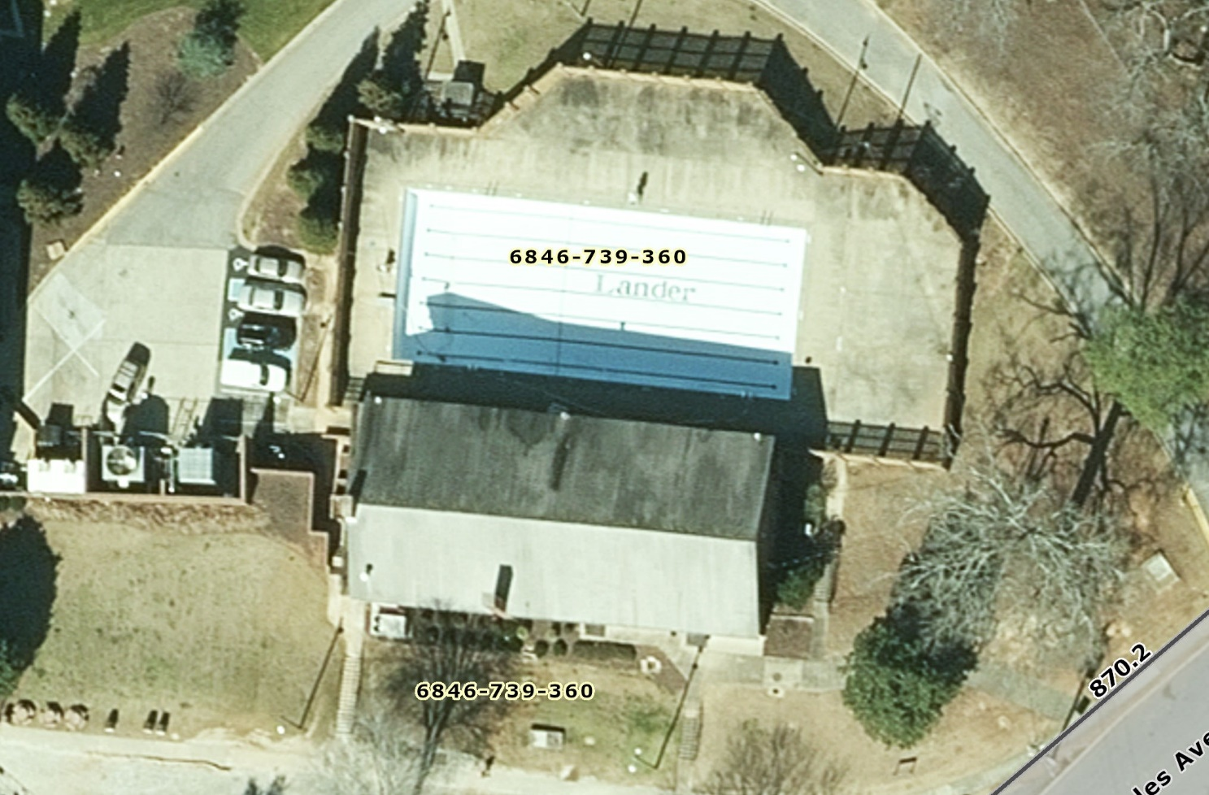
This building has been demo’d and disposed of
Standalone facility with enter access from the pool side
W
M
Proposed location
of the restroom facility

(Exhibit E)
Owner Preferred Design Criteria
Outdoor Pool Demolition and Construction
State Project Number: H21-N069-CB

- Lander University will rely on the experience and construction knowledge of proposed construction techniques and materials to “best” provide a quality, affordable, long lasting product.
- Lander University will rely on the experience of the design team to incorporate all project concepts required to ensure compliance with SC DHEC, concerning pool construction, pool tangible features and safeguards.
- Lander University has established a total project, not to exceed project budget of $1,200,000.

- The SC DHEC submittal shall include all dimensions and distances to ensure compliance with Regulation 61- 51. Section C, Item 16-17:
Regulation 61-51. Section C, Item 16-17

Item 16: Filter Backwash.
Backwash from the filter(s) must be piped to a disposal pit, tile field, or other disposal method approved by the Department. If the backwash water is to be discharged to a sanitary sewer system or municipal separate storm sewer system, specific approval must be obtained from the municipality or sewer authority for such discharge. If the method of backwash will be to an on-site storm sewer system, the location of the discharge and the name and distance of any receiving body of water must be identified on the project plans. Any discharge of backwash water to a water body must receive prior approval from the Department. All pools that directly discharge backwash water to waters of the State or stocked ponds must be equipped with an appropriately sized dechlorination device. If the method of backwash disposal will be to a pit or tile field, the location of discharge must be identified on the project plans and the receptacle must be adequately sized to accept the pool drainage. Also, a three (3) minute backwash cycle must be conducted at the time of the final inspection to ensure that there is adequate capacity of the disposal system. A minimum six (6) inch air gap must be maintained at the discharge point or two (2) single in-line check valves must be installed in the backwash line. The receptacle must be sufficiently sized to accommodate the backwash flow.

Item 17: Pool Drainage.
The method and location of discharge employed to drain the pool must be included on the project plans and the receptacle must be adequately sized to accept the pool drainage. If the pool drains to a sanitary sewer system or municipal separate storm sewer system, specific approval must be obtained from the municipality or sewer authority for such discharge.
- Maximum pool depth not to exceed 5 ft.
- Pool sidewall and bottom plaster material will utilize an aggregate of quartz or riverstone, creating a “pebble finish”. This preference is to provide a reliable finish that is longer lasting than Marcite, providing a reduce maintenance cost and refinishing interval. Marcite, a mixture composed primarily of white Portland cement and marble dust is not permitted.
- Lander University has contracted with a hazardous material analysis firm to sample and provide laboratory analysis of the existing materials of the pool’s sidewalls and bottom for the presence of an asbestos qualifying content and lead. The abatement, if applicable, is part of this project. The results will be communicated.
- Pool surface area not to exceed 4,000 sq. feet.
- Zero depth wheel chair entry. Lander University would like to avoid the hardware and maintenance of a wheelchair lift. The Beach Entry will be designed such that the entry handrails are not required.
- ADA depth not to:
  - Pose a safety issue for a wheelchair bound occupant
  - Inhibit wheelchair maneuvering
  - Allow wheelchair to enter deeper, within limits, sections of the pool

- The pool will be filled via a connection with the City of Greenwood’s POTABLE Water System

- The pool design will include the appropriately sized automated water disinfectant system

- The pool design will include the appropriately sized recirculation system

- The pool design will include the appropriately sized filtration system
- The pool design will include the evaluation of the existing Pump Room, as to whether it can be salvaged, to spatially compliment the new pool piping, filtration, disinfectant system, de-chlorination system, storage, ventilation, required utilities, etc… If found to be inadequate, the propose a new Pump Room Building

- The project will ensure the integrity of the existing underground drain pipe, to the receiving stream, is in good physical condition. If not, the the properly sized replacement will be required

- The pool design is not restricted to the existing perimeter dimensions. Lander University is open-minded and is willing to consider a more modern, irregular, eye catching geometric shape. However, a balance must be established between pool dimensions and surrounding available seating / event space.

- Aesthetically pleasing pool sidewall and bottom colors, void of swimming lanes

- Shallow pockets where the water depth entices lounging / sitting

- Submerged sitting ledges

- Multi-colored capable, submerged night lighting system
- Lander University has established a maximum pool occupancy of 100 persons.

- Lander University will be permitting night-time swimming.

Other Pool Design Parameters, Willing to Consider

- Open to the recommended disinfectant system: Salt, Chlorine, Other?
- Mechanically pumped overhead water feature(s)
- Automated pool bottom cleaning system

RESTROOM FACILITY
- Standalone restroom facility configured into two separate restrooms to serve the needs of Men and Woman.
- The respective areas will be multi-occupant, provide restroom appliances, changing area, and a single occupant shower. The shower area will be able to provide a separation from the restroom changing area, in such a manner as to provide a sense of privacy.
- The facility design shall ensure compliance with the ICC A117.1, Accessible and Usable Buildings and Facilities, American’s with Disabilities Act (ADA) and all applicable construction codes.
- Restrooms to be equipped with hand-washing vanities
- All lighting to be LED
- The facility design shall ensure compliance with standards set for by SC DHEC.
- The facility to be located adjacent to the new pool, with entry from the poolside. The facility will be equipped to provide seasonal HVAC conditioning and ventilation.
- The facility shall provide a means where water bottles can be filled.

