STUDENT AFFAIRS INSTITUTIONAL EFFECTIVENESS PLAN (UNIT GOALS)
FOR ACADEMIC YEAR: 2014/2015
DEPARTMENT: Wellness Center
SUBMISSION DATE: October 2015

Mission: To provide a healthful, comfortable and productive work and study environment for all faculty, staff and students.

Department Description: The Wellness Center offers a variety of health services, programs, information, and other resources to help students maintain optimal emotional and physical health. The Wellness Center provides students with a centralized location for the departments under its umbrella: Counseling Services, Disability Services, and Health Services. This umbrella of services creates a more holistic and integrated continuum of care for students. The Wellness Center develops and coordinates programming and activities within each of its departments to promote optimal health.
The Office of Counseling Services provides personal counseling for students who need help with overcoming and working through mental health problems. Counseling sessions are free to the student and are confidential. Sessions are tailored to accommodate each student’s needs.
The Office of Disability Services coordinates accommodations for students with disabilities at Lander University. The Wellness Center notifies faculty of appropriate accommodations and assures that students receive the necessary physical accommodations based on their medical condition. This office is the first point of contact for all students with disabilities.
The Office of Health Services provides a registered nurse who is on-duty for routine nursing treatments during these hours. A Campus Nurse is available during office hours when school is in session. Students who have a health concern, become sick or injured, should come to the Wellness Center for evaluation and/or treatment during office hours.

Goals:
This report is based on data gathered from the Fall 2014 and Spring 2015 academic year. The use of the Skyfactor/Educational Benchmarking Inc. (EBI) Counseling Services Assessment allowed for a broader measure of the unit goals set for the Wellness Center, Disability Services, and Health Services. This was due to the ability to reach more students for feedback by developing and adding Institutional Specific Questions on the Skyfactor/EBI Counseling Services Assessment, Resident Assessment, and Recreational Services Assessment. The goals were worded in a more general way to try to capture what was viewed as important to measure when given the constraints of a limited number of questions allowed. For an additional cost, more questions can be ordered. The need for this will be tracked for 2 years to determine if the wider range questions meet the Wellness Center needs. All areas of the Wellness Center are reflected in this report.

Wellness Center:

- Students are satisfied with the Wellness Center Programs presented.
  - Strategic Goal Supported: Enrollment
  - Indicators of Success and Summary of Data:
Indicator | 2013-2014 | 2014-2015 | 2015-2016 | 2016-2017 | 2017-2018
1. a. Percent Score: Evaluation responses of “strongly agree” and “agree” to: "Over-all the presentation /program was worth my time", “The presentation/program/event was enjoyable”, “I would attend this presentation/program /event if offered in the future”, or “I would recommend this presentation /program to my friends”. | 99%  (185/187) | 89%  (1678/1890)
1. a. 1 Percent Score: Blood Borne Pathogen Training (8/06/2014) Evaluation responses of “strongly agree” and “agree” to: "Over-all the presentation was worth my time". | N/A | 100%  (19/19)
1. a. 2 Percent Score: WelLU Kickoff Event (9/08/2014) Evaluation responses of “strongly agree” and “agree” to: "Over-all the presentation was worth my time". | N/A | 100%  (27/27)
1. a. 3 Percent Score: Alcohol Education for Chipley Hall (9/15/2014) Evaluation responses of “strongly agree” and “agree” to: "The presentation was enjoyable” and “I would recommend it to my friends”. | N/A | 100%  (18/18)
1. a. 4 Percent Score:” Sex in a Fishbowl” (9/16/2014) Evaluation responses of “strongly agree” and “agree” to: "Over-all the presentation was worth my time". | N/A | 97%  (28/29)
1. a. 5 Percent Score: Blood Connection Blood Drive, House Calls, Anxiety Screening, Depressions Screening, Healthy Relationships, Breaking the Chain, Great American Smoke-Out, De-stress Fest, Safe Spring Break, and/or Girls Night Out with Dr. Amaya Evaluation responses of “strongly agree” and “agree”and “mildly agree” to: "Over-all the presentation was worth my time" and “I would attend these programs if offered in the future.” | N/A | 82%  (733/896)
1. a. 6 Percent Score: WelLu Kickoff/ Volleyball Game with LUPD, the WelLU Everyday Challenge, Pink Zumba, Home Runs for Healthy Relationships, and/or the Healing Hearts Race program evaluation responses of “strongly agree” and “agree”and “mildly agree” to: "Over-all the programs was worth my time" and “I would attend these programs if offered in the future.” | N/A | 95%  (413/437)
1. a. 7 Percent Score: The Moonshine Run 5K and/or the Run or Dye/Color Run event evaluation responses of “strongly agree” and “agree”and “mildly agree” to: "Over-all the event was worth my time" and “I would attend these events if offered in the future.” | N/A | 95%  (440/464)
  - Assessment Instruments and Frequency of Assessment:
Indicator | Instrument | Frequency
Indicators of Success and sub-indicators: 1.a. (1.a.1,1.a.2, 1.a.3, 1.a.4)  Indicators of Success and sub-indicators: 1.a. (1.a.5, 1.a.6, 1.a.7) | Student Affairs Workshop Evaluation  Educational Benchmarking Inc. (EBI) Recreation Services Assessment (0Q1, 0Q3, 0Q4, 0Q6) and Resident Assessment (0Q7, 0Q9) Institutional Specific Questions | At the end of the event.  Annually
  - Expected Outcomes:
Indicator | Met | Partially Met | Not Met
All Indicators of Success | Between 85% and 100% of responses are answered "strongly agree”, “mildy agree” or "agree" | etween 60% and 84.9% of responses are answered "strongly agree”, “mildy agree” or "agree" | Less than 60% of responses are answered "strongly agree”, “mildy agree” or "agree"
  - Review of Results and Actions Taken:
Indicator
1. a. Percent Score: Evaluation responses of “strongly agree” and “agree” to: "Over-all the presentation /program was worth my time", “The presentation/program/event was enjoyable”, “I would attend this presentation/program /event if offered in the future”, or “I would recommend this presentation /program to my friends”. | The threshold of 85% was met for this indicator. All of the student responses to the evaluation indicate that students were satisfied except of one sub-indicator involving most of the “passive” programming events. This will be monitored to check for a trend o pattern and if one exist in the next reporting period, future programming planning may need to focus on more “active” events. In addition, student attendance at these events is negatively impacted due to ineligibility for Lander University’s “Fine Arts Lecture Series” credit.
1. a. 1 Percent Score: Blood Borne Pathogen Training (8/06/2014) Evaluation responses of “strongly agree” and “agree” to: "Over-all the presentation was worth my time". | No action required.
1. a. 2 Percent Score: WelLU Kickoff Event (9/08/2014) Evaluation responses of “strongly agree” and “agree” to: "Over-all the presentation was worth my time". | No action required.
1. a. 3 Percent Score: Alcohol Education for Chipley Hall (9/15/2014) Evaluation responses of “strongly agree” and “agree” to: "The presentation was enjoyable” and “I would recommend it to my friends”. | No action required.
1. a. 4 Percent Score:” Sex in a Fishbowl” (9/16/2014) Evaluation responses of “strongly agree” and “agree” to: "Over-all the presentation was worth my time". | No action required.
1. a. 5 Percent Score: Blood Connection Blood Drive, House Calls, Anxiety Screening, Depressions Screening, Healthy Relationships, Breaking the Chain, Great American Smoke-Out, De-stress Fest, Safe Spring Break, and/or Girls Night Out with Dr. Amaya Evaluation responses of “strongly agree” and “agree”and “mildly agree” to: "Over-all the presentation was worth my time" and “I would attend these programs if offered in the future.” | See 1. a
1. a. 6 Percent Score: WelLu Kickoff/ Volleyball Game with LUPD, the WelLU Everyday Challenge, Pink Zumba, Home Runs for Healthy Relationships, and/or the Healing Hearts Race program evaluation responses of “strongly agree” and “agree”and “mildly agree” to: "Over-all the programs was worth my time" and “I would attend these programs if offered in the future.”
1. a. 7 Percent Score: The Moonshine Run 5K and/or the Run or Dye/Color Run event evaluation responses of “strongly agree” and “agree”and “mildly agree” to: "Over-all the event was worth my time" and “I would attend these events if offered in the future.”
  - Outcomes:
Indicator | 2013-2014 | 2014-2015 | 2015-2016 | 2016-2017 | 2017-2018
1. a. Percent Score: Evaluation responses of “strongly agree” and “agree” to: "Over-all the presentation /program was worth my time", “The presentation/program/event was enjoyable”, “I would attend this presentation/program /event if offered in the future”, or “I would recommend this presentation /program to my friends”. | Met  (3.00) | Met  (2.86)
1. a. 1 Percent Score: Blood Borne Pathogen Training (8/06/2014) Evaluation responses of “strongly agree” and “agree” to: "Over-all the presentation was worth my time". | N/A | Met  (3.00)
1. a. 2 Percent Score: WelLU Kickoff Event (9/08/2014) Evaluation responses of “strongly agree” and “agree” to: "Over-all the presentation was worth my time". | N/A | Met  (3.00)
1. a. 3 Percent Score: Alcohol Education for Chipley Hall (9/15/2014) Evaluation responses of “strongly agree” and “agree” to: "The presentation was enjoyable” and “I would recommend it to my friends”. | N/A | Met  (3.00)
1. a. 4 Percent Score:” Sex in a Fishbowl” (9/16/2014) Evaluation responses of “strongly agree” and “agree” to: "Over-all the presentation was worth my time". | N/A | Met  (3.00)
1. a. 5 Percent Score: Blood Connection Blood Drive, House Calls, Anxiety Screening, Depressions Screening, Healthy Relationships, Breaking the Chain, Great American Smoke-Out, De-stress Fest, Safe Spring Break, and/or Girls Night Out with Dr. Amaya Evaluation responses of “strongly agree” and “agree”and “mildly agree” to: "Over-all the presentation was worth my time" and “I would attend these programs if offered in the future.” | N/A | Partially Met  (2.00)
1. a. 6 Percent Score: WelLu Kickoff/ Volleyball Game with LUPD, the WelLU Everyday Challenge, Pink Zumba, Home Runs for Healthy Relationships, and/or the Healing Hearts Race program evaluation responses of “strongly agree” and “agree”and “mildly agree” to: "Over-all the programs was worth my time" and “I would attend these programs if offered in the future.” | N/A | Met  (3.00)
1. a. 7 Percent Score: The Moonshine Run 5K and/or the Run or Dye/Color Run event evaluation responses of “strongly agree” and “agree”and “mildly agree” to: "Over-all the event was worth my time" and “I would attend these events if offered in the future.” | N/A | Met  (3.00)
- Additional Resources Requested to Achieve or Sustain results: None Requested
Indicator
1. a. Percent Score: Evaluation responses of “strongly agree” and “agree” to: "Over-all the presentation /program was worth my time", “The presentation/program/event was enjoyable”, “I would attend this presentation/program /event if offered in the future”, or “I would recommend this presentation /program to my friends”. | None
1. a. 1 Percent Score: Blood Borne Pathogen Training (8/06/2014) Evaluation responses of “strongly agree” and “agree” to: "Over-all the presentation was worth my time". | None
1. a. 2 Percent Score: WelLU Kickoff Event (9/08/2014) Evaluation responses of “strongly agree” and “agree” to: "Over-all the presentation was worth my time". | None
1. a. 3 Percent Score: Alcohol Education for Chipley Hall (9/15/2014) Evaluation responses of “strongly agree” and “agree” to: "The presentation was enjoyable” and “I would recommend it to my friends”. | None
1. a. 4 Percent Score: “Sex in a Fishbowl” (9/16/2014) Evaluation responses of “strongly agree” and “agree” to: "Over-all the presentation was worth my time". | None
1. a. 5 Percent Score: Blood Connection Blood Drive, House Calls, Anxiety Screening, Depressions Screening, Healthy Relationships, Breaking the Chain, Great American Smoke-Out, De-stress Fest, Safe Spring Break, and/or Girls Night Out with Dr. Amaya Evaluation responses of “strongly agree” and “agree”and “mildly agree” to: "Over-all the presentation was worth my time" and “I would attend these programs if offered in the future.” | None
1. a. 6 Percent Score: WelLu Kickoff/ Volleyball Game with LUPD, the WelLU Everyday Challenge, Pink Zumba, Home Runs for Healthy Relationships, and/or the Healing Hearts Race program evaluation responses of “strongly agree” and “agree”and “mildly agree” to: "Over-all the programs was worth my time" and “I would attend these programs if offered in the future.” | None
1. a. 7 Percent Score: The Moonshine Run 5K and/or the Run or Dye/Color Run event evaluation responses of “strongly agree” and “agree”and “mildly agree” to: "Over-all the event was worth my time" and “I would attend these events if offered in the future.” | None
g. Summary Comments: (2014/2015) The indicator of suucess for the Unit Porgram Goal of “Students are satisfied with the Wellness Center Programs presented” was met. However, one of the seven sub-indicators was partially met with an 82% agreement repsonse. This sub-indicator involved student satisfaction with more of the sedate or less “active” programs. This will be monitored to check on a trend or pattern. If one occurs, then this could be used in future programming planning.

2. Students increased knowledge/awareness of the presentation/program subject when attending
Wellness Center programs and the material presented influenced them to make positive changes
in their behaviors/choices.
  - Strategic Goal Supported: Learning
  - Indicators of Success and Summary of Data:
Indicator | 2013-2014 | 2014-2015 | 2015-2016 | 2016-2017 | 2017-2018
2. a. Percent Score: Evaluation response of “strongly agree”, “agree”, and/or “mildly agree” to: "This presentation/program/event increased my knowledge/awareness of the subject”and “The material presented will influence me to make positive changes in my behaviors/choices”. | 91%  (416/457) | 91%  (967/1068)
2. a. 1 Percent Score: Blood Borne Pathogen Training (8/06/2014) Evaluation responses of “strongly agree”, “agree”, and/or “mildly agree” to: "This presentation increased my knowledge/awareness of the subject”and “The material presented will influence me to make positive changes in my behaviors/choices”. | N/A | 100%  (38/38)
2. a. 2 Percent Score: WelLU Kickoff Event (9/08/2014) Evaluation response of “strongly agree”, “agree”, and/or “mildly agree” to: "This program/event increased my knowledge/awareness of the subject”and “The material presented will influence me to make positive changes in my behaviors/choices”. | N/A | 100%  (54/54)
2. a. 3. Percent Score Alcohol Education for Chipley Hall (9/15/2014) Evaluation response response of “strongly agree”, “agree”, and/or “mildly agree” to: "This presentation increased my knowledge/awareness of the subject”and “The material presented will influence me to make positive changes in my behaviors/choices”. | N/A | 94%  (34/36)
2. a. 4 Percent Score: “Sex in a Fishbowl” (9/16/2014) Evaluation response response of “strongly agree”, “agree”, and/or “mildly agree” to: "This presentation increased my knowledge/awareness of the subject”and “The material presented will influence me to make positive changes in my behaviors/choices”. | N/A | 100%  (58/58)
2. a. 5 Percent Score: Students responded “strongly agree”, “agree”, and/or “mildly agree” to the question, “Participating in a WelLU program provided them with information which motivated them to make positive changes in their behaviors/choices”. | 74%  (111/151) | 97%  (62/64)
2. a. 6 Percent Score: Blood Connection Blood Drive, House Calls, Anxiety Screening, Depressions Screening, Healthy Relationships, Breaking the Chain, Great American Smoke-Out, De-stress Fest, Safe Spring Break, and/or Girls Night Out with Dr. Amaya Evaluation responses of “strongly agree” and “agree”and “mildly agree” to: "This program/event increased my knowledge/awareness of the subject”and “The material program/event will influence me to make positive changes in my behaviors/choices”. | N/A | 84%  (370/440)
2. a. 7 Percent Score: WelLu Kickoff/ Volleyball Game with LUPD, the WelLU Everyday Challenge, Pink Zumba, Home Runs for Healthy Relationships, and/or the Healing Hearts Race program evaluation responses of “strongly agree” , “agree”and “mildly agree” to"This material/ program/event increased my knowledge/awareness of the subject”and “The event will influence me to make positive changes in my behaviors/choices”. | N/A | 92%  (166/180)
2. a. 8 Percent Score: The Moonshine Run 5K and/or the Run or Dye/Color Run event evaluation responses of “strongly agree” and “agree”and “mildly agree” to: "This material/program/event increased my knowledge/awareness of the subject”and “The event will influence me to make positive changes in my behaviors/choices”. | N/A | 93%  (185/198)
  - Assessment Instruments and Frequency of Assessment:
Indicator | Instrument | Frequency
Indicators of Success and sub-indicators: 2.a. (2.a.1, 2.a.2, 2.a.3, 2.a.4)  Indicators of Success and sub-indicators: 2.a. (2.a.5, 2.a.6, 2.a.7, 2.a.8) | Student Affairs Workshop Evaluation  Educational Benchmarking Inc. (EBI) Counseling Services Assessment (0Q8), Recreation Services Assessment (0Q2, 0Q5), and Resident Assessment (0Q8) Institutional Specific Questions | At the end of the event.  Annually
  - Expected Outcomes:
Indicator | Met | Partially Met | Not Met
Indicators of Success and sub-indicators: 2.a. (2.a.1, 2.a.2, 2.a.3, 2.a.4)  Indicators of Success and sub-indicators: 2.a. (2.a.5, 2.a.6, 2.a.7, 2.a.8) | Between 85% and 100% of responses are answered "strongly agree" or "agree"  Between 85% and 100% of responses are answered "strongly agree", "agree" and/or “mildly agree” | Between 60% and 84.9% of responses are answered "strongly agree" or "agree"  Between 60% and 84.9% of responses are answered "strongly agree", "agree" and/or “mildly agree” | Less than 60% of responses are answered "strongly agree" or "agree"  Less than 60% of responses are answered "strongly agree", "agree" and/or “mildly agree”
  - Review of Results and Actions Taken:
Indicator
2. a. Percent Score: Evaluation response of “strongly agree”, “agree”, and/or “mildly agree” to: "This presentation/program/event increased my knowledge/awareness of the subject”and “The material presented will influence me to make positive changes in my behaviors/choices”. | All of the student responses to the evaluation indicate that students gained awareness/knowledge of the subject and would make positive changes in their behaviors/choices. However, one of the eight sub-indicators was partially met with an 84% agreement repsonse. This sub-indicator involved more of the sedate or less “active” programs (the same results are seen in Unit Indicator 1). This will be monitored to track any trend or pattern. If one occurs, then this could be used in future programming planning.
2. a. 1 Percent Score: Blood Borne Pathogen Training (8/06/2014) Evaluation responses of “strongly agree”, “agree”, and/or “mildly agree” to: "This presentation increased my knowledge/awareness of the subject”and “The material presented will influence me to make positive changes in my behaviors/choices”. | No action required.
2. a. 2 Percent Score: WelLU Kickoff Event (9/08/2014) Evaluation response of “strongly agree”, “agree”, and/or “mildly agree” to: "This program/event increased my knowledge/awareness of the subject”and “The material presented will influence me to make positive changes in my behaviors/choices”. | No action required.
2. a. 3. Percent Score Alcohol Education for Chipley Hall (9/15/2014) Evaluation response response of “strongly agree”, “agree”, and/or “mildly agree” to: "This presentation increased my knowledge/awareness of the subject”and “The material presented will influence me to make positive changes in my behaviors/choices”. | No action required.
2. a. 4 Percent Score: “Sex in a Fishbowl” (9/16/2014) Evaluation response response of “strongly agree”, “agree”, and/or “mildly agree” to: "This presentation increased my knowledge/awareness of the subject”and “The material presented will influence me to make positive changes in my behaviors/choices”. | No action required.
2. a. 5 Students responded “strongly agree”, “agree”, and/or “mildly agree” to the question, “Participating in a WelLU program provided them with information which motivated them to make positive changes in their behaviors/choices”. | No action required.
2. a. 6 Percent Score: Blood Connection Blood Drive, House Calls, Anxiety Screening, Depressions Screening, Healthy Relationships, Breaking the Chain, Great American Smoke-Out, De-stress Fest, Safe Spring Break, and/or Girls Night Out with Dr. Amaya Evaluation responses of “strongly agree” and “agree”and “mildly agree” to: "This program/event increased my knowledge/awareness of the subject”and “The material program/event will influence me to make positive changes in my behaviors/choices”. | This sub-indicator for success was partially met and will be tracked.
2. a. 7 Percent Score: WelLu Kickoff/ Volleyball Game with LUPD, the WelLU Everyday Challenge, Pink Zumba, Home Runs for Healthy Relationships, and/or the Healing Hearts Race program evaluation responses of “strongly agree” , “agree”and “mildly agree” to"This material/ program/event increased my knowledge/awareness of the subject”and “The event will influence me to make positive changes in my behaviors/choices”. | No action required.
2. a. 8 Percent Score: The Moonshine Run 5K and/or the Run or Dye/Color Run event evaluation responses of “strongly agree” and “agree”and “mildly agree” to: "This material/program/event increased my knowledge/awareness of the subject”and “The event will influence me to make positive changes in my behaviors/choices”. | No action required.
  - Outcomes:
Indicator | 2013-2014 | 2014-2015 | 2015-2016 | 2016-2017 | 2017-2018
2. a. Percent Score: Evaluation response of “strongly agree”, “agree”, and/or “mildly agree” to: "This presentation/program/event increased my knowledge/awareness of the subject”and “The material presented will influence me to make positive changes in my behaviors/choices”. | Met  (2.80) | Met  (2.88)
2. a. 1 Percent Score: Blood Borne Pathogen Training (8/06/2014) Evaluation responses of “strongly agree”, “agree”, and/or “mildly agree” to: "This presentation increased my knowledge/awareness of the subject”and “The material presented will influence me to make positive changes in my behaviors/choices”. | N/A | Met  (3.00)
2. a. 2 Percent Score: WelLU Kickoff Event (9/08/2014) Evaluation response of “strongly agree”, “agree”, and/or “mildly agree” to: "This program/event increased my knowledge/awareness of the subject”and “The material presented will influence me to make positive changes in my behaviors/choices”. | N/A | Met  (3.00)
2. a. 3. Percent Score Alcohol Education for Chipley Hall (9/15/2014) Evaluation response response of “strongly agree”, “agree”, and/or “mildly agree” to: "This presentation increased my knowledge/awareness of the subject”and “The material presented will influence me to make positive changes in my behaviors/choices”. | N/A | Met  (3.00)
2. a. 4 Percent Score: “Sex in a Fishbowl” (9/16/2014) Evaluation response response of “strongly agree”, “agree”, and/or “mildly agree” to: "This presentation increased my knowledge/awareness of the subject”and “The material presented will influence me to make positive changes in my behaviors/choices”. | N/A | Met  (3.00)
2. a. 5 Students responded “strongly agree”, “agree”, and/or “mildly agree” to the question, “Participating in a WelLU program provided them with information which motivated them to make positive changes in their behaviors/choices”. | Partially Met  (2.00) | Met  (3.00)
2. a. 6 Percent Score: Blood Connection Blood Drive, House Calls, Anxiety Screening, Depressions Screening, Healthy Relationships, Breaking the Chain, Great American Smoke-Out, De-stress Fest, Safe Spring Break, and/or Girls Night Out with Dr. Amaya Evaluation responses of “strongly agree” and “agree”and “mildly agree” to: "This program/event increased my knowledge/awareness of the subject”and “The material program/event will influence me to make positive changes in my behaviors/choices”. | N/A | Partially Met  (2.00)
2. a. 7 Percent Score: WelLu Kickoff/ Volleyball Game with LUPD, the WelLU Everyday Challenge, Pink Zumba, Home Runs for Healthy Relationships, and/or the Healing Hearts Race program evaluation responses of “strongly agree” , “agree”and “mildly agree” to"This material/ program/event increased my knowledge/awareness of the subject”and “The event will influence me to make positive changes in my behaviors/choices”. | N/A | Met  (3.00)
2. a. 8 Percent Score: The Moonshine Run 5K and/or the Run or Dye/Color Run event evaluation responses of “strongly agree” and “agree”and “mildly agree” to: "This material/program/event increased my knowledge/awareness of the subject”and “The event will influence me to make positive changes in my behaviors/choices”. | N/A | Met  (3.00)
- Additional Resources Requested to Achieve or Sustain results: None Requested
Indicator
2. a. Percent Score: Evaluation response of “strongly agree”, “agree”, and/or “mildly agree” to: "This presentation/program/event increased my knowledge/awareness of the subject”and “The material presented will influence me to make positive changes in my behaviors/choices”. | None
2. a. 1 Percent Score: Blood Borne Pathogen Training (8/06/2014) Evaluation responses of “strongly agree”, “agree”, and/or “mildly agree” to: "This presentation increased my knowledge/awareness of the subject”and “The material presented will influence me to make positive changes in my behaviors/choices”. | None
2. a. 2 Percent Score: WelLU Kickoff Event (9/08/2014) Evaluation response of “strongly agree”, “agree”, and/or “mildly agree” to: "This program/event increased my knowledge/awareness of the subject”and “The material presented will influence me to make positive changes in my behaviors/choices”. | None
2. a. 3. Percent Score Alcohol Education for Chipley Hall (9/15/2014) Evaluation response response of “strongly agree”, “agree”, and/or “mildly agree” to: "This presentation increased my knowledge/awareness of the subject”and “The material presented will influence me to make positive changes in my behaviors/choices”. | None
2. a. 4 Percent Score: “Sex in a Fishbowl” (9/16/2014) Evaluation response response of “strongly agree”, “agree”, and/or “mildly agree” to: "This presentation increased my knowledge/awareness of the subject”and “The material presented will influence me to make positive changes in my behaviors/choices”. | None
2. a. 5 Students responded “strongly agree”, “agree”, and/or “mildly agree” to the question, “Participating in a WelLU program provided them with information which motivated them to make positive changes in their behaviors/choices”. | None
2. a. 6 Percent Score: Blood Connection Blood Drive, House Calls, Anxiety Screening, Depressions Screening, Healthy Relationships, Breaking the Chain, Great American Smoke-Out, De-stress Fest, Safe Spring Break, and/or Girls Night Out with Dr. Amaya Evaluation responses of “strongly agree” and “agree”and “mildly agree” to: "This program/event increased my knowledge/awareness of the subject”and “The material program/event will influence me to make positive changes in my behaviors/choices”. | None
2. a. 7 Percent Score: WelLu Kickoff/ Volleyball Game with LUPD, the WelLU Everyday Challenge, Pink Zumba, Home Runs for Healthy Relationships, and/or the Healing Hearts Race program evaluation responses of “strongly agree” , “agree”and “mildly agree” to"This material/ program/event increased my knowledge/awareness of the subject”and “The event will influence me to make positive changes in my behaviors/choices”. | None
2. a. 8 Percent Score: The Moonshine Run 5K and/or the Run or Dye/Color Run event evaluation responses of “strongly agree” and “agree”and “mildly agree” to: "This material/program/event increased my knowledge/awareness of the subject”and “The event will influence me to make positive changes in my behaviors/choices”. | None
Summary Comments: (2014/2015) The indicator of suucess for the Unit Porgram Goal of “Students increased knowledge/awareness of the presentation/program’s subject when attending Wellness Center programs and the material presented influenced them to make positive changes in their behavior/choices” was met. However, one of the eight sub-indicators was partially met with an 84% agreement repsonse. This sub-indicator involved more of the sedate or less “active” programs (the same results are seen in Unit Indicator 1). This will be monitored to track any trend or pattern. If one occurs, then this could be used in future programming planning.

3. The Wellness Center markets their presentations and programs effectively to students.
- Strategic Goal Supported: Learning
- Indicators of Success and Summary of Data:
Indicator | 2013-2014 | 2014-2015 | 2015-2016 | 2016-2017 | 2017-2018
3. a Percent Score: Students are aware of the WelLU healthy choice initiatives (Safe Spring break, Tunnel of Oppression, Moonshine Run, etc.) on campus. | 87%  (176/202) | 90%  (86/96)
3. b Results: A Peer education program will be developed. | Program Developed  Fall 2013 | Program Maintained for Fall 2014
3. b. 1 Results: Peer educators will be hired. | 11 Peer Educators hired | 7 Peer Educators Hired
3. c Results: A branding symbol will be developed, maintained, and used for all Wellness Center programs/presentations. | Logo was created Fall 2013 | Logo does not appear on all promotions.
- Assessment Instruments and Frequency of Assessment:
Indicator | Instrument | Frequency
Indicator of Success: 3 .a.  Indicator of Success and sub-indicator: 3. b. (3. b. 1)  Indicator of Success: 3. c. | Educational Benchmarking Inc. (EBI) Counseling Services Assessment Institutional Specific Question 0Q7  Personnel paperwork  maintained in Wellness Center.  Symbol placed on all promotions. | Annually  Current Fall Semester  Each event promoted
- Expected Outcomes:
Indicator | Met | Partially Met | Not Met
Indicator of Success: 3 .a.  Indicator of Success and sub-indicator: 3. b. (3. b. 1)  Indicator of Success: 3. C. | Between 85% and 100% of responses are answered "strongly agree", "agree" and/or “mildly agree”  Paperwork exists and is maintained on current Peer Educators  Logo appears on all event promotions. | Between 60% and 84.9% of responses are answered "strongly agree", "agree" and/or “mildly agree”  Not Applicable  Not Applicable | Less than 60% of responses are answered "strongly agree", "agree" and/or “mildly agree”  Paperwork does not exist on current Peer Educators  Logo does not appear on all event promotions.
- Review of Results and Actions Taken:
Indicator
3. a Percent Score: Students are aware of the WelLU healthy choice initiatives (Safe Spring break, Tunnel of Oppression, Moonshine Run, etc.) on campus. | The threshold for this indicator was met. The “WelLU logo was created and used for marketing. However, it is not listed on the Wellness Center website.
3. b Results: A Peer education program will be developed. | The threshold for this indicator was met. However, the program and/or list of peer educators do not appear on the website for the Wellness Center.
3. b. 1 Results: Peer educators will be hired. | Seven peer educators were hired.
3. c Results: A branding symbol will be developed, maintained, and used for all Wellness Center programs/presentations. | The WelU logo was created and used as branding for all Wellness Center events. However, the logo does not appear on all Student Affairs announcement/promotions dealing with WeLU events. The marketing coordinator will be notified of the need to brand these events. Some events were co-sponsored and thus were not branded. This will be need to be addressed as the original programming committee set this goal in 2013/2014.
- Outcomes:
Indicator | 2013-2014 | 2014-2015 | 2015-2016 | 2016-2017 | 2017-2018
3. a Percent Score: Students are aware of the WelLU healthy choice initiatives (Safe Spring break, Tunnel of Oppression, Moonshine Run, etc.) on campus. | Met  (3.00) | Met  (2.33)
3. b Results: A Peer education program will be developed. | Met  (3.00) | Met  (3.00)
3. b. 1 Results: Peer educators will be hired. | Met  (3.00) | Met  (3.00)
3. c Results: A branding symbol will be developed, maintained, and used for all Wellness Center programs/presentations. | Met  (3.00) | Not Met  (1.00)
- Additional Resources Requested to Achieve or Sustain results: None Requested
Indicator
3. a Percent Score: Students are aware of the WelLU healthy choice initiatives (Safe Spring break, Tunnel of Oppression, Moonshine Run, etc.) on campus. | None
3. b Results: A Peer education program will be developed. | None
3. b. 1 Results: Peer educators will be hired. | None
3. c Results: A branding symbol will be developed, maintained, and used for all Wellness Center programs/presentations. | None
- Summary Comments: (2014/2015) Two of the three unit indicators for the Unit Porgram Goal of “The Wellness Center markets their presentations and programs effectively to students” was met (with a 2.33 instead of a 3:00 rating). One unit indicator’s establshed threshold was not met. Inpromoting Wellness Center Programming events, the marketing coordinator for Student Affiairs has not placed the logo on the announments sent out via email or on Axis TV for ALL of the Wellness Center events. An email was sent to all involved parties on 10/16/2015 to ask for this issue to be addressed, so improvement can be made on this indicator of success. The response to this email indicated that events whch are co-sponsored will not contain the logo. This will be need to be addressed as the original programming committee set this goal in 2013/2014. Another option would be to change the the wording for this goal will change for the 2015/2016 Academic Year.

4. The Wellness Center presentations and programs represent a collaborative Student Affairs
effort and reflect current issues/concerns, etc.
- Strategic Goal Supported: Learning
- Indicators of Success and Summary of Data:
Indicator | 2013-2014 | 2014-2015 | 2015-2016 | 2016-2017 | 2017-2018
4. a Number Score: Student Affairs Departments will collaborate on at least 3 programs/events. | 7 Events | 7 Events
4. b. Number Score: At least 4 Wellness Center’s programs & presentations will reflect Healthy Campus 2020 Initiatives and/or student feedback. | 4 + Programs | 6 + Programs
- Assessment Instruments and Frequency of Assessment:
Indicator | Instrument | Frequency
Indicators of Success: 4. a & 4. b | Student Affairs Marketing/Program Summary Report | Annually
- Expected Outcomes:
Indicator | Met | Partially Met | Not Met
Indicator of Success: 4. a  Indicator of Success: 4. b | 3 or more programs occur with 2 or more Student/Academic Affairs sponsors or participants.  Four or more Wellness Center Programs reflect Healthy Campus 2020 objectives and/or student feedback. | 1-2 programs occur with 2 or more Student/  Academic Affairs sponsors or participants.  1-3 Wellness Center Programs reflect Healthy Campus 2020 objectives and/or student feedback. | No programs occur with 2 or more Student/  Academic Affairs sponsors or participants.  No Wellness Center Programs reflect Healthy Campus 2020 objectives and/or student feedback.
- Review of Results and Actions Taken:
Indicator
4. a Number Score: Student Affairs Departments will collaborate on at least 3 programs/events. | Collaboration occurred on seven programs: “De-stress Fest (12/03/2014), Domestic Violence Awareness Week (10/20-23/2014), Homeruns for Healthy relationships (10/22/2014), Self-Defense Workshop (3/2, 3, 4/2015), Moonshine 5K Run (10/27/2014), Safe Spring Break (03/05/2015), and House Calls.
4. b. Number Score: At least 4 Wellness Center’s programs & presentations will reflect Healthy Campus 2020 Initiatives and/or student feedback. | There were 17 programs reflecting Healthy Campus 2020 initiatives and student feedback. “Sleep-Get Your Zzz’s to get A’s” (11/12/2014), Domestic Violence Awareness Week (10/20-23/2014), Mental Health awareness Week (10/7-10/2014), Hand Washing Awareness (12/03/2014) . Self-Defense Workshop (self-defense classes, “Sex in a Fishbowl” (more information about sex) and Alcohol Education @ Chipley (offer more health classes) targeted some of the student feedback issues identified. A complete listing is included in the results section for 4.b.
- Outcomes:
Indicator | 2013-2014 | 2014-2015 | 2015-2016 | 2016-2017 | 2017-2018
4. a Number Score: Student Affairs Departments will collaborate on at least 3 programs/events. | Met  (3.00) | Met  (3.00)
4. b. Number Score: At least 4 Wellness Center’s programs & presentations will reflect Healthy Campus 2020 Initiatives and/or student feedback. | Met  (3.00) | Met  (3.00)
- Additional Resources Requested to Achieve or Sustain results: None Requested
Indicator
4. a Number Score: Student Affairs Departments will collaborate on at least 3 programs/events. | None
4. b. Number Score: At least 4 Wellness Center’s programs & presentations will reflect Healthy Campus 2020 Initiatives and/or student feedback. | None
h. Summary Comments: (2014/2015) The two indicators of success for the Unit Program Goal of “The Wellness Center presentations and programs represent a collaborative Student Affairs effort and reflect current issues/concerns, etc” were met.

The Office of Counseling Services
For the 2014/2015 academic year reporting period, the Skyfactor/Educational Benchmarking Inc. (EBI) Counseling Services’ Assessment was used to gain additional input from consumers for a more thorough assessment process. This was the second year, this assessment was available. The Skyfactor/EBI Counseling Services” Assessment groups questions together to comprise a specific factor measuring a certain outcome. There were 18 factors but only 14 were used for goals and unit indicators of success because these are the factors that can be more directly impacted. In addition to providing Lander specific data that can be compared over time, it provides a comparison of Lander University’s results with all other intuitions participating in this survey. By being able to use benchmark comparisons, a more accurate picture of the results occurs for normalizing areas that might have been changed if relying only on Lander University’s results. Some of the factors composition changed from the 2013/2014 reporting period and this is denoted as “N/A” in one of the two “2013/2014” or “2014/2015” reporting slots.

5. Students are satisfied with Counseing Services’ office, services, and staff.
- Strategic Goal Supported: Enrollment
- Indicators of Success and Summary of Data:
Indicator | 2013-2014 | 2014-2015 | 2015-2016 | 2016-2017 | 2017-2018
5. a Mean Score: Students are satisfied with Counseling services’ office environment. | 6.55  (5.87) | 6.22  (6.20, 6.03)
5. a. 1 Mean Score: Students indicated their agreement that the Counseling Services office is easy to locate. | 6.38  (5.83) | 6.24  (6.06, 5.94)
5. a. 2 Mean Score: Students indicated their agreement that the Counseling Services office is accessible. | 6.43  (6.05) | 6.30  (6.28, 6.16)
5. a. 3 Mean Score: Students indicated their agreement that they felt comfortable in the Counseling Services waiting area. | 6.63  (5.58) | 6.00  (6.12, 5.83)
5. a. 4. Mean Score: Students indicated they were satisfied with the Counseling Services Facility (temperature, atmosphere, etc.). | 6.77  (6.06) | 6.26  (6.41, 6.23)
5. b Mean Score: Students are satisfied with Counseling services’ office service. | 6.72  (6.00) | 6.38  (6.41, 6.20)
5. b. 1 Mean Score: Students indicated their agreement that they could easily fill out the necessary paperwork. | 6.56  (6.06) | 6.29  (6.41, 6.23)
5. b. 2 Mean Score: Students indicated their agreement that they could easily schedule an appointment. | 6.67  (5.54) | 6.23  (6.30, 5.90)
5. b. 3 Mean Score: Students indicated their agreement that the Counseling Services personnel were professional. | 6.72  (6.25) | 6.49  (6.41, 6.32)
5. b. 4 Mean Score: Students indicated their agreement that the Counseling Services personnel were welcoming. | 6.80  (5.99) | 6.48  (6.51, 6.23)
5. b. 5 Mean Score: Students indicated their agreement that they trust their information is held confidential. | 6..84  (6.23) | 6.45  (6.44, 6.33)
5. c Mean Score: Students are satisfied with individual counseling meetings. | 6.57  (5.83) | 5.95  (5.86, 5.85)
5. c. 1 Mean Score: Students indicated their counselor spend as much time with them as they needed. | 6.50  (5.59) | 5.78  (5.63, 5.61)
5. c. 2 Mean Score: Students indicated their counselor scheduled meetings within a time frame that met their needs. | 6.61  (5.97) | 5.96  (6.09, 6.03)
5. c. 3 Mean Score: Students indicated their counselor started their meetings on time. | 6.59  (5.98) | 6.07  (5.96, 5.97)
5. d Mean Score: Students are satisfied with their individual counseling relationship... | 6.70  (5.86) | 6.07  (6.13, 6.01)
5. d. 1 Mean Score: Students indicated their agreement that they were able to talk about what was most important to them. | 6.70  (5.85) | 5.96  (6.09, 5.98)
5. d. 2 Mean Score: Students indicated their agreement that their counselor encouraged them to make their own decisions. | 6.60  (5.94) | 5.95  (6.20, 6.07)
5. d. 3 Mean Score: Students indicated their agreement that their counselor respected them as a person. | 6.77  (6.15) | 6.19  (6.39, 6.28)
5. d. 4 Mean Score: Students indicated their agreement that their counselor understood the concerns they brought to counseling. | 6.70  (5.83) | 6.06  (6.19, 6.02)
5. d. 5 Mean Score: Students indicated their agreement that their counselor helped them to clarify the nature of their concerns. | 6.73  (5.74) | 5.96  (6.08, 5.91)
5. d. 6 Mean Score: Students indicated their agreement that they would recommend their counselor to a close friend. | 6.68  (5.68) | 6.22  (6.14, 5.92)
5. e Mean Score: Students are satisfied with their group counseling leader. | 6.50  (6.07) | 5.70  (5.80, 5.83)
5. e. 1 Mean Score: During group counseling, students reported the leader created an accepting environment. | 6.17  (6.40) | 5.51  (5.86, 5.93)
5. e. 2 Mean Score: During group counseling, students reported the leader promoted meaningful discussion. | 6.50  (6.00) | 5.83  (5.80, 5.83)
5. e. 3 Mean Score: During group counseling, students reported the leader kept the group focused on important topics. | 6.83  (6.00) | 5.72  (6.03, 6.03)
5. f Mean Score: Students are satisfied with their group counseling relationships. | 6.56  (5.98) | 5.95  (5.52, 5.56)
5. f. 1 Mean Score: Students indicated their agreement that they were able to talk about what was most important to them. | 6.50  (5.60) | 5.86  (5.54, 5.55)
5. f. 2 Mean Score: Students indicated their agreement that their group leader encouraged them to express themselves. | 6.33  (6.20) | 5.81  (5.88, 5.92)
5. f. 3 Mean Score: Students indicated their agreement that their group leader respected them. | 6.67  (6.20) | 5.88  (5.80, 5.85)
5. f. 4 Mean Score: Students indicated their agreement that their group leader understood the concerns they brought to group. | 6.67  (5.80) | 5.69  (5.71, 5.72)
5. f. 5 Mean Score: Students indicated their agreement that their group leader listened to them. | 6.67  (6.20) | 5.65  (5.97, 6.00)
5. f. 6 Mean Score: Students indicated their agreement that my fellow group members were respectful to them. | 6.67  (6.40) | 5.92  (5.72, 5.81)
5. f. 7 Mean Score: Students indicated their agreement that my fellow group members listened to them. | 6.83  (5.80) | 5.92  (5.81, 5.81)
5. f. 8 Mean Score: Students indicated their agreement that they would recommend their group counseling experience to a close friend. | 6.17  (5.60) | 5.95  (5.34, 5.41)
5. g Counseling services enhanced knowledge integration. | 5.74  (5.03) | 5.63  (5.56, 5.29)
5. g. 1 Mean Score: Students indicated their agreement that by participating in counseling services they were able to use the information to improve their personal life. | 5.64  (5.03) | 5.73  (5.57, 5.29)
5. g. 2 Mean Score: Students indicated their agreement that by participating in counseling services they were able to use the information to improve their academic life. | 5.73  (4.90) | 5.53  (5.38, 5.12)
5. g. 3 Mean Score: Students indicated their agreement that by participating in counseling services they were able to use the information to improve ways of coping with their concerns. | 5.83  (5.16) | 5.76  (5.68, 5.41)
5. h. Overall, students were satisfied with Counseling Services. | 5.74  (5.03) | 6.13  (6.01, 5.68)
5. h. 1 Overall, students reported their Counseling Services experience at Lander University was an accepting environment. | 6.41  (5.85) | 6.14  (6.20, 6.02)
5. h. 2 Overall, students are satisfied with their counseling experiences at Lander University. | 6.45  (5.40) | 6.27  (6.16, 5.76)
5. h. 3Students would recommend counseling services to a close friend. | N/A | 6.11  (6.11, 5.86)
5. h. 4 The counseling services experience at Lander University fulfilled the student’s expectations. | N/A | 6.00  (5.72, 5.40)
5. h. 5 The counseling services experience at Lander University met the student’s needs. | N.A | 5.96  (5.85, 5.50)
- Assessment Instruments and Frequency of Assessment:
Indicator | Instrument | Frequency
All Indicators of Success (and sub-Indicators of Success) | Educational Benchmarking, Inc. (EBI) Counseling Services Assessment Survey | Annually (End of Spring semester)
- Expected Outcomes:
Indicator | Met | Partially Met | Not Met
All Indicators of Success (and sub-Indicators of Success) | Lander EBI mean is above the EBI comparison mean for all EBI participants this year. | Not Applicable. | Lander EBI mean is not above the EBI comparison mean for all EBI participants this year.
- Review of Results and Actions Taken:
Indicator
5. a Mean Score: Students are satisfied with Counseling services’ office environment. | The threshold was met for two of the four sub-indicators and partially met for the other two sub-indicators. The partially met sub-indicators centered on the actual waiting area and the facility. Since all sub-indicators were met for the 2013/2014 reporting period, these two will be monitored and if not met for the next reporting period, a plan of action for improvement will be developed.
5. a. 1 Mean Score: Students indicated their agreement that the Counseling Services office is easy to locate. | Threshold was met. No action is required.
5. a. 2 Mean Score: Students indicated their agreement that the Counseling Services office is accessible. | Threshold was met. No action is required.
5. a. 3 Mean Score: Students indicated their agreement that they felt comfortable in the Counseling Services waiting area. | See 5.a
5. a. 4. Mean Score: Students indicated they were satisfied with the Counseling Services Facility (temperature, atmosphere, etc.). | See 5.a
5. b Mean Score: Students are satisfied with Counseling services’ office service. | Two of the five sub-indicator thresholds were met for this indicator and the other three were partially met. Since all sub-indicators were met for the 2013/2014 reporting period, these three will be monitored and if not met for the next reporting period, a plan of action for improvement will be developed.
5. b. 1 Mean Score: Students indicated their agreement that they could easily fill out the necessary paperwork. | See 5. b
5. b. 2 Mean Score: Students indicated their agreement that they could easily schedule an appointment. | See 5. b
5. b. 3 Mean Score: Students indicated their agreement that the Counseling Services personnel were professional. | Threshold was met. No action is required.
5. b. 4 Mean Score: Students indicated their agreement that the Counseling Services personnel were welcoming. | See 5. b
5. b. 5 Mean Score: Students indicated their agreement that they trust their information is held confidential. | Threshold was met. No action is required.
5. c Mean Score: Students are satisfied with individual counseling meetings. | Of the two sub-indicators, the threshold for success was met on one and not met on the indicator about scheduling a meeting within a time frame to meet the student’s needs. This could have been due to the two counselors teaching two sections of University 101 and having limited availability. For the 2015/2016 Academic Year, the two counselors will only teach one section of this class to leave more time available for appointments. This will be monitored.
5. c. 1 Mean Score: Students indicated their counselor spend as much time with them as they needed. | Threshold was met. No action is required.
5. c. 2 Mean Score: Students indicated their counselor scheduled meetings within a time frame that met their needs. | See 5.c
5. c. 3 Mean Score: Students indicated their counselor started their meetings on time. | Threshold was met. No action is required.
5. d Mean Score: Students are satisfied with their individual counseling relationship... | The threshold for this indicator was partially met with only one of the six sub-indicators’ thresholds being met. Since all sub-indicators were met for the 2013/2014 reporting period, these three will be monitored and if not met for the next reporting period, a plan of action for improvement will be developed.
5. d. 1 Mean Score: Students indicated their agreement that they were able to talk about what was most important to them. | See 5.d
5. d. 2 Mean Score: Students indicated their agreement that their counselor encouraged them to make their own decisions. | See 5.d
5. d. 3 Mean Score: Students indicated their agreement that their counselor respected them as a person. | See 5.d
5. d. 4 Mean Score: Students indicated their agreement that their counselor understood the concerns they brought to counseling. | See 5.d
5. d. 5 Mean Score: Students indicated their agreement that their counselor helped them to clarify the nature of their concerns. | See 5.d
5. d. 6 Mean Score: Students indicated their agreement that they would recommend their counselor to a close friend. | Threshold was met. No action is required.
5. e Mean Score: Students are satisfied with their group counseling leader. | The threshold for this indicator was not met. This could be due to the fact that most of the groups facilitated on campus are created for students mandated to deal with anger issues. The group leader often has to ensure behavioral accountability for the participants which could be viewed as being unaccepting. During the last reporting period, the response data indicated that the leader did not provide an accepting environment and the mean for this sub-indicator actually decreased for this reporting period. Counselor support for these types of groups may need to be implemented through active clinical supervision.
5. e. 1 Mean Score: During group counseling, students reported the leader created an accepting environment. | See 5.e
5. e. 2 Mean Score: During group counseling, students reported the leader promoted meaningful discussion. | See 5.e
5. e. 3 Mean Score: During group counseling, students reported the leader kept the group focused on important topics. | See 5.e
5. f Mean Score: Students are satisfied with their group counseling relationships. | The threshold for this indicator was met with only five of the eight sub-indicators’ thresholds being met. Since all sub-indicators were met for the 2013/2014 reporting period, these three will be monitored and if not met for the next reporting period, a plan of action for improvement will be developed.
5. f. 1 Mean Score: Students indicated their agreement that they were able to talk about what was most important to them. | Threshold was met. No action is required.
5. f. 2 Mean Score: Students indicated their agreement that their group leader encouraged them to express themselves. | Monitor
5. f. 3 Mean Score: Students indicated their agreement that their group leader respected them. | Threshold was met. No action is required.
5. f. 4 Mean Score: Students indicated their agreement that their group leader understood the concerns they brought to group. | Monitor
5. f. 5 Mean Score: Students indicated their agreement that their group leader listened to them. | Monitor
5. f. 6 Mean Score: Students indicated their agreement that my fellow group members were respectful to them. | Threshold was met. No action is required.
5. f. 7 Mean Score: Students indicated their agreement that my fellow group members listened to them. | Threshold was met. No action is required.
5. f. 8 Mean Score: Students indicated their agreement that they would recommend their group counseling experience to a close friend. | Threshold was met. No action is required.
5. g Counseling services enhanced knowledge integration. | Threshold was met. No action is required.
5. g. 1 Mean Score: Students indicated their agreement that by participating in counseling services they were able to use the information to improve their personal life. | Threshold was met. No action is required.
5. g. 2 Mean Score: Students indicated their agreement that by participating in counseling services they were able to use the information to improve their academic life. | Threshold was met. No action is required.
5. g. 3 Mean Score: Students indicated their agreement that by participating in counseling services they were able to use the information to improve ways of coping with their concerns. | Threshold was met. No action is required.
5. h. Overall, students were satisfied with Counseling Services. | The threshold was met for this unit indicator but two of the sub-indicators partially met their set threshold. No action is required. Since all sub-indicators were met for the 2013/2014 reporting period and two new sub-indicators were added to this factor, these partially met sub-indicators will be monitored and if not met for the next reporting period, a plan of action for improvement will be developed.
5. h. 1 Overall, students reported their Counseling Services experience at Lander University was an accepting environment. | See 5. h
5. h. 2 Overall, students are satisfied with their counseling experiences at Lander University. | Threshold was met. No action is required.
5. h. 3Students would recommend counseling services to a close friend. | See 5. h
5. h. 4 The counseling services experience at Lander University fulfilled the student’s expectations. | New question added in a sub-indicator for 2014/2015 for this indicator of success
5. h. 5 The counseling services experience at Lander University met the student’s needs. | New question added in a sub-indicator for 2014/2015 for this indicator of success
- Outcomes:
Indicator | 2013-2014 | 2014-2015 | 2015-2016 | 2016-2017 | 2017-2018
5. a Mean Score: Students are satisfied with Counseling services’ office environment. | Met  (3.00) | Met  (2.5)
5. a. 1 Mean Score: Students indicated their agreement that the Counseling Services office is easy to locate. | Met  (3.00) | Met  (3.00)
5. a. 2 Mean Score: Students indicated their agreement that the Counseling Services office is accessible. | Met  (3.00) | Met  (3.00)
5. a. 3 Mean Score: Students indicated their agreement that they felt comfortable in the Counseling Services waiting area. | Met  (3.00) | Partially Met  (2.00)
5. a. 4. Mean Score: Students indicated they were satisfied with the Counseling Services Facility (temperature, atmosphere, etc.). | Met  (3.00) | Partially Met  (2.00)
5. b Mean Score: Students are satisfied with Counseling services’ office service. | Met  (3.00) | Met  (2.4)
5. b. 1 Mean Score: Students indicated their agreement that they could easily fill out the necessary paperwork. | Met  (3.00) | Partially Met  (2.00)
5. b. 2 Mean Score: Students indicated their agreement that they could easily schedule an appointment. | Met  (3.00) | Partially Met  (2.00)
5. b. 3 Mean Score: Students indicated their agreement that the Counseling Services personnel were professional. | Met  (3.00) | Met  (3.00)
5. b. 4 Mean Score: Students indicated their agreement that the Counseling Services personnel were welcoming. | Met  (3.00) | Partially Met  (2.00)
5. b. 5 Mean Score: Students indicated their agreement that they trust their information is held confidential. | Met  (3.00) | Met  (3.00)
5. c Mean Score: Students are satisfied with individual counseling meetings. | Met  (3.00) | Met  (2.67)
5. c. 1 Mean Score: Students indicated their counselor spend as much time with them as they needed. | Met  (3.00) | Met  (3.00)
5. c. 2 Mean Score: Students indicated their counselor scheduled meetings within a time frame that met their needs. | Met  (3.00) | Partially Met  (2.00)
5. c. 3 Mean Score: Students indicated their counselor started their meetings on time. | Met  (3.00) | Met  (3.00)
5. d Mean Score: Students are satisfied with their individual counseling relationship... | Met  (3.00) | Met  (2.17)
5. d. 1 Mean Score: Students indicated their agreement that they were able to talk about what was most important to them. | Met  (3.00) | Partially Met  (2.00)
5. d. 2 Mean Score: Students indicated their agreement that their counselor encouraged them to make their own decisions. | Met  (3.00) | Partially Met  (2.00)
5. d. 3 Mean Score: Students indicated their agreement that their counselor respected them as a person. | Met  (3.00) | Partially Met  (2.00)
5. d. 4 Mean Score: Students indicated their agreement that their counselor understood the concerns they brought to counseling. | Met  (3.00) | Partially Met  (2.00)
5. d. 5 Mean Score: Students indicated their agreement that their counselor helped them to clarify the nature of their concerns. | Met  (3.00) | Partially Met  (2.00)
5. d. 6 Mean Score: Students indicated their agreement that they would recommend their counselor to a close friend. | Met  (3.00) | Met  (3.00)
5. e Mean Score: Students are satisfied with their group counseling leader. | Met  (2.33) | Not Met  (1.00)
5. e. 1 Mean Score: During group counseling, students reported the leader created an accepting environment. | Not Met  (1.00) | Not Met  (1.00)
5. e. 2 Mean Score: During group counseling, students reported the leader promoted meaningful discussion. | Met  (3.00) | Not Met  (1.00)
5. e. 3 Mean Score: During group counseling, students reported the leader kept the group focused on important topics. | Met  (3.00) | Not Met  (1.00)
5. f Mean Score: Students are satisfied with their group counseling relationships. | Met  (3.00) | Met  (2.25)
5. f. 1 Mean Score: Students indicated their agreement that they were able to talk about what was most important to them. | Met  (3.00) | Met  (3.00)
5. f. 2 Mean Score: Students indicated their agreement that their group leader encouraged them to express themselves. | Met  (3.00) | Not Met  (1.00)
5. f. 3 Mean Score: Students indicated their agreement that their group leader respected them. | Met  (3.00) | Met  (3.00)
5. f. 4 Mean Score: Students indicated their agreement that their group leader understood the concerns they brought to group. | Met  (3.00) | Not Met  (1.00)
5. f. 5 Mean Score: Students indicated their agreement that their group leader listened to them. | Met  (3.00) | Not Met  (1.00)
5. f. 6 Mean Score: Students indicated their agreement that my fellow group members were respectful to them. | Met  (3.00) | Met  (3.00)
5. f. 7 Mean Score: Students indicated their agreement that my fellow group members listened to them. | Met  (3.00) | Met  (3.00)
5. f. 8 Mean Score: Students indicated their agreement that they would recommend their group counseling experience to a close friend. | Met  (3.00) | Met  (3.00)
5. g Counseling services enhanced knowledge integration. | Met  (3.00) | Met  (3.00)
5. g. 1 Mean Score: Students indicated their agreement that by participating in counseling services they were able to use the information to improve their personal life. | Met  (3.00) | Met  (3.00)
5. g. 2 Mean Score: Students indicated their agreement that by participating in counseling services they were able to use the information to improve their academic life. | Met  (3.00) | Met  (3.00)
5. g. 3 Mean Score: Students indicated their agreement that by participating in counseling services they were able to use the information to improve ways of coping with their concerns. | Met  (3.00) | Met  (3.00)
5. h. Overall, students were satisfied with Counseling Services. | Met  (3.00) | Met  (2.6)
5. h. 1 Overall, students reported their Counseling Services experience at Lander University was an accepting environment. | Met  (3.00) | Partially Met  (2.00)
5. h. 2 Overall, students are satisfied with their counseling experiences at Lander University. | Met  (3.00) | Met  (3.00)
5. h. 3Students would recommend counseling services to a close friend. | N/A | Partially Met  (2.00)
5. h. 4 The counseling services experience at Lander University fulfilled the student’s expectations. | N/A | Met  (3.00)
5. h. 5 The counseling services experience at Lander University met the student’s needs. | N/A | Met  (3.00)
- Additional Resources Requested to Achieve or Sustain results: None Requested
Indicator
5. a Mean Score: Students are satisfied with Counseling services’ office environment. | None
5. a. 1 Mean Score: Students indicated their agreement that the Counseling Services office is easy to locate. | None
5. a. 2 Mean Score: Students indicated their agreement that the Counseling Services office is accessible. | None
5. a. 3 Mean Score: Students indicated their agreement that they felt comfortable in the Counseling Services waiting area. | None
5. a. 4. Mean Score: Students indicated they were satisfied with the Counseling Services Facility (temperature, atmosphere, etc.). | None
5. b Mean Score: Students are satisfied with Counseling services’ office service. | None
5. b. 1 Mean Score: Students indicated their agreement that they could easily fill out the necessary paperwork. | None
5. b. 2 Mean Score: Students indicated their agreement that they could easily schedule an appointment. | None
5. b. 3 Mean Score: Students indicated their agreement that the Counseling Services personnel were professional. | None
5. b. 4 Mean Score: Students indicated their agreement that the Counseling Services personnel were welcoming. | None
5. b. 5 Mean Score: Students indicated their agreement that they trust their information is held confidential. | None
5. c Mean Score: Students are satisfied with individual counseling meetings. | None
5. c. 1 Mean Score: Students indicated their counselor spend as much time with them as they needed. | None
5. c. 2 Mean Score: Students indicated their counselor scheduled meetings within a time frame that met their needs. | None
5. c. 3 Mean Score: Students indicated their counselor started their meetings on time. | None
5. d Mean Score: Students are satisfied with their individual counseling relationship... | None
5. d. 1 Mean Score: Students indicated their agreement that they were able to talk about what was most important to them. | None
5. d. 2 Mean Score: Students indicated their agreement that their counselor encouraged them to make their own decisions. | None
5. d. 3 Mean Score: Students indicated their agreement that their counselor respected them as a person. | None
5. d. 4 Mean Score: Students indicated their agreement that their counselor understood the concerns they brought to counseling. | None
5. d. 5 Mean Score: Students indicated their agreement that their counselor helped them to clarify the nature of their concerns. | None
5. d. 6 Mean Score: Students indicated their agreement that they would recommend their counselor to a close friend. | None
5. e Mean Score: Students are satisfied with their group counseling leader. | None
5. e. 1 Mean Score: During group counseling, students reported the leader created an accepting environment. | None
5. e. 2 Mean Score: During group counseling, students reported the leader promoted meaningful discussion. | None
5. e. 3 Mean Score: During group counseling, students reported the leader kept the group focused on important topics. | None
5. f Mean Score: Students are satisfied with their group counseling relationships. | None
5. f. 1 Mean Score: Students indicated their agreement that they were able to talk about what was most important to them. | None
5. f. 2 Mean Score: Students indicated their agreement that their group leader encouraged them to express themselves. | None
5. f. 3 Mean Score: Students indicated their agreement that their group leader respected them. | None
5. f. 4 Mean Score: Students indicated their agreement that their group leader understood the concerns they brought to group. | None
5. f. 5 Mean Score: Students indicated their agreement that their group leader listened to them. | None
5. f. 6 Mean Score: Students indicated their agreement that my fellow group members were respectful to them. | None
5. f. 7 Mean Score: Students indicated their agreement that my fellow group members listened to them. | None
5. f. 8 Mean Score: Students indicated their agreement that they would recommend their group counseling experience to a close friend. | None
5. g Counseling services enhanced knowledge integration. | None
5. g. 1 Mean Score: Students indicated their agreement that by participating in counseling services they were able to use the information to improve their personal life. | None
5. g. 2 Mean Score: Students indicated their agreement that by participating in counseling services they were able to use the information to improve their academic life. | None
5. g. 3 Mean Score: Students indicated their agreement that by participating in counseling services they were able to use the information to improve ways of coping with their concerns. | None
5. h. Overall, students were satisfied with Counseling Services. | None
5. h. 1 Overall, students reported their Counseling Services experience at Lander University was an accepting environment. | None
5. h. 2 Overall, students are satisfied with their counseling experiences at Lander University. | None
5. h. 3Students would recommend counseling services to a close friend. | None
5. h. 4 The counseling services experience at Lander University fulfilled the student’s expectations. | None
5. h. 5 The counseling services experience at Lander University met the student’s needs. | None
h. Summary Comments: (2014/2015) For this reporting period, the set thresholds for seven of the eight indicators were met for the Unit Program Goal of, “Students are satisfied with Counseing Services’ office, services, and staff.”Although the data show that the goal was met for most of the indiactors of success, there was an overall, decrease in satisfaction responses from the 2013/2014 reporting period. In terms of plans of action to be addressed, the following two areas were discussed: Of the two sub-indicators for the indicator: “Students are satisfied with individual counseling meetings” - the threshold for success was met on one and not met on the sub-indicator about scheduling a meeting within a time frame to meet the student’s needs. This could have been due to the two counselors teaching two sections of University 101 and having limited availability. For the 2015/2016 Academic Year, the two counselors will only teach one section of this class to leave more time available for appointments. This will be monitored. None of the sub-indicators for the indicator of success: “Students are satisfied with their group counseling leader” were met. This could be due to the fact that most of the groups facilitated on campus are created for students mandated to deal with anger issues. The group leader often has to ensure behavioral accountability for the participants which could be viewed as being unaccepting. During the last reporting period, the response data indicated that the leader did not provide an accepting environment and the mean for this sub-indicator actually decreased for this reporting period. Counselor support for these types of groups may need to be implemented through active clinical supervision.

6. Participation in counseling services enhanced a student’s academic, social, and personal
development.
- Strategic Goal Supported: Learning
- Indicators of Success and Summary of Data:
Indicator | 2013-2014 | 2014-  2015 | 2015-2016 | 2016-2017 | 2017-2018
6. a Mean Score: Participating in counseling services enhanced the student’s cognitive complexity. | 5.79  (4.78) | 5.48  (5.44, 5.10)
6. a. 1 Mean Score: Students better understood who they were as a result of participating in counseling services. | 5.64  (4.53) | 5.20  (5.30, 4.90)
6. a. 2 Mean Score: Students better understood their problems as a result of participating in counseling services. | 5.87  (5.31) | 5.78  (5.56, 5.43)
6. a. 3 Mean Score: Students better understood who their health goals as a result of participating in counseling services. | 5.40  (4.68) | 5.15  (5.32, 4.98)
6. a. 4 Mean Score: Students better understood how they could be academically successful as a result of participating in counseling services. | 5.93  (4.61) | 5.54  (5.35, 4.96)
6. a. 5 Mean Score: Students better understood how they could be successful in life as a result of participating in counseling services. | 6.04  (4.64) | 5.55  (5.48, 5.05)
6. b Mean Score: Participating in counseling services enhanced the student’s intrapersonal development. | 6.01  (4.79) | 5.38  (5.48, 5.13)
6. b. 1 Mean Score: Students could better articulate their likes and dislikes as a result of participating in counseling services. | 5.90  (4.57) | 5.35  (5.33, 4.95)
6. b. 2 Mean Score: Students could better articulate their values as a result of participating in counseling services. | 5.94  (4.60) | 5.35  (5.45, 5.02)
6. b. 3 Mean Score: Students could better advocate for themselves as a result of participating in counseling services. | 6.11  (4.85) | 5.38  (5.49, 5.17)
6. b. 4 Mean Score: Students could better understand themselves as a result of participating in counseling services. | 6.07  (4.93) | 5.47  (5.59, 5.26)
6. c Mean Score: Participating in counseling services enhanced the student’s interpersonal competence. | 5.88  (4.63) | 5.39  (5.47, 5.06)
6. c. 1 Mean Score: Students could better build meaningful relationships with others as a result of participating in counseling services. | 5.79  (4.52) | 5.32  (5.46, 5.01)
6. c. 2 Mean Score: Students could seek feedback from others better as a result of participating in counseling services. | 5.87  (4.56) | 5.35  (5.38, 4.90)
6. c. 3 Mean Score: Students could listen to others better as a result of participating in counseling services. | 6.02  (4.70) | 5.54  (5.60, 5.17)
6. d Mean Score: Participating in counseling services enhanced the student’s understanding of personal differences. | 5.88  (4.64) | 5.53  (5.57, 5.12)
6. d. 1 Mean Score: Students could understand that people are different as a result of participating in counseling services. | 6.10  (4.78) | 5.57  (5.66, 5.24)
6. d. 2 Mean Score: Students could interact better with people who were different from them as a result of participating in counseling services. | 5.67  (4.46) | 5.48  (5.48, 4.99)
6. e Mean Score: Participating in counseling services enhanced the student’s practical competencies. | 6.01  (4.92) | 5.48  (5.58, 5.24)
6. e. 1 Mean Score: Students could better manage their commitments (school, work, leisure time) as a result of participating in counseling services. | 5.98  (4.74) | 5.44  (5.41, 5.07)
6. e. 2 Mean Score: Students could communicate with others more effectively as a result of participating in counseling services. | 5.79  (4.79) | 5.27  (5.46, 5.12)
6. e. 3 Mean Score: Students could study more effectively as a result of participating in counseling services. | 5.75  (4.28) | 5.04  (5.20, 4.74)
6. e. 4 Mean Score: Students could better use resources to help them be more successful as a result of participating in counseling services. | 5.91  (4.78) | 5.38  (5.54, 5.15)
6. e. 5 Mean Score: Students could seek help better if they needed it as a result of participating in counseling services. | 6.30  (5.31) | 5.82  (5.82, 5.56)
6. e. 6 Mean Score: Students could be independent better as a result of participating in counseling services. | 6.20  (4.79) | 5.48  (5.67, 5.24)
6. e. 7 Mean Score: Students could better make conscious choices as a result of participating in counseling services. | 5.98  (4.94) | 5.62  (5.66, 5.30)
6. e. 8 Mean Score: Students could better understand their personal problems as a result of participating in counseling services. | 6.13  (5.25) | 5.70  (5.87, 5.55)
6. f Mean Score: Overall, participating in counseling services enhanced the student’s academic, personal, and social development. | 5.93  (5.02) | 5.68  (5.57, 5.29)
6. f. 1 Mean Score: Participating in counseling services improved students’ academic performance. | 5.55  (4.14) | 4.89  (4.62, 4.37)
6. f. 2 Mean Score: Participating in counseling services provided a positive learning experience. | 6.26  (5.36) | 5.92  (5.85, 5.60)
6. f. 3 Mean Score: Participating in counseling services challenged students’ to make decisions. | 5.93  (4.79) | 5.72  (5.44, 5.11)
6. f. 4 Mean Score: Students learned valuable information as a result of participating in counseling services. | 5.91  (5.31) | 5.96  (5.82, 5.55)
6. f. 5 Mean Score: Students learned information that was applicable to their lives as a result of participating in counseling services. | 5.94  (5.38) | 5.91  (5.97, 5.66)
- Assessment Instruments and Frequency of Assessment:
Indicator | Instrument | Frequency
All Indicators of Success (and sub-Indicators of Success) | Educational Benchmarking, Inc. (EBI) Counseling Services Assessment Survey | Annually (End of Spring semester)
- Expected Outcomes:
Indicator | Met | Partially Met | Not Met
All Indicators of Success (and sub-Indicators of Success) | Lander EBI mean is above the EBI comparison mean for all EBI participants this year. | Not Applicable. | Lander EBI mean is not above the EBI comparison mean for all EBI participants this year.
- Review of Results and Actions Taken:
Indicator
6. a Participating in counseling services enhanced the student’s cognitive complexity. | The established threshold was met for this indicator of success with three sub-indicators being met and two being partially met. Since all sub-indicators were met for the 2013/2014 reporting period, these partially met sub-indicators will be monitored and if not met for the next reporting period, a plan of action for improvement will be developed.
6. a. 1 Students better understood who they were as a result of participating in counseling services. | See 6. a
6. a. Students better understood their problems as a result of participating in counseling services. | No action taken.
6. a. 3 Students better understood who their health goals as a result of participating in counseling services. | See 6. a
6. a. 4 Students better understood how they could be academically successful as a result of participating in counseling services. | No action taken.
6. a. 5 Students better understood how they could be successful in life as a result of participating in counseling services. | No action taken.
6. b Participating in counseling services enhanced the student’s intrapersonal development. | The established threshold was met for this indicator of success with one sub-indicator being met and three being partially met. Since all sub-indicators were met for the 2013/2014 reporting period, these partially met sub-indicators will be monitored and if not met for the next reporting period, a plan of action for improvement will be developed.
6. b. 1 Students could better articulate their likes and dislikes as a result of participating in counseling services. | No action taken.
6. b. 2 Students could better articulate their values as a result of participating in counseling services. | See 6. b
6. b. 3 Students could better advocate for themselves as a result of participating in counseling services. | See 6. b
6. b. 4 Students could better understand themselves as a result of participating in counseling services. | See 6. b
6. c Participating in counseling services enhanced the student’s interpersonal competence. | The established threshold was partially met for this indicator of success with all three sub-indicators being partially met. Since all sub-indicators were met for the 2013/2014 reporting period, these partially met sub-indicators will be monitored and if not met for the next reporting period, a plan of action for improvement will be developed.
6. c. 1 Students could better build meaningful relationships with others as a result of participating in counseling services. | See 6. c
6. c. 2 Students could seek feedback from others better as a result of participating in counseling services. | See 6. c
6. c. 3 Students could listen to others better as a result of participating in counseling services. | See 6. c
6. d Participating in counseling services enhanced the student’s understanding of personal differences. | The established threshold was partially met for this indicator of success with both sub-indicators being partially met. Since all sub-indicators were met for the 2013/2014 reporting period, these partially met sub-indicators will be monitored and if not met for the next reporting period, a plan of action for improvement will be developed.
6. d. 1 Students could understand that people are different as a result of participating in counseling services. | See 6. d
6. d. 2 Mean Score: Students could interact better with people who were different from them as a result of participating in counseling services. | See 6. d
6. e Participating in counseling services enhanced the student’s practical competencies. | The established threshold was met for this indicator of success with one sub-indicator being met and seven being partially met. Since all sub-indicators were met for the 2013/2014 reporting period, these partially met sub-indicators will be monitored and if not met for the next reporting period, a plan of action for improvement will be developed.
6. e. 1 Students could better their commitments (school, work, leisure time) as a result of participating in counseling services. | No action taken.
6. e. 2 Students could communicate with others more effectively as a result of participating in counseling services. | See 6. e
6. e. 3 Mean Score: Students could study more effectively as a result of participating in counseling services. | See 6. e
6. e. 4 Students could better use resources to help them be more successful as a result of participating in counseling services. | See 6. e
6. e. 5 Students could seek help better if they needed it as a result of participating in counseling services. | See 6. e
6. e. 6 Students could be independent better as a result of participating in counseling services. | See 6. e
6. e. 7 Students could better make conscious choices as a result of participating in counseling services. | See 6. e
6. e. 8 Students could better understand their personal problems as a result of participating in counseling services. | See 6. e
6. f Overall, participating in counseling services enhanced the student’s academic, personal, and social development. | The established threshold was met for this indicator of success with four sub-indicators being met and one being partially met. Since all sub-indicators were met for the 2013/2014 reporting period, this partially met sub-indicator will be monitored and if not met for the next reporting period, a plan of action for improvement will be developed.
6. f. 1 Participating in counseling services improved students’ academic performance. | No action taken.
6. f. 2 Participating in counseling services provided a positive learning experience. | No action taken.
6. f. 3 Participating in counseling services challenged students’ to make decisions. | No action taken.
6. f. 4 Students learned valuable information as a result of participating in counseling services. | No action taken.
6. f. 5 Students learned information that was applicable to their lives as a result of participating in counseling services. | See 6. f
- Outcomes:
Indicator | 2013-2014 | 2014-2015 | 2015-2016 | 2016-2017 | 2017-2018
6. a Participating in counseling services enhanced the student’s cognitive complexity. | Met  (3.00) | Met  (2.8)
6. a. 1 Students better understood who they were as a result of participating in counseling services. | Met  (3.00) | Partially Met  (2.00)
6. a. Students better understood their problems as a result of participating in counseling services. | Met  (3.00) | Met  (3.00)
6. a. 3 Students better understood who their health goals as a result of participating in counseling services. | Met  (3.00) | Partially Met  (2.00)
6. a. 4 Students better understood how they could be academically successful as a result of participating in counseling services. | Met  (3.00) | Met  (3.00)
6. a. 5 Students better understood how they could be successful in life as a result of participating in counseling services. | Met  (3.00) | Met  (3.00)
6. b Participating in counseling services enhanced the student’s intrapersonal development. | Met  (3.00) | Met  (2.25)
6. b. 1 Students could better articulate their likes and dislikes as a result of participating in counseling services. | Met  (3.00) | Met  (3.00)
6. b. 2 Students could better articulate their values as a result of participating in counseling services. | Met  (3.00) | Partially Met  (2.00)
6. b. 3 Students could better advocate for themselves as a result of participating in counseling services. | Met  (3.00) | Partially Met  (2.00)
6. b. 4 Students could better understand themselves as a result of participating in counseling services. | Met  (3.00) | Partially Met  (2.00)
6. c Participating in counseling services enhanced the student’s interpersonal competence. | Met  (3.00) | Partially Met  (2.00)
6. c. 1 Students could better build meaningful relationships with others as a result of participating in counseling services. | Met  (3.00) | Partially Met  (2.00)
6. c. 2 Students could seek feedback from others better as a result of participating in counseling services. | Met  (3.00) | Partially Met  (2.00)
6. c. 3 Students could listen to others better as a result of participating in counseling services. | Met  (3.00) | Partially Met  (2.00)
6. d Participating in counseling services enhanced the student’s understanding of personal differences. | Met  (3.00) | Partially Met  (2.00)
6. d. 1 Students could understand that people are different as a result of participating in counseling services. | Met  (3.00) | Partially Met  (2.00)
6. d. 2 Mean Score: Students could interact better with people who were different from them as a result of participating in counseling services. | Met  (3.00) | Partially Met  (2.00)
6. e Participating in counseling services enhanced the student’s practical competencies. | Met  (3.00) | Met  (2.12)
6. e. 1 Students could better their commitments (school, work, leisure time) as a result of participating in counseling services. | Met  (3.00) | Met  (3.00)
6. e. 2 Students could communicate with others more effectively as a result of participating in counseling services. | Met  (3.00) | Partially Met  (2.00)
6. e. 3 Mean Score: Students could study more effectively as a result of participating in counseling services. | Met  (3.00) | Partially Met  (2.00)
6. e. 4 Students could better use resources to help them be more successful as a result of participating in counseling services. | Met  (3.00) | Partially Met  (2.00)
6. e. 5 Students could seek help better if they needed it as a result of participating in counseling services. | Met  (3.00) | Partially Met  (2.00)
6. e. 6 Students could be independent better as a result of participating in counseling services. | Met  (3.00) | Partially Met  (2.00)
6. e. 7 Students could better make conscious choices as a result of participating in counseling services. | Met  (3.00) | Partially Met  (2.00)
6. e. 8 Students could better understand their personal problems as a result of participating in counseling services. | Met  (3.00) | Partially Met  (2.00)
6. f Overall, participating in counseling services enhanced the student’s academic, personal, and social development. | Met  (3.00) | Met  (2.8)
6. f. 1 Participating in counseling services improved students’ academic performance. | Met  (3.00) | Met  (3.00)
6. f. 2 Participating in counseling services provided a positive learning experience. | Met  (3.00) | Met  (3.00)
6. f. 3 Participating in counseling services challenged students’ to make decisions. | Met  (3.00) | Met  (3.00)
6. f. 4 Students learned valuable information as a result of participating in counseling services. | Met  (3.00) | Met  (3.00)
6. f. 5 Students learned information that was applicable to their lives as a result of participating in counseling services. | Met  (3.00) | Partially Met  (2.00)
- Additional Resources Requested to Achieve or Sustain results: None Requested
Indicator
6. a Participating in counseling services enhanced the student’s cognitive complexity. | None
6. a. 1 Students better understood who they were as a result of participating in counseling services. | None
6. a. Students better understood their problems as a result of participating in counseling services. | None
6. a. 3 Students better understood who their health goals as a result of participating in counseling services. | None
6. a. 4 Students better understood how they could be academically successful as a result of participating in counseling services. | None
6. a. 5 Students better understood how they could be successful in life as a result of participating in counseling services. | None
6. b Participating in counseling services enhanced the student’s intrapersonal development. | None
6. b. 1 Students could better articulate their likes and dislikes as a result of participating in counseling services. | None
6. b. 2 Students could better articulate their values as a result of participating in counseling services. | None
6. b. 3 Students could better advocate for themselves as a result of participating in counseling services. | None
6. b. 4 Students could better understand themselves as a result of participating in counseling services. | None
6. c Participating in counseling services enhanced the student’s interpersonal competence. | None
6. c. 1 Students could better build meaningful relationships with others as a result of participating in counseling services. | None
6. c. 2 Students could seek feedback from others better as a result of participating in counseling services. | None
6. c. 3 Students could listen to others better as a result of participating in counseling services. | None
6. d Participating in counseling services enhanced the student’s understanding of personal differences. | None
6. d. 1 Students could understand that people are different as a result of participating in counseling services. | None
6. d. 2 Mean Score: Students could interact better with people who were different from them as a result of participating in counseling services. | None
6. e Participating in counseling services enhanced the student’s practical competencies. | None
6. e. 1 Students could better their commitments (school, work, leisure time) as a result of participating in counseling services. | None
6. e. 2 Students could communicate with others more effectively as a result of participating in counseling services. | None
6. e. 3 Mean Score: Students could study more effectively as a result of participating in counseling services. | None
6. e. 4 Students could better use resources to help them be more successful as a result of participating in counseling services. | None
6. e. 5 Students could seek help better if they needed it as a result of participating in counseling services. | None
6. e. 6 Students could be independent better as a result of participating in counseling services. | None
6. e. 7 Students could better make conscious choices as a result of participating in counseling services. | None
6. e. 8 Students could better understand their personal problems as a result of participating in counseling services. | None
6. f Overall, participating in counseling services enhanced the student’s academic, personal, and social development. | None
6. f. 1 Participating in counseling services improved students’ academic performance. | None
6. f. 2 Participating in counseling services provided a positive learning experience. | None
6. f. 3 Participating in counseling services challenged students’ to make decisions. | None
6. f. 4 Students learned valuable information as a result of participating in counseling services. | None
6. f. 5 Students learned information that was applicable to their lives as a result of participating in counseling services. | None
h. Summary Comments: (2014/2015) The threshold for the Unit Program Goal inidcator of, “Participation in counseling services enhanced a student’s academic, social, and personal development”, was met. Four of the six indicators met the establshed threshold of having a mean higher than all of the comparison groups and two of the six indicators had a mean higher than one of the comparison groups thus partially meeting the criteria set. Since all indicators (factors) and sub-indicators were met for this goal during the 2013/2014 reporting period, these results will be monitored and if not met for the next reporting period, a plan of action for improvement will be developed.

7. Overall, the Office of Counseling Services is effective in its provision of services to students.
- Strategic Goal Supported: Environment
- Indicators of Success and Summary of Data:
Indicator | 2013-2014 | 2014-  2015 | 2015-2016 | 2016-2017 | 2017-2018
7. a Mean Score: Overall, Counseling Services was effective in its provision of services to students. | 6.08  (4.97) | 5.94  (5.79, 5.47)
7. a. 1 Mean Score: Students’ counseling services experience at Lander University influenced their decision to stay in school. | 5.53  (3.69) | N/A
7. a. 2 Mean Score: Students would recommend the counseling services experience at Lander University to a close friend. | 6.24  (5.62) | 6.11  (6.11, 5.86)
7. a. 3 Mean Score: Students’ counseling services experience at Lander University fulfilled their expectations. | 6/17  (5.09) | 6.00  (5.72, 5.40)
7. a. 4 Mean Score: Students’ counseling services experience at Lander University met their needs. | 6.22  (5.18) | 5.96  (5.85, 5.50)
7. a. 5 Mean Score: Regarding their counseling services experience at Lander University, it improved students’ academic performance. | N/A | 4.89  (4.62, 4.37)
7. a. 6 Regarding their counseling services experience at Lander University it was an accepting environment to students. | N/A | 6.14  (6.20, 6.02)
7. a. 7 Regarding their counseling services experience at Lander University it provided a positive learning experience for students. | N/A | 5.92  (5.82, 5.55)
7. a. 8 Regarding their counseling services experience at Lander University, students were challenged to make decisions | N/A | 5.72  (5.44, 5.11)
7. a. 9 Regarding their counseling services experience at Lander University, students learned valuable information | N/A | 5.92  (5.82, 5.55)
7. a. 10 Regarding their counseling services experience at Lander University, students learned information applicable to their life. | N/A | 5.91  (5.97, 5.66)
7. a. 11 Regarding their counseling services experience at Lander University, students are satisfied. | N/A | 6.27  (6.16, 5.76)
- Assessment Instruments and Frequency of Assessment:
Indicator | Instrument | Frequency
All Indicators of Success (and sub-Indicators of Success) | Educational Benchmarking, Inc. (EBI) Counseling Services Assessment Survey | Annually (End of Spring semester)
- Expected Outcomes:
Indicator | Met | Partially Met | Not Met
All Indicators of Success (and sub-Indicators of Success) | Lander EBI mean is above the EBI comparison mean for all EBI participants this year. | Not Applicable. | Lander EBI mean is not above the EBI comparison mean for all EBI participants this year.
- Review of Results and Actions Taken:
Indicator
7. a Overall, Counseling Services was effective in its provision of services to students. | The threshold was met for this unit indicator but three of the sub-indicators partially met their set threshold. No action is required. Since all sub-indicators were met for the 2013/2014 reporting period and seven new sub-indicators were added to this factor, these partially met sub-indicators will be monitored and if not met for the next reporting period, a plan of action for improvement will be developed.
7. a. 1 Students’ counseling services experience at Lander University influenced their decision to stay in school. | No action taken.
7. a. 2 Students would recommend the counseling services experience at Lander University to a close friend. | See 7. a
7. a. 3 Students’ counseling services experience at Lander University fulfilled their expectations. | No action taken.
7. a. 4 Students’ counseling services experience at Lander University met their needs. | No action taken.
7. a. 5 Mean Score: Regarding their counseling services experience at Lander University, it improved students’ academic performance. | No action taken.
7. a. 6 Regarding their counseling services experience at Lander University it was an accepting environment to students. | See 7. a
7. a. 7 Regarding their counseling services experience at Lander University it provided a positive learning experience for students. | No action taken.
7. a. 8 Regarding their counseling services experience at Lander University, students were challenged to make decisions | No action taken.
7. a. 9 Regarding their counseling services experience at Lander University, students learned valuable information | No action taken.
7. a. 10 Regarding their counseling services experience at Lander University, students learned information applicable to their life. | See 7. a
7. a. 11 Regarding their counseling services experience at Lander University, students are satisfied. | No action taken.
- Outcomes:
Indicator | 2013-2014 | 2014-2015 | 2015-2016 | 2016-2017 | 2017-2018
7. a Overall, Counseling Services was effective in its provision of services to students. | Met  (3.00) | Met  (2.73)
7. a. 1 Students’ counseling services experience at Lander University influenced their decision to stay in school. | Met  (3.00) | Met  (3.00)
7. a. 2 Students would recommend the counseling services experience at Lander University to a close friend. | Met  (3.00) | Partially Met  (2.00)
7. a. 3 Students’ counseling services experience at Lander University fulfilled their expectations. | Met  (3.00) | Met  (3.00)
7. a. 4 Students’ counseling services experience at Lander University met their needs. | Met  (3.00) | Met  (3.00)
7. a. 5 Mean Score: Regarding their counseling services experience at Lander University, it improved students’ academic performance. | N/A | Met  (3.00)
7. a. 6 Regarding their counseling services experience at Lander University it was an accepting environment to students. | N/A | Partially Met  (2.00)
7. a. 7 Regarding their counseling services experience at Lander University it provided a positive learning experience for students. | N/A | Met  (3.00)
7. a. 8 Regarding their counseling services experience at Lander University, students were challenged to make decisions | N/A | Met  (3.00)
7. a. 9 Regarding their counseling services experience at Lander University, students learned valuable information | N/A | Met  (3.00)
7. a. 10 Regarding their counseling services experience at Lander University, students learned information applicable to their life. | N/A | Partially Met  (2.00)
7. a. 11 Regarding their counseling services experience at Lander University, students are satisfied. | N/A | Met  (3.00)
- Additional Resources Requested to Achieve or Sustain results: None Requested
Indicator
7. a Overall, Counseling Services was effective in its provision of services to students. | None
7. a. 1 Students’ counseling services experience at Lander University influenced their decision to stay in school. | None
7. a. 2 Students would recommend the counseling services experience at Lander University to a close friend. | None
7. a. 3 Students’ counseling services experience at Lander University fulfilled their expectations. | None
7. a. 4 Students’ counseling services experience at Lander University met their needs. | None
7. a. 5 Mean Score: Regarding their counseling services experience at Lander University, it improved students’ academic performance. | None
7. a. 6 Regarding their counseling services experience at Lander University it was an accepting environment to students. | None
7. a. 7 Regarding their counseling services experience at Lander University it provided a positive learning experience for students. | None
7. a. 8 Regarding their counseling services experience at Lander University, students were challenged to make decisions | None
7. a. 9 Regarding their counseling services experience at Lander University, students learned valuable information | None
7. a. 10 Regarding their counseling services experience at Lander University, students learned information applicable to their life. | None
7. a. 11 Regarding their counseling services experience at Lander University, students are satisfied. | None
- Summary Comments: (2014/2015) The threshold was met for the Unit Program Goal of, “Overall, the Office of Counseling Services is effective in its provision of services to students”. However, three of the sub-indicators partially met their set threshold. Since all sub-indicators were met for the 2013/2014 reporting period and seven new sub-indicators were added to this factor, these partially met sub-indicators will be monitored and if not met for the next reporting period, a plan of action for improvement will be developed.
The Office of Disability Services
For the 2014/2015 academic year reporting period, the Skyfactor/Educational Benchmarking Inc. (EBI) Institutional Specific Questions for the Counseling Services’ Assessment and the accessibility factor measure for students with self-reported disabilities on the Campus-wide Student Climate/Diversity Assessment were used to gain additional input from consumers for a more thorough assessment process. This was the second year, Skyfactor/EBI had this assessment available.

8. Disability Services is effective in its provision of services to students.
- Strategic Goal Supported: Enrollment
- Indicators of Success and Summary of Data:
Indicator | 2013-2014 | 2014-2015 | 2015-2016 | 2016-2017 | 2017-2018
8. a. Mean Score: Students reported the Disability Coordinator assisted them in utilizing their accommodations by providing information, support, and resources. | 5.49 | 5.76
8. b Mean Score: Students reported receiving appropriate accommodations helped them be a successful student at Lander University | 5.93 | 6.03
8. c. Mean Score: Overall, students reported they were satisfied with the assistance they received from Disability Services’ staff. | 5.52 | 5.66
8. d Results: Procedures for establishing a disability case and contact information is posted on the Wellness Center website. | Posted on Website | Posted on Website
- Assessment Instruments and Frequency of Assessment:
Indicator | Instrument | Frequency
All Blue Indicators of Success  All Green Indicators of Success | Educational Benchmarking, Inc. (EBI) Counseling Services Assessment Institutional Specific Questions (OQ4, OQ5, OQ6)  Wellness Center Website | Annually (End of Spring Semester)  Actual Time
- Expected Outcomes:
Indicator | Met | Partially Met | Not Met
All Blue Indicators of Success  All Green Indicators of Success | Mean is 5.6 or above.  Currently Posted on Website. | Mean is between 4.20 – 5.59  Not Applicable. | Mean is below 4.20.  Currently Not Posted on Website.
- Review of Results and Actions Taken:
Indicator
8. a. Students reported the Disability Coordinator assisted them in utilizing their accommodations by providing information, support, and resources. | The established threshold for this indicator was met. No action needed.
8. b Students reported receiving appropriate accommodations helped them be a successful student at Lander University | The established threshold for this indicator was met. No action needed.
8. c. Overall, students reported they were satisfied with the assistance they received from Disability Services’ staff. | The established threshold for this indicator was met. No action needed.
8. d Procedures for establishing a disability case and contact information is posted on the Wellness Center website. | The established threshold for this indicator was met. No action needed.
- Outcomes:
Indicator | 2013-2014 | 2014-2015 | 2015-2016 | 2016-2017 | 2017-2018
8. a. Students reported the Disability Coordinator assisted them in utilizing their accommodations by providing information, support, and resources. | Partially Met  (2.00) | Met  (3.00)
8. b Students reported receiving appropriate accommodations helped them be a successful student at Lander University | Met  (3.00) | Met  (3.00)
8. c. Overall, students reported they were satisfied with the assistance they received from Disability Services’ staff. | Partially Met  (2.00) | Met  (3.00)
8. d Procedures for establishing a disability case and contact information is posted on the Wellness Center website. | Met  (3.00) | Met  (3.00)
- Additional Resources Requested to Achieve or Sustain results: None Requested
Indicator
8. a. Students reported the Disability Coordinator assisted them in utilizing their accommodations by providing information, support, and resources. | None
8. b Students reported receiving appropriate accommodations helped them be a successful student at Lander University | None
8. c. Overall, students reported they were satisfied with the assistance they received from Disability Services’ staff. | None
8. d Procedures for establishing a disability case and contact information is posted on the Wellness Center website. | None
h. Summary Comments: (2014/2015) The Unit Program Goal of, “Disability Services is effective in its provision of services to students”, was met for all four indicators of success. In addition, all of the means were higher when compared to the 2013/2014 reporting period.

9. The Lander University campus is accessible.
- Strategic Goal Supported: Enrollment
- Indicators of Success and Summary of Data:
Indicator | 2013-2014 | 2014-2015 | 2015-2016 | 2016-2017 | 2017-2018
9. a Mean Score: Students with a self-reported disability indicate Lander University is accessible. | 6.27  (5.98, 5.91) | 5.65  (5.87, 5.85)
9. a. 1 Mean Score: Students indicated their agreement that they could easily5.87, 5.85) access classrooms. | 6.30  (6.13, 6.08) | 5.80  (6.07, 5.96)
9. a. 2 Mean Score: Students indicated their agreement that they could easily access course materials (e.g., textbooks, online materials). | 6.20  (6.11, 5.95) | 5.80  (5.65, 5.69)
9. a. 3 Mean Score: Students indicated their agreement that they could easily access administrative functions (e.g., registering for classes, applying for financial aid). | 6.35  (5.84, 5.77) | N/A
9. a. 4 Mean Score: Students indicated their agreement that they could easily access campus dining facilities. | 5.89  (6.03, 5.93) | 5.68  (5.82, 5.77)
9. a. 5 Mean Score: Students indicated their agreement that they could easily access campus events (e.g. sporting events, lectures, concerts). | 6.00  (6.07, 5.82) | 5.61  (5.81, 5.73)
9. a. 6 Mean Score: Students indicated their agreement that they could easily access campus websites. | 6.47  (6.10, 6.06) | 6.04  (6.02, 5.98)
9. a. 7 Mean Score: Students indicated their agreement that they could easily access campus sidewalks. | 6.55  (5.89, 5.99) | 5.28  (5.88, 5.91)
9. a .8 Mean Score: Students indicated their agreement that they could easily access campus buildings. | 6.42  (6.04, 5.93) | 5.40  (5.92, 5.91)
- Assessment Instruments and Frequency of Assessment:
Indicator | Instrument | Frequency
All Indicators of Success | Educational Benchmarking, Inc. (EBI) Campus-wide Student Climate/Diversity Assessment | Annually (At the end of the spring semester)
- Expected Outcomes:
Indicator | Met | Partially Met | Not Met
All Indicators of Success | Lander EBI mean is above both of the EBI comparison means for the “select six” peer and all EBI participants this year. | Lander EBI mean is above only one of the EBI comparison means for the “select six” peer and all EBI participants this year. | Lander EBI mean is below both of the EBI comparison means for the “select six” peer and all EBI participants this year.
- Review of Results and Actions Taken:
Indicator
9. a Students with a self-reported disability indicate Lander University is accessible. | The Unit Program Goal of “The Lander University campus is accessible” was only partially met. This was due to only three of the eight sub-indicators being met. Two of these sub-indicators were partially or not met during the 2013/2014 reporting period and this information will be reported to the Advisory Committee for the Disabled (Jeannie McCallum). Students reported that campus dining facilities and events were not easily accessible. The other three were partially or not met for this reporting period only but were met for the 2013/2014 reporting period. These dealt with campus sidewalks, campus buildings, and campus classrooms not being considered easily accessible. For the 2014/2015 Academic Year, there was a construction project for the “New Entrance” to Lander University which interfered with more accessible routes to buildings, sidewalks, etc. and most likely contributed to these results. This construction project is now complete but for the 2015/2016 Academic Year, another construction project involving the plaza which connects the Grier Student Center, the Jackson Library, and the Carnell Learning Center, has begun and will continue to disrupt accessibility.
9. a. Students indicated their agreement that they could easily access classrooms. | See 9. a
9. a. 2 Students indicated their agreement that they could easily access course materials (e.g., textbooks, online materials). | No action needed.
9. a. 3 Students indicated their agreement that they could easily access administrative functions (e.g., registering for classes, applying for financial aid). | No action needed.
9. a. 4 Students indicated their agreement that they could easily access campus dining facilities. | See 9. a
9. a. 5 Students indicated their agreement that they could easily access campus events (e.g. sporting events, lectures, concerts). | See 9. a
9. a. 6 Students indicated their agreement that they could easily access campus websites. | No action needed.
9. a. 7 Mean Score: Students indicated their agreement that they could easily access campus sidewalks. | See 9. a
9. a. 8 Mean Score: Students indicated their agreement that they could easily access campus buildings. | See 9. a
- Outcomes:
Indicator | 2013-2014 | 2014-2015 | 2015-2016 | 2016-2017 | 2017-2018
9. a Mean Score: Students with a self-reported disability indicate Lander University is accessible. | Met  (2.63) | Partially Met  (1.75)
9. a. 1 Mean Score: Students indicated their agreement that they could easily access classrooms. | Met  (3.00) | Not Met  (1.00)
9. a. 2 Mean Score: Students indicated their agreement that they could easily access course materials (e.g., textbooks, online materials). | Met  (3.00) | Met  (3.00)
9. a. 3 Mean Score: Students indicated their agreement that they could easily access administrative functions (e.g., registering for classes, applying for financial aid). | Met  (3.00) | Met  (3.00)
9. a. 4 Mean Score: Students indicated their agreement that they could easily access campus dining facilities. | Not Met  (1.00) | Not Met  (1.00)
9. a. 5 Mean Score: Students indicated their agreement that they could easily access campus events (e.g. sporting events, lectures, concerts). | Partially Met  (2.00) | Not Met  (1.00)
9. a. 6 Mean Score: Students indicated their agreement that they could easily access campus websites. | Met  (3.00) | Met  (3.00)
9. a. 7 Mean Score: Students indicated their agreement that they could easily access campus sidewalks. | Met  (3.00) | Not Met  (1.00)
9. a. 8 Mean Score: Students indicated their agreement that they could easily access campus buildings. | Met  (3.00) | Not Met  (1.00)
- Additional Resources Requested to Achieve or Sustain results: None Requested
Indicator
9. a Mean Score: Students with a self-reported disability indicate Lander University is accessible. | None
9. a. 1 Mean Score: Students indicated their agreement that they could easily access classrooms. | None
9. a. 2 Mean Score: Students indicated their agreement that they could easily access course materials (e.g., textbooks, online materials). | None
9. a. 3 Mean Score: Students indicated their agreement that they could easily access administrative functions (e.g., registering for classes, applying for financial aid). | None
9. a. 4 Mean Score: Students indicated their agreement that they could easily access campus dining facilities. | None
9. a. 5 Mean Score: Students indicated their agreement that they could easily access campus events (e.g. sporting events, lectures, concerts). | None
9. a. 6 Mean Score: Students indicated their agreement that they could easily access campus websites. | None
9. a. 7 Mean Score: Students indicated their agreement that they could easily access campus sidewalks. | None
9. a. 8 Mean Score: Students indicated their agreement that they could easily access campus buildings. | None
h. Summary Comments: The Unit Program Goal of “The Lander University campus is accessible” was only partially met. This was due to only three of the eight sub-indicators being met. Two of these sub-indicators were partially or not met during the 2013/2014 reporting period and this information will be reported to the Advisory Committee for the Disabled (Jeannie McCallum). Students reported that campus dining facilities and events were not easily accessible. The other three were partially or not met for this reporting period only but were met for the 2013/2014 reporting period. These dealt with campus sidewalks, campus buildings, and campus classrooms not being considered easily accessible. For the 2014/2015 Academic Year, there was a construction project for the “New Entrance” to Lander University which interfered with more accessible routes to buildings, sidewalks, etc. and most likely contributed to these results. This construction project is now complete but for the 2015/2016 Academic Year, another construction project involving the plaza which connects the Grier Student Center, the Jackson Library, and the Carnell Learning Center, has begun and will continue to disrupt accessibility.

10. All charts on students with established disability cases will contain specified documentation
(uniform clinical records).
- Strategic Goal Supported: Enrollment
- Indicators of Success and Summary of Data:
Indicator | 2013-2014 | 2014-2015 | 2015-2016 | 2016-2017 | 2017-2018
10. a Results: A checklist for required chart documentation will be developed and maintained in order to standardize all charts. | Checklist maintained | Checklist maintained
10. b Percent Score: All charts will be reviewed during the academic year for compliance with the checklist. | 100% of Charts in Compliance with Checklist | 100% of Charts in Compliance with Checklist
- Assessment Instruments and Frequency of Assessment:
Indicator | Instrument | Frequency
Indicator of Success 10. a  Indicator of Success 10. b | Disability Services Chart Checklist  Disability Services Chart Checklist | Once  Each Academic Year (i.e. Fall 2014/Spring 2015)
- Expected Outcomes:
Indicator | Met | Partially Met | Not Met
Indicator of Success 10. a  Indicator of Success 10. b | Checklist is completed by Fall/2009 and maintained.  Specified documentation is contained in at least 90% of the charts. | Checklist is completed by Spring/2010 and maintained.  Specified documentation is contained in at least 60% to 89% of the charts. | Checklist is not completed or maintained.  Specified documentation is contained in less than 60% of the charts.
- Review of Results and Actions Taken:
Indicator
10. a A checklist for required chart documentation will be developed and maintained in order to standardize all charts. | The checklist for the documentation is to be included in a file and the order that the documentation needs to occur in the chart was developed in the Fall 2009 semester and has been maintained. Since it is still being maintained for chart compliance and consistency, no action is required.
10. b All charts will be reviewed during the academic year for compliance with the checklist. | The files monitored were in compliance. No action required.
- Outcomes:
Indicator | 2013-2014 | 2014-2015 | 2015-2016 | 2016-2017 | 2017-2018
10. a A checklist for required chart documentation will be developed and maintained in order to standardize all charts. | Met  (3.00) | Met  (3.00)
10. b All charts will be reviewed during the academic year for compliance with the checklist. | Met  (3.00) | Met  (3.00)
- Additional Resources Requested to Achieve or Sustain results: None Requested
Indicator
10. a A checklist for required chart documentation will be developed and maintained in order to standardize all charts. | None
10. b All charts will be reviewed during the academic year for compliance with the checklist. | None
h. Summary Comments: (2014/2015) The Unit Program Goal of, “All charts on students with established diability cases will contain specified documentation (uniform clinical records)” was met for both indicators of success.

The Office of Health Services
For the 2014/2015 Academic Year reporting period, the Skyfactor/Educational Benchmarking Inc. (EBI) Institutional Specific Questions for the Counseling Services’ Assessment was used to gain additional input from consumers for a more thorough assessment process. This was the second year, Skyfactor/EBI had this assessment available.
11. The Office of Health Services is effective in its provision of services to students.
- Strategic Goal Supported: Enrollment
- Indicators of Success and Summary of Data:
Indicator | 2013-2014 | 2014-2015 | 2015-2016 | 2016-2017 | 2017-2018
11. a. Mean Score: Students reported the nurse was competent and able to help them with their health concerns. | 6.09 | 6.31
11. b Mean Score: Students reported the nurse understood their concerns and issues. | 6.01 | 6.29
11. c. Mean Score: Overall, students reported they were satisfied with the treatment they received from the nurses in the Wellness Center. | 6.14 | 6.27
- Assessment Instruments and Frequency of Assessment:
Indicator | Instrument | Frequency
All Indicators of Success | Skyfactor/EBI Counseling Services Assessment Institutional Specific Questions (OQ1, OQ2, OQ3) | Annually (End of Spring Semester)
- Expected Outcomes:
Indicator | Met | Partially Met | Not Met
All Indicators of Success | Mean is 5.95 or above. | Mean is between 5.00 – 5.94. | Mean is below 5.00.
- Review of Results and Actions Taken:
Indicator
11. a. Students reported the nurse was competent and able to help them with their health concerns. | The established threshold was met for the overall indicator.
11. b Students reported the nurse understood their concerns and issues. | The established threshold was met for the overall indicator.
11. c Overall, students reported they were satisfied with the treatment they received from the nurses in the Wellness Center. | The established threshold was met for the overall indicator.
- Outcomes:
Indicator | 2013-2014 | 2014-2015 | 2015-2016 | 2016-2017 | 2017-2018
11. a. Students reported the nurse was competent and able to help them with their health concerns. | Met  (300) | Met  (300)
11. b Students reported the nurse understood their concerns and issues. | Met  (3.00) | Met  (3.00)
11. c Overall, students reported they were satisfied with the treatment they received from the nurses in the Wellness Center. | Met  (3.00) | Met  (3.00)
- Additional Resources Requested to Achieve or Sustain results: None Requested
Indicator
11. a. Students reported the nurse was competent and able to help them with their health concerns. | None
11. b Students reported the nurse understood their concerns and issues. | None
11. c Overall, students reported they were satisfied with the treatment they received from the nurses in the Wellness Center. | None
h. Summary Comments: (2014/2015) All indicators of success met their established thresholds for the Unit Program Goal of, “The Office of Health Services is effective in its provision of services to students”.

12. Wellness Center Staff act in a professional (customer service) manner.
- Strategic Goal Supported: Enrollment
- Indicators of Success and Summary of Data:
Indicator | 2013-2014 | 2014-2015 | 2015-2016 | 2016-2017 | 2017-2018
12. a. Mean Score: Students reported the Wellness Center staff members are welcoming. | 6.32 | 6.39
12. b. Mean Score: Students reported the Wellness Center staff treated them with respect. | 6.01 | 6.55
- Assessment Instruments and Frequency of Assessment:
Indicator | Instrument | Frequency
All Indicators of Success | Educational Benchmarking, Inc. (EBI) Counseling Services Assessment Institutional Specific Questions (OQ9 & OQ10) | Annually (End of Spring Semester)
- Expected Outcomes:
Indicator | Met | Partially Met | Not Met
All Indicators of Success | Mean is 5.95 or above. | Mean is between 5.00 – 5.94. | Mean is below 5.00.
- Review of Results and Actions Taken:
Indicator
12. a. Students reported the Wellness Center staff are welcoming. | The established threshold was met for the overall indicator.
12. b. Students reported the Wellness Center staff treated them with respect. | The established threshold was met for the overall indicator.
- Outcomes:
Indicator | 2013-2014 | 2014-2015 | 2015-2016 | 2016-2017 | 2017-2018
12. a. Students reported the Wellness Center staff are welcoming. | Met  (300) | Met  (300)
12. b. Students reported the Wellness Center staff treated them with respect. | Met  (3.00) | Met  (3.00)
- Additional Resources Requested to Achieve or Sustain results: None Requested
Indicator
12. a. Students reported the Wellness Center staff are welcoming. | None
12. b. Students reported the Wellness Center staff treated them with respect. | None
- Summary Comments: (2014/2015) All indicators of success met their established thresholds for the Unit Program Goal of, “Wellness Center Staff act in a professional (customer service) manner”.

Assessments:
Student Affairs’ Workshop Evaluation
Educational Benchmarking Inc. (EBI) Counseling Assessment Survey
Educational Benchmarking Inc. (EBI) Counseling Assessment Survey
Educational Benchmarking Inc. (EBI) Campus Climate Assessment

Educational Benchmarking Inc. (EBI) Recreation Services Assessment Institutional Specific Questions
Educational Benchmarking Inc. (EBI) Counseling Assessment Survey Institutional Specific Questions
Educational Benchmarking Inc. (EBI) Resident Assessment Survey Institutional Specific Questions
Programming Coordinator Documentation
Peer Educator Files

Location of Data/Information: All results of surveys, reports, logs, or tally sheets are maintained in the office of the Vice President of Student Affairs (Conference Room File Drawer). The Director of the Wellness Center is responsible for the collection and tabulation of all assessment results and the provision of these results to the Student Affairs Assessment Coordinator. The Coordinator will compile the results into the appropriate formats and disseminate to the Vice President of Student Affairs and departmental staff for discussion and review.

UNIT/PROGRAM SUMMARY
Unit/Program Goal | Strategic Goal Supported | Unit/Program Goal Outcome |  | Additional Resources  Required to Achieve or Sustain Results
Unit/Program Goal | Strategic Goal Supported | Score | Evaluation  Met: 3:00-2.01  Partially Met: 2:00 – 1.01  Not Met: 1:00 – 0.01  Not Evaluated: 0.00 | Additional Resources  Required to Achieve or Sustain Results
- (Wellness Center) Students are satisfied with the Wellness Center Programs presented. | Enrollment | 2.86 | Met | None
- (Wellness Center) Students increased knowledge/awareness of the presentation subject when attending Wellness Center programs and the material presented influenced them to make positive changes in their behaviors/choices. | Learning | 2.88 | Met | None
- (Wellness Center) The Wellness Center markets their presentations and programs effectively to students. | Enrollment | 2.33 | Met | None
- (Wellness Center) The Wellness Center presentations and programs represent a collaborative Student Affairs effort and reflect current issues/concerns, etc. | Enrollment | 3.00 | Met | None
- (Counseling Services) Students are satisfied with Counseing Services’ office, services, and staff. | Enrollment | 2.32 | Met | None
- (Counseling Services) Participation in counseling services enhanced a student’s academic, social, and personal development. | Learning | 2.33 | Met | None
- (Counseling Services) Overall, the Office of Counseling Services is effective in its provision of services to students. | Enrollment | 2.73 | Met | None
- (Disability Services) Disability Services is effective in its provision of services to students. | Enrollment | 3.00 | Met | None
- (Disability Services) The Lander University campus is accessible. | Enrollment | 1.75 | Partially Met | None
- (Disability Services) All charts on students with established disability cases will contain specified documentation (uniform clinical records). | Accountability | 3.00 | Met | None
- (Health Services) The Office of Health Services is effective in its provision of services to students. | Enrollment | 3.00 | Met | None
- (Wellness Center) Wellness Center staff act in a professional (customer service) manner. | Enrollment | 3.00 | Met | None
TOTAL |  | 2.68 | Met

Unit/Program Summary (2014/2015): The Wellness Center met all of its Unit Program Goals for this reporting period except one which was partially met -(Disability Services) The Lander University campus is accessible. However some of the indicators and sub-indicators were either partially met or not met. These will be tracked and monitored for next year in order to determine if a trend exits requiring the development of a plan of action. These are listed below:
- (Wellness Center) Students are satisfied with the Wellness Center Programs presented (Goal 1).
  - The indicator of suucess for the Unit Porgram Goal of “Students are satisfied with the Wellness Center Programs presented” was met. However, one of the seven sub-indicators was partially met with an 82% agreement repsonse. This sub-indicator involved student satisfaction with more of the sedate or less “active” programs. This will be monitored to check on a trend or pattern. If one occurs, then this could be used in future programming planning.
- (Wellness Center) Students are satisfied with the Wellness Center Programs presented (Goal 2).
  - The indicator of suucess for the Unit Porgram Goal of “Students increased knowledge/awareness of the presentation/program’s subject when attending Wellness Center programs and the material presented influenced them to make positive changes in their behavior/choices” was met. However, one of the eight sub-indicators was partially met with an 84% agreement repsonse. This sub-indicator involved more of the sedate or less “active” programs (the same results are seen in Unit Indicator 1). This will be monitored to track any trend or pattern. If one occurs, then this could be used in future programming planning.
- (Wellness Center) Students are satisfied with the Wellness Center Programs presented (Goal 1).
  - Two of the three unit indicators for the Unit Porgram Goal of “The Wellness Center markets their presentations and programs effectively to students” was met (with a 2.33 instead of a 3:00 rating). One unit indicator’s establshed threshold was not met. Inpromoting Wellness Center Programming events, the marketing coordinator for Student Affiairs has not placed the logo on the announments sent out via email or on Axis TV for ALL of the Wellness Center events. An email was sent to all involved parties on 10/16/2015 to ask for this issue to be addressed, so improvement can be made on this indicator of success. The response to this email indicated that events whch are co-sponsored will not contain the logo. This will be need to be addressed as the original programming committee set this goal in 2013/2014. Another option would be to change the the wording for this goal will change for the 2015/2016 Academic Year.
- (Counseling Services) Students are satisfied with Counseing Services’ office, services, and staff (Goal 5).
  - For this reporting period, the set thresholds for seven of the eight indicators were met for the Unit Program Goal of, “Students are satisfied with Counseing Services’ office, services, and staff.”Although the data show that the goal was met for most of the indiactors of success, there was an overall, decrease in satisfaction responses from the 2013/2014 reporting period. In terms of plans of action to be addressed, the following two areas were discussed: Of the two sub-indicators for the indicator: “Students are satisfied with individual counseling meetings” - the threshold for success was met on one and not met on the sub-indicator about scheduling a meeting within a time frame to meet the student’s needs. This could have been due to the two counselors teaching two sections of University 101 and having limited availability. For the 2015/2016 Academic Year, the two counselors will only teach one section of this class to leave more time available for appointments. This will be monitored. None of the sub-indicators for the indicator of success: “Students are satisfied with their group counseling leader” were met. This could be due to the fact that most of the groups facilitated on campus are created for students mandated to deal with anger issues. The group leader often has to ensure behavioral accountability for the participants which could be viewed as being unaccepting. During the last reporting period, the response data indicated that the leader did not provide an accepting environment and the mean for this sub-indicator actually decreased for this reporting period. Counselor support for these types of groups may need to be implemented through active clinical supervision.
- (Counseling Services) Participation in counseling services enhanced a student’s academic, social, and personal development (Goal 6).
  - The threshold for the Unit Program Goal inidcator of, “Participation in counseling services enhanced a student’s academic, social, and personal development”, was met. Four of the six indicators met the establshed threshold of having a mean higher than all of the comparison groups and two of the six indicators had a mean higher than one of the comparison groups thus partially meeting the criteria set. Since all indicators (factors) and sub-indicators were met for this goal during the 2013/2014 reporting period, these results will be monitored and if not met for the next reporting period, a plan of action for improvement will be developed.
- (Counseling Services) Students are satisfied with the Wellness Center Programs presented (Goal 7).
  - The threshold was met for the Unit Program Goal of, “Overall, the Office of Counseling Services is effective in its provision of services to students”. However, three of the sub-indicators partially met their set threshold. Since all sub-indicators were met for the 2013/2014 reporting period and seven new sub-indicators were added to this factor, these partially met sub-indicators will be monitored and if not met for the next reporting period, a plan of action for improvement will be developed.

- (Disability Services) The Lander University Campus is accessible (Goal 9).
  - The Unit Program Goal of “The Lander University campus is accessible” was only partially met. This was due to only three of the eight sub-indicators being met. Two of these sub-indicators were partially or not met during the 2013/2014 reporting period and this information will be reported to the Advisory Committee for the Disabled (Jeannie McCallum). Students reported that campus dining facilities and events were not easily accessible. The other three were partially or not met for this reporting period only but were met for the 2013/2014 reporting period. These dealt with campus sidewalks, campus buildings, and campus classrooms not being considered easily accessible. For the 2014/2015 Academic Year, there was a construction project for the “New Entrance” to Lander University which interfered with more accessible routes to buildings, sidewalks, etc. and most likely contributed to these results. This construction project is now complete but for the 2015/2016 Academic Year, another construction project involving the plaza which connects the Grier Student Center, the Jackson Library, and the Carnell Learning Center, has begun and will continue to disrupt accessibility.

Present for Discussion: Kim Shannon (Director of the Wellness Center) and Joe Franks (Student Affairs’ Assessment Coordinator)

Date Met: August 18, 2015 @ 1:00 pm

Plan(s) of Action for the 2015/2016 Academic Year:
1. Monitor the following indicators and sub-indicators to ensure that there is not a pattern or trend which warrants
action:
2. a. 5 –Participating in a WelLu program provided students with information which motivated them to make positive changes in their behavior/choices.
5. e. 2 – During group counseling, students reported the leader created an accepting environment.
8. a – Students reported the Disability Coordinator assisted them in utilizing their accommodations by providing information, support, and resources.
8. c. – Overall, students reported they were satisfied with the assistance they received from Disability Services’ staff.
9.a. 4 - Students indicated their agreement that they could easily access campus dining facilities.
9.a. 5 – Students indicated their agreement that they could easily access campus events.

Deadline Date: Fall 2015

Responsible Party: Kim Shannon – Director of Wellness Center

Results:
1. Students are satisfied with the Wellness Center Programs presented.
THRESHOLD FOR GOAL: Met 2.86 (89% - 1678/1890) STRATEGIC GOAL SUPPORTED: Enrollment
Summary Comments: (2014-2015) The indicator of suucess for the Unit Porgram Goal of “Students are satisfied with the Wellness Center Programs presented” was met. However, one of the seven sub-indicators was partially met with an 82% agreement repsonse. This sub-indicator involved student satisfaction with more of the sedate or less “active” programs. This will be monitored to check on a trend or pattern. If one occurs, then this could be used in future programming planning.

1. a (1.a.1, 1.a.2, 1.a.3. 1. a. 4)
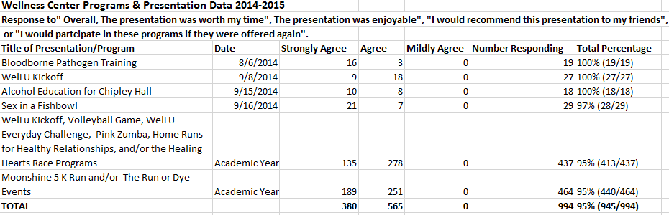

1.a.5 Blood Connection Blood Drive, House Calls, Anxiety & Depression Screening, Healthy Relationships, Breaking the Chain, Great American Smoke-Out, De-Stress Fest, Safe Spring Break, and/or Girls Night Out with Dr. Amaya.
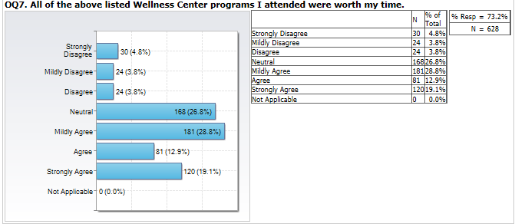
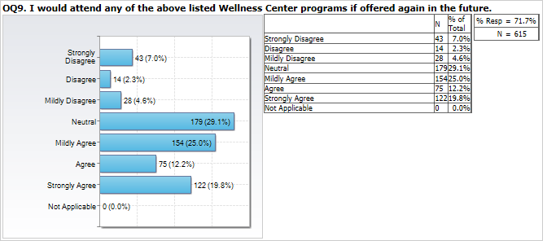

1.a.6 WelLU Kickoff/Volleyball game with LUPD, the WelLU Everyday Challenge, Pink Zumba, Home Run for Healthy relationships, and/or the Healing Hearts race.
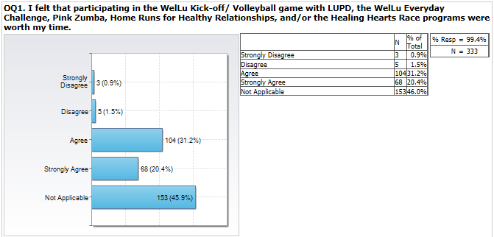

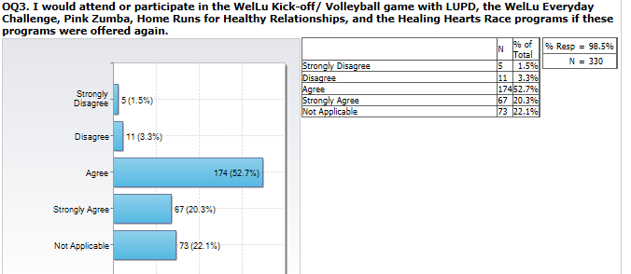

2. Students increased knowledge/awareness of the presentation/program subject when attending

1.a.7 Moonshine Run and/or the Run or Dye Color Run
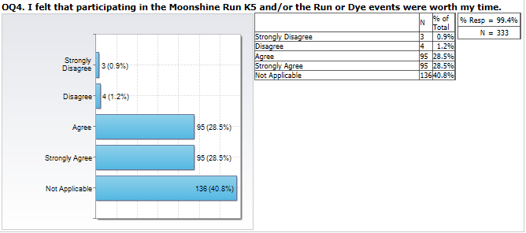

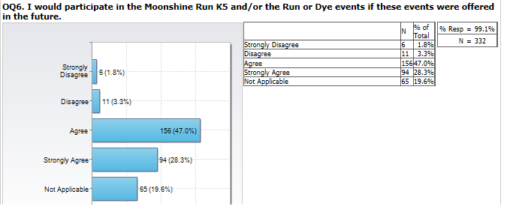

Wellness Center programs and the material presented influenced them to make positive changes
in their behaviors/choices.
THRESHOLD FOR GOAL: Met 2.80 (91% - 967/1068) STRATEGIC GOAL SUPPORTED: Learning
Summary Comments: (2014-2015) The indicator of success for the Unit Porgram Goal of “Students increased knowledge/awareness of the presentation/program’s subject when attending Wellness Center programs and the material presented influenced them to make positive changes in their behavior/choices” was met. However, one of the eight sub-indicators was partially met with an 84% agreement repsonse. This sub-indicator involved more of the sedate or less “active” programs (the same results are seen in Unit Indicator 1). This will be monitored to track any trend or pattern. If one occurs, then this could be used in future programming planning.

2.a (2.a.1, 2.a.2, 2.a.3, 2.a. 4, and 2.a.5)
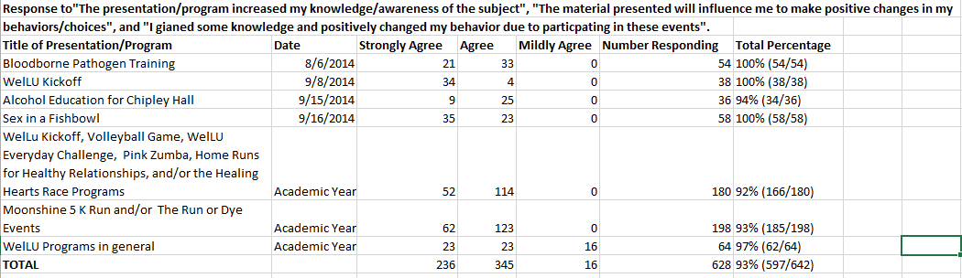

2.a. 6
Blood Connection Blood Drive, House Calls, Anxiety & Depression Screening, Healthy Relationships, Breaking the Chain, Great American Smoke-Out, De-Stress Fest, Safe Spring Break, and/or Girls Night Out with Dr. Amaya.

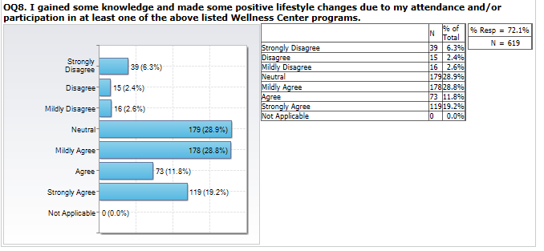

2.a 7
Moonshine Run and/or the Run or Dye Color Run
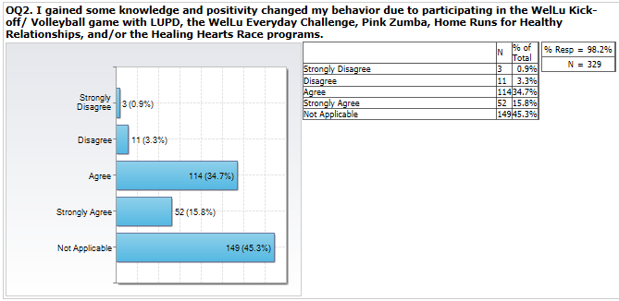

2.a. 8
Moonshine Run and/or the Run or Dye Color Run
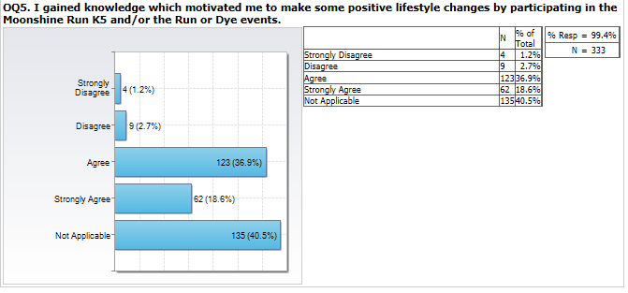

3. The Wellness Center markets their presentations and programs effectively to students.
THRESHOLD FOR GOAL: Met 3.00 (90% - 86/96) STRATEGIC GOAL SUPPORTED: Enrollment
Summary Comments: (2014-2015) Two of the three unit indicators for the Unit Program Goal of “The Wellness Center markets their presentations and programs effectively to students” was met (with a 2.33 instead of a 3:00 rating). One unit indicator’s establshed threshold was not met. In promoting Wellness Center Programming events, the marketing coordinator for Student Affairs has not placed the logo on the announments sent out via email or on Axis TV for ALL of the Wellness Center events. An email was sent to all involved parties on 10/16/2015 to ask for this issue to be addressed, so improvement can be made on this indicator of success. The response to this email indicated that events whch are co-sponsored will not contain the logo. This will be need to be addressed as the original programming committee set this goal in 2013/2014. Another option would be to change the the wording for this goal will change for the 2015/2016 Academic Year.

3. a
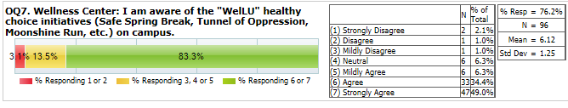

3. c Logo on website but not on all promotional activities.
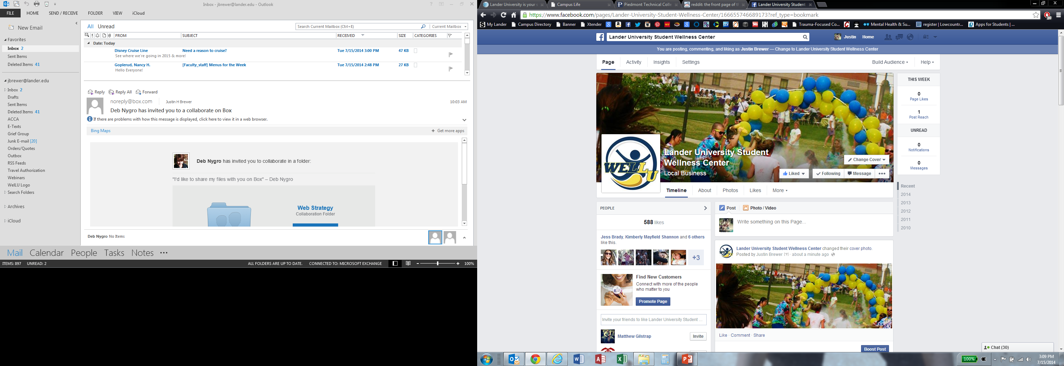
3. b.
A Peer Educator Program was maintained for the Fall 2014/Spring 2015 Academic Year.
3. b. 1
Seven Peer Educators were hired (Wellness Center Year End Board Report) for the 2014/2015 Academic Year.

4. The Wellness Center presentations and programs represent a collaborative Student Affairs’ effort and reflect current issues/concerns, etc.
THRESHOLD FOR GOAL: Met (3.00) STRATEGIC GOAL SUPPORTED: Learning
Summary Comments: (2014/2015) The two indicators of success for the Unit Program Goal of “The Wellness Center presentations and programs represent a collaborative Student Affairs effort and reflect current issues/concerns, etc” were met.

4.a and 4.b
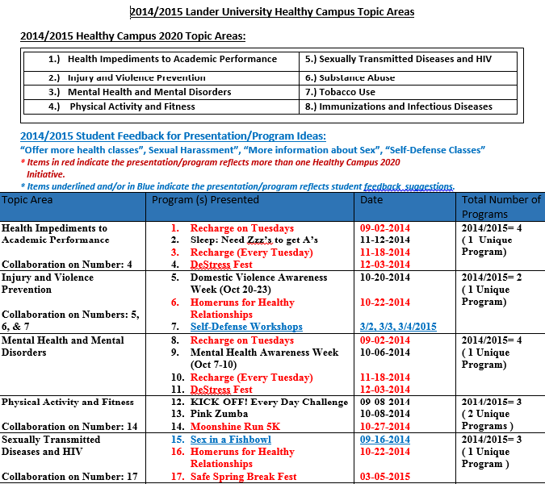

4.a and 4.b Continued

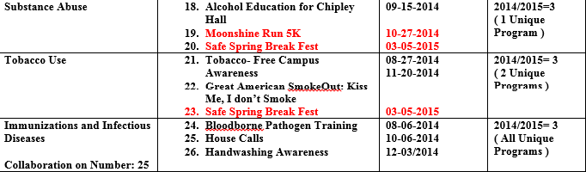

5. Students are satisfied with Counseling Services’ office, services, and staff.
THRESHOLD FOR GOAL: Met 2.32 STRATEGIC GOAL SUPPORTED: Enrollment
Summary Comments: (2014/2015) For this reporting period, the set thresholds for seven of the eight indicators were met for the Unit Program Goal of, “Students are satisfied with Counseling Services’ office, services, and staff.”Although the data show that the goal was met for most of the indicators of success, there was an overall, decrease in satisfaction responses from the 2013/2014 reporting period. In terms of plans of action to be addressed, the following two areas were discussed: Of the two sub-indicators for the indicator: “Students are satisfied with individual counseling meetings” - the threshold for success was met on one and not met on the sub-indicator about scheduling a meeting within a time frame to meet the student’s needs. This could have been due to the two counselors teaching two sections of University 101 and having limited availability. For the 2015/2016 Academic Year, the two counselors will only teach one section of this class to leave more time available for appointments. This will be monitored. Another factor which could account for this decrease is the increase in number of students receiving services. Compared to the 2013/2014 reporting period, the number of students increased from 265 to 281 (6% increase); the number of sessions scheduled increased from 789.5 to 961 (21.7% increase); and the number of sessions kept increased from 639.5 to 766 (19.8% increase). With increasing numbers and the same number of staff providing services, satisfaction may be compromised. None of the sub-indicators for the indicator of success: “Students are satisfied with their group counseling leader” were met. This could be due to the fact that for this reporting period, all of the groups facilitated were mandated anger management groups when compared to a mixture of mandated and voluntary groups being facilitated during the previous reporting period. This fact could also account for the decrease in results for this sub-indicator for this reporting period. For 2015/2016 reporting period, these results will be monitored and if not met, a plan of action for improvement will be developed.

5. a
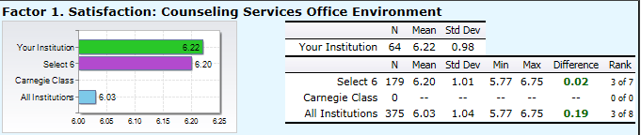

5. a. 1

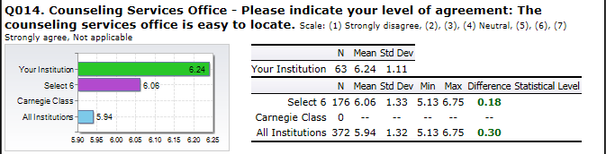

5. a. 2
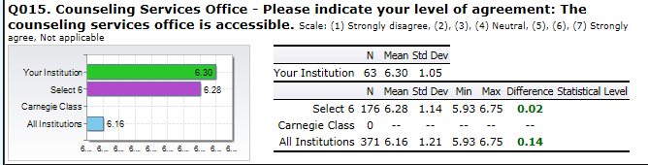

5. a. 3
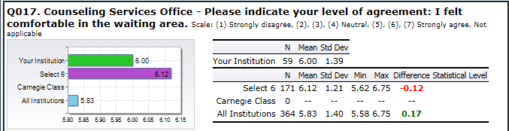

5. a. 4
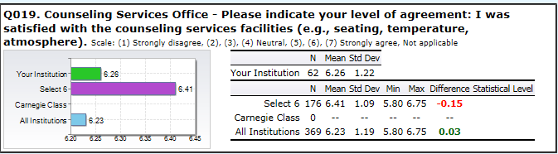

5. b.
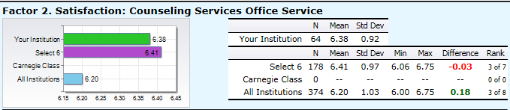

5. b. 1
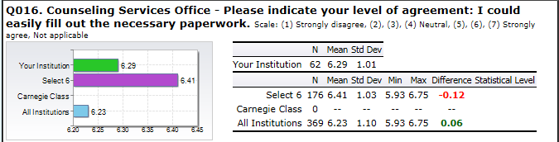

5. b. 2
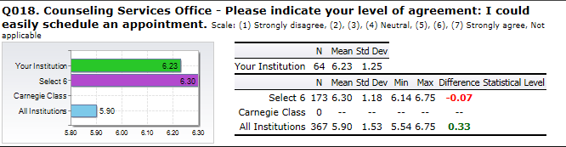

5. b. 3
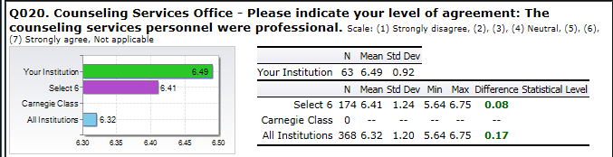

5. b. 4
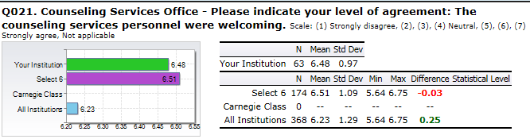

5. b. 5
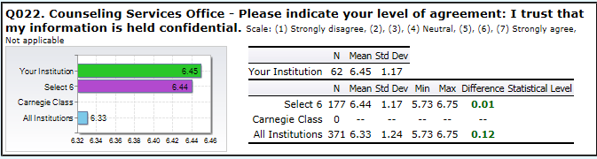

5. c
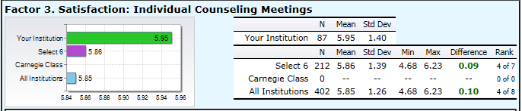

5. c. 1
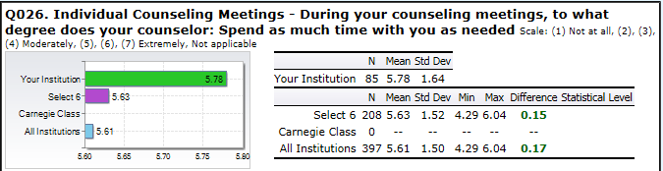

5. c. 2
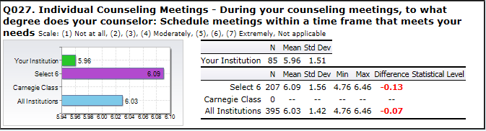

5. c. 3
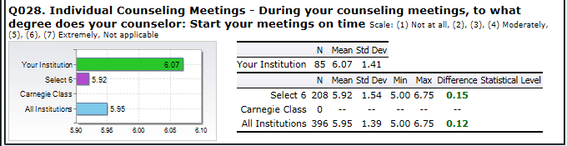

5. d.
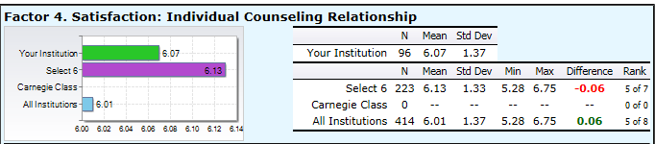

5. d. 1
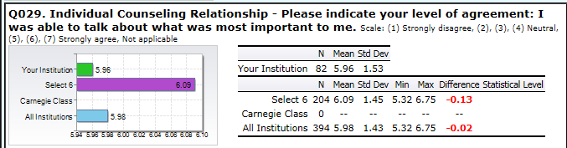

5. d. 2
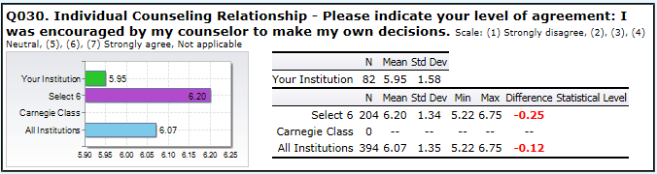

5. d. 3
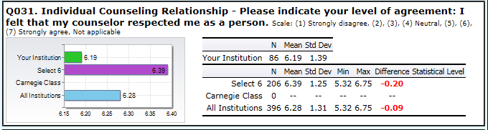

5. d. 4
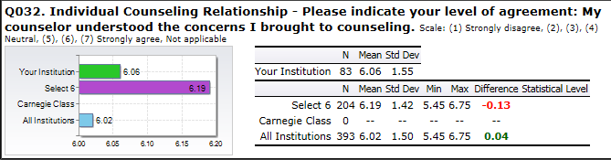

5. d. 5
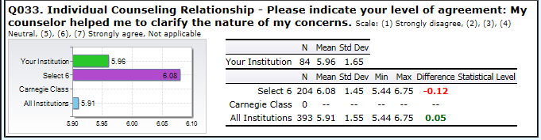

5. d. 6
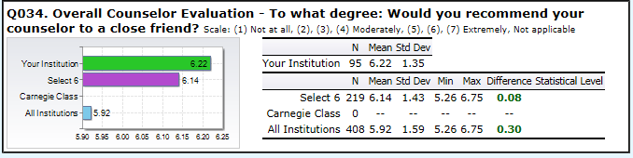

5. e
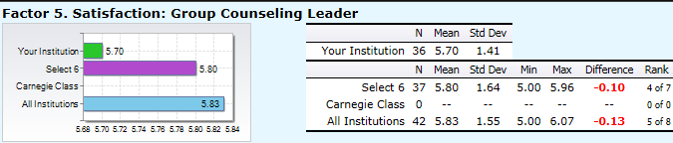

5. e. 1
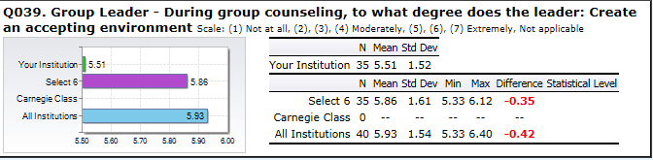

5. e. 2
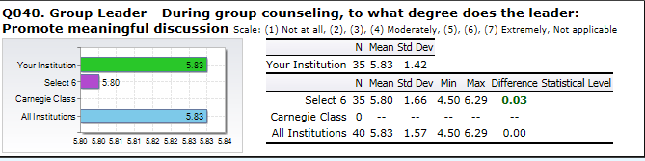

5. e. 3
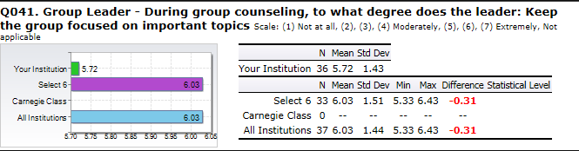

5. f
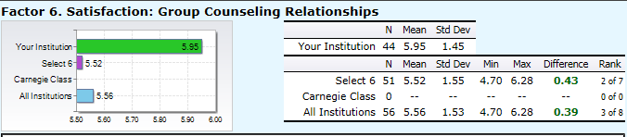

5. f. 1
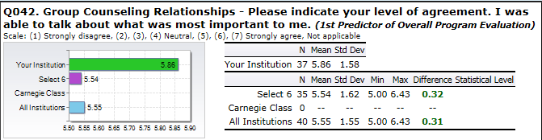

5. f. 2
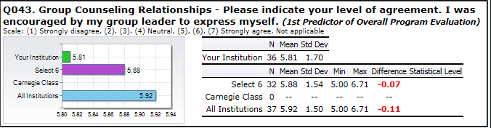

5. f. 3
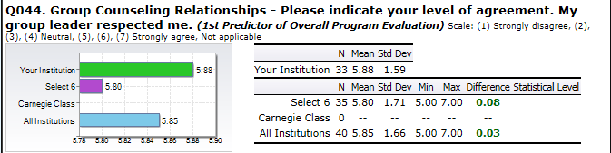

5. f. 4
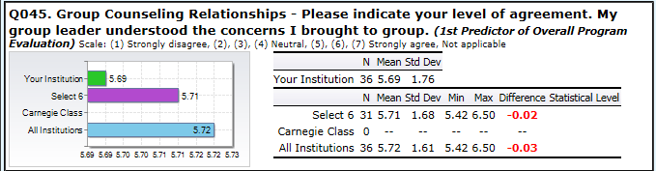

5. f. 5
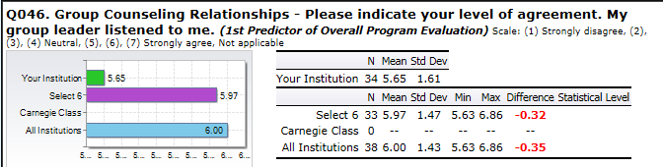

5. f. 6
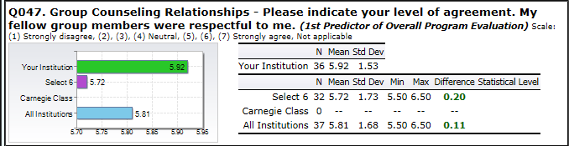

5. f. 7
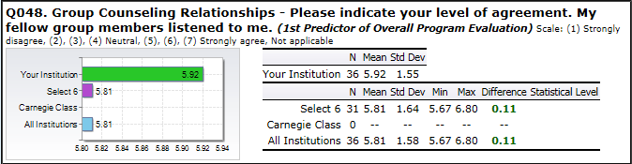

5. f. 8
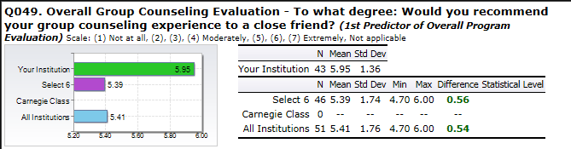

5. g.
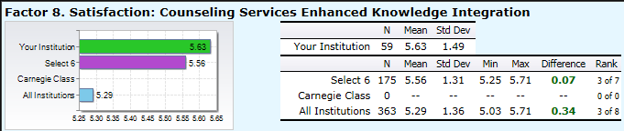

5. g. 1
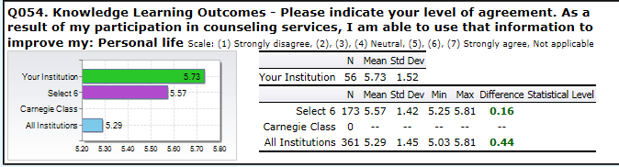

5. g. 2
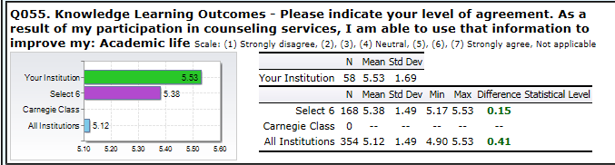

5. g. 3
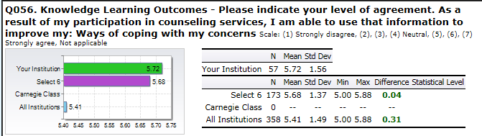

5. h.
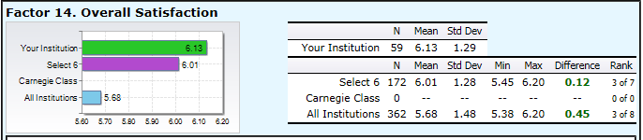

5. h. 1
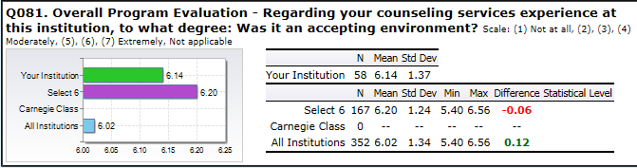

5. h. 2
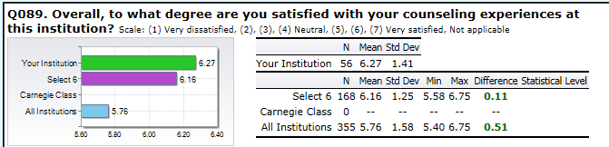

5. h. 3
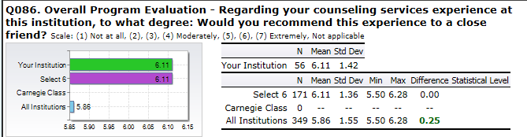

5. h. 4
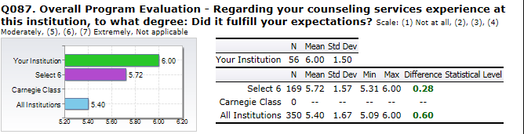

5. h. 5
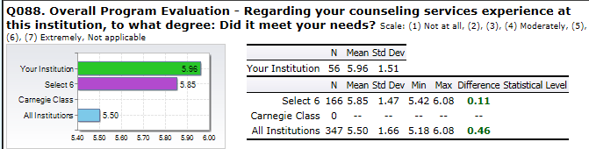

6. Participation in counseling services enhanced a student’s academic, social, and personal
development.
THRESHOLD FOR GOAL: Met 2.33 STRATEGIC GOAL SUPPORTED: Learning
Summary Comments: (2014/2015) The threshold for the Unit Program Goal indicator of, “Participation in counseling services enhanced a student’s academic, social, and personal development”, was met. Four of the six indicators met the establshed threshold of having a mean higher than all of the comparison groups. Since all indicators (factors) and sub-indicators were met for this goal during the 2013/2014 reporting period, these results will be monitored and if not met for the next reporting period, a plan of action for improvement will be developed.

6. a.
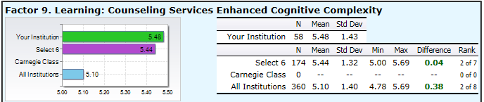

6. a. 1
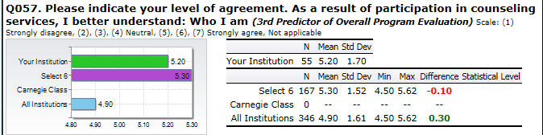

6. a. 2

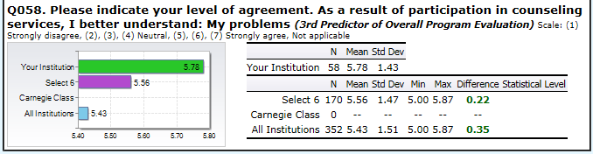

6. a. 3
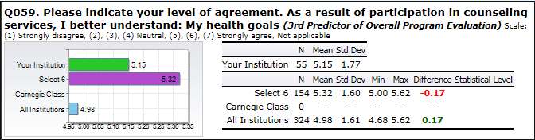

6. a. 4
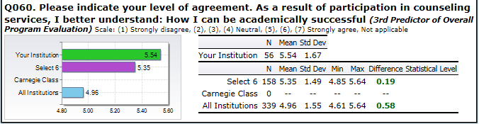

6. a. 5
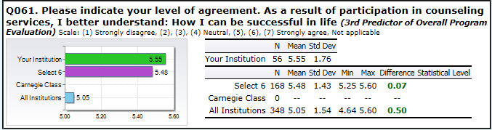

6. b
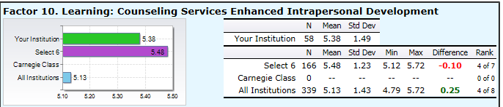

6 .b. 1
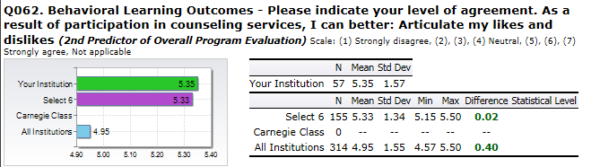

6 .b. 2
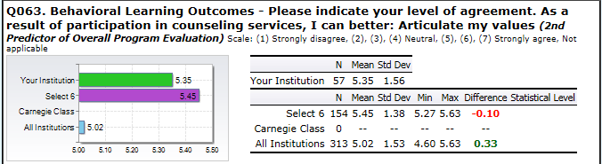

6 .b. 3
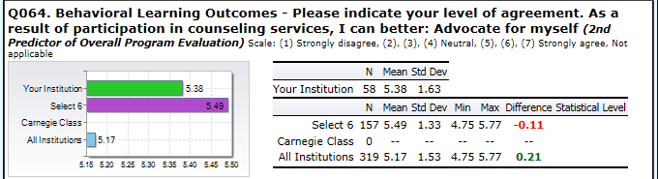

6 .b. 4
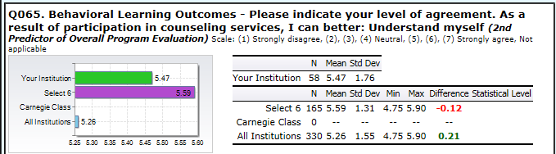

6 c
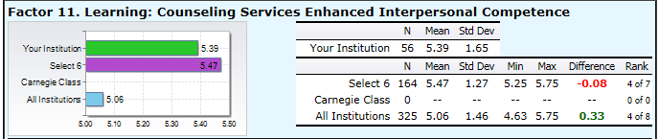

6 c. 1
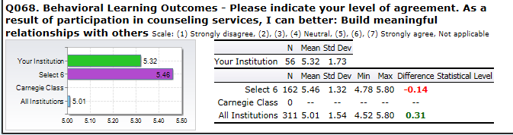

6 c. 2
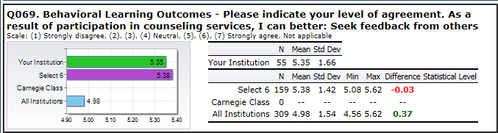
6 c. 3
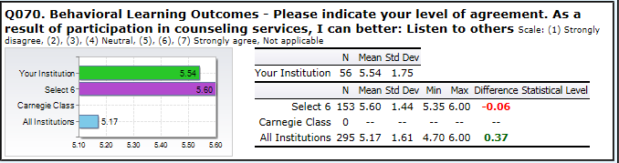

6. d
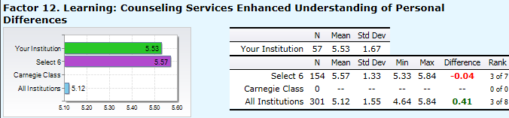

6. d. 2
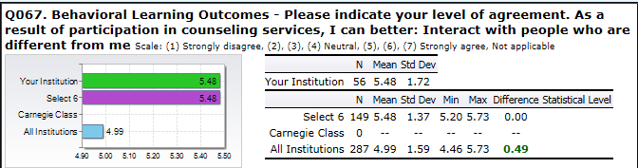
6. d. 1
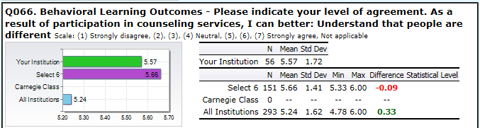

6. e
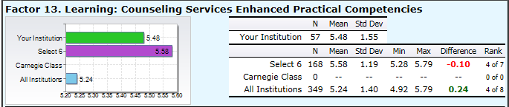

6. e. 1
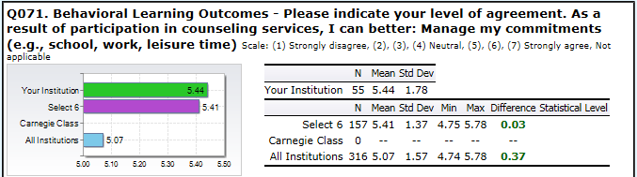

6. e. 2
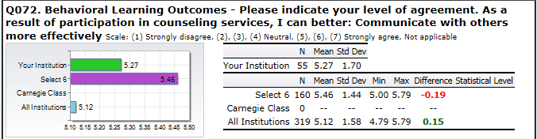

6. e. 3
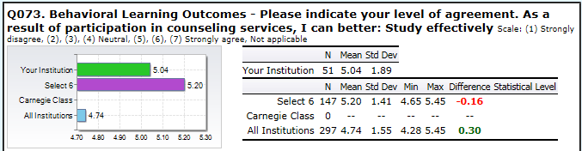

6. e. 4
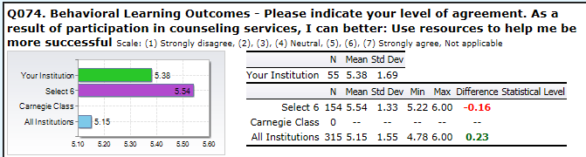

6. e. 5
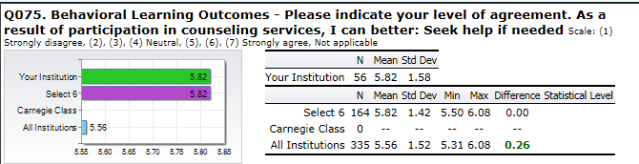

6. e. 6
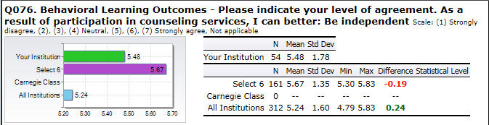

6. e. 7
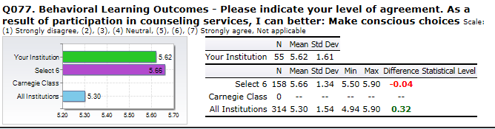

6. e. 8
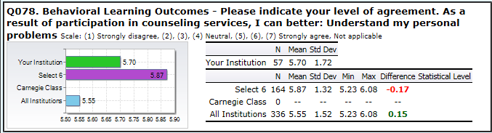

6. f
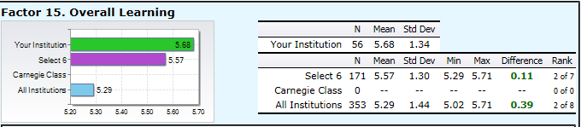

6. f. 1
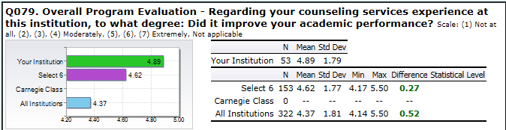

6. f. 2
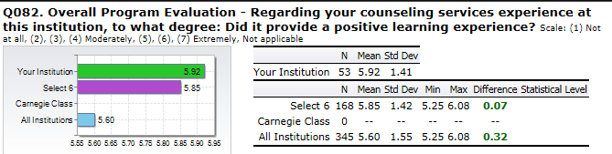

6. f. 3
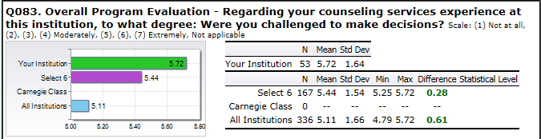

6. f. 4
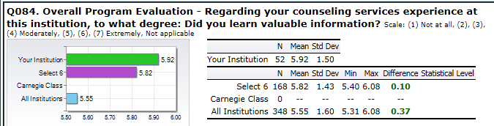

6. f. 5
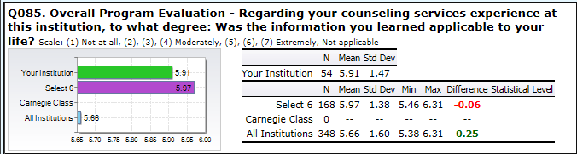

7. Overall, the Office of Counseling Services is effective in its provision of services to students.
THRESHOLD FOR GOAL: Met 2.73 STRATEGIC GOAL SUPPORTED: Enrollment
Summary Comments: (2014/2015) The threshold was met for the Unit Program Goal of, “Overall, the Office of Counseling Services is effective in its provision of services to students”. However, three of the sub-indicators partially met their set threshold. Since all sub-indicators were met for the 2013/2014 reporting period and seven new sub-indicators were added to this factor, these partially met sub-indicators will be monitored and if not met for the next reporting period, a plan of action for improvement will be developed.

7.a.
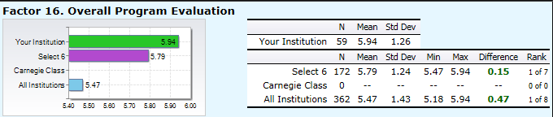

7. a. 1 Not used as a sub-indicator (question) for this indicator (factor) this reporting period.
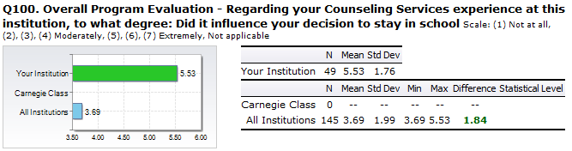

7. a. 3
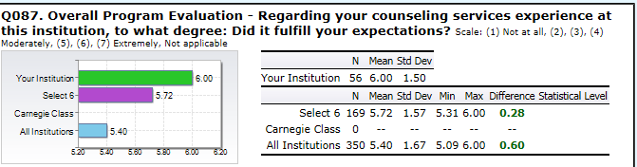

7. a. 2
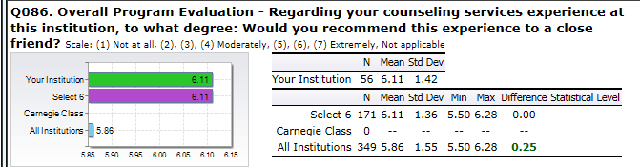

7. a. 4
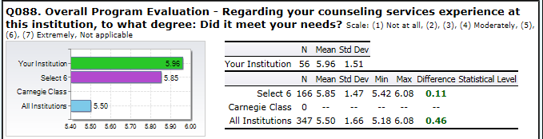

7. a. 5
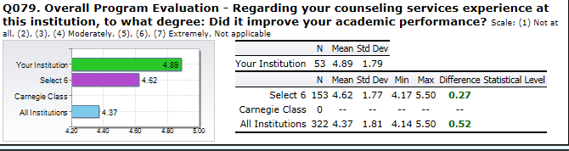

7. a. 6
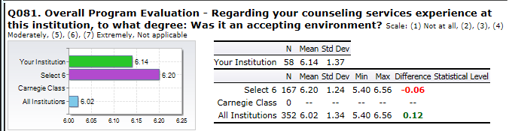

7. a. 7
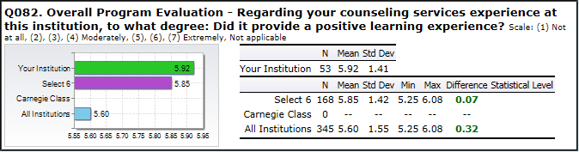

7. a. 8
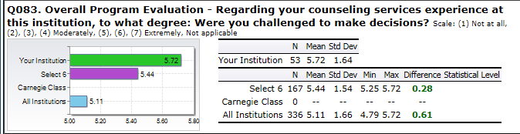

7. a. 9
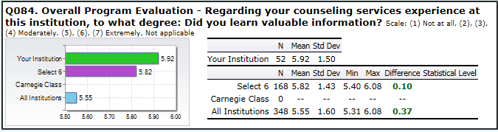

7. a. 10
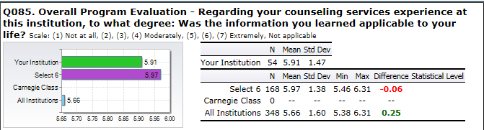

7. a. 11
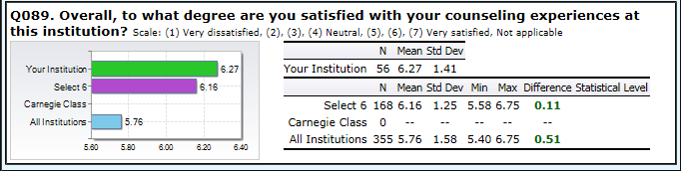

8. The Office of Disabilities Services is effective in its provision of services to students.
THRESHOLD FOR GOAL: Met 3.00 STRATEGIC GOAL SUPPORTED: Enrollment
Summary Comments: (2014/2015) The Unit Program Goal of, “Disability Services is effective in its provision of services to students”, was met for all four indicators of success. In addition, all of the means were higher when compared to the 2013/2014 reporting period.

8. a. (Threshold mean established at 5.60 (80% of a 7.0 scale). The mean is above the threshold at 5.76 and partially meets the criteria set).

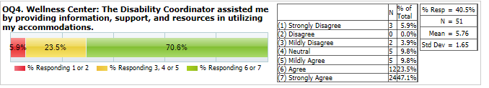

8. b. (Threshold mean established at 5.60 (80% of a 7.0 scale). The mean is above the threshold at 6.03 and meets the criteria set).

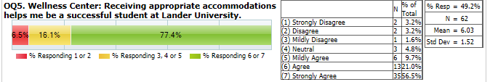

8. c. (Threshold mean established at 5.60 (80% of a 7.0 scale). The mean is below the threshold at 5..52 and meets the criteria set).
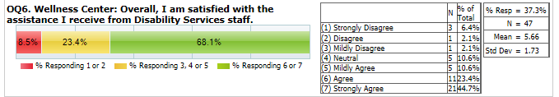

8.d. (http://www.lander.edu/Student-Affairs/Wellness-Center/Disability-Services.aspx)
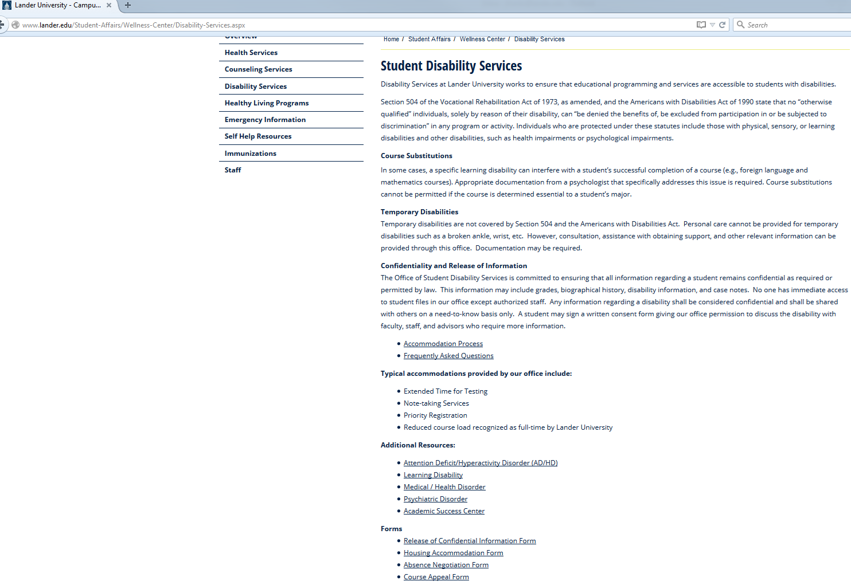

8.d . (http://www.lander.edu/docs/default-source/student-affairs-documents/Accommodation_Process.pdf?sfvrsn=0)
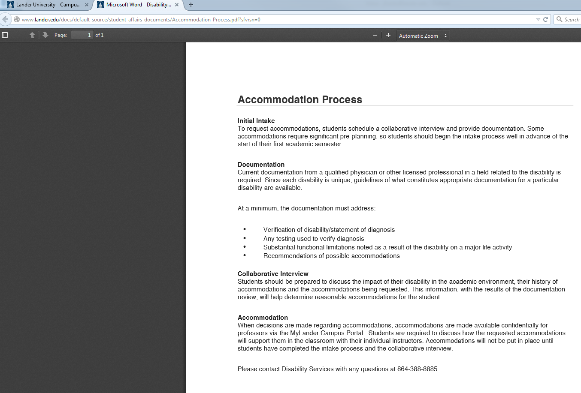

9. The Lander University campus is accessible to students with disabilities.

9. The Lander University Campus is Accessible.
THRESHOLD FOR GOAL: Partially Met 1.75 STRATEGIC GOAL SUPPORTED: Enrollment
Summary Comments The Unit Program Goal of “The Lander University campus is accessible” was only partially met. This was due to only three of the eight sub-indicators being met. Two of these sub-indicators were partially or not met during the 2013/2014 reporting period and this information will be reported to the Advisory Committee on the Disabled. Students reported that campus dining facilities and events were not easily accessible. The other three were partially or not met for this reporting period only but were met for the 2013/2014 reporting period. These dealt with campus sidewalks, campus buildings, and campus classrooms not being considered easily accessible. For the 2014/2015 Academic Year, there was a construction project for the “New Entrance” to Lander University which interfered with more accessible routes to buildings, sidewalks, etc. and most likely contributed to these results. This construction project is now complete but for the 2015/2016 Academic Year, another construction project involving the plaza which connects the Grier Student Center, the Jackson Library, and the Carnell Learning Center, has begun and will continue to disrupt accessibility.

9. a
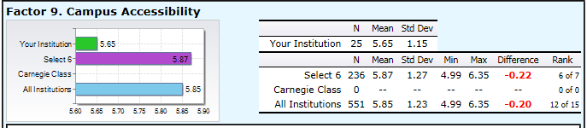

9. a. 1
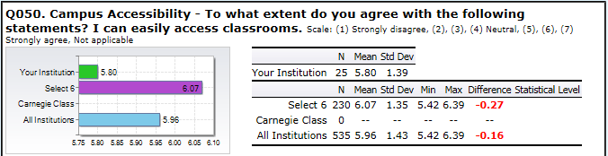

9. a. 2
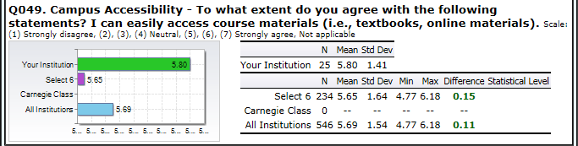

9. a. 3
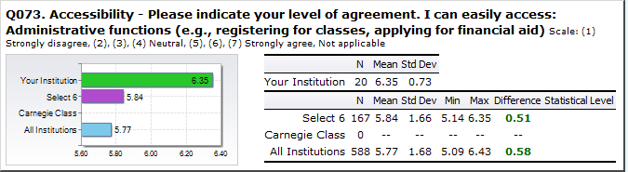

9. a. 4
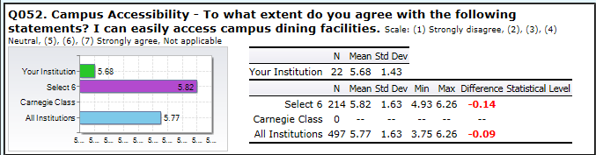

9. a. 5
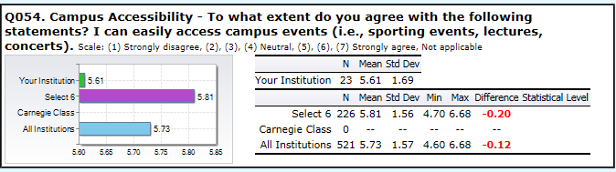

9. a. 6
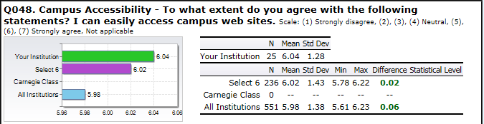

V1
9. a. 7 This sub-indicator (question) was dropped for this indicator (factor) for the 2014/2015 reporting period.
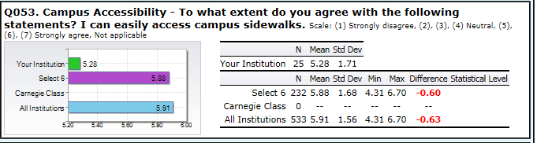

9. a. 8
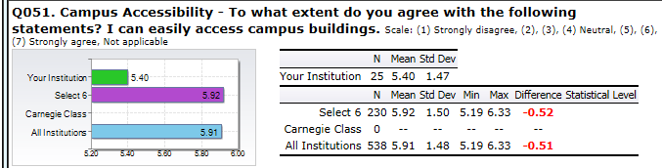

10. All charts on students with established disability cases will contain specified documentation (Uniform Clinical Records).
10. a THRESHOLD FOR GOAL: Met (3.00) STRATEGIC GOAL SUPPORTED: Accountability
Summary Comments: (2014/2015) The Unit Program Goal of, “All charts on students with established diability cases will contain specified documentation (uniform clinical records)” was met for both indicators of success.

10. a. 1 Copy of Checklist
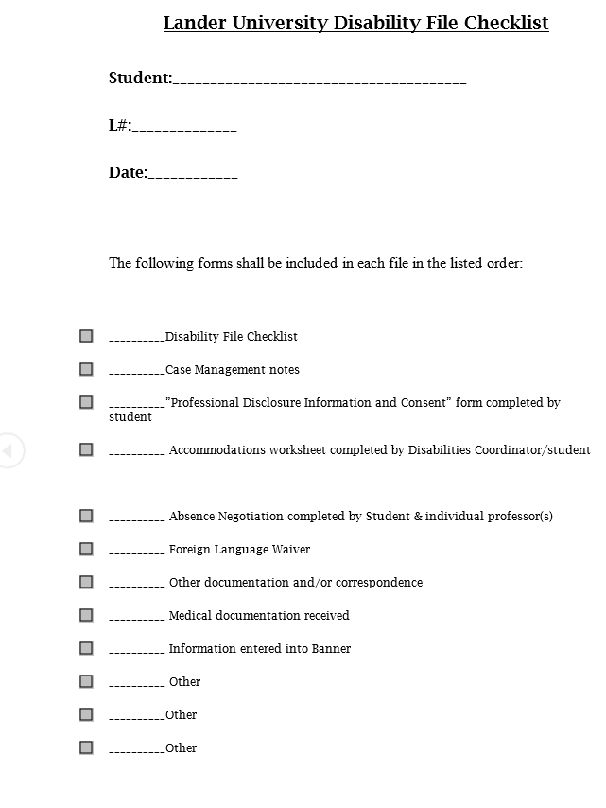

10. a. 2 Number of Charts for 2014-2015
Number of Charts in Compliance: 95/95 Charts in compliance
Percent Score: 100%

11. Health Services is effective in its provision of services to students.
THRESHOLD FOR GOAL: Met (3.00) STRATEGIC GOAL SUPPORTED: Enrollment
Summary Comments: (2014/2015) All indicators of success met their established thresholds for the Unit Program Goal of, “The Office of Health Services is effective in its provision of services to students”.

11. a
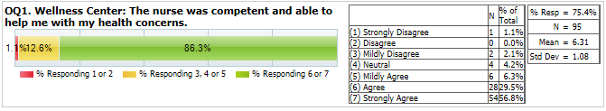

11. b.
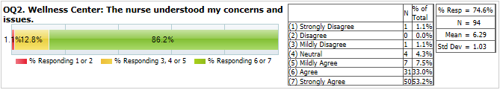

11. c.
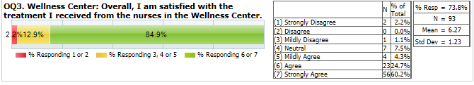

12. Wellness Center staff act in a professional (customer service) manner.
THRESHOLD FOR GOAL: Met 3.00 STRATEGIC GOAL SUPPORTED: Enrollment
Summary Comments: (2014/2015) All indicators of success met their established thresholds for the Unit Program Goal of, “Wellness Center Staff act in a professional (customer service) manner”.

12.a.
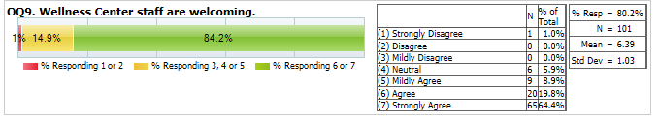

12.b.
