STUDENT AFFAIRS INSTITUTIONAL EFFECTIVENESS PLAN (UNIT GOALS)
FOR ACADEMIC YEAR: 2014/2015
DEPARTMENT: Housing & Residence Life
SUBMISSION DATE: Summer 2015

Mission: The Lander University Department of Housing & Residence Life supports the overall mission of Lander University and the Division of Student Affairs by providing an on-campus residential experience which is secure, well-maintained, and affordable where student learning is extended beyond the classroom by empowering residents and staff to learn, innovate, and succeed, and to that end endeavors to be a community of individuals who teach the value of human diversity, who promote civility and the value of good citizenship. In addition, the Department of Housing & Residence Life is committed to acting with integrity, dignity, and competence in our service to resident students and the university community.

Department Description: The Department of Housing and Residence Life is responsible for administering all residence hall matters, including physical facilities, staffing, programs, room assignments, budgeting, policy development and communication, and hall government advising. The Central Office Staff consists of the Director of Housing & Residence Life, the Assistant Director of Housing & Residence Life, etc. Residence Life involves staff recruitment, selection, and training of resident assistants who are responsible for developing a positive living experience and learning environment for resident students. Resident Assistants live with the residents of each building or floor. They are student staff members selected on the basis of their skills, interests and activities that enable them to effectively assist and advise students. Each Resident Assistant is trained to assist and/or refer students with academic and personal concerns, and assist students in maintaining an educational environment.

Goals:
For the 2014/2015 academic year reporting, the Educational Benchmarking, Inc. (EBI) Resident Assessment and Student Staff Assessment were used to measure the Department of Housing & Residence Life’s goals and unit indicators of success. These assessments provide benchmarking comparisons which assist in normalizing results that might otherwise be changed if based only on Lander University’s data. Also, the goals and unit indicators obtained from the EBI are ones that the Department of Housing & Residence Life chose from all of the factors (derived from a specific group of questions) which can be changed, impacted, and monitored for continuous quality improvement. Not all factors measured were chosen.

1. Monitor occupancy rates to report to the President’s Cabinet and the Board of Directors for the purpose of
determining projected capacity for an academic year.
  - Strategic Goal Supported: Accountability
  - Indicators of Success and Summary of Data:
Indicator | 2013-2014 | 2014-2015 | 2015-2016 | 2016-2017 | 2017-2018
1. a Results: Occupancy report is submitted to the Vice President for Student Affairs weekly and tracked in a yearly report. | Housing Application Report submitted. | Housing Application Report submitted.
1.b Results: Number of decisions made based on information from the projected capacity of the occupancy rate regarding residence life staff, residence assistants, and residence halls remaining open, and building new and/or repairing current residence halls. | 4 | 2
  - Assessment Instruments and Frequency of Assessment:
Indicator | Instrument | Frequency
1. a Occupancy report is submitted to the Vice President for Student Affairs weekly and tracked in a yearly report. | Housing Application Report | Annually
1. b Number of decisions made based on information from the projected capacity of the occupancy rate regarding residence life staff, residence assistants, and residence halls remaining open, and building new and/or repairing current residence halls. | June 2015  Student Affairs Board Report Board | Annually
  - Expected Outcomes:
Indicator | Met | Partially Met | Not Met
1. a Occupancy report is submitted to the Vice President for Student Affairs monthly and tracked in a yearly report. | Report Submitted with Monthly Tracking Documented | N/A | Report Not Submitted
1. b Decisions made based on information from the projected capacity of the occupancy rate regarding residence life staff, residence assistants, and residence halls remaining open, and building new and/or repairing current residence halls. | At Least One Decision Made Based on Projected Occupancy Rates | N/A | No Decisions Made

  - Review of Results and Actions Taken:
Indicator
1. a Occupancy report is submitted to the Vice President for Student Affairs monthly and tracked in a yearly report. | 2014-2015: The Director of Housing and Residence Life submitted reports on a monthly basis and submitted a year-end annual Housing Application report to the Vice President of Student Affairs on 6/11/2015.
1. b Decisions made based on information from the projected capacity of the occupancy rate regarding residence life staff, residence assistants, and residence halls remaining open, and building new and/or repairing current residence halls. | 2014-2015: The residence halls are assigned based on first year and upperclassmen resident student type with bed capacity originally designated as: First Year – 622 beds and Upperclassmen – 766 beds. Decision 1: Based on the occupancy projections for Fall 2015 and the opening of the New Residence Hall, the Department of Housing & Residence Life requested and is closing all buildings of Brookside Residence Halls for student occupancy. The future of Brookside Residence Halls has yet to be determined but the Department is waiting on confirmation to keep Brookside Buildings 2 & 3 open to serve only as storage facilities for the Fall 2015/Spring 2016 Academic Year. At the end of each academic year, furniture and mattresses for all buildings are inventoried. The Brookside Residence Halls’ furniture and mattresses were assessed to be in excellent condition. Also, it was noted that the Bearcat Village furniture is the exact same finish as what is being used for the new residence hall and is in excellent condition. Therefore, in an effort to save money, since Brookside will not be occupied, the Bearcat Village furniture will be moved to the New Residence Hall and the Brookside furniture will be moved to Bearcat Village. In utilizing the current furniture inventory, the Department will save an estimated $299,000. An additional estimate of $21,000 will be saved by using the mattresses from the Brookside Residence Halls. (2015 Student Affairs Board Report)  Decision 2: Last year, the Department of Housing and Residence Life also closed McGhee Court to student occupancy. Rather than leaving these buildings empty, Lander University is providing an opportunity for Lander University employees to lease Apartments at McGhee Court. This will provide a presence at the facility as well as provide income for the university. The leases are based on a first-come-first-serve basis and will be on a 12 month lease option. (2015 Student Affairs Board Report)
  - Outcomes:
Indicator | 2013-2014 | 2014-2015 | 2015-2016 | 2016-2017 | 2017-2018
1. a Occupancy report is submitted to the Vice President for Student Affairs weekly and tracked in a yearly report. | Met  (3) | Met  (3)
1. b Number of decisions made based on information from the projected capacity of the occupancy rate regarding residence life staff, residence assistants, and residence halls remaining open, and building new and/or repairing current residence halls. | Met  (3) | Met  (3)
  - Additional Resources Requested to Achieve or Sustain Results: None Requested
Indicator | 2013-2014 | 2014-2015 | 2015-2016 | 2016-2017 | 2017-2018 | 2018-2019
1. a Occupancy report is submitted to the Vice President for Student Affairs weekly and tracked in a yearly report. | None | None
1. b Number of decisions made based on information from the projected capacity of the occupancy rate regarding residence life staff, residence assistants, and residence halls remaining open, and building new and/or repairing current residence halls. | None | None
  - Summary Comments:
2014-2015: The Director of Housing & Residence Life consistently monitors the new applications and occupancy rates and updates the Vice President of Student Affairs on the projected capacity every week in order for the Vice President to report this information in the President’s Cabinet weekly meeting. This information is then documented in a monthly report and the Director of Housing & Residence Life submits a year-end report to the Vice President of Student Affairs. This report is used (in conjunction with other information) to make decisions about residential buildings and Housing and Residence Life staffing issues.
- Provide Lander University resident students with a satisfactory living and learning environment.
  - Strategic Goal Supported: Learning
  - Indicators of Success and Summary of Data:
Indicator | 2013-2014 | 2014-2015 | 2015-2016 | 2016-2017 | 2017-2018
2. a Mean Score: Students are satisfied with their experience with housing and residence life staff. | 6.08  (5.78, 5.47, 5.78) | 6.26  (5.72, 5.57, 5.87)
2. a. 1 Resident students are satisfied with the availability of their Resident Assistant. | 6.07  (5.83, 5.47, 5.76) | 6.21  (5.73, 5.62, 5.84)
2. a. 2 Resident students are satisfied with their Resident Assistant’s efforts to get to know them. | 6.03  (5.62, 5.28, 5.63) | 6.19  (5.55, 5.35, 5.68)
2. a. 3 Resident students are satisfied with their Resident Assistant’s ability to gain their respect. | 6.08  (5.70, 5.39, 5.74) | N/A
2. a. 4 Resident students are satisfied with their Resident Assistant’s assistance with a problem. | 6.07  (5.75, 5.49, 5.76) | 6.16  (5.61, 5.48, 5.79)
2. a. 5 Resident students are satisfied with their Resident Assistants regarding them treating everyone fairly. | 6.22  (5.94, 5.68, 5.98) | 6.41  (5.92, 5.74, 6.05)
2. a. 6 Resident students are satisfied with their Resident Assistants regarding organizing programs/activities. | 5.83  (5.53, 5.35, 5.67) | 6.05  (5.46, 5.31, 5.72)
2. a. 7 Resident students are satisfied with their Resident Assistants in promoting tolerance of others. | 6.09  (5.86, 5.55, 5.88) | 6.26  (5.79, 5.66, 5.94)
2. a. 8 Resident students are satisfied with their Resident Assistants regarding the communication of rules and regulations. | 6.27  (6.01, 5.64, 5.94) | 6.38  (5.91, 5.69, 6.00)
2. a. 9 Resident students are satisfied with their Resident Assistants regarding enforcing policies | N/A | 6.37  (5.72, 5.59, 5.87)
2. a. 10 Resident students are satisfied with their Resident Assistants regarding overall performance | N/A | 6.39  (5.90, 5.76, 6.03)
2. a. 11 Resident students are satisfied with their Resident Assistants regarding connecting them with resources. | 5.76 | 5.36
2. a. 12 Resident students are satisfied with their Resident Assistants regarding assistance in reaching their personal goals. | 5.48 | 5.14
2. a. 13 Resident students are satisfied with their Resident Assistants regarding assistance in reaching their academic goals. | 5.47 | 5.17
2. a. 14 Resident students are satisfied with their Resident Assistants regarding modeling professionalism. | 5.89 | 5.61
2. b. Mean Score: Students are satisfied with social / educational / cultural programs and activities provided by resident life staff members. | 5.22  (5.08, 4.91, 5.15) | 5.48  (5.03, 4.90, 5.20)
2. b. 1 Resident students are satisfied with the social/educational programs. | 5.28  (5.08, 4.91, 5.16) | 5.50  (5.08, 4.90, 5.22)
2. b. 2 Resident students are satisfied with the athletic/recreational programs. | 5.12  (4.95, 4.72, 5.02) | 5.47  (4.86, 4.87, 5.06)
2. b. 3 Resident students are satisfied with the variety of programs. | 5.21  (5.10, 4.98, 5.19) | 5.45  (5.06, 4.90, 5.24)
2. b. 4 Resident students are satisfied with the quality of programs. | 5.26  (5.14, 5.03, 5.21) | 5.48  (5.11, 4.93, 5.26)
2. c Mean Score: Students are satisfied with their room / hall / floor environment. | 5.58  (5.39, 5.22, 5.40) | 5.77  (5.26, 5.33, 5.42)
2. c. 1 Resident students are satisfied with their ability to study in their room. | 5.70  (5.42, 5.31, 5.39) | 5.90  (5.31, 5.31, 5.43)
2. c. 2 Resident students are satisfied with their ability to sleep in their room. | 5.91  (5.76, 5.47, 5.68) | 6.04  (5.61, 5.65, 5.70)
2. c. 3 Resident students are satisfied with their degree of privacy. | 5.75  (5.64, 5.55, 5.58) | 5.98  (5.47, 5.55, 5.59)
2. c. 4 Resident students are satisfied with the noise level of their floor/hall/community. | 4.98  (4.73, 4.56, 4.94) | 5.16  (4.68, 4.85, 4.98)
2. d. Mean Score: Students are satisfied with the services provided for their residence hall rooms and / or facilities. | 5.30  (5.17, 4.82, 5.14) | 5.60  (5.04, 4.93, 5.19)
2. d. 1 Resident students are satisfied with the internet connectivity in their room. | 4.62  (4.40, 3.95, 4.53) | 4.96  (3.94, 4.38, 4.40)
2. d. 2. Resident students are satisfied laundry room facilities. | 5.33  (4.96, $.65, 4.89) | 5.63  (4.68, 4.56, 4.90)
2. d. 3 Resident students are satisfied with the common areas provided (i.e. study rooms, meeting rooms, lobbies, etc.). | 5.68  (5.40, 5.18, 5.44) | 5.85  (5.34, 5.27, 5.50)
2. d. 4 Resident students are satisfied with the computing facilities in their hall/floor/building. | 5.40  (5.01, 4.59, 5.06) | N/A
2. d. 5 Resident students are satisfied with Cable TV services. | 5.21  (5.47, 5.25, 5.27) | 5.44  (5.27, 4.86, 5.31)
2. d 6 Resident students are satisfied with vending services. | 5.15  (5.07, 4.71, 5.09) | N/A
2. d. 7 Resident students are satisfied with postal services | N/A | 5.93  (5.74, 5.33, 5.56)
2. d. 8 Resident students are satisfied with information desk services. | 5.56  (5.52, 5.13, 5.52) | 5.88  (5.52, 5.19, 5.64)
2. e. Mean Score: Students are satisfied with the room assignment and/or room change process. | 5.59  (5.38, 5.11, 5.35) | 5.76  (5.03, 4.81, 5.14)
2. e. 1 Resident students are satisfied with the flexibility of the room change policy. | 5.51  (5.12, 4.79, 5.04) | 5.84  (4.98, 4.92, 5.11)
2. e. 2 Resident students are satisfied with the room assignment process. | 5.54  (5.14, 4.78, 5.13) | 5.71  (5.02, 4.71, 5.12)
2. e. 3 Resident students are satisfied with their room assignment. | 5.70  (5.74, 5.58, 5.69) | N/A
2. f. Mean Score: Overall, students living on-campus are satisfied with their on-campus housing experience. | 5.56  (5.47, 5.24, 5.47) | 5.63  (5.30, 5.07, 5.38)
2. f. 1 Living on campus contributed to resident student’s sense of belonging to this institution | N/A | 5.53  (5.31, 5.05, 5.30)
2. f. 2 Resident students are satisfied with their on-campus housing experience this year. | 5.48  (5.31,5.07,  5.34) | 5.59  (5.11, 4.95, 5.27)
2. f. 3 On-campus housing was an accepting environment. | 5.63  (5.62, 5.41, 5.60) | N/A
2. f. 4 Living on-campus fulfilled the resident student’s expectations. | 5.23  (4.94, 4.69, 5.06) | N/A
2. f. 5 Resident students would recommend living on-campus to new students. | 5.55  (5.55, 5.33, 5.55) | 5.79  (5.50, 5.22, 5.59)
  - Assessment Instruments and Frequency of Assessment:
Indicator | Instrument | Frequency
All Indicators of Success (and sub-Indicators of Success) | Educational Benchmarking, Inc. (EBI) Resident Assessment Survey and Survey Institutional Specific Questions (OQ1, OQ2, OQ3, OQ4) | Annually
  - Expected Outcomes:
Indicator | Met | Partially Met | Not Met
All Indicators of Success (and sub-Indicators of Success) | Lander EBI mean comparison is above all of the EBI means for the following: Select 6 Peers, Carnegie Peers, and all EBI participants for the year or mean of 5.50 for Institutional Specific Questions. | Lander EBI mean comparison is above one or two of the EBI means for the following: Select 6 Peers, Carnegie Peers, and all EBI participants for the year or mean of 4.5 -5.49 for Institutional Specific Questions. | Lander EBI mean comparison is above none of the EBI means for the following: Select 6 Peers, Carnegie Peers, and all EBI participants for the year or below mean of 4.5 for Institutional Specific Questions.
  - Review of Results and Actions Taken:
Indicator
2. a Mean Score: Students are satisfied with their experience with housing and residence life staff. | The threshold for this indicator was met. Lander University’s mean was above all of the EBI mean comparison groups. In breaking down the survey responses to specific questions measuring the satisfaction of students with their housing and residence life staff, each question’s mean was above all of the benchmark/set means except for three questions in this area: My resident assistant assisted me in connecting to campus resources; My resident assistant assisted me in reaching my personal goals, and My resident assistant assisted me in reaching my academic goals. These questions were some of the institutional specific questions asked and the two underlined were partially met for the last two years.
2. a. 1 Resident students are satisfied with the availability of their Resident Assistant. | The threshold for this indicator was met. Lander University’s mean was above all of the EBI mean comparison groups. No action will be taken.
2. a. 2 Resident students are satisfied with their Resident Assistant’s efforts to get to know them. | The threshold for this indicator was met. Lander University’s mean was above all of the EBI mean comparison groups. No action will be taken.
2. a. 3 Resident students are satisfied with their Resident Assistant’s ability to gain their respect. | The threshold for this indicator was met. Lander University’s mean was above all of the EBI mean comparison groups. No action will be taken.
2. a. 4 Resident students are satisfied with their Resident Assistant’s assistance with a problem. | The threshold for this indicator was met. Lander University’s mean was above all of the EBI mean comparison groups. No action will be taken.
2. a. 5 Resident students are satisfied with their Resident Assistants regarding them treating everyone fairly. | The threshold for this indicator was met. Lander University’s mean was above all of the EBI mean comparison groups. No action will be taken.
2. a. 6 Resident students are satisfied with their Resident Assistants regarding organizing programs/activities. | The threshold for this indicator was met. Lander University’s mean was above all of the EBI mean comparison groups. No action will be taken.
2. a. 7 Resident students are satisfied with their Resident Assistants in promoting tolerance of others. | The threshold for this indicator was met. Lander University’s mean was above all of the EBI mean comparison groups. No action will be taken.
2. a. 8 Resident students are satisfied with their Resident Assistants regarding the communication of rules and regulations. | The threshold for this indicator was met. Lander University’s mean was above all of the EBI mean comparison groups. No action will be taken.
2. a. 9 Resident students are satisfied with their Resident Assistants regarding enforcing policies | The threshold for this indicator was met. Lander University’s mean was above all of the EBI mean comparison groups. No action will be taken.
2. a. 10 Resident students are satisfied with their Resident Assistants regarding overall performance | The threshold for this indicator was met. Lander University’s mean was above all of the EBI mean comparison groups. No action will be taken.
2. a. 11 Resident students are satisfied with their Resident Assistants regarding connecting them with resources. | This is the second reporting period with the responses to this particular question not meeting the established threshold. For the 2015/2016 Academic Year, this issue will be addressed in the annual training for Resident Assistants.
2. a. 12 Resident students are satisfied with their Resident Assistants regarding assistance in reaching their personal goals. | See 2. a. 11
2. a. 13 Resident students are satisfied with their Resident Assistants regarding assistance in reaching their academic goals. | This threshold for this sub-indicator was not met for this reporting period but was met for the 2013/2014 period. These results for this sub-indicator will continued to be monitored and if improvement is not shown next reporting period, then a plan of action will be developed.
2. a. 14 Resident students are satisfied with their Resident Assistants regarding modeling professionalism. | The threshold for this indicator was met. Lander University’s mean was above all of the EBI mean comparison groups. No action will be taken.
2. b Mean Score: Students are satisfied with social / educational / cultural programs and activities provided by resident life staff members. | The threshold for this indicator was met. Lander University’s mean was above all of the EBI mean comparison groups. No action will be taken.
2. b. 1 Resident students are satisfied with the social/educational programs. | The threshold for this indicator was met. Lander University’s mean was above all of the EBI mean comparison groups. No action will be taken.
2. b. 2 Resident students are satisfied with the athletic/recreational programs. | The threshold for this indicator was met. Lander University’s mean was above all of the EBI mean comparison groups. No action will be taken.
2. b. 3 Resident students are satisfied with the variety of programs. | The threshold for this indicator was met. Lander University’s mean was above all of the EBI mean comparison groups. No action will be taken.
2. b. 4 Resident students are satisfied with the quality of programs. | The threshold for this indicator was met. Lander University’s mean was above all of the EBI mean comparison groups. No action will be taken.
2. c Mean Score: Students are satisfied with their room / hall / floor environment. | All thresholds for this indicator of success were met. Lander University’s mean was above all of the EBI mean comparison groups. No action will be taken.
2. c. 1 Resident students are satisfied with their ability to study in their room. | The threshold for this indicator was met. Lander University’s mean was above all of the EBI mean comparison groups. No action will be taken.
2. c. 2 Resident students are satisfied with their ability to sleep in their room. | The threshold for this indicator was met. Lander University’s mean was above all of the EBI mean comparison groups. No action will be taken.
2. c. 3 Resident students are satisfied with their degree of privacy. | The threshold for this indicator was met. Lander University’s mean was above all of the EBI mean comparison groups. No action will be taken.
2. c. 4 Resident students are satisfied with the noise level of their floor/hall/community. | The threshold for this indicator was met. Lander University’s mean was above all of the EBI mean comparison groups. No action will be taken.
2. d Mean Score: Students are satisfied with the services provided for their residence hall rooms and / or facilities. | All thresholds for this indicator of success were met. However, in looking at the break-down of satisfaction with internet connectivity, there were still many residence halls where this service did not meet student expectations. Due to this being an issue last year, this information was given to Robin Lawrence – the Director of Lander University’s ITS Department.
2. d. 1 Resident students are satisfied with the internet connectivity in their room. | Met with Robin Lawrence on 8/4/2015
2. d. 2. Resident students are satisfied laundry room facilities. | The threshold for this indicator was met. Lander University’s mean was above all of the EBI mean comparison groups. No action will be taken.
2. d. 3 Resident students are satisfied with the common areas provided (i.e. study rooms, meeting rooms, lobbies, etc.). | The threshold for this indicator was met. Lander University’s mean was above all of the EBI mean comparison groups. No action will be taken.
2. d. 4 Resident students are satisfied with the computing facilities in their hall/floor/building. | This question was removed for this indicator by EBI for the 2014/2015 year.
2. d. 5 Resident students are satisfied with Cable TV services. | The threshold for this indicator was met. Lander University’s mean was above all of the EBI mean comparison groups. No action will be taken.
2. d 6 Resident students are satisfied with vending services. | This question was removed for this indicator by EBI for the 2014/2015 year.
2. d. 7 Resident students are satisfied with postal services | The threshold for this indicator was met. Lander University’s mean was above all of the EBI mean comparison groups. No action will be taken.
2. d. 8 Resident students are satisfied with information desk services. | The threshold for this indicator was met. Lander University’s mean was above all of the EBI mean comparison groups. No action will be taken.
2. e Mean Score: Students are satisfied with the room assignment and/or room change process. | All thresholds for this indicator of success were met. Lander University’s mean was above all of the EBI mean comparison groups. No action will be taken.
2. e. 1 Resident students are satisfied with the flexibility of the room change policy. | The threshold for this indicator was met. Lander University’s mean was above all of the EBI mean comparison groups. No action will be taken.
2. e. 2 Resident students are satisfied with the room assignment process. | The threshold for this indicator was met. Lander University’s mean was above all of the EBI mean comparison groups. No action will be taken.
2. e. 3 Resident students are satisfied with their room assignment. | This question was removed for this indicator by EBI for the 2014/2015 year.
2. f. Mean Score: Overall, students living on-campus are satisfied with their on-campus housing experience. | All thresholds for this indicator of success were met. Lander University’s mean was above all of the EBI mean comparison groups. No action will be taken.
2. f. 1 Living on-campus contributed to resident student’s sense of belonging to this institution. | The threshold for this indicator was met. Lander University’s mean was above all of the EBI mean comparison groups. No action will be taken.
2. f. 2 Resident students are satisfied with their on-campus housing experience this year. | The threshold for this indicator was met. Lander University’s mean was above all of the EBI mean comparison groups. No action will be taken.
2. f. On-campus housing was an accepting environment. | This question was removed for this indicator by EBI for the 2014/2015 year.
2. f. 4. Living on-campus fulfilled the resident student’s expectations | This question was removed for this indicator by EBI for the 2014/2015 year.
2. f. 5 Resident students would recommend living on-campus to new students. | The threshold for this indicator was met. Lander University’s mean was above all of the EBI mean comparison groups. No action will be taken.
  - Outcomes:
Indicator | 2013-2014 | 2014-2015 | 2015-2016 | 2016-2017 | 2017-2018
2. a Mean Score: Students are satisfied with their experience with housing and residence life staff. | Met  (2.83) | Met  (2.78)
2. a. 1 Resident students are satisfied with the availability of their Resident Assistant. | Met  (3) | Met  (3)
2. a. 2 Resident students are satisfied with their Resident Assistant’s efforts to get to know them. | Met  (3) | Met  (3)
2. a. 3 Resident students are satisfied with their Resident Assistant’s ability to gain their respect. | Met  (3) | Met  (3)
2. a. 4 Resident students are satisfied with their Resident Assistant’s assistance with a problem. | Met  (3) | Met  (3)
2. a. 5 Resident students are satisfied with their Resident Assistants regarding them treating everyone fairly. | Met  (3) | Met  (3)
2. a. 6 Resident students are satisfied with their Resident Assistants regarding organizing programs/activities. | Met  (3) | Met  (3)
2. a. 7 Resident students are satisfied with their Resident Assistants in promoting tolerance of others. | Met  (3) | Met  (3)
2. a. 8 Resident students are satisfied with their Resident Assistants regarding the communication of rules and regulations. | Met  (3) | Met  (3)
2. a. 9 Resident students are satisfied with their Resident Assistants regarding enforcing policies | N/A | Met  (3)
2. a. 10 Resident students are satisfied with their Resident Assistants regarding overall performance | N/A | Met  (3)
2. a. 11 Resident students are satisfied with their Resident Assistants regarding connecting them with resources. | Met  (3) | Partially Met  (2)
2. a. 12 Resident students are satisfied with their Resident Assistants regarding assistance in reaching their personal goals. | Partially Met  (2) | Partially Met  (2)
2. a. 13 Resident students are satisfied with their Resident Assistants regarding assistance in reaching their academic goals. | Partially Met  (2) | Partially Met  (2)
2. a. 14 Resident students are satisfied with their Resident Assistants regarding modeling professionalism. | Met  (3) | Met  (3)
2. b Mean Score: Students are satisfied with social / educational / cultural programs and activities provided by resident life staff members. | Met  (3) | Met  (3)
2. b. 1 Resident students are satisfied with the social/educational programs. | Met  (3) | Met  (3)
2. b. 2 Resident students are satisfied with the athletic/recreational programs. | Met  (3) | Met  (3)
2. b. 3 Resident students are satisfied with the variety of programs. | Met  (3) | Met  (3)
2. b. 4 Resident students are satisfied with the quality of programs. | Met  (3) | Met  (3)
2. c Mean Score: Students are satisfied with their room / hall / floor environment. | Met  (3) | Met  (3)
2. c. 1 Resident students are satisfied with their ability to study in their room. | Met  (3) | Met  (3)
2. c. 2 Resident students are satisfied with their ability to sleep in their room. | Met  (3) | Met  (3)
2. c. 3 Resident students are satisfied with their degree of privacy. | Met  (3) | Met  (3)
2. c. 4 Resident students are satisfied with the noise level of their floor/hall/community. | Met  (3) | Met  (3)
2. d Mean Score: Students are satisfied with the services provided for their residence hall rooms and / or facilities. | Met  (3) | Met  (3)
2. d. 1 Resident students are satisfied with the internet connectivity in their room. | Met  (3) | Met  (3)
2. d. 2. Resident students are satisfied laundry room facilities. | Met  (3) | Met  (3)
2. d. 3 Resident students are satisfied with the common areas provided (i.e. study rooms, meeting rooms, lobbies, etc.). | Met  (3) | Met  (3)
2. d. 4 Resident students are satisfied with the computing facilities in their hall/floor/building. | Met  (3) | N/A
2. d. 5 Resident students are satisfied with Cable TV services. | Met  (3) | Met  (3)
2. d 6 Resident students are satisfied with vending services. | Met  (3) | N/A
2. d. 7 Resident students are satisfied with postal services | N/A | Met  (3)
2. d. 8 Resident students are satisfied with information desk services. | Met  (3) | Met  (3)
2. e Mean Score: Students are satisfied with the room assignment and/or room change process. | Met  (3) | Met  (3)
2. e. 1 Resident students are satisfied with the flexibility of the room change policy. | Met  (3) | Met  (3)
2. e. 2 Resident students are satisfied with the room assignment process. | Met  (3) | Met  (3)
2. e. 3 Resident students are satisfied with their room assignment. | Met  (3) | N/A
2. f Mean Score: Overall, students living on-campus are satisfied with their on-campus housing experience. | Met  (2.5) | Met  (3)
2. f. 1 Living on-campus contributed to resident student’s sense of belonging to this institution. | N/A | Met  (3)
2. f. 2 Resident students are satisfied with their on-campus housing experience this year. | Met  (3) | Met  (3)
2. f. On-campus housing was an accepting environment. | Met  (3) | N/A
2. f. 4. Living on-campus fulfilled the resident student’s expectations | Met  (3) | N/A
2. f. 5 Resident students would recommend living on-campus to new students. | Partially Met  (2) | Met  (3)
  - Additional Resources Requested to Achieve or Sustain Results: None Requested
Indicator | 2014-2015
2. a Mean Score: Students are satisfied with their experience with housing and residence life staff. | None
2. a. 1 Resident students are satisfied with the availability of their Resident Assistant. | None
2. a. 2 Resident students are satisfied with their Resident Assistant’s efforts to get to know them. | None
2. a. 3 Resident students are satisfied with their Resident Assistant’s ability to gain their respect. | None
2. a. 4 Resident students are satisfied with their Resident Assistant’s assistance with a problem. | None
2. a. 5 Resident students are satisfied with their Resident Assistants regarding them treating everyone fairly. | None
2. a. 6 Resident students are satisfied with their Resident Assistants regarding organizing programs/activities. | None
2. a. 7 Resident students are satisfied with their Resident Assistants in promoting tolerance of others. | None
2. a. 8 Resident students are satisfied with their Resident Assistants regarding the communication of rules and regulations. | None
2. a. 9 Resident students are satisfied with their Resident Assistants regarding enforcing policies | None
2. a. 10 Resident students are satisfied with their Resident Assistants regarding overall performance | None
2. a. 11 Resident students are satisfied with their Resident Assistants regarding connecting them with resources. | None
2. a. 12 Resident students are satisfied with their Resident Assistants regarding assistance in reaching their personal goals. | None
2. a. 13 Resident students are satisfied with their Resident Assistants regarding assistance in reaching their academic goals. | None
2. a. 14 Resident students are satisfied with their Resident Assistants regarding modeling professionalism. | None
2. b Mean Score: Students are satisfied with social / educational / cultural programs and activities provided by resident life staff members. | None
2. b. 1 Resident students are satisfied with the social/educational programs. | None
2. b. 2 Resident students are satisfied with the athletic/recreational programs. | None
2. b. 3 Resident students are satisfied with the variety of programs. | None
2. b. 4 Resident students are satisfied with the quality of programs. | None
2. c Mean Score: Students are satisfied with their room / hall / floor environment. | None
2. c. 1 Resident students are satisfied with their ability to study in their room. | None
2. c. 2 Resident students are satisfied with their ability to sleep in their room. | None
2. c. 3 Resident students are satisfied with their degree of privacy. | None
2. c. 4 Resident students are satisfied with the noise level of their floor/hall/community. | None
2. d Mean Score: Students are satisfied with the services provided for their residence hall rooms and / or facilities. | None
2. d. 1 Resident students are satisfied with the internet connectivity in their room. | None
2. d. 2. Resident students are satisfied laundry room facilities. | None
2. d. 3 Resident students are satisfied with the common areas provided (i.e. study rooms, meeting rooms, lobbies, etc.). | None
2. d. 4 Resident students are satisfied with the computing facilities in their hall/floor/building. | N/Ae
2. d. 5 Resident students are satisfied with Cable TV services. | None
2. d 6 Resident students are satisfied with vending services. | NA
2. d. 7 Resident students are satisfied with postal services | None
2. d. 8 Resident students are satisfied with information desk services. | None
2. e Mean Score: Students are satisfied with the room assignment and/or room change process. | None
2. e. 1 Resident students are satisfied with the flexibility of the room change policy. | None
2. e. 2 Resident students are satisfied with the room assignment process. | None
2. e. 3 Resident students are satisfied with their room assignment. | N/A
2. f Mean Score: Overall, students living on-campus are satisfied with their on-campus housing experience. | None
2. f. 1 Living on-campus contributed to resident student’s sense of belonging to this institution. | None
2. f. 2 Resident students are satisfied with their on-campus housing experience this year. | None
2. f. On-campus housing was an accepting environment. | N/A
2. f. 4. Living on-campus fulfilled the resident student’s expectations | N/A
2. f. 5 Resident students would recommend living on-campus to new students. | None
  - Summary Comments:
2014-2015: The goal of providing Lander University resident students with a satisfactory living and learning environment was met for all six indicators of success. This was the second reporting period the EBI (Educational Benchmarking Inc.) assessment surveys were used to measure this goal. The threshold for each unit indicator was set by comparing Lander University’s results with several different comparison groups (Select 6 Peers, Carnegie Peers, and all EBI participants). In breaking down the survey responses to specific questions measuring the satisfaction of students with their housing and residence life staff, each question’s mean was above all of the benchmark/set means except for three questions in this area: My resident assistant assisted me in connecting to campus resources; My resident assistant assisted me in reaching my personal goals, and My resident assistant assisted me in reaching my academic goals. These questions were some of the institutional specific questions asked and the two underlined were partially met for the last two years. In addition, a meeting occurred with the Director of ITS to present the assessment results around student satisfaction with their internet connectivity in the residence halls.
- Provide a residence life environment that promotes the opportunity for resident students to grow and develop academically and socially.
  - Strategic Goal Supported: Learning
  - Indicators of Success and Summary of Data:
Indicator | 2013-2014 | 2014-2015 | 2015-2016 | 2016-2017 | 2017-2018
3. a Overall, living on-campus enhanced the resident students’ academic performance/learning. | 5.32  (4.80, 4.68, 4.90) | 5.56  (4.97, 4.84, 5.08)
3. a. 1 Living on-campus enhanced/contributed to the resident student’s academic performance. | 5.21  (4.65, 4.53, 4.75) | 5.41  (4.77, 4.64, 4.92)
3. a. 2 Resident students’ learned valuable information/learned as a result of their on-campus housing experience. | 5.38  (4.94, 4.84, 5.04) | 5.71  (5.18, 5.06, 5.26)
3. b Living on-campus enhanced the personal interactions of resident students. | 5.46  (5.15, 4.99, 5.22) | 5.74  (5.19, 5.09, 5.30)
3. b. 1 Living on-campus enhanced the resident student’s ability to meet other students. | 5.46  (5.19, 5.17, 5.30) | 5.62  (5.26, 5.20, 5.34)
3. b. 2 Living on-campus enhanced the resident student’s ability to live cooperatively. | 5.55  (5.30, 5.12, 5.36) | 5.87  (5.38, 5.26, 5.48)
3. b. 3 Living on-campus enhanced the resident student’s ability to resolve conflict. | 5.34  (4.89, 4.67, 4.98) | 5.73  (4.95, 4.79, 5.09)
3. b. 4 Living on-campus enhanced the resident student’s ability to improve interpersonal skills. | 5.51  (5.21, 5.01, 5.24) | 5.78  (5.18, 5.12, 5.29)
3. c Living on-campus helped to enhance an awareness of diversity and social justice in resident students. | 5.57  (5.11, 4.98, 5.19) | 5.65  (4.94, 4.86, 5.15)
3. c. 1 Living on-campus helped resident students interact with residents who are different from them. | 5.64  (5.29, 5.18, 5.36) | 5.72  (5.07, 5.00, 5.27)
3. c. 2 Living on-campus helped resident students understand other residents by putting themselves in their place | N/A | 5.61  (4.81, 4.72, 5.03)
3. c. 3 Living on-campus helped resident students understand the difficulties experienced by others who are different from them. | 5.56  (5.12, 5.01, 5.19) | 5.66  (4.95, 4.87, 5.17)
3. c. 4 Living on-campus helped resident students develop a sense of justice and fairness. | 5.62  (5.08, 4.95, 5.15) | N/A
3. c. 5 Living on-campus helped resident students become an advocate for others. | 5.47  (4.96, 4.81, 5.02) | N/A
3. d Living on-campus improved the intrapersonal development of resident students. | 5.71  (5.10, 5.08, 5.17) | N/A
3. d. 1 Living on-campus improved the resident student’s ability to articulate their core values. | 5.64  (5.02, 4.92, 5.08) | N/A
3. d. 2 Living on-campus improved the resident student’s ability to articulate their academic goals. | 5.74  (5.21, 5.18, 5.26) | N/A
3. d. 3 Living on-campus improved the resident student’s ability to articulate their career goals. | 5.74  (5.07, 5.14, 5.16) | N/A
3. e Living on-campus improved the life skills of resident students (Self-management) | 5.62  (5.18, 5.00, 5.17) | 5.56  (5.01, 4.88, 5.10)
3. e. 1 Living on-campus improved the resident student’s ability to make decisions. | 5.76  (5.14, 4.99, 5.15) | N/A
3. e. 2 Living on-campus improved the resident student’s ability to manage money. | 5.45  (4.90, 4.71, 4.94) | 5.25  (4.54, 4.46, 4.71)
3. e. 3 Living on-campus improved the resident student’s ability to manage time | N/A | 5.55  (5.08, 4.92, 5.14)
3. e. 4 Living on-campus improved the resident student’s ability to solve problems. | 5.71  (5.18, 5.00, 5.20) | 5.94  (5.57, 5.46, 5.61)
3. e. 5 Living on-campus improved the resident student’s ability to study effectively. | 5.41  (5.12, 4.90, 5.05) | N/A
3. e. 6 Living on-campus improved the resident student’s ability to balance social, work and academic commitments. | 5.52  (5.26, 5.11, 5.18) | 5.65  (5.34, 5.16, 5.34)
3. e. 7 Living on-campus improved the resident student’s ability to live independently. | 5.93  (5.66, 5.61, 5.65) | N/A
3. e. 8 Living on-campus improved the resident student’s ability to live a healthy life (sleep, exercise, diet, etc.) | 5.46  (4.92, 4.60, 4.90) | 5.40  (4.56, 4.44, 4.71)
3. e. 9 Living on-campus improved the resident student’s ability to seek help if needed. | 5.66  (5.27, 5.07, 5.22) | N/A
3. f Living on-campus improved the integration to college for resident students. | 5.62  (5.46, 5.29, 5.42) | N/A
3. f. 1 Living on-campus improved the social transition to college for resident students | 5.70  (5.55, 5.41, 5.52) | N/A
3. f. 2 Living on-campus improved the sense of belonging to the university for resident students. | 5.57  (5.47, 5.26, 5.44) | N/A
3. f. 3 Living on-campus improved the academic transition to college for resident students. | 5.57  (5.35, 5.19, 5.32) | N/A
3. f. 4 Living on-campus improved the ability of resident students to integrate their academic and social life. | 5.58  (5.48, 5.31, 5.40) | N/A
3. g. Living on-campus enhanced the retention and graduation of resident students from Lander University. | 5.63  (5.42, 5.26, 5.44) | N/A
3. g. 1 Living on-campus positively impacted the decision of the resident student to return to this university next year. | 5.58  (5.40, 5.21, 5.42) | N/A
3. g. 2 Living on-campus positively impacted the decision of the resident student to graduate from this university. | 5.62  5.42, 5.28, 5.43) | N/A
  - Assessment Instruments and Frequency of Assessment:
Indicator | Instrument | Frequency
All Indicators of Success (and sub-Indicators of Success) | Educational Benchmarking, Inc. (EBI) Resident Assessment Survey | Annually
  - Expected Outcomes:
Indicator | Met | Partially Met | Not Met
All Indicators of Success (and sub-Indicators of Success) | Lander EBI mean comparison is above all of the EBI means for the following: Select 6 Peers, Carnegie Peers, and all EBI participants for the year. | Lander EBI mean comparison is above one or two of the EBI means for the following: Select 6 Peers, Carnegie Peers, and all EBI participants for the year. | Lander EBI mean comparison is above none of the EBI means for the following: Select 6 Peers, Carnegie Peers, and all EBI participants for the year.
  - Review of Results and Actions Taken:
Indicator
3. a Overall, living on-campus enhanced the resident students’ academic performance/learning. | The threshold for the indicator of success on the survey factor that over-all, living on-campus enhanced their academic performance/learning was met. Each survey question gauging this indicator for success documented survey responses with a mean above all the EBI benchmark comparison means. At this time, no action is needed for this indicator.
3. a. 1 Living on-campus enhanced/contributed to the resident student’s academic performance. | The threshold for this indicator was met. Lander University’s mean was above all of the EBI mean comparison groups. No action will be taken.
3. a. 2 Resident students’ learned valuable information/learned as a result of their on-campus housing experience. | The threshold for this indicator was met. Lander University’s mean was above all of the EBI mean comparison groups. No action will be taken.
3. b Living on-campus enhanced the personal interactions of resident students. | The threshold for the indicator of success on the survey factor that living on-campus enhanced the personal interactions of resident students was met. Each survey question gauging this indicator for success documented survey responses with a mean above all the EBI benchmark comparison means. At this time, no action is needed for this indicator.
3. b. 1 Living on-campus enhanced the resident student’s ability to meet other students. | The threshold for this indicator was met. Lander University’s mean was above all of the EBI mean comparison groups. No action will be taken.
3. b. 2 Living on-campus enhanced the resident student’s ability to live cooperatively. | The threshold for this indicator was met. Lander University’s mean was above all of the EBI mean comparison groups. No action will be taken.
3. b. 3 Living on-campus enhanced the resident student’s ability to resolve conflict. | The threshold for this indicator was met. Lander University’s mean was above all of the EBI mean comparison groups. No action will be taken.
3. b. 4 Living on-campus enhanced the resident student’s ability to improve interpersonal skills. | The threshold for this indicator was met. Lander University’s mean was above all of the EBI mean comparison groups. No action will be taken.
3. c. Living on-campus helped to enhance an awareness of diversity and social justice in resident students. | The threshold for the indicator of success on the survey factor that living on-campus helped to enhance an awareness of diversity and social justice in resident students was met. Each survey question gauging this indicator for success documented survey responses with a mean above all the EBI benchmark comparison means. At this time, no action is needed for this indicator.
3. c. 1 Living on-campus helped resident students interact with residents who are different from them. | The threshold for this indicator was met. Lander University’s mean was above all of the EBI mean comparison groups. No action will be taken.
3. c. 2 Living on-campus helped resident students understand other residents by putting themselves in their place | The threshold for this indicator was met. Lander University’s mean was above all of the EBI mean comparison groups. No action will be taken.
3. c. 3 Living on-campus helped resident students understand the difficulties experienced by others who are different from them. | The threshold for this indicator was met. Lander University’s mean was above all of the EBI mean comparison groups. No action will be taken.
3. c. 4 Living on-campus helped resident students develop a sense of justice and fairness. | This question was removed for this indicator by EBI for the 2014/2015 year
3. c. 5 Living on-campus helped resident students become an advocate for others. | This question was removed for this indicator by EBI for the 2014/2015 year
3. d Living on-campus improved the intrapersonal development of resident students. | This factor was removed for this indicator by EBI for the 2014/2015 year.
3. d. 1 Living on-campus improved the resident student’s ability to articulate their core values. | This question was removed for this indicator by EBI for the 2014/2015 year.
3. d. 2 Living on-campus improved the resident student’s ability to articulate their academic goals. | This question was removed for this indicator by EBI for the 2014/2015 year.
3. d. 3 Living on-campus improved the resident student’s ability to articulate their career goals. | This question was removed for this indicator by EBI for the 2014/2015 year.
3. e Living on-campus improved the life skills of resident students (Self-management) | The threshold for this indicator was met. Lander University’s mean was above all of the EBI mean comparison groups. No action will be taken.
3. e. 1 Living on-campus improved the resident student’s ability to make decisions. | This question was removed for this indicator by EBI for the 2014/2015 year.
3. e. 2 Living on-campus improved the resident student’s ability to manage money. | The threshold for this indicator was met. Lander University’s mean was above all of the EBI mean comparison groups. No action will be taken.
3. e. 3 Living on-campus improved the resident student’s ability to manage time | The threshold for this indicator was met. Lander University’s mean was above all of the EBI mean comparison groups. No action will be taken.
3. e. 4 Living on-campus improved the resident student’s ability to solve problems. | The threshold for this indicator was met. Lander University’s mean was above all of the EBI mean comparison groups. No action will be taken.
3. e. 5 Living on-campus improved the resident student’s ability to study effectively. | This question was removed for this indicator by EBI for the 2014/2015 year.
3. e. 6 Living on-campus improved the resident student’s ability to balance social, work and academic commitments. | The threshold for this indicator was met. Lander University’s mean was above all of the EBI mean comparison groups. No action will be taken.
3. e. 7 Living on-campus improved the resident student’s ability to live independently. | This question was removed for this indicator by EBI for the 2014/2015 year.
3. e. 8 Living on-campus improved the resident student’s ability to live a healthy life (sleep, exercise, diet, etc.) | The threshold for this indicator was met. Lander University’s mean was above all of the EBI mean comparison groups. No action will be taken.
3. e. 9 Living on-campus improved the resident student’s ability to seek help if needed. | This question was removed for this indicator by EBI for the 2014/2015 year.
3. f Living on-campus improved the integration to college for resident students. | This factor was removed for this indicator by EBI for the 2014/2015 year.
3. f. 1 Living on-campus improved the social transition to college for resident students | This question was removed for this indicator by EBI for the 2014/2015 year.
3. f. 2 Living on-campus improved the sense of belonging to the university for resident students. | This question was removed for this indicator by EBI for the 2014/2015 year.
3. f. 3 Living on-campus improved the academic transition to college for resident students. | This question was removed for this indicator by EBI for the 2014/2015 year.
3. f. 4 Living on-campus improved the ability of resident students to integrate their academic and social life. | This question was removed for this indicator by EBI for the 2014/2015 year.
3. g Living on-campus enhanced the retention and graduation of resident students from Lander University. | This factor was removed for this indicator by EBI for the 2014/2015 year.
3. g. 1 Living on-campus positively impacted the decision of the resident student to return to this university next year. | This question was removed for this indicator by EBI for the 2014/2015 year.
3. g. 2 Living on-campus positively impacted the decision of the resident student to graduate from this university. | This question was removed for this indicator by EBI for the 2014/2015 year.
  - Outcomes:
Indicator | 2013-2014 | 2014-2015 | 2015-2016 | 2016-2017 | 2017-2018
3. a Overall, living on-campus enhanced the resident students’ academic performance/learning. | Met  (3) | Met  (3)
3. a. 1 Living on-campus enhanced/contributed to the resident student’s academic performance. | Met  (3) | Met  (3)
3. a. 2 Resident students’ learned valuable information/learned as a result of their on-campus housing experience. | Met  (3) | Met  (3)
3. b Living on-campus enhanced the personal interactions of resident students. | Met  (3) | Met  (3)
3. b. 1 Living on-campus enhanced the resident student’s ability to meet other students. | Met  (3) | Met  (3)
3. b. 2 Living on-campus enhanced the resident student’s ability to live cooperatively. | Met  (3) | Met  (3)
3. b. 3 Living on-campus enhanced the resident student’s ability to resolve conflict. | Met  (3) | Met  (3)
3. b. 4 Living on-campus enhanced the resident student’s ability to improve interpersonal skills. | Met  (3) | Met  (3)
3. c Living on-campus helped to enhance an awareness of diversity and social justice in resident students. | Met  (3) | Met  (3)
3. c. 1 Living on-campus helped resident students interact with residents who are different from them. | Met  (3) | Met  (3)
3. c. 2 Living on-campus helped resident students understand other residents by putting themselves in their place | Met  (3) | Met  (3)
3. c. 3 Living on-campus helped resident students understand the difficulties experienced by others who are different from them. | Met  (3) | Met  (3)
3. c. 4 Living on-campus helped resident students develop a sense of justice and fairness. | Met  (3) | N/A
3. c. 5 Living on-campus helped resident students become an advocate for others. | Met  (3) | N/A
3. d Living on-campus improved the intrapersonal development of resident students. | Met  (3) | N/A
3. d. 1 Living on-campus improved the resident student’s ability to articulate their core values. | Met  (3) | N/A
3. d. 2 Living on-campus improved the resident student’s ability to articulate their academic goals. | Met  (3) | N/A
3. d. 3 Living on-campus improved the resident student’s ability to articulate their career goals. | Met  (3) | N/A
3. e Living on-campus improved the life skills of resident students (Self-management) | Met  (3) | Met  (3)
3. e. 1 Living on-campus improved the resident student’s ability to make decisions. | Met  (3) | N/A
3. e. 2 Living on-campus improved the resident student’s ability to manage money. | Met  (3) | Met  (3)
3. e. 3 Living on-campus improved the resident student’s ability to manage time | Met  (3) | Met  (3)
3. e. 4 Living on-campus improved the resident student’s ability to solve problems. | Met  (3) | Met  (3)
3. e. 5 Living on-campus improved the resident student’s ability to study effectively. | Met  (3) | N/A
3. e. 6 Living on-campus improved the resident student’s ability to balance social, work and academic commitments. | Met  (3) | Met  (3)
3. e. 7 Living on-campus improved the resident student’s ability to live independently. | Met  (3) | Met  (3)
3. e. 8 Living on-campus improved the resident student’s ability to live a healthy life (sleep, exercise, diet, etc.) | Met  (3) | Met  (3)
3. e. 9 Living on-campus improved the resident student’s ability to seek help if needed. | Met  (3) | N/A
3. f Living on-campus improved the integration to college for resident students. | Met  (3) | N/A
3. f. 1 Living on-campus improved the social transition to college for resident students | Met  (3) | N/A
3. f. 2 Living on-campus improved the sense of belonging to the university for resident students. | Met  (3) | N/A
3. f. 3 Living on-campus improved the academic transition to college for resident students. | Met  (3) | N/A
3. f. 4 Living on-campus improved the ability of resident students to integrate their academic and social life. | Met  (3) | N/A
3. g Living on-campus enhanced the retention and graduation of resident students from Lander University. | Met  (3) | N/A
3. g. 1 Living on-campus positively impacted the decision of the resident student to return to this university next year. | Met  (3) | N/A
3. g. 2 Living on-campus positively impacted the decision of the resident student to graduate from this university. | Met  (3) | N/A
  - Additional Resources Requested to Achieve or Sustain Results: None Requested
Indicator | 2013-2014 | 2014-2015 | 2015-2016 | 2016-2017 | 2017-2018
3. a Overall, living on-campus enhanced the resident students’ academic performance/learning. | None | None
3. a. 1 Living on-campus enhanced/contributed to the resident student’s academic performance. | None | None
3. a. 2 Resident students’ learned valuable information/learned as a result of their on-campus housing experience. | None | None
3. b Living on-campus enhanced the personal interactions of resident students. | None | None
3. b. 1 Living on-campus enhanced the resident student’s ability to meet other students. | None | None
3. b. 2 Living on-campus enhanced the resident student’s ability to live cooperatively. | None | None
3. b. 3 Living on-campus enhanced the resident student’s ability to resolve conflict. | None | None
3. b. 4 Living on-campus enhanced the resident student’s ability to improve interpersonal skills. | None | None
3. c Living on-campus helped to enhance an awareness of diversity and social justice in resident students. | None | None
3. c. 1 Living on-campus helped resident students interact with residents who are different from them. | None | None
3. c. 2 Living on-campus helped resident students understand other residents by putting themselves in their place | None | None
3. c. 3 Living on-campus helped resident students understand the difficulties experienced by others who are different from them. | None | None
3. c. 4 Living on-campus helped resident students develop a sense of justice and fairness. | None | N/A
3. c. 5 Living on-campus helped resident students become an advocate for others. | None | N/A
3. d. Living on-campus improved the intrapersonal development of resident students. | None | N/A
3. d. 1 Living on-campus improved the resident student’s ability to articulate their core values. | None | N/A
3. d. 2 Living on-campus improved the resident student’s ability to articulate their academic goals. | None | N/A
3. d. 3 Living on-campus improved the resident student’s ability to articulate their career goals. | None | N/A
3. e Living on-campus improved the life skills of resident students (Self-management) | None | None
3. e. 1 Living on-campus improved the resident student’s ability to make decisions. | None | None
3. e. 2 Living on-campus improved the resident student’s ability to manage money. | None | None
3. e. 3 Living on-campus improved the resident student’s ability to manage time | None | None
3. e. 4 Living on-campus improved the resident student’s ability to solve problems. | None | None
3. e. 5 Living on-campus improved the resident student’s ability to study effectively. | None | N/A
3. e. 6 Living on-campus improved the resident student’s ability to balance social, work and academic commitments. | None | None
3. e. 7 Living on-campus improved the resident student’s ability to live independently. | None | N/A
3. e. 8 Living on-campus improved the resident student’s ability to live a healthy life (sleep, exercise, diet, etc.) | None | None
3. e. 9 Living on-campus improved the resident student’s ability to seek help if needed. | None | N/A
3. f Living on-campus improved the integration to college for resident students. | None | N/A
3. f. 1 Living on-campus improved the social transition to college for resident students | None | N/A
3. f. 2 Living on-campus improved the sense of belonging to the university for resident students. | None | N/A
3. f. 3 Living on-campus improved the academic transition to college for resident students. | None | N/A
3. f. 4 Living on-campus improved the ability of resident students to integrate their academic and social life. | None | N/A
3. g. Living on-campus enhanced the retention and graduation of resident students from Lander University. | None | N/A
3. g. 1 Living on-campus positively impacted the decision of the resident student to return to this university next year. | None | N/A
3. g. 2 Living on-campus positively impacted the decision of the resident student to graduate from this university. | None | N/A
  - Summary Comments:
2014-2015: The goal of providing Lander University resident students with a residence life environment that promotes the opportunity for them to grow and develop academically and socially was met for all five indicators of success. This was the second reporting period the EBI (Educational Benchmarking Inc.) assessment surveys were used to measure this goal. The threshold for each unit indicator was set by comparing Lander University’s results with several different comparison groups (Select 6 Peers, Carnegie Peers, and all EBI participants). The following indicators were dropped as measures for success: “Living on-campus improved the integration to college for resident students” and “Living on-campus enhanced the retention and graduation of resident students from Lander University.”

- Provide adequate training and support for Resident Assistants to promote the opportunity for Resident Assistant student staff members to grow and develop academically and socially.
  - Strategic Goal Supported: Learning
  - Indicators of Success and Summary of Data:
Indicator | 2013-2014 | 2014-2015 | 2015-2016 | 2016-2017 | 2017-2018
4. a Employment as a Resident Assistant (RA) improved the intrapersonal competence of the student staff member (empathy) | 6.42  (5.93, 5.89, 5.92) | 6.56  (5.92, 6.18, 5.91)
4. a. 1 The Resident Assistant experience enhanced the RA’s ability to develop trust among their residents. | 6.27  (5.71, 5.64, 5.71) | 6.51  (5.75, 6.00, 5.69)
4. a. 2 The Resident Assistant experience enhanced the RA’s ability to earn the respect of their residents. | 6.40  (5.85, 5.91, 5.90) | 6.53  (5.90, 6.18, 5.90)
4. a. 3 The Resident Assistant experience enhanced the RA’s ability to effectively manage conflict their residents. | 6.50  (5.90, 5.82, 5.90) | 6.51  (5.89, 6.09, 5.90)
4. a. 4 The Resident Assistant experience enhanced the RA’s ability to work effectively with their residents. | 6.58  (6.02, 5.93, 5.97) | 6.51  (5.94, 6.15, 5.96)
4. a. 5 The Resident Assistant experience enhanced the RA’s ability to listen effectively to their residents. | 6.60  (6.11, 6.04, 6.12) | 6.65  (6.11, 6.35, 6.12)
4. a. 6 The Resident Assistant experience enhanced the RA’s ability to motivate others. | 6.24  (5.87, 5.78, 5.83) | 6.51  (5.79, 6.17, 5.82)
4. a. 7 The Resident Assistant experience enhanced the RA’s ability to understand others by putting themselves in their place | 6.36  (5.94, 5.92, 5.94) | 6.56  (5.97, 6.18, 5.94)
4. a. 8 The Resident Assistant experience enhanced the RA’s ability to successfully establish personal relationships. | 6.38  (6.00, 5.87, 5.96) | 6.56  (5.99, 6.22, 5.94)
4. a. 9 The Resident Assistant experience enhanced the RA’s ability to successfully establish professional relationships. | 6.53  (5.96, 6.02, 5.97) | 6.72  (6.00, 6.23, 5.95)
4. b Employment as a Resident Assistant (RA) enhanced self-knowledge and skills of the student staff member. | 6.36  (5.78, 5.90, 5.80) | 6.67  (5.84, 6.03, 5.80)
4. b. 1 The Resident Assistant experience enhanced the RA’s self-confidence | 6.29  (5.70, 5.88, 5.69) | 6.63  (5.71, 6.07, 5.67)
4. b. 2 The Resident Assistant experience enhanced the RA’s knowledge of talents/limitations. | 6.30  (5.87, 5.86, 5.83) | 6.63  (5.88, 6.07, 5.82)
4. b. 3 The Resident Assistant experience enhanced the RA’s communication skills. | 6.44  (6.01, 5.96, 5.98) | 6.72  (6.02, 5.98, 5.99)
4. b. 4 The Resident Assistant experience enhanced the RA’s critical thinking skills. | 6.33  (5.55, 5.85, 5.69) | 6.67  (5.74, 5.93, 5.70)
4. b. 5 The Resident Assistant experience enhanced the RA’s problem-solving skills. | 6.44  (5.80, 5.99, 5.85) | 6.70  (5.87, 6.11, 5.85)
4. c Employment as a Resident Assistant (RA) improved the student staff member’s personal competence. | 6.39  (5.86, 5.94, 5.81) | 6.59  (5.82, 6.11, 5.80)
4. c. 1 The Resident Assistant experience improved RA’s understanding of their contribution to the organization. | 6.29  (5.74, 5.89, 5.70) | 6.56  (5.68, 6.07, 5.69)
4. c. 2 The Resident Assistant experience improved the RA’s confidence to assume greater responsibility in the future. | 6.47  (6.05, 5.99, 5.97) | 6.58  (5.96, 6.02, 5.94)
4. c. 3 The Resident Assistant experience improved RA’s sense of ownership of your department’s mission. | 6.33  (5.78, 5.86, 5.63) | 6.51  (5.63, 6.02, 5.60)
4. c. 4 The Resident Assistant experience improved RA’s ability to share knowledge with others. | 6.52  (5.93, 5.98, 5.97) | 6.74  (6.04, 6.25, 5.97)
4. d Employment as a Resident Assistant (RA) enhanced the student staff member’s practical competence. | 6.39  (5.74, 5.89, 5.83) | 6.63  (5.87, 6.09, 5.83)
4. d. 1 The Resident Assistant experience enhanced the RA’s time management skills. | 6.53  (5.93, 5.95, 5.85) | 6.65  (5.81, 6.05, 5.86)
4. d. 2 The Resident Assistant experience enhanced the RA’s ability to run a meeting. | 6.14  (5.46, 5.96, 5.68) | 6.65  (5.72, 6.09, 5.66)
4. d. 3 The Resident Assistant experience enhanced the RA’s ability to organize events. | 6.52  (5.80, 5.92, 6.00) | 6.63  (5.99, 6.04, 5.96)
4. d. 4 The Resident Assistant experience enhanced the RA’s ability to publicize events. | 6.53  (5.81, 5.94, 5.88) | 6.65  (5.89, 6.22, 5.85)
4. d. 5 The Resident Assistant experience enhanced the RA’s ability to influence residents’ behaviors/habits. | 6.20  (5.69, 5.71, 5.75) | 6.44  (5.78, 5.93, 5.72)
4. e Employment as a Resident Assistant (RA) enhanced the student staff member’s diverse interactions. | 6.64  (6.08, 6.09, 6.11) | 6.75  (6.21, 6.30, 6.10)
4. e. 1 The Resident Assistant experience enhanced the RA’s ability to interact with people who differ from them. | 6.68  (6.08, 6.12, 6.12) | 6.72  (6.25, 6.31, 6.11)
4. e. 2 The Resident Assistant experience enhanced the RA’s ability to work with diverse populations. | 6.69  (6.03, 6.05, 6.07) | 6.72  (6.17, 6.31, 6.06)
4. e. 3 The Resident Assistant experience enhanced the RA’s ability to value and respect people who differ from them. | 6.66  (6.12, 6.09, 6.13) | 6.81  (6.24, 6.27, 6.14)
  - Assessment Instruments and Frequency of Assessment:
Indicator | Instrument | Frequency
All Indicators of Success (and sub-Indicators of Success) | Educational Benchmarking, Inc. (EBI) Student Staff Assessment Survey | Annually
  - Expected Outcomes:
Indicator | Met | Partially Met | Not Met
All Indicators of Success (and sub-Indicators of Success) | Lander EBI mean comparison is above all of the EBI means for the following: Select 6 Peers, Carnegie Peers, and all EBI participants for the year. | Lander EBI mean comparison is above one or two of the EBI means for the following: Select 6 Peers, Carnegie Peers, and all EBI participants for the year. | Lander EBI mean comparison is above none of the EBI means for the following: Select 6 Peers, Carnegie Peers, and all EBI participants for the year.

  - Review of Results and Actions Taken:
Indicator
4. a Employment as a Resident Assistant (RA) improved the intrapersonal competence of the student staff member. | The threshold for the indicator of success on the survey factor signifying that employment as a Resident Assistant improved the intrapersonal competence of the student staff member was met. Each survey question gauging this indicator for success documented survey responses with a mean above all the EBI benchmark comparison groups. At this time, no action is needed for this indicator.
4. a. 1 The Resident Assistant experience enhanced the RA’s ability to develop trust among their residents. | The threshold for this indicator was met. Lander University’s mean was above all of the EBI mean comparison groups. No action will be taken.
4. a. 2 The Resident Assistant experience enhanced the RA’s ability to earn the respect of their residents. | Same as 4. a. 1
4. a. 3 The Resident Assistant experience enhanced the RA’s ability to effectively manage conflict their residents. | Same as 4. a. 1
4. a. 4 The Resident Assistant experience enhanced the RA’s ability to work effectively with their residents. | Same as 4. a. 1
4. a. 5 The Resident Assistant experience enhanced the RA’s ability to listen effectively to their residents. | Same as 4. a. 1
4. a. 6 The Resident Assistant experience enhanced the RA’s ability to motivate others. | Same as 4. a. 1
4. a. 7 The Resident Assistant experience enhanced the RA’s ability to understand others. | Same as 4. a. 1
4. a. 8 The Resident Assistant experience enhanced the RA’s ability to successfully establish personal relationships. | Same as 4. a. 1
4. a. 9 The Resident Assistant experience enhanced the RA’s ability to successfully establish professional relationships. | Same as 4. a. 1
4. b Employment as a Resident Assistant (RA) enhanced self-knowledge and skills of the student staff member. | The threshold for the indicator of success on the survey factor signifying that employment as a Resident Assistant enhanced self-knowledge and skills of the student staff member was met. Each survey question gauging this indicator for success documented survey responses with a mean above all the EBI benchmark comparison groups. At this time, no action is needed for this indicator.
4. b. 1 The Resident Assistant experience enhanced the RA’s self-confidence | The threshold for this indicator was met. Lander University’s mean was above all of the EBI mean comparison groups. No action will be taken.
4. b. 2 The Resident Assistant experience enhanced the RA’s knowledge of talents/limitations. | Same as 4. b. 2
4. b. 3 The Resident Assistant experience enhanced the RA’s communication skills. | Same as 4. b. 2
4. b. 4 The Resident Assistant experience enhanced the RA’s critical thinking skills. | Same as 4. b. 2
4. b. 5 The Resident Assistant experience enhanced the RA’s problem-solving skills. | Same as 4. b. 2
4. c Employment as a Resident Assistant (RA) improved the student staff member’s personal competence. | The threshold for the indicator of success on the survey factor signifying that employment as a Resident Assistant improved the student staff member’s personal competence was met. Each survey question gauging this indicator for success documented survey responses with a mean above all the EBI benchmark comparison groups. At this time, no action is needed for this indicator.
4. c. 1 The Resident Assistant experience improved RA’s understanding of their contribution to the organization. | The threshold for this indicator was met. Lander University’s mean was above all of the EBI mean comparison groups. No action will be taken.
4. c. 2 The Resident Assistant experience improved the RA’s confidence to assume greater responsibility in the future. | The threshold for this indicator was met. Lander University’s mean was above all of the EBI mean comparison groups. No action will be taken.
4. c. 3 The Resident Assistant experience improved RA’s sense of ownership of your department’s mission. | The threshold for this indicator was met. Lander University’s mean was above all of the EBI mean comparison groups. No action will be taken.
4. c. 4 The Resident Assistant experience improved RA’s ability to share knowledge with others. | The threshold for this indicator was met. Lander University’s mean was above all of the EBI mean comparison groups. No action will be taken.
4. d Employment as a Resident Assistant (RA) enhanced the student staff member’s practical competence. | The threshold for the indicator of success on the survey factor signifying that employment as a Resident Assistant improved the student staff member’s practical competence was met. Each survey question gauging this indicator for success documented survey responses with a mean above all the EBI benchmark comparison groups. At this time, no action is needed for this indicator.
4. d. 1 The Resident Assistant experience enhanced the RA’s time management skills. | The threshold for this indicator was met. Lander University’s mean was above all of the EBI mean comparison groups. No action will be taken.
4. d. 2 The Resident Assistant experience enhanced the RA’s ability to run a meeting. | The threshold for this indicator was met. Lander University’s mean was above all of the EBI mean comparison groups. No action will be taken.
4. d. 3 The Resident Assistant experience enhanced the RA’s ability to organize events. | The threshold for this indicator was met. Lander University’s mean was above all of the EBI mean comparison groups. No action will be taken.
4. d. 4 The Resident Assistant experience enhanced the RA’s ability to publicize events. | The threshold for this indicator was met. Lander University’s mean was above all of the EBI mean comparison groups. No action will be taken.
4. d. 5 The Resident Assistant experience enhanced the RA’s ability to influence residents’ behaviors/habits. | The threshold for this indicator was met. Lander University’s mean was above all of the EBI mean comparison groups. No action will be taken.
4. e Employment as a Resident Assistant (RA) enhanced the student staff member’s diverse interactions. | The threshold for the indicator of success on the survey factor signifying that employment as a Resident Assistant enhanced the student staff member’s diverse interactions was met. Each survey question gauging this indicator for success documented survey responses with a mean above all the EBI benchmark comparison groups. At this time, no action is needed for this indicator.
4. e. 1 The Resident Assistant experience enhanced the RA’s ability to interact with people who differ from them. | The threshold for this indicator was met. Lander University’s mean was above all of the EBI mean comparison groups. No action will be taken.
4. e. 2 The Resident Assistant experience enhanced the RA’s ability to work with diverse populations. | The threshold for this indicator was met. Lander University’s mean was above all of the EBI mean comparison groups. No action will be taken.
4. e. 3 The Resident Assistant experience enhanced the RA’s ability to value and respect people who differ from them. | The threshold for this indicator was met. Lander University’s mean was above all of the EBI mean comparison groups. No action will be taken.
  - Outcomes:
Indicator | 2013-2014 | 2014-2015 | 2015-2016 | 2016-2017 | 2017-2018
4. a Employment as a Resident Assistant (RA) improved the intrapersonal competence of the student staff member. | Met  (3) | Met  (3)
4. a. 1 The Resident Assistant experience enhanced the RA’s ability to develop trust among their residents. | Met  (3) | Met  (3)
4. a. 2 The Resident Assistant experience enhanced the RA’s ability to earn the respect of their residents. | Met  (3) | Met  (3)
4. a. 3 The Resident Assistant experience enhanced the RA’s ability to effectively manage conflict their residents. | Met  (3) | Met  (3)
4. a. 4 The Resident Assistant experience enhanced the RA’s ability to work effectively with their residents. | Met  (3) | Met  (3)
4. a. 5 The Resident Assistant experience enhanced the RA’s ability to listen effectively to their residents. | Met  (3) | Met  (3)
4. a. 6 The Resident Assistant experience enhanced the RA’s ability to motivate others. | Met  (3) | Met  (3)
4. a. 7 The Resident Assistant experience enhanced the RA’s ability to understand others. | Met  (3) | Met  (3)
4. a. 8 The Resident Assistant experience enhanced the RA’s ability to successfully establish personal relationships. | Met  (3) | Met  (3)
4. a. 9 The Resident Assistant experience enhanced the RA’s ability to successfully establish professional relationships. | Met  (3) | Met  (3)
4. b Employment as a Resident Assistant (RA) enhanced self-knowledge and skills of the student staff member. | Met  (3) | Met  (3)
4. b. 1 The Resident Assistant experience enhanced the RA’s self-confidence | Met  (3) | Met  (3)
4. b. 2 The Resident Assistant experience enhanced the RA’s knowledge of talents/limitations. | Met  (3) | Met  (3)
4. b. 3 The Resident Assistant experience enhanced the RA’s communication skills. | Met  (3) | Met  (3)
4. b. 4 The Resident Assistant experience enhanced the RA’s critical thinking skills. | Met  (3) | Met  (3)
4. b. 5 The Resident Assistant experience enhanced the RA’s problem-solving skills. | Met  (3) | Met  (3)
4. c Employment as a Resident Assistant (RA) improved the student staff member’s personal competence. | Met  (3) | Met  (3)
4. c. 1 The Resident Assistant experience improved RA’s understanding of their contribution to the organization. | Met  (3) | Met  (3)
4. c. 2 The Resident Assistant experience improved the RA’s confidence to assume greater responsibility in the future. | Met  (3) | Met  (3)
4. c. 3 The Resident Assistant experience improved RA’s sense of ownership of your department’s mission. | Met  (3) | Met  (3)
4. c. 4 The Resident Assistant experience improved RA’s ability to share knowledge with others. | Met  (3) | Met  (3)
4. d Employment as a Resident Assistant (RA) enhanced the student staff member’s practical competence. | Met  (3) | Met  (3)
4. d. 1 The Resident Assistant experience enhanced the RA’s time management skills. | Met  (3) | Met  (3)
4. d. 2 The Resident Assistant experience enhanced the RA’s ability to run a meeting. | Met  (3) | Met  (3)
4. d. 3 The Resident Assistant experience enhanced the RA’s ability to organize events. | Met  (3) | Met  (3)
4. d. 4 The Resident Assistant experience enhanced the RA’s ability to publicize events. | Met  (3) | Met  (3)
4. d. 5 The Resident Assistant experience enhanced the RA’s ability to influence residents’ behaviors/habits. | Met  (3) | Met  (3)
4. e Employment as a Resident Assistant (RA) enhanced the student staff member’s diverse interactions. | Met  (3) | Met  (3)
4. e. 1 The Resident Assistant experience enhanced the RA’s ability to interact with people who differ from them. | Met  (3) | Met  (3)
4. e. 2 The Resident Assistant experience enhanced the RA’s ability to work with diverse populations. | Met  (3) | Met  (3)
4. e. 3 The Resident Assistant experience enhanced the RA’s ability to value and respect people who differ from them. | Met  (3) | Met  (3)
  - Additional Resources Requested to Achieve or Sustain Results:
Indicator | 2015-2015
4. a Employment as a Resident Assistant (RA) improved the intrapersonal competence of the student staff member. | None
4. a. 1 The Resident Assistant experience enhanced the RA’s ability to develop trust among their residents. | None
4. a. 2 The Resident Assistant experience enhanced the RA’s ability to earn the respect of their residents. | None
4. a. 3 The Resident Assistant experience enhanced the RA’s ability to effectively manage conflict their residents. | None
4. a. 4 The Resident Assistant experience enhanced the RA’s ability to work effectively with their residents. | None
4. a. 5 The Resident Assistant experience enhanced the RA’s ability to listen effectively to their residents. | None
4. a. 6 The Resident Assistant experience enhanced the RA’s ability to motivate others. | None
4. a. 7 The Resident Assistant experience enhanced the RA’s ability to understand others. | None
4. a. 8 The Resident Assistant experience enhanced the RA’s ability to successfully establish personal relationships. | None
4. a. 9 The Resident Assistant experience enhanced the RA’s ability to successfully establish professional relationships. | None
4. b Employment as a Resident Assistant (RA) enhanced self-knowledge and skills of the student staff member. | None
4. b. 1 The Resident Assistant experience enhanced the RA’s self-confidence | None
4. b. 2 The Resident Assistant experience enhanced the RA’s knowledge of talents/limitations. | None
4. b. 3 The Resident Assistant experience enhanced the RA’s communication skills. | None
4. b. 4 The Resident Assistant experience enhanced the RA’s critical thinking skills. | None
4. b. 5 The Resident Assistant experience enhanced the RA’s problem-solving skills. | None
4. c Employment as a Resident Assistant (RA) improved the student staff member’s personal competence. | None
4. c. 1 The Resident Assistant experience improved RA’s understanding of their contribution to the organization. | None
4. c. 2 The Resident Assistant experience improved the RA’s confidence to assume greater responsibility in the future. | None
4. c. 3 The Resident Assistant experience improved RA’s sense of ownership of your department’s mission. | None
4. c. 4 The Resident Assistant experience improved RA’s ability to share knowledge with others. | None
4. d Employment as a Resident Assistant (RA) enhanced the student staff member’s practical competence. | None
4. d. 1 The Resident Assistant experience enhanced the RA’s time management skills. | None
4. d. 2 The Resident Assistant experience enhanced the RA’s ability to run a meeting. | None
4. d. 3 The Resident Assistant experience enhanced the RA’s ability to organize events. | None
4. d. 4 The Resident Assistant experience enhanced the RA’s ability to publicize events. | None
4. d. 5 The Resident Assistant experience enhanced the RA’s ability to influence residents’ behaviors/habits. | None
4. e Employment as a Resident Assistant (RA) enhanced the student staff member’s diverse interactions. | None
4. e. 1 The Resident Assistant experience enhanced the RA’s ability to interact with people who differ from them. | None
4. e. 2 The Resident Assistant experience enhanced the RA’s ability to work with diverse populations. | None
4. e. 3 The Resident Assistant experience enhanced the RA’s ability to value and respect people who differ from them. | None
  - Summary Comments:
2014-2015: The goal of providing adequate training and support for Resident Assistants to promote the opportunity for Resident Assistant student staff members to grow and develop academically and socially was met for all five indicators of success. This was the second reporting period the EBI (Educational Benchmarking Inc.) assessment surveys were used to measure this goal. The threshold for each unit indicator was set by comparing Lander University’s results with several different comparison groups (Select 6 Peers, Carnegie Peers, and all EBI participants). By using the same survey for the next reporting period, the ability to compare Lander University’s results over time benefited in establishing new thresholds, identifying patterns, changing thresholds, employing solutions/changes or measuring solutions/changes initiated.

- Provide adequate and satisfactory supervisory support and training for Resident Assistants.
  - Strategic Goal Supported: Learning
  - Indicators of Success and Summary of Data:
Indicator | 2013-2014 | 2014-2015 | 2015-2016 | 2016-2017 | 2017-2018
5. a The Resident Assistant Training provided Resident Assistants (RAs) with beneficial and useful information needed for the effective performance of their job. | 6.25  (5.30, 5.71, 5.31) | 6.64  (5.21, 5.94, 5.33)
5. a. 1 Overall, the Resident Assistant Training provided the RA with the skills necessary to be successful on the job. | 6.33  (5.32, 5.83, 5.28) | 6.72  (5.14, 6.00, 5.30)
5. a. 2 The Resident Assistant Training provided the RA with the skills necessary to effectively enforce policies. | 6.16  (5.46, 5.70, 5.49) | 6.67  (5.37, 5.98, 5.53)
5. a. 3 The Resident Assistant Training provided the RA with the skills necessary to effectively perform administrative duties ((i.e. staff meetings, desk work, documentation of incidents, etc.). | 6.34  (5.44, 5.83, 5.33) | 6.63  (5.21, 6.02, 5.36)
5. a. 4 The Resident Assistant Training provided the RA with the skills necessary to effectively interact with students. | 6.24  (5.24, 5.62, 5.28) | 6.65  (5.23, 5.89, 5.31)
5. a. 5 The Resident Assistant Training provided the RA with the skills necessary to effectively plan activities / programs. | 6.22  (5.07, 5.65, 5.12) | 6.56  (5.00, 5.91, 5.09)
5. a. 6 The Resident Assistant Training provided the RA with the skills necessary to effectively maintain personal behavioral standards (i.e. academic performance, role modeling, adherence to polices, etc.). | 6.22  (5.32, 5.63, 5.37) | 6.60  (5.36, 5.85, 5.42)
5. b Clear job expectations were established regarding aspects of the Resident Assistant student staff position. | 6.19  (5.70, 5.70, 5.74) | 6.45  (5.67, 5.77, 5.74)
5. b. 1 Resident Assistants are satisfied with the degree to which clear expectations were established regarding the enforcement of policies. | 6.31  (5.64, 5.70, 5.71) | 6.40  (5.66, 5.63, 5.73)
5. b. 2 Resident Assistants are satisfied with the degree to which clear expectations were established regarding the programming responsibilities. | 5.91  (5.47, 5.51, 5.52) | 6.47  (5.44, 5.48, 5.48)
5. b. 3 Resident Assistants are satisfied with the degree to which clear expectations were established regarding the administrative duties (i.e. staff meetings, front desk, documentation of incidents, | 6.22  (5.58, 5.75, 5.69) | 6.30  (5.54, 5.87, 5.69)
5. b. 4 Resident Assistants are satisfied with the degree to which clear expectations were established regarding interaction with students. | 6.18  (6.00, 5.94, 5.96) | 6.58  (5.98, 6.12, 5.97)
5. b. 5 Resident Assistants are satisfied with the degree to which clear expectations were established regarding personal behavioral standards (i.e. academic performance, role modeling, adherence to polices, etc.) | 6.31  (5.82, 5.81, 5.85) | 6.49  (5.75, 5.73, 5.86)
5. c Resident Assistants are satisfied with their job expectations and compensation. | 5.90  (5.14, 5.21, 5.24) | 6.23  (5.08, 5.29, 5.20)
5. c. 1 Resident Assistants are satisfied with their number of work hours. | 5.76  (5.30, 5.34, 5.30) | 6.21  (5.13, 5.46, 5.25)
5. c. 2 Resident Assistants are satisfied with their privacy. | 6.02  (5.25, 5.66, 5.27) | 6.35  (5.16, 5.76, 5.22)
5. c. 3 Resident Assistants are satisfied with their room accommodations. | 6.27  (5.61, 5.62, 5.77) | 6.28  (5.72, 5.24, 5.76)
5. c. 4 Resident Assistants are satisfied with their constraints on leaving campus. | 5.80  (4.50, 4.83, 4.93) | 6.12  (4.71, 4.80, 4.85)
5. c. 5 Resident Assistants are satisfied with balancing their academics and the job. | 5.73  (4.98, 5.39, 5.10) | 6.19  (4.81, 5.37, 5.06)
5. c. 6 Resident Assistants are satisfied with their remuneration (i.e. salary, room, board, etc.). | 5.80  (5.20, 4.37, 5.04) | 6.23  (4.97, 5.11, 5.04)
5. d Resident Assistants are satisfied with their Residence Life Coordinator’s supervision. | 6.30  5.69, 6.01, 5.84) | 6.53  (5.82, 6.00, 5.85)
5. d. 1 Resident Assistants are satisfied with their supervisor’s ability to set goals. | 6.31  (5.65, 5.96, 5.76) | 6.47  (5.76, 5.89, 5.77)
5. d. 2 Resident Assistants are satisfied with their supervisor’s ability to prioritize responsibilities. | 6.29  (5.46, 5.90, 5.67) | 6.49  (5.64, 5.87, 5.67)
5. d. 3 Resident Assistants are satisfied with their supervisor’s ability to set clear expectations for their job performance | 6.38  (5.63, 5.96, 5.73) | 6.51  (5.74, 6.09, 5.76)
5. d. 4 The Residence Life Coordinator treated the Resident Assistant with respect. | 6.40  (6.06, 6.29, 6.14) | 6.67  (6.08, 6.26, 6.15)
5. d. 5 Resident Assistants are satisfied with their supervisor’s ability to be fair. | 6.20  (5.61, 5.96, 5.82) | 6.56  (5.74, 5.96, 5.82)
5. d. 6 Resident Assistants are satisfied with their supervisor’s availability. | 5.98  (5.59, 5.87, 5.76) | 6.42  (5.78, 5.87, 5.79)
5. d. 7 The Residence Life Coordinator supports Resident Assistants in their work. | 6.49  (5.85, 6.10, 6.04) | 6.63  (6.04, 6.11, 6.04)
5. e Resident Assistants are satisfied with their supervisor’s management skills. | 6.42  (5.72, 6.00, 5.91) | 6.51  (5.87, 5.96, 5.91)
5. e. 1 The Residence Life Coordinator helps to resolve floor/unit problems. | 6.41  (5.82, 6.04, 6.01) | 6.49  (6.04, 5.96, 6.00)
5. e. 2 Resident Assistants are satisfied with their Residence Life Coordinator‘s consistent enforcement of policies. | 6.38  (5.73, 6.04, 5.99) | 6.49  (5.89, 6.00, 5.99)
5. e. 3 Resident Assistants are satisfied with staff meetings. | 6.47  (5.69, 5.91, 5.84) | 6.49  (5.84, 5.91, 5.85)
5. e. 4 Resident Assistants are satisfied with their Residence Life Coordinator‘s provision of constructive criticism. | 6.42  (5.72, 6.01, 5.81) | 6.58  (5.77, 6.00, 5.81)
5. f Resident Assistants are satisfied with the student staff selection process. | 6.01  (5.25, 5.39, 5.39) | 6.26  (5.46, 5.30, 5.41)
5. f. 1 Resident Assistants are satisfied with the fairness of the selection process. | 6.07  (5.22, 5.45, 5.43) | 6.47  (5.52, 5.20, 5.48)
5. f. 2 Resident Assistants are satisfied with the quality of the interviews and group experiences. | 6.24  (5.47, 5.50, 5.54) | 6.42  (5.58, 5.38, 5.56)
5. f. 3 Resident Assistants are satisfied with the quality of the student staff members selected. | 5.56  (4.98, 5.06, 5.15) | 5.86  (5.31, 5.09, 5.16)
5. f. 4 Resident Assistants are satisfied with the overall student staff selection process. | 6.16  (5.32, 5.49, 5.44) | 6.28  (5.44, 5.50, 5.46)
5. g Overall, Resident Assistants are satisfied with their student staff and academic experience. | 6.30  (5.58, 5.61, 5.68) | 6.68  (5.71, 5.77, 5.65)
5. g. 1 The Resident Assistant experience fulfilled the student staff members’ expectations. | 6.13  (5.48, 5.63, 5.59) | 6.60  (5.56, 5.93, 5.56)
5. g. 2 The Resident Assistant experience improved the value of the student staff members’ education. | 6.22  (5.37, 5.66, 5.50) | 6.56  (5.52, 5.98, 5.48)
5. g. 3 The Resident Assistant experience provided a positive learning experience. | 6.33  (5.73, 5.75, 5.82) | 6.67  (5.82, 5.93, 5.79)
5. g. 4 The Resident Assistant is satisfied with their student staff members’ experience. | 6.29  (5.66, 5.64, 5.70) | 6.72  (5.76, 5.84, 5.66)
5. g. 5 The Resident Assistant would recommend being a student staff member on this campus to a close friend. | 6.51  (5.66, 5.40, 5.79) | 6.72  (5.81, 5.58, 5.73)
5. g. 6 Overall, the Resident Assistant is satisfied with their academic experience on this campus. | 6.29  (5.83, 5.83, 5.79) | 6.58  (5.66, 5.91, 5.78)
- Assessment Instruments and Frequency of Assessment:
Indicator | Instrument | Frequency
All Indicators of Success (and sub-Indicators of Success) | Educational Benchmarking, Inc. (EBI) Student Staff Assessment Survey | Annually
- Expected Outcomes:
Indicator | Met | Partially Met | Not Met
All Indicators of Success (and sub-Indicators of Success) | Lander EBI mean comparison is above all of the EBI means for the following: Select 6 Peers, Carnegie Peers, and all EBI participants for the year. | Lander EBI mean comparison is above one or two of the EBI means for the following: Select 6 Peers, Carnegie Peers, and all EBI participants for the year. | Lander EBI mean comparison is above none of the EBI means for the following: Select 6 Peers, Carnegie Peers, and all EBI participants for the year.
- Review of Results and Actions Taken:
Indicator
5. a The Resident Assistant Training provided Resident Assistants (RAs) with beneficial and useful information needed for the effective performance of their job. | The threshold for the indicator of success on the survey factor demonstrating that the Resident Assistant Training provided Resident Assistants with beneficial and useful information needed for the effective performance of their job was met. Each survey question gauging this indicator for success documented survey responses with a mean above all the EBI benchmark comparison groups. At this time, no action is needed for this indicator.
5. a. 1 Overall, the Resident Assistant Training provided the RA with the skills necessary to be successful on the job. | The threshold for this indicator was met. Lander University’s mean was above all of the EBI mean comparison groups. No action will be taken.
5. a. 2 The Resident Assistant Training provided the RA with the skills necessary to effectively enforce policies. | The threshold for this indicator was met. Lander University’s mean was above all of the EBI mean comparison groups. No action will be taken.
5. a. 3 The Resident Assistant Training provided the RA with the skills necessary to effectively perform administrative duties ((i.e. staff meetings, desk work, documentation of incidents, etc.). | The threshold for this indicator was met. Lander University’s mean was above all of the EBI mean comparison groups. No action will be taken.
5. a. 4 The Resident Assistant Training provided the RA with the skills necessary to effectively interact with students. | The threshold for this indicator was met. Lander University’s mean was above all of the EBI mean comparison groups. No action will be taken.
5. a. 5 The Resident Assistant Training provided the RA with the skills necessary to effectively plan activities / programs. | The threshold for this indicator was met. Lander University’s mean was above all of the EBI mean comparison groups. No action will be taken.
5. a. 6 The Resident Assistant Training provided the RA with the skills necessary to effectively maintain personal behavioral standards (i.e. academic performance, role modeling, adherence to polices, etc.). | The threshold for this indicator was met. Lander University’s mean was above all of the EBI mean comparison groups. No action will be taken.
5. b Clear job expectations were established regarding aspects of the Resident Assistant student staff position. | The threshold for the indicator of success on the survey factor demonstrating that clear job expectations were established regarding aspects of the Resident Assistant student staff position was met. Each survey question gauging this indicator for success documented survey responses with a mean above all the EBI benchmark comparison groups. At this time, no action is needed for this indicator.
5. b. 1 Resident Assistants are satisfied with the degree to which clear expectations were established regarding the enforcement of policies. | The threshold for this indicator was met. Lander University’s mean was above all of the EBI mean comparison groups. No action will be taken.
5. b. 2 Resident Assistants are satisfied with the degree to which clear expectations were established regarding the programming responsibilities. | The threshold for this indicator was met. Lander University’s mean was above all of the EBI mean comparison groups. No action will be taken.
5. b. 3 Resident Assistants are satisfied with the degree to which clear expectations were established regarding the administrative duties (i.e. staff meetings, front desk, documentation of incidents, | The threshold for this indicator was met. Lander University’s mean was above all of the EBI mean comparison groups. No action will be taken.
5. b. 4 Resident Assistants are satisfied with the degree to which clear expectations were established regarding interaction with students. | The threshold for this indicator was met. Lander University’s mean was above all of the EBI mean comparison groups. No action will be taken.
5. b. 5 Resident Assistants are satisfied with the degree to which clear expectations were established regarding personal behavioral standards (i.e. academic performance, role modeling, adherence to polices, etc.) | The threshold for this indicator was met. Lander University’s mean was above all of the EBI mean comparison groups. No action will be taken.
5. c Resident Assistants are satisfied with their job expectations and compensation. | The threshold for the indicator of success on the survey factor demonstrating that Resident Assistants are satisfied with job expectations and compensation was met. Each survey question gauging this indicator for success documented survey responses with a mean above all the EBI benchmark comparison groups. At this time, no action is needed for this indicator.
5. c. 1 Resident Assistants are satisfied with their number of work hours. | The threshold for this indicator was met. Lander University’s mean was above all of the EBI mean comparison groups. No action will be taken.
5. c. 2 Resident Assistants are satisfied with their privacy. | The threshold for this indicator was met. Lander University’s mean was above all of the EBI mean comparison groups. No action will be taken.
5. c. 3 Resident Assistants are satisfied with their room accommodations. | The threshold for this indicator was met. Lander University’s mean was above all of the EBI mean comparison groups. No action will be taken.
5. c. 4 Resident Assistants are satisfied with their constraints on leaving campus. | The threshold for this indicator was met. Lander University’s mean was above all of the EBI mean comparison groups. No action will be taken.
5. c. 5 Resident Assistants are satisfied with balancing their academics and the job. | The threshold for this indicator was met. Lander University’s mean was above all of the EBI mean comparison groups. No action will be taken.
5. c. 6 Resident Assistants are satisfied with their remuneration (i.e. salary, room, board, etc.). | The threshold for this indicator was met. Lander University’s mean was above all of the EBI mean comparison groups. No action will be taken.
5. d Resident Assistants are satisfied with their Residence Life Coordinator’s supervision. | The threshold for this indicator was met. Lander University’s mean was above all of the EBI mean comparison groups. Each survey question gauging this indicator for success documented survey responses with a mean above all the EBI benchmark comparison groups. At this time, no action is needed for this indicator.
5. d. 1 Resident Assistants are satisfied with their supervisor’s ability to set goals. | The threshold for this indicator was met. Lander University’s mean was above all of the EBI mean comparison groups. No action will be taken.
5. d. 2 Resident Assistants are satisfied with their supervisor’s ability to prioritize responsibilities. | The threshold for this indicator was met. Lander University’s mean was above all of the EBI mean comparison groups. No action will be taken.
5. d. 3 Resident Assistants are satisfied with their supervisor’s ability to set clear expectations for their job performance | The threshold for this indicator was met. Lander University’s mean was above all of the EBI mean comparison groups. No action will be taken.
5. d. 4 The Residence Life Coordinator treated the Resident Assistant with respect. | The threshold for this indicator was met. Lander University’s mean was above all of the EBI mean comparison groups. No action will be taken.
5. d. 5 Resident Assistants are satisfied with their supervisor’s ability to be fair. | The threshold for this indicator was met. Lander University’s mean was above all of the EBI mean comparison groups. No action will be taken.
5. d. 6 Resident Assistants are satisfied with their supervisor’s availability. | The mean for this question was above two of the three means for the comparison groups. Future responses to this question will be monitored. There were 257 out of 314 student responses (82%) indicating they were moderately or very satisfied with their Residence Life Coordinator’s supervision regarding their availability.
5. d. 7 The Residence Life Coordinator supports Resident Assistants in their work. | The threshold for this indicator was met. Lander University’s mean was above all of the EBI mean comparison groups. No action will be taken.
5. e Resident Assistants are satisfied with their supervisor’s management skills. | The threshold for the indicator of success on the survey factor demonstrating that Resident Assistants are satisfied with their supervisor’s management skills was met. Each survey question gauging this indicator for success documented survey responses with a mean above all the EBI benchmark comparison groups. At this time, no action is needed for this indicator.
5. e. 1 The Residence Life Coordinator helps to resolve floor/unit problems. | The threshold for this indicator was met. Lander University’s mean was above all of the EBI mean comparison groups. No action will be taken.
5. e. 2 Resident Assistants are satisfied with their Residence Life Coordinator‘s consistent enforcement of policies. | The threshold for this indicator was met. Lander University’s mean was above all of the EBI mean comparison groups. No action will be taken.
5. e. 3 Resident Assistants are satisfied with staff meetings. | The threshold for this indicator was met. Lander University’s mean was above all of the EBI mean comparison groups. No action will be taken.
5. e. 4 Resident Assistants are satisfied with their Residence Life Coordinator‘s provision of constructive criticism. | The threshold for this indicator was met. Lander University’s mean was above all of the EBI mean comparison groups. No action will be taken.
5. f Resident Assistants are satisfied with the student staff selection process. | The threshold for the indicator of success on the survey factor demonstrating that Resident Assistants are satisfied with the student staff selection process was met. Each survey question gauging this indicator for success documented survey responses with a mean above all the EBI benchmark comparison groups. At this time, no action is needed for this indicator.
5. f. 1 Resident Assistants are satisfied with the fairness of the selection process. | The threshold for this indicator was met. Lander University’s mean was above all of the EBI mean comparison groups. No action will be taken.
5. f. 2 Resident Assistants are satisfied with the quality of the interviews and group experiences. | The threshold for this indicator was met. Lander University’s mean was above all of the EBI mean comparison groups. No action will be taken.
5. f. 3 Resident Assistants are satisfied with the quality of the student staff members selected. | The threshold for this indicator was met. Lander University’s mean was above all of the EBI mean comparison groups. No action will be taken.
5. f. 4 Resident Assistants are satisfied with the overall student staff selection process. | The threshold for this indicator was met. Lander University’s mean was above all of the EBI mean comparison groups. No action will be taken.
5. g Overall, Resident Assistants are satisfied with their student staff and academic experience. | The threshold for the indicator of success on the survey factor demonstrating that overall, Resident Assistants are satisfied with their student staff and academic experience was met. Each survey question gauging this indicator for success documented survey responses with a mean above all the EBI benchmark comparison groups. At this time, no action is needed for this indicator.
5. g. 1 The Resident Assistant experience fulfilled the student staff members’ expectations. | The threshold for this indicator was met. Lander University’s mean was above all of the EBI mean comparison groups. No action will be taken.
5. g. 2 The Resident Assistant experience improved the value of the student staff members’ education. | The threshold for this indicator was met. Lander University’s mean was above all of the EBI mean comparison groups. No action will be taken.
5. g. 3 The Resident Assistant experience provided a positive learning experience. | The threshold for this indicator was met. Lander University’s mean was above all of the EBI mean comparison groups. No action will be taken.
5. g. 4 The Resident Assistant is satisfied with their student staff members’ experience. | The threshold for this indicator was met. Lander University’s mean was above all of the EBI mean comparison groups. No action will be taken.
5. g. 5 The Resident Assistant would recommend being a student staff member on this campus to a close friend. | The threshold for this indicator was met. Lander University’s mean was above all of the EBI mean comparison groups. No action will be taken.
5. g. 6 Overall, the Resident Assistant is satisfied with their academic experience on this campus. | The threshold for this indicator was met. Lander University’s mean was above all of the EBI mean comparison groups. No action will be taken.
- Outcomes:
Indicator | 2013-2014 | 2014-2015 | 2015-2016 | 2016-2017 | 2017-2018
5. a The Resident Assistant Training provided Resident Assistants (RAs) with beneficial and useful information needed for the effective performance of their job. | Met  (3) | Met  (3)
5. a. 1 Overall, the Resident Assistant Training provided the RA with the skills necessary to be successful on the job. | Met  (3) | Met  (3)
5. a. 2 The Resident Assistant Training provided the RA with the skills necessary to effectively enforce policies. | Met  (3) | Met  (3)
5. a. 3 The Resident Assistant Training provided the RA with the skills necessary to effectively perform administrative duties ((i.e. staff meetings, desk work, documentation of incidents, etc.). | Met  (3) | Met  (3)
5. a. 4 The Resident Assistant Training provided the RA with the skills necessary to effectively interact with students. | Met  (3) | Met  (3)
5. a. 5 The Resident Assistant Training provided the RA with the skills necessary to effectively plan activities / programs. | Met  (3) | Met  (3)
5. a. 6 The Resident Assistant Training provided the RA with the skills necessary to effectively maintain personal behavioral standards (i.e. academic performance, role modeling, adherence to polices, etc.). | Met  (3) | Met  (3)
5. b Clear job expectations were established regarding aspects of the Resident Assistant student staff position. | Met  (3) | Met  (3)
5. b. 1 Resident Assistants are satisfied with the degree to which clear expectations were established regarding the enforcement of policies. | Met  (3) | Met  (3)
5. b. 2 Resident Assistants are satisfied with the degree to which clear expectations were established regarding the programming responsibilities. | Met  (3) | Met  (3)
5. b. 3 Resident Assistants are satisfied with the degree to which clear expectations were established regarding the administrative duties (i.e. staff meetings, front desk, documentation of incidents, | Met  (3) | Met  (3)
5. b. 4 Resident Assistants are satisfied with the degree to which clear expectations were established regarding interaction with students. | Met  (3) | Met  (3)
5. b. 5 Resident Assistants are satisfied with the degree to which clear expectations were established regarding personal behavioral standards (i.e. academic performance, role modeling, adherence to polices, etc.) | Met  (3) | Met  (3)
5. c Resident Assistants are satisfied with their job expectations and compensation. | Met  (3) | Met  (3)
5. c. 1 Resident Assistants are satisfied with their number of work hours. | Met  (3) | Met  (3)
5. c. 2 Resident Assistants are satisfied with their privacy. | Met  (3) | Met  (3)
5. c. 3 Resident Assistants are satisfied with their room accommodations. | Met  (3) | Met  (3)
5. c. 4 Resident Assistants are satisfied with their constraints on leaving campus. | Met  (3) | Met  (3)
5. c. 5 Resident Assistants are satisfied with balancing their academics and the job. | Met  (3) | Met  (3)
5. c. 6 Resident Assistants are satisfied with their remuneration (i.e. salary, room, board, etc.). | Met  (3) | Met  (3)
5. d Resident Assistants are satisfied with their Residence Life Coordinator’s supervision. | Met  (2.43) | Met  (3)
5. d. 1 Resident Assistants are satisfied with their supervisor’s ability to set goals. | Met  (3) | Met  (3)
5. d. 2 Resident Assistants are satisfied with their supervisor’s ability to prioritize responsibilities. | Met  (3) | Met  (3)
5. d. 3 Resident Assistants are satisfied with their supervisor’s ability to set clear expectations for their job performance | Met  (3) | Met  (3)
5. d. 4 The Residence Life Coordinator treated the Resident Assistant with respect. | Met  (3) | Met  (3)
5. d. 5 Resident Assistants are satisfied with their supervisor’s ability to be fair. | Met  (3) | Met  (3)
5. d. 6 Resident Assistants are satisfied with their supervisor’s availability. | Partially Met  (2) | Met  (3)
5. d. 7 The Residence Life Coordinator supports Resident Assistants in their work. | Met  (3) | Met  (3)
5. e Resident Assistants are satisfied with their supervisor’s management skills. | Met  (3) | Met  (3)
5. e. 1 The Residence Life Coordinator helps to resolve floor/unit problems. | Met  (3) | Met  (3)
5. e. 2 Resident Assistants are satisfied with their Residence Life Coordinator‘s consistent enforcement of policies. | Met  (3) | Met  (3)
5. e. 3 Resident Assistants are satisfied with staff meetings. | Met  (3) | Met  (3)
5. e. 4 Resident Assistants are satisfied with their Residence Life Coordinator‘s provision of constructive criticism. | Met  (3) | Met  (3)
5. f Resident Assistants are satisfied with the student staff selection process. | Met  (3) | Met  (3)
5. f. 1 Resident Assistants are satisfied with the fairness of the selection process. | Met  (3) | Met  (3)
5. f. 2 Resident Assistants are satisfied with the quality of the interviews and group experiences. | Met  (3) | Met  (3)
5. f. 3 Resident Assistants are satisfied with the quality of the student staff members selected. | Met  (3) | Met  (3)
5. f. 4 Resident Assistants are satisfied with the overall student staff selection process. | Met  (3) | Met  (3)
5. g Overall, Resident Assistants are satisfied with their student staff and academic experience. | Met  (3) | Met  (3)
5. g. 1 The Resident Assistant experience fulfilled the student staff members’ expectations. | Met  (3) | Met  (3)
5. g. 2 The Resident Assistant experience improved the value of the student staff members’ education. | Met  (3) | Met  (3)
5. g. 3 The Resident Assistant experience provided a positive learning experience. | Met  (3) | Met  (3)
5. g. 4 The Resident Assistant is satisfied with their student staff members’ experience. | Met  (3) | Met  (3)
5. g. 5 The Resident Assistant would recommend being a student staff member on this campus to a close friend. | Met  (3) | Met  (3)
5. g. 6 Overall, the Resident Assistant is satisfied with their academic experience on this campus. | Met  (3) | Met  (3)
- Additional Resources Requested to Achieve or Sustain Results: None Requested
Indicator | 2014-2015
5. a The Resident Assistant Training provided Resident Assistants (RAs) with beneficial and useful information needed for the effective performance of their job. | None
5. a. 1 Overall, the Resident Assistant Training provided the RA with the skills necessary to be successful on the job. | None
5. a. 2 The Resident Assistant Training provided the RA with the skills necessary to effectively enforce policies. | None
5. a. 3 The Resident Assistant Training provided the RA with the skills necessary to effectively perform administrative duties ((i.e. staff meetings, desk work, documentation of incidents, etc.). | None
5. a. 4 The Resident Assistant Training provided the RA with the skills necessary to effectively interact with students. | None
5. a. 5 The Resident Assistant Training provided the RA with the skills necessary to effectively plan activities / programs. | None
5. a. 6 The Resident Assistant Training provided the RA with the skills necessary to effectively maintain personal behavioral standards (i.e. academic performance, role modeling, adherence to polices, etc.). | None
5. b Clear job expectations were established regarding aspects of the Resident Assistant student staff position. | None
5. b. 1 Resident Assistants are satisfied with the degree to which clear expectations were established regarding the enforcement of policies. | None
5. b. 2 Resident Assistants are satisfied with the degree to which clear expectations were established regarding the programming responsibilities. | None
5. b. 3 Resident Assistants are satisfied with the degree to which clear expectations were established regarding the administrative duties (i.e. staff meetings, front desk, documentation of incidents, | None
5. b. 4 Resident Assistants are satisfied with the degree to which clear expectations were established regarding interaction with students. | None
5. b. 5 Resident Assistants are satisfied with the degree to which clear expectations were established regarding personal behavioral standards (i.e. academic performance, role modeling, adherence to polices, etc.) | None
5. c Resident Assistants are satisfied with their job expectations and compensation. | None
5. c. 1 Resident Assistants are satisfied with their number of work hours. | None
5. c. 2 Resident Assistants are satisfied with their privacy. | None
5. c. 3 Resident Assistants are satisfied with their room accommodations. | None
5. c. 4 Resident Assistants are satisfied with their constraints on leaving campus. | None
5. c. 5 Resident Assistants are satisfied with balancing their academics and the job. | None
5. c. 6 Resident Assistants are satisfied with their remuneration (i.e. salary, room, board, etc.). | None
5. d Resident Assistants are satisfied with their Residence Life Coordinator’s supervision. | None
5. d. 1 Resident Assistants are satisfied with their supervisor’s ability to set goals. | None
5. d. 2 Resident Assistants are satisfied with their supervisor’s ability to prioritize responsibilities. | None
5. d. 3 Resident Assistants are satisfied with their supervisor’s ability to set clear expectations for their job performance | None
5. d. 4 The Residence Life Coordinator treated the Resident Assistant with respect. | None
5. d. 5 Resident Assistants are satisfied with their supervisor’s ability to be fair. | None
5. d. 6 Resident Assistants are satisfied with their supervisor’s availability. | None
5. d. 7 The Residence Life Coordinator supports Resident Assistants in their work. | None
5. e Resident Assistants are satisfied with their supervisor’s management skills. | None
5. e. 1 The Residence Life Coordinator helps to resolve floor/unit problems. | None
5. e. 2 Resident Assistants are satisfied with their Residence Life Coordinator‘s consistent enforcement of policies. | None
5. e. 3 Resident Assistants are satisfied with staff meetings. | None
5. e. 4 Resident Assistants are satisfied with their Residence Life Coordinator‘s provision of constructive criticism. | None
5. f Resident Assistants are satisfied with the student staff selection process. | None
5. f. 1 Resident Assistants are satisfied with the fairness of the selection process. | None
5. f. 2 Resident Assistants are satisfied with the quality of the interviews and group experiences. | None
5. f. 3 Resident Assistants are satisfied with the quality of the student staff members selected. | None
5. f. 4 Resident Assistants are satisfied with the overall student staff selection process. | None
5. g Overall, Resident Assistants are satisfied with their student staff and academic experience. | None
5. g. 1 The Resident Assistant experience fulfilled the student staff members’ expectations. | None
5. g. 2 The Resident Assistant experience improved the value of the student staff members’ education. | None
5. g. 3 The Resident Assistant experience provided a positive learning experience. | None
5. g. 4 The Resident Assistant is satisfied with their student staff members’ experience. | None
5. g. 5 The Resident Assistant would recommend being a student staff member on this campus to a close friend. | None
5. g. 6 Overall, the Resident Assistant is satisfied with their academic experience on this campus. | None
- Summary Comments:
2014-2015: The goal of providing Lander University Resident Assistants with adequate supervisory support and training was met for all seven indicators of success. This was the second reporting period the EBI (Educational Benchmarking Inc.) assessment surveys were used to measure this goal. The threshold for each unit indicator was set by comparing Lander University’s results with several different comparison groups (Select 6 Peers, Carnegie Peers, and all EBI participants). By using the same survey for the next reporting period, the ability to compare Lander University’s results over time benefited in establishing new thresholds, identifying patterns, changing thresholds, employing solutions/changes or measuring solutions/changes initiated.

- The Department of Housing and Residence Life was effective in its provision of services to students.
  - Strategic Goal Supported: Enrollment
  - Indicators of Success and Summary of Data:
Indicator | 2013-2014 | 2014-2015 | 2015-2016 | 2016-2017 | 2017-2018
6. a The Department of Housing & Residence Life was effective in its provision of services to students. | N/A | 5.43  (5.00, 4.80, 5.10)
6. a. 1 Overall, living on- campus contributed to a resident student’s sense of belonging to Lander University. | N/A | 5.53  (5.31, 5.05, 5.30)
6. a. 2 Overall, living on- campus contributed to a resident student’s learning. | N/A | 5.71  (5.18, 5.06, 5.26)
6. a. 3 Overall, resident students living on-campus were satisfied with their on-campus housing experience this year. | N/A | 5.59  (5.11, 4.95, 5.27)
6. a. 4. Overall, living on- campus contributed to a resident student’s academic performance. | N/A | 5.41  (4.77, 4.64, 4.92)
6. a. 5 Overall, resident students living on0camous would recommend living in on-campus housing to new students. | N/A | 5.79  (5.50, 5.22, 5.59)
6. a. 6 Living on-campus positively impacted the decision of the resident student to return to this university next year. | N/A | 5.41  (4.96, 4.67, 5.12)
6. a. 7 Students living on-campus rate the overall value of their on-campus living experiences when comparing costs to quality. | N/A | 4.61  (4.18, 3.98, 4.26)

- Assessment Instruments and Frequency of Assessment:
Indicator | Instrument | Frequency
All Indicators of Success (and sub-Indicators of Success) | Educational Benchmarking, Inc. (EBI) Resident Assessment Survey | Annually
- Expected Outcomes:
Indicator | Met | Partially Met | Not Met
All Indicators of Success (and sub-Indicators of Success) | Lander EBI mean comparison is above all of the EBI means for the following: Select 6 Peers, Carnegie Peers, and all EBI participants for the year. | Lander EBI mean comparison is above one or two of the EBI means for the following: Select 6 Peers, Carnegie Peers, and all EBI participants for the year. | Lander EBI mean comparison is above none of the EBI means for the following: Select 6 Peers, Carnegie Peers, and all EBI participants for the year.
- Review of Results and Actions Taken:
Indicator
6. a The Department of Housing & Residence Life was effective in its provision of services to students. | The threshold for the indicator of success on the survey factor demonstrating that the Department of Housing & Resident Life was effective in its provisions of services to students was met. This was a new factor or indicator added during this reporting period. Each survey question gauging this indicator for success documented survey responses with a mean above all the EBI benchmark comparison groups. At this time, no action is needed for this indicator.
6. a. 1 Overall, living on- campus contributed to a resident student’s sense of belonging to Lander University. | The threshold for this indicator was met. Lander University’s mean was above all of the EBI mean comparison groups. No action will be taken.
6. a. 2 Overall, living on- campus contributed to a resident student’s learning. | The threshold for this indicator was met. Lander University’s mean was above all of the EBI mean comparison groups. No action will be taken.
6. a. 3 Overall, resident students living on-campus were satisfied with their on-campus housing experience this year. | The threshold for this indicator was met. Lander University’s mean was above all of the EBI mean comparison groups. No action will be taken.
6. a. 4. Overall, living on- campus contributed to a resident student’s academic performance. | The threshold for this indicator was met. Lander University’s mean was above all of the EBI mean comparison groups. No action will be taken.
6. a. 5 Overall, resident students living on0camous would recommend living in on-campus housing to new students. | The threshold for this indicator was met. Lander University’s mean was above all of the EBI mean comparison groups. No action will be taken.
6. a. 6 Living on-campus positively impacted the decision of the resident student to return to this university next year. | The threshold for this indicator was met. Lander University’s mean was above all of the EBI mean comparison groups. No action will be taken.
6. a. 7 Students living on-campus rate the overall value of their on-campus living experiences when comparing costs to quality. | The threshold for this indicator was met. Lander University’s mean was above all of the EBI mean comparison groups. No action will be taken.
- Outcomes:
Indicator | 2013-2014 | 2014-2015 | 2015-2016 | 2016-2017 | 2017-2018
6. a The Department of Housing & Residence Life was effective in its provision of services to students. | N/A | Met  (3)
6. a. 1 Overall, living on- campus contributed to a resident student’s sense of belonging to Lander University. | N/A | Met  (3)
6. a. 2 Overall, living on- campus contributed to a resident student’s learning. | N/A | Met  (3)
6. a. 3 Overall, resident students living on-campus were satisfied with their on-campus housing experience this year. | N/A | Met  (3)
6. a. 4. Overall, living on- campus contributed to a resident student’s academic performance. | N/A | Met  (3)
6. a. 5 Overall, resident students living on-campus would recommend living in on-campus housing to new students. | N/A | Met  (3)
6. a. 6 Living on-campus positively impacted the decision of the resident student to return to this university next year. | N/A | Met  (3)
6. a. 7 Students living on-campus rate the overall value of their on-campus living experiences when comparing costs to quality. | N/A | Met  (3)
- Additional Resources Requested to Achieve or Sustain Results: None Requested
Indicator | 2014-2015
6. a The Department of Housing & Residence Life was effective in its provision of services to students. | None
6. a. 1 Overall, living on- campus contributed to a resident student’s sense of belonging to Lander University. | None
6. a. 2 Overall, living on- campus contributed to a resident student’s learning. | None
6. a. 3 Overall, resident students living on-campus were satisfied with their on-campus housing experience this year. | None
6. a. 4. Overall, living on- campus contributed to a resident student’s academic performance. | None
6. a. 5 Overall, resident students living on0camous would recommend living in on-campus housing to new students. | None
6. a. 6 Living on-campus positively impacted the decision of the resident student to return to this university next year. | None
6. a. 7 Students living on-campus rate the overall value of their on-campus living experiences when comparing costs to quality. | None
- Summary Comments:
2014-2015: The threshold for the indicator of success on the survey factor demonstrating that the Department of Housing & Resident Life was effective in its provisions of services to students was met. This was a new factor or indicator added during this reporting period. Each survey question gauging this indicator for success documented survey responses with a mean above all the EBI benchmark comparison groups. At this time, no action is needed for this indicator.
- Provide a quality safe living learning environment for Lander University Resident Students.
  - Strategic Goal Supported: Learning
  - Indicators of Success and Summary of Data:
Indicator | 2013-2014 | 2014-2015 | 2015-2016 | 2016-2017 | 2017-2018
7. a Conduct Health & Safety Inspections of the Lander University Residence Hall facilities with Residence Life Staff in regard to maintenance and facility needs and safety and security issues. | 100%  (547/547) | 100%  (538/538)
7. b Conduct Fire Drills in all residence halls with centralized fire alarm systems each semester. | 100%  (9/9) | Not Evaluated
7. c Evaluate condition of room at move-in as well as at move-out to determine repair needs, upgrades, etc. | 100%  (1302/1302) | Not Evaluated
7. d Evaluate overall satisfaction of LU living learning environment. | Evaluated in Goal 2.f. | Evaluated in Goal 2.f.
7. e Evaluate overall satisfaction of safety and security of residence hall room and building. | 5.86  (6.12, 6.01,  6.01) | 6.10  (5.80, 5.90, 5.95)
7. e. 1 Students are satisfied with the safety and security of their residence hall room and building. | 6.10  (6.37, 6.15, 6.24) | 6.26  (6.12, 6.10, 6.21)
7. e. 2 Resident students are satisfied with the security of their possessions in their room. | 6.01  (6.21, 6.04, 6.08) | 6.23  (5.89, 5.88, 6.01)
7. e.. 3 Resident students feel safe in their room. | 6.14  (6.43, 6.30, 6.32) | 6.33  (6.17, 6.17, 6.27)
7. e. 4 Resident students feel safe walking on campus at night. | 5.20  (5.47, 5.58, 5.40) | 5.57  (5.03, 5.45, 5.33)
  - Assessment Instruments and Frequency of Assessment:
Indicator | Instrument | Frequency
7. a Conduct Health & Safety Inspections of the Lander University Residence Hall facilities with Residence Life Staff in regard to maintenance and facility needs and safety and security issues. | Inspection Compliance Form | One time each semester.
7. b Conduct Fire Drills in all residence halls with centralized fire alarm systems each semester. | Campus OSHA Compliance Officer’s Log | One time each semester.
7. c Evaluate condition of room at move-in as well as at move-out to determine repair needs, upgrades, etc. | Inspection Compliance Form | Every time student checks in or out of a room.
7. d Evaluate overall satisfaction of LU living learning environment. | Evaluated in Goal 2.f. | Evaluated in Goal 2.f.
7. e Evaluate overall satisfaction of safety and security of residence hall room and building. | Educational Benchmarking, Inc. Resident Assessment Survey | Annually
7. e. 1 Students are satisfied with the safety and security of their residence hall room and building. | Educational Benchmarking, Inc. Resident Assessment Survey | Annually
7. e. 2 Resident students are satisfied with the security of their possessions in their room. | Educational Benchmarking, Inc. Resident Assessment Survey | Annually
7. e.. 3 Resident students feel safe in their room. | Educational Benchmarking, Inc. Resident Assessment Survey | Annually
7. e. 4 Resident students feel safe walking on campus at night. | Educational Benchmarking, Inc. Resident Assessment Survey | Annually
  - Expected Outcomes:
Indicator | Met | Partially Met | Not Met
7. a Conduct Health & Safety Inspections of the Lander University Residence Hall facilities with Residence Life Staff in regard to maintenance and facility needs and safety and security issues. | Greater than or equal to 100% | N/A | Less than 100%
7. b Conduct Fire Drills in all residence halls with centralized fire alarm systems each semester. | Greater than or equal to 100% | N/A | Less than 100%
7. c Evaluate condition of room at move-in as well as at move-out to determine repair needs, upgrades, etc. | Greater than or equal to 100% | N/A | Less than 100%
7. d Evaluate overall satisfaction of LU living learning environment. | Evaluated in Goal 2.f. | Evaluated in Goal 2.f. | Evaluated in Goal 2.f.
7. e (7.e.1, 7.e.2, 7.e.1, 7.e.2) Evaluate overall satisfaction of safety and security of residence hall room and building. | Lander EBI mean comparison is above all of the EBI means for the following: Select 6 Peers, Carnegie Peers, and all EBI participants for the year. | Lander EBI mean comparison is above one or two of the EBI means for the following: Select 6 Peers, Carnegie Peers, and all EBI participants for the year. | Lander EBI mean comparison is above none of the EBI means for the following: Select 6 Peers, Carnegie Peers, and all EBI participants for the year.

  - Review of Results and Actions Taken:
Indicator
7. a Conduct Health & Safety Inspections of the Lander University Residence Hall facilities with Residence Life Staff in regard to maintenance and facility needs and safety and security issues. | Residence Life staff complete an inspection form indicating compliance or requirements needed to remedy non-compliant room conditions. Residence Life Staff completed 538 inspection forms for 538 rooms indicating compliance or requirements needed to remedy non-compliant room conditions. The inspections were conducted on October 20-24, 2014 (Resident assistants followed up on issues) for Fall semester and on February 16-20, 2015 for the Spring semester. Follow-up inspections due to the academic year end were conducted on April 13-17, 2015. All room violations were corrected from the Inspection Orders. Resident Assistants keep a log of violations and report to Residence Life Coordinators any violations not corrected. No Action Needed.
7. b Conduct Fire Drills in all residence halls with centralized fire alarm systems each semester. | Goal was dropped for this reporting period.
7. c Evaluate condition of room at move-in as well as at move-out to determine repair needs, upgrades, etc. | Goal was dropped for this reporting period.
7. d Evaluate overall satisfaction of LU living learning environment. | The EBI Mapworks Benchmark Assessment for Residence Life was purchased and used to assess this goal for this reporting period and is contained in another area of this report – Goal 2.f.. At this time, this indicator will not be reported on.
7. e Evaluate overall satisfaction of safety and security of residence hall room and building. | The threshold for the indicator of success on the survey factor demonstrating that Resident Assistants are satisfied with the safety and security of their residence halls and buildings was met. This period showed an improvement on each survey question gauging this indicator when compared to the 2013/2014 survey results. At this time, no action is needed for this indicator.
7. e. 1 Students are satisfied with the safety and security of their residence hall room and building. | The mean for this question was above all of the three means for the comparison groups This information was disseminated to Lander University’s Police Department. No Action Needed.
7. e. 2 Resident students are satisfied with the security of their possessions in their room. | The mean for this question was above all of the three means for the comparison groups This information was disseminated to Lander University’s Police Department. No Action Needed.
7. e.. 3 Resident students feel safe in their room. | The mean for this question was above all of the three means for the comparison groups This information was disseminated to Lander University’s Police Department. No Action Needed.
7. e. 4 Resident students feel safe walking on campus at night. | The mean for this question was above all of the three means for the comparison groups This information was disseminated to Lander University’s Police Department. No Action Needed.
  - Outcomes:
Indicator | 2013-2014 | 2014-2015 | 2015-2016 | 2016-2017 | 2017-2018
7. a Conduct Health & Safety Inspections of the Lander University Residence Hall facilities with Residence Life Staff in regard to maintenance and facility needs and safety and security issues. | Met  (3) | Met  (3)
7. b Conduct Fire Drills in all residence halls with centralized fire alarm systems each semester. | Met  (3) | Not Evaluated
7. c Evaluate condition of room at move-in as well as at move-out to determine repair needs, upgrades, etc. | Met  (3) | Not Evaluated
7. d Evaluate overall satisfaction of LU living learning environment. | Evaluated in Goal 2.f. | Evaluated in Goal 2.f.
7. e Evaluate overall satisfaction of safety and security of residence hall room and building. | Not Met  (1) | Met  (3)
7. e. 1 Students are satisfied with the safety and security of their residence hall room and building. | Not Met  (1) | Met  (3)
7. e. 2 Resident students are satisfied with the security of their possessions in their room. | Not Met  (1) | Met  (3)
7. e.. 3 Resident students feel safe in their room. | Not Met  (1) | Met  (3)
7. e. 4 Resident students feel safe walking on campus at night. | Not Met  (1) | Met  (3)
  - Additional Resources Requested to Achieve or Sustain Results: None Requested
Indicator | 2014-2015
7. a Conduct Health & Safety Inspections of the Lander University Residence Hall facilities with Residence Life Staff in regard to maintenance and facility needs and safety and security issues. | None
7. b Conduct Fire Drills in all residence halls with centralized fire alarm systems each semester. | Not Evaluated
7. c Evaluate condition of room at move-in as well as at move-out to determine repair needs, upgrades, etc. | Not Evaluated
7. d Evaluate overall satisfaction of LU living learning environment. | Not Evaluated in this goal.
7. e Evaluate overall satisfaction of safety and security of residence hall room and building. | None
7. e. 1 Students are satisfied with the safety and security of their residence hall room and building. | None
7. e. 2 Resident students are satisfied with the security of their possessions in their room. | None
7. e.. 3 Resident students feel safe in their room. | None
7. e. 4 Resident students feel safe walking on campus at night. | None

  - Summary Comments:
2014-2015: Two of the five unit indicators were dropped (7.b & 7.c) due to one of these being monitored by another department as a goal and the other being a mandated practice. Another unit indicator – 7.d was measured in a different section of the report (2.f). The other two indicators show the established thresholds were met.

Assessments:
Inspection Compliance Form – 6 (c)
Educational Benchmarking Inc. (EBI) Resident Assessment Survey - 2(a, b, c, d, e, f); 3(a, b, c, d, e, f, g); 6 (d & e)
Educational Benchmarking Inc. (EBI) Student Staff Assessment Survey – 4(a, b, c, d, e); 5(a, b, c, d, e, f, g)
Campus OSHA Compliance Officer’s Log – 6(a, b)
Director of Housing & Residence Life’s Paid Resident Application Year-End Report /Student Affairs’ Board Report– 1(a, b)

Location of Data/Information: All results of surveys, reports, logs, or tally sheets are maintained in the office of the Vice President of Student Affairs (Conference Room File Drawer). The Director of Housing & Residence Life is responsible for the collection and tabulation of all assessment results and the provision of these results to the Student Affairs Assessment Coordinator. The Coordinator compiles the results into the appropriate formats and disseminates to the Vice President of Student Affairs and departmental staff for discussion and review.

2014/2015 DEPARTMENT OF HOUSING & RESIDENCE LIFE UNIT/PROGRAM SUMMARY

Unit/Program Goal | Strategic Goal Supported | Unit/Program Goal Outcome |  | Additional Resources  Required to Achieve or Sustain Results
Unit/Program Goal | Strategic Goal Supported | Score | Evaluation  Met: 3:00-2.01  Partially Met: 2:00 – 1.01  Not Met: 1:00 – 0.01  Not Evaluated: 0.00 | Additional Resources  Required to Achieve or Sustain Results
- Monitor occupancy rates to report to the President’s Council and the Board of Directors for the purpose of determining projected capacity for an academic year. | Accountability | 3.00 | Met | $0.00
- Provide Lander University resident students with a satisfactory living and learning environment. | Enrollment | 2.96 | Met | $0.00
- Provide a residence life environment that promotes the opportunity for resident students to grow and develop academically and socially. | Learning | 3.00 | Met | $0.00
- Provide adequate training and support for Resident Assistants to promote the opportunity for Resident Assistant student staff members to grow and develop academically and socially. | Learning | 3.00 | Met | $0.00
- Provide adequate and satisfactory supervisory support and training for Resident Assistants. | Enrollment | 3.00 | Met | $0.00
- Overall, the Department of Housing & Residence Life is effective in its provision of services to students. | Enrollment | 3.00 | Met | $0.00
- Provide a quality, safe living learning environment for Lander University Resident Students. | Environment | 3.00 | Met | $0.00
TOTAL |  | 2.99 | Met | $0.00
Unit/Program Summary (2014/2015): All seven Unit/Program goal thresholds were met for the 2014/2015 reporting period. The threshold for each unit indicator was set by comparing Lander University’s results with several different comparison groups (Select 6 Peers, Carnegie Peers, and all EBI participants). By using the same survey for the next reporting period, the ability to compare Lander University’s results over time will benefit in establishing new thresholds, identifying patterns, changing thresholds, employing solutions/changes or measuring solutions/changes initiated.

Dissemination/Discussion:
Date: July 23, 2015

Present Were: Randy Bouknight (Vice President of Student Affairs), Cindy Dysart (Director of Housing & Residence Life), and Joe Franks (Student Affairs’ Assessment Coordinator).

Discussion:
All Unit/Program Goals along with their indicators and sub-indicators were discussed. All seven Unit/Program Goals were met. Two decisions were made based on the occupancy report for the 2015/2016 Academic Year. The goal of providing Lander University resident students with a satisfactory living and learning environment was met for all six indicators of success. This was the second reporting period the EBI (Educational Benchmarking Inc.) assessment surveys were used to measure this goal. In breaking down the survey responses to specific questions measuring the satisfaction of students with their housing and residence life staff, each question’s mean was above all of the benchmark/set means except for three questions in this area: My resident assistant assisted me in connecting to campus resources; My resident assistant assisted me in reaching my personal goals; and My resident assistant assisted me in reaching my academic goals. These questions were some of the institutional specific questions asked and the two underlined were partially met for the last two years. These will be addressed in the Resident assistant training and meeting during the 2015/2016 Academic Year. If improvement is not seen for the 2015/2916 reporting period, the established threshold may need to be lowered. In addition, even though the indicator of success was met in terms of satisfaction with internet connectivity in resident hall rooms, only residents in one resident hall – Thomason - were satisfied. A meeting occurred with the Director of Information Technology Systems (ITS) – Robin Lawrence on July 8, 2015 to present the assessment results around student satisfaction with their internet connectivity in the residence halls. A follow-up email was sent with a summary of the results on 11/2/2015. These results will be shared with the ITS Director every year.
Plan(s) of Action for 2015/2016 Academic Year
- Based on occupancy rates for the 2015/2016 year, The Department of Housing & Residence Life will:
  - Close all buildings of Brookside Residence Halls for student occupancy and monitor the need for these buildings based on future capacity projections for the 2016/2017 Academic Year.
  - Keep Brookside Buildings 2 & 3 open to serve only as storage facilities for the Fall 2015/Spring 2016 Academic Year.
- The Department of Housing and Residence Life will employ measures to save or earn money:
  - Since Brookside will not be occupied, the Bearcat Village furniture will be moved to the New Residence Hall and the Brookside furniture will be moved to Bearcat Village. In utilizing the current furniture inventory, the Department could save an estimated $299,000. An additional estimate of $21,000 will be saved by using the mattresses from the Brookside Residence Halls.
  - Last year, the Department of Housing and Residence Life also closed McGhee Court to student occupancy. Rather than leaving these buildings empty, Lander University Department of Housing & Residence Life will provide an opportunity for Lander University employees to lease Apartments at McGhee Court. This will provide a presence at the facility as well as provide income for the university. The leases are based on a first-come-first-serve basis and will be on a 12 month lease option. (2015 Student Affairs Board Report)
- Incorporate into the 2015/2016 Resident Assistant training sessions around connecting residents to resources and having intentional conversations with residents in order to assist residents in reaching personal and/or academic goals.
  - Continue to monitor this goal and if performance does not improve with continued training, then the established success criterion may need to be lowered.
- Send 2015/2016 data on residence hall breakdown of internet connectivity satisfaction to the Director of Information Technology Services.

Person Responsible: Cindy Dysart (Director of Housing & Residence Life) – Goal 1 & 2
Joe Franks (Student Affairs Assessment Coordinator) – Goal 4
Jalyssa O’Conner (Resident Life Coordinator – Goal 3

Results:

- Monitor new applications and occupancy rates to report to the President’s Cabinet and the Board of Directors for the purpose of determining projected capacity for an academic year.
  - New applications and occupancy rate report is submitted to the Vice President for Student Affairs weekly/monthly/on an as needed basis and tracked in a yearly report.
MET: Report Submitted Documenting Monthly Tracking PARTIALLY MET: N/A NOT MET: Report Not Submitted
  - Information from the projected capacity of the new application/occupancy rate is used to make decisions around residence life staff, resident assistants, and residence halls remaining open, and building new and/or repairing current residence halls.
MET: At least one decision made based on occupancy rates PARTIALLY MET: N/A NOT MET: No decisions made based on occupancy rates.
THRESHOLD MET FOR GOAL: 3.00 STRATEGIC GOAL SUPPORTED: ACCOUNTABILITY
1.a. Report was submitted to Vice President for Student Affairs on a weekly basis and submitted by month in an annual year-end report.
1.a. Goal Met: Established Threshold: 3.0

1.b. The Director of Housing & Residence Life reported that information from this report (in conjunction with other information) was used in making the following decisions: Based on the occupancy projections for Fall 2015 and the opening of the New Residence Hall, the Department of Housing & Residence Life requested and is closing all buildings of Brookside Residence Halls for student occupancy. The future of Brookside Residence Halls has yet to be determined but the Department is waiting on confirmation to keep Brookside Buildings 2 & 3 open to serve only as storage facilities for the Fall 2015/Spring 2016 Academic Year. At the end of each academic year, furniture and mattresses for all buildings are inventoried. The Brookside Residence Halls’ furniture and mattresses were assessed to be in excellent condition. Also, it was noted that the Bearcat Village furniture is the exact same finish as what is being used for the new residence hall and is in excellent condition. Therefore, in an effort to save money, since Brookside will not be occupied, the Bearcat Village furniture will be moved to the New Residence Hall and the Brookside furniture will be moved to Bearcat Village. In utilizing the current furniture inventory, the Department will save an estimated $299,000. An additional estimate of $21,000 will be saved by using the mattresses from the Brookside Residence Hall and last year, the Department of Housing and Residence Life also closed McGhee Court to student occupancy. Rather than leaving these buildings empty, Lander University is providing an opportunity for Lander University employees to lease Apartments at McGhee Court. This will provide a presence at the facility as well as provide income for the university. The leases are based on a first-come-first-serve basis and will be on a 12 month lease option. (2015 Student Affairs Board Report)
1.b. Goal Met: Established Threshold: 3.0

- Provide Lander University resident students with a satisfactory living and learning environment.
2. Provide Lander University resident students with a satisfactory living and learning environment.

MET THRESHOLD FOR GOAL: 2.96 STRATEGIC GOAL SUPPORTED: ENROLLMENT

The goal of providing Lander University resident students with a satisfactory living and learning environment was met for all six indicators of success. This was the second reporting period the EBI (Educational Benchmarking Inc.) assessment surveys were used to measure this goal. The threshold for each unit indicator was set by comparing Lander University’s results with several different comparison groups (Select 6 Peers, Carnegie Peers, and all EBI participants). In breaking down the survey responses to specific questions measuring the satisfaction of students with their housing and residence life staff, each question’s mean was above all of the benchmark/set means except for three questions in this area: My resident assistant assisted me in connecting to campus resources; My resident assistant assisted me in reaching my personal goals, and My resident assistant assisted me in reaching my academic goals. These questions were some of the institutional specific questions asked and the two underlined were partially met for the last two years. In addition, a meeting occurred with the Director of ITS to present the assessment results around student satisfaction with their internet connectivity in the residence halls.

2. a. Students are satisfied with their experience with housing and residence life staff.

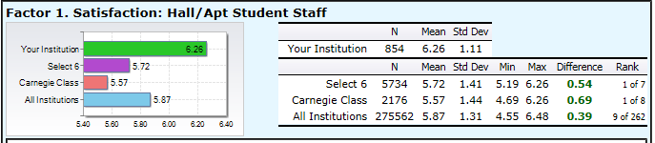
The threshold for this indicator was met. Lander University’s mean was above all of the EBI mean comparison groups. In breaking down the survey responses to specific questions measuring the satisfaction of students with their housing and residence life, each question’s mean was above all of the benchmark/set means except for three questions in this area: My resident assistant assisted me in connecting to campus resources; My resident assistant assisted me in reaching my personal goals, and My resident assistant assisted me in reaching my academic goals. These questions were some of the institutional specific questions asked and the two underlined were partially met for the last two years.

2. a. 1
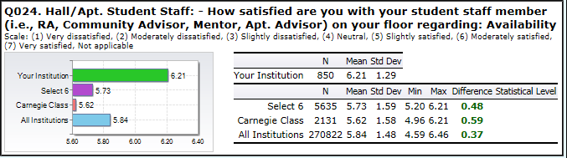

2. a. 2
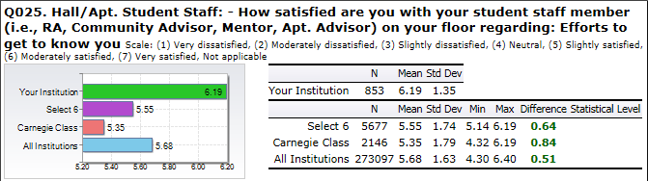

2. a. 3 Resident students are satisfied with their Resident Assistant’s ability to gain their respect. This question was not included in with this factor for this reporting period.

2. a. 4
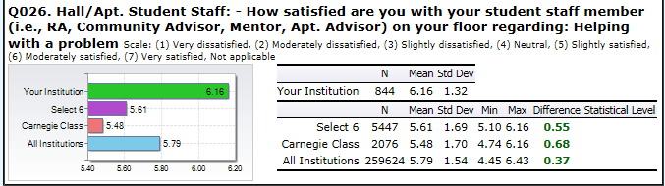

2. a. 5
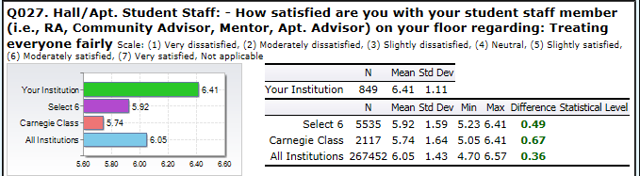

2. a. 6
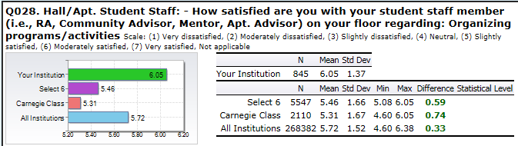

2. a. 7
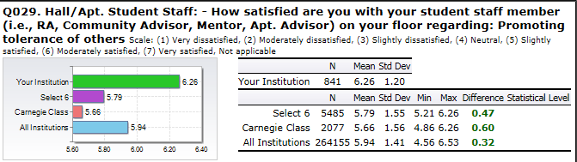

2. a. 8
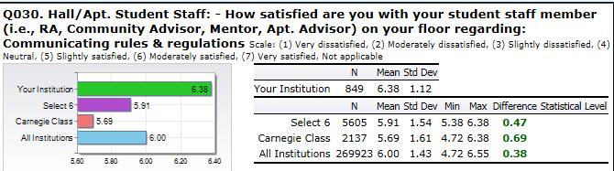

2. a. 9
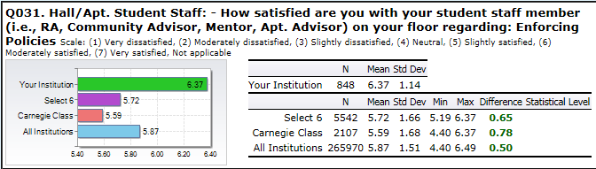

2. a. 10
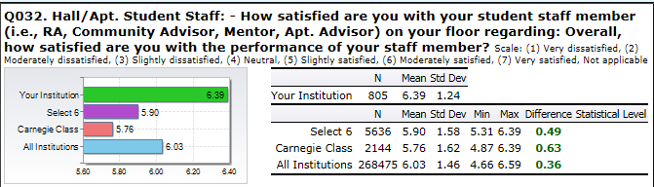

2. a. 11
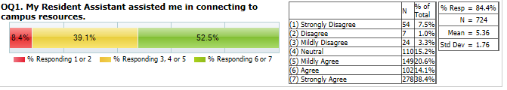

2. a. 12
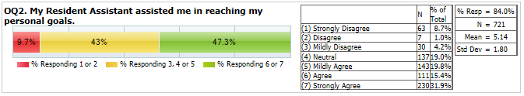

2. a. 13
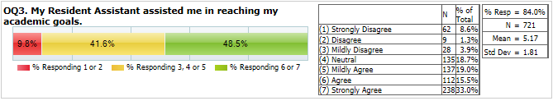

2. a. 14
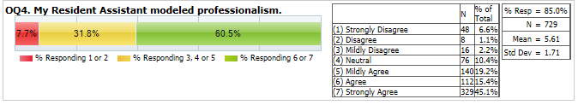

2. b. Students are satisfied with social/educational/cultural programs and activities provided by residence life staff members. 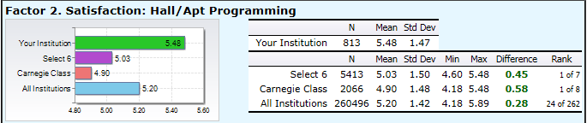
The threshold for this indicator was met. Lander University’s mean was above all of the EBI mean comparison groups. No action will be taken.

2. b. 1
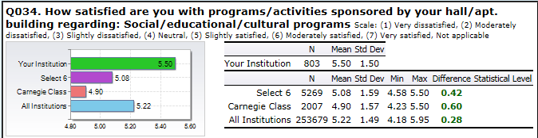

2. b. 2
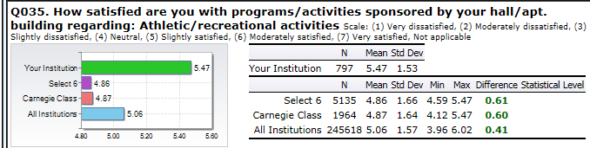

2. b. 3
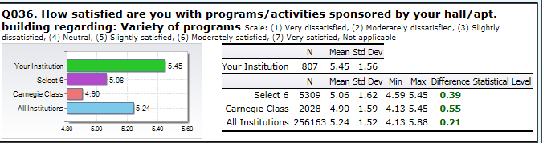

2. b. 4
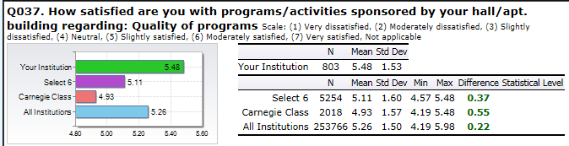

2. c. Students are satisfied with their room/hall/floor environment.
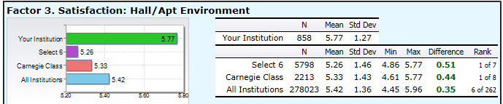

All thresholds for this indicator of success were met. Lander University’s mean was above all of the EBI mean comparison groups. No action will be taken.

2. c. 1
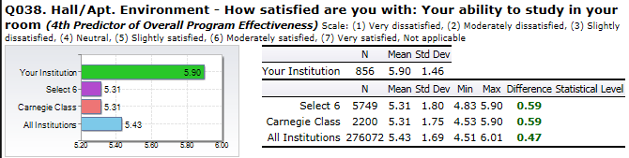

2. c. 2
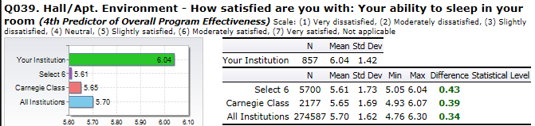

2. c. 3
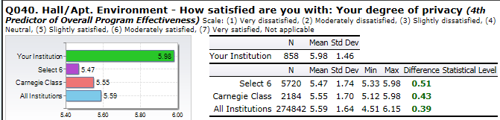

2. c. 4 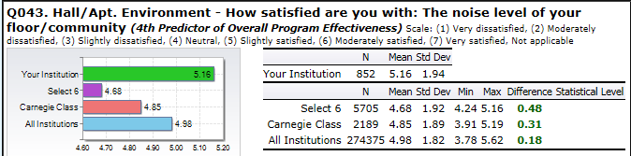

2. d. Students are satisfied with the services provided for their residence hall rooms and / or facilities.
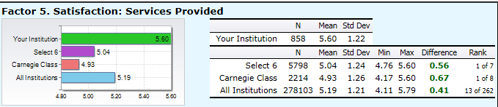
All thresholds for this indicator of success were met. However, in looking at the break-down of satisfaction with internet connectivity, there were still many residence halls where this service did not meet student expectations. Due to this being an issue last year, this information was given to Robin Lawrence – the Director of Lander University’s ITS Department.

2. d. 1
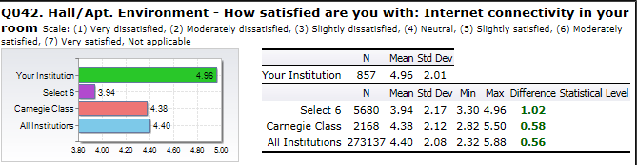

2. d. 2
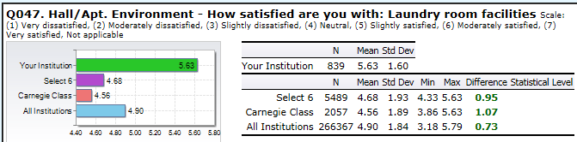

2. d. 3
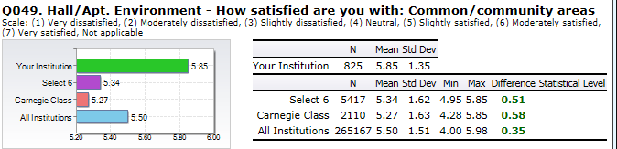

2. d. 4
Resident students are satisfied with the computing facilities in their floor/hall/building.
This question was not used as a sub-indicator for this factor (indicator) the 2014/2015 reporting period.

2. d. 5
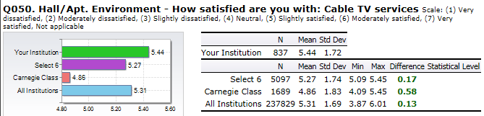

2. d. 6
Resident students are satisfied with vending services.
This question was not used as a sub-indicator for this factor (indicator) the 2014/2015 reporting period.

2. d. 7
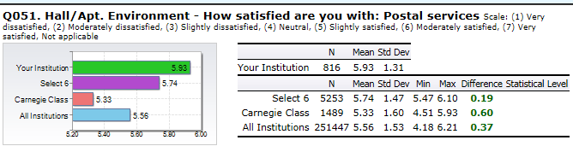

2. d. 8
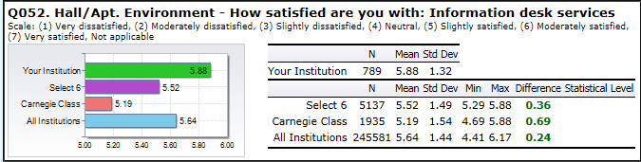

2. e. Students are satisfied with the room assignment process.
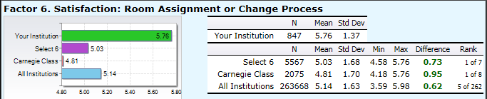
All thresholds for this indicator of success were met. Lander University’s mean was above all of the EBI mean comparison groups. No action will be taken.

2. e. 1
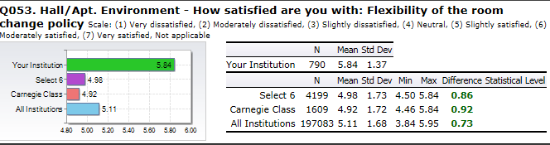

2. e. 2
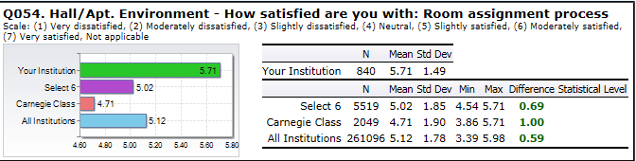

2. e. 3
Resident students are satisfied with their room assignment.
This question was not used as a sub-indicator for this factor (indicator) the 2014/2015 reporting period.

f. Overall, students living on-campus are satisfied with their on-campus housing experience.
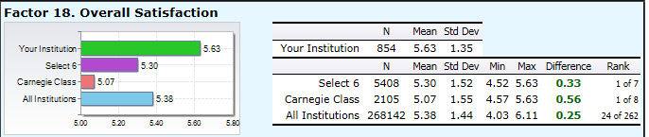

All thresholds for this indicator of success were met. Lander University’s mean was above all of the EBI mean comparison groups. No action will be taken.

2. f. 1
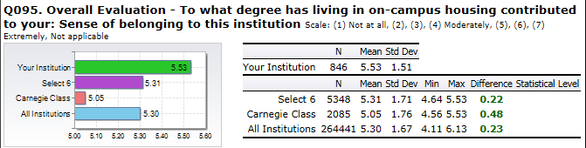

2. f. 2
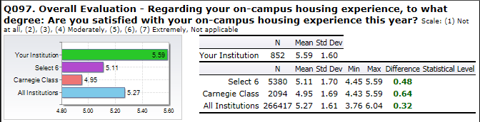

2. f. 3
On-Campus Housing was an accepting environment.
This question was not used as a sub-indicator for this factor (indicator) the 2014/2015 reporting period.

2. f. 4
Living on-campus fulfilled the resident student’s expectations.
This question was not used as a sub-indicator for this factor (indicator) the 2014/2015 reporting period.

2. f. 5
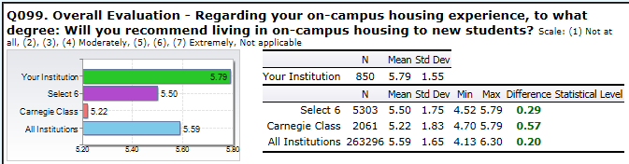

- Provide a residence life environment that promotes the opportunity for resident students to grow and develop academically and socially.
THRESHOLD MET FOR GOAL: 3.00 STRATEGIC GOAL SUPPORTED: LEARNING
The goal of providing Lander University resident students with a residence life environment that promotes the opportunity for them to grow and develop academically and socially was met for all five indicators of success. This was the second reporting period the EBI (Educational Benchmarking Inc.) assessment surveys were used to measure this goal. The threshold for each unit indicator was set by comparing Lander University’s results with several different comparison groups (Select 6 Peers, Carnegie Peers, and all EBI participants). The following indicators were dropped as measures for success: “Living on-campus improved the integration to college for resident students” and “Living on-campus enhanced the retention and graduation of resident students from Lander University.”

3. a. Overall, living on-campus enhanced the resident students’ academic performance.
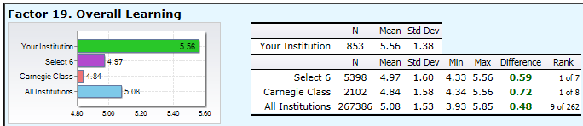

The threshold for the indicator of success on the survey factor that over-all, living on-campus enhanced their academic performance/learning was met. Each survey question gauging this indicator for success documented survey responses with a mean above all the EBI benchmark comparison means. At this time, no action is needed for this indicator.

3. a. 1
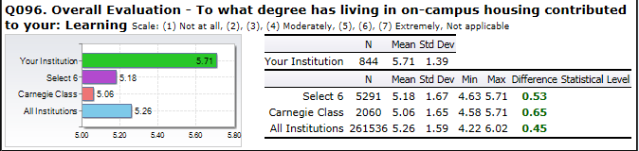

3. a. 2
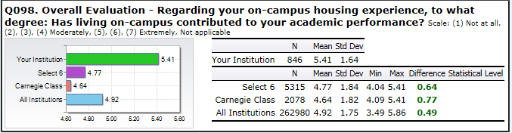

3. b. Living on-campus enhanced the personal interactions of resident students.

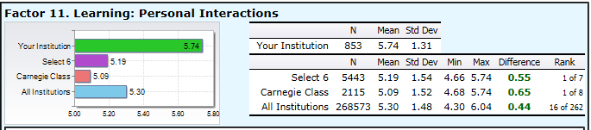

The threshold for the indicator of success on the survey factor that living on-campus enhanced the personal interactions of resident students was met. Each survey question gauging this indicator for success documented survey responses with a mean above all the EBI benchmark comparison means. At this time, no action is needed for this indicator.

3. b. 1
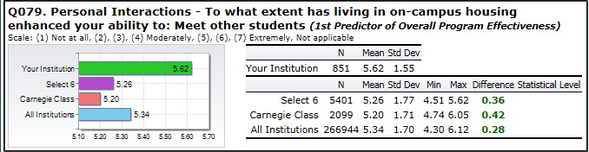

3. b. 2
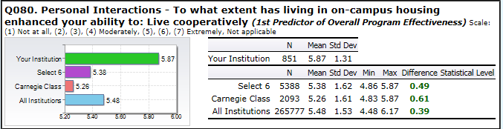

3. b. 3
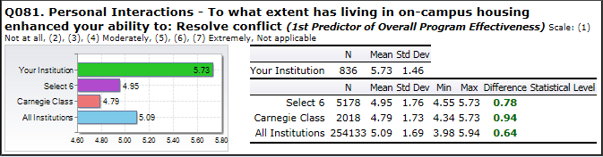

3. b. 4
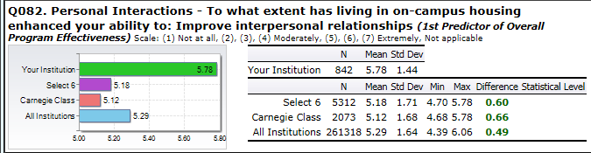

3. c. Living on-campus helped to enhance an awareness of diversity and social justice in resident students.
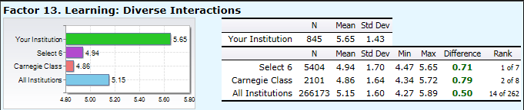
The threshold for the indicator of success on the survey factor that living on-campus helped to enhance an awareness of diversity and social justice in resident students was met. Each survey question gauging this indicator for success documented survey responses with a mean above all the EBI benchmark comparison means. At this time, no action is needed for this indicator.

3. c. 1
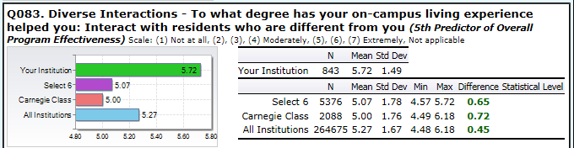

3. c. 2
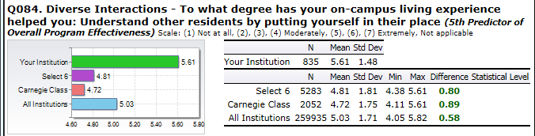

3. c. 3
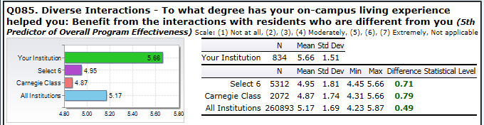

3. c. 4
Living on-campus helped resident students develop a sense of justice and fairness.
This question was not used as a sub-indicator for this factor (indicator) the 2014/2015 reporting period.

3. c. 5
Living on-campus helped resident students become an advocate for each other.
This question was not used as a sub-indicator for this factor (indicator) the 2014/2015 reporting period.

3. d. Living on-campus improved the intrapersonal development of resident students.
This factor (indicator) the 2014/2015 reporting period.

3. d. 1 Living on-campus improved the resident student’s ability to articulate their core values.
This question was not used as a sub-indicator for this factor (indicator) the 2014/2015 reporting period.

3. d. 2 Living on-campus improved the resident student’s ability to articulate their academic goals.
This question was not used as a sub-indicator for this factor (indicator) the 2014/2015 reporting period.

3. d. 3 Living on-campus improved the resident student’s ability to articulate their career goals.
This question was not used as a sub-indicator for this factor (indicator) the 2014/2015 reporting period.

3. e. Living on-campus improved the life skills of resident students (Self-Management)
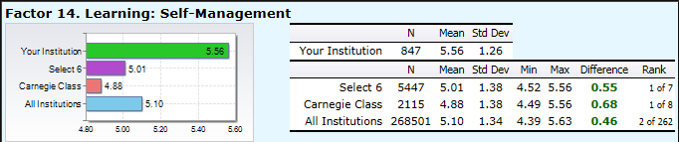
The threshold for this indicator was met. Lander University’s mean was above all of the EBI mean comparison groups. No action will be taken.

3. e. 1 Living on-campus improved the resident student’s ability to make decisions.
This question was not used as a sub-indicator for this factor (indicator) the 2014/2015 reporting period.

3. e. 2
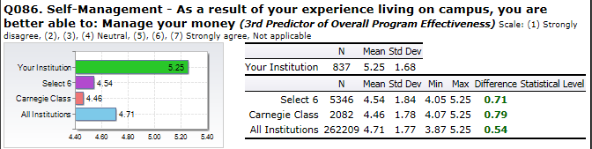

3. e. 3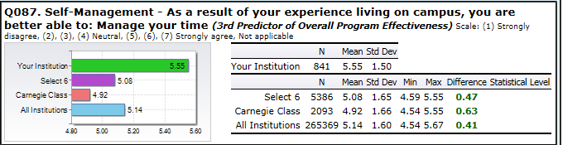

3. e. 4
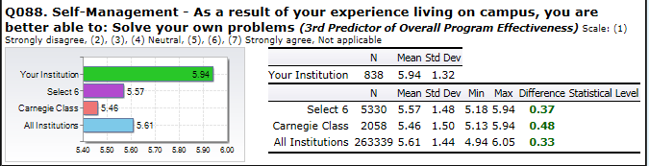

3. e. 5 Living on-campus improved the resident student’s ability to study effectively.
This question was not used as a sub-indicator for this factor (indicator) the 2014/2015 reporting period.

3. e. 6
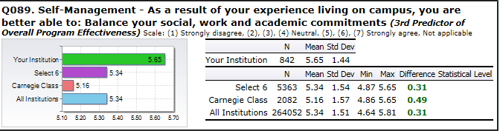

3. e. 7 Living on-campus improved the resident student’s ability to live independently.
This question was not used as a sub-indicator for this factor (indicator) the 2014/2015 reporting period.

3. e. 8
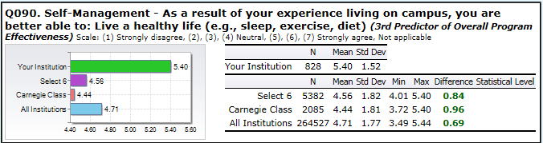

3. e. 9 Living on-campus improved the resident student’s ability to seek help if needed.
This question was not used as a sub-indicator for this factor (indicator) the 2014/2015 reporting period.

3. f. Living on-campus improved the integration to college for resident students.
This factor (indicator) the 2014/2015 reporting period.

3. f. 1 Living on-campus improved the social transition for resident students.
This question was not used as a sub-indicator for this factor (indicator) the 2014/2015 reporting period.

3. f. 2 Living on-campus improved the sense of belonging to the university for resident students.
This question was not used as a sub-indicator for this factor (indicator) the 2014/2015 reporting period.

3. f. 3 Living on-campus improved the academic transition to college for resident students.
This question was not used as a sub-indicator for this factor (indicator) the 2014/2015 reporting period.

3. f. 4 Living on-campus improved the ability of students to integrate their academic and social life.
This question was not used as a sub-indicator for this factor (indicator) the 2014/2015 reporting period.

3. g. Living on-campus enhanced the retention and graduation of resident students from Lander University.
This factor (indicator) the 2014/2015 reporting period.

3. g. 1 Living on-campus positively impacted the decision of the resident student to return to this university next year.
This question was not used as a sub-indicator for this factor (indicator) the 2014/2015 reporting period.

3. g. 2 Living on-campus positively impacted the decision of the resident student to graduate from this university.
This question was not used as a sub-indicator for this factor (indicator) the 2014/2015 reporting period.

- Provide adequate training and support for Resident Assistants to promote the opportunity for Resident Assistant student staff members to grow and develop academically and socially.
THRESHOLD MET FOR GOAL: 3 STRATEGIC GOAL SUPPORTED: LEARNING
The goal of providing adequate training and support for Resident Assistants to promote the opportunity for Resident Assistant student staff members to grow and develop academically and socially was met for all five indicators of success. This was the second reporting period the EBI (Educational Benchmarking Inc.) assessment surveys were used to measure this goal. The threshold for each unit indicator was set by comparing Lander University’s results with several different comparison groups (Select 6 Peers, Carnegie Peers, and all EBI participants). By using the same survey for the next reporting period, the ability to compare Lander University’s results over time benefited in establishing new thresholds, identifying patterns, changing thresholds, employing solutions/changes or measuring solutions/changes initiated.

4. a. Employment as a Resident Assistant (RA) improved the intrapersonal competence or empathy of the student staff member.
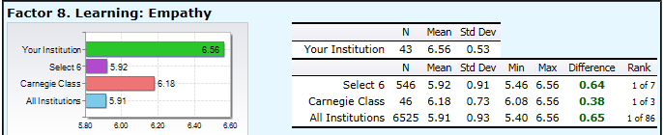
The threshold for the indicator of success on the survey factor signifying that employment as a Resident Assistant improved the intrapersonal competence of the student staff member was met. Each survey question gauging this indicator for success documented survey responses with a mean above all the EBI benchmark comparison groups. At this time, no action is needed for this indicator.

4. a. 1
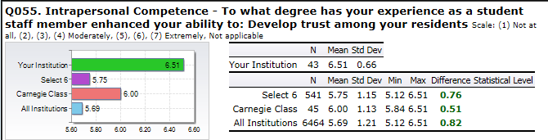

4. a. 2
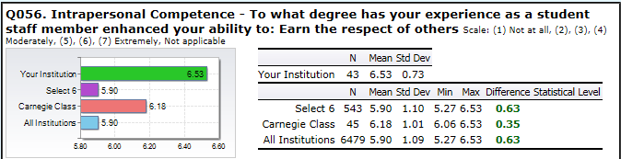

4. a. 3
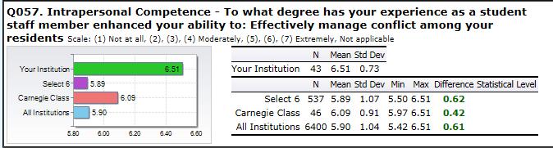

4. a. 4
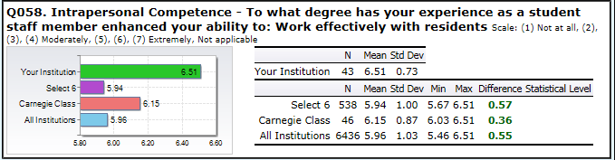

4. a. 5
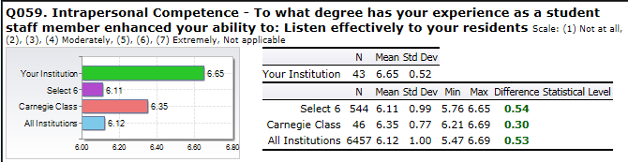

4. a. 6
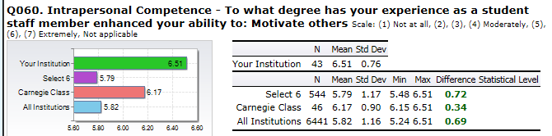

4. a. 7
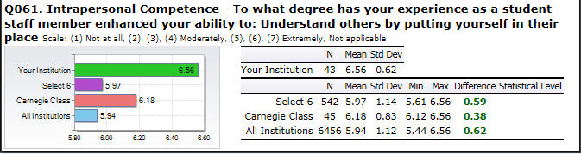

4. a. 8
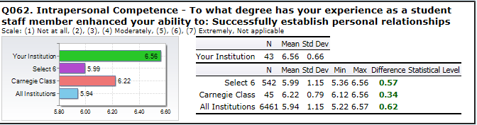

4. a. 9
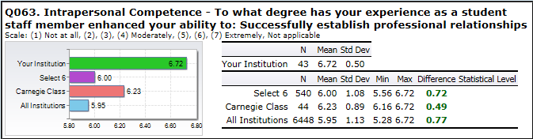

4. b. Employment as a Resident Assistant (RA) enhanced self-knowledge and skills of the student staff member.
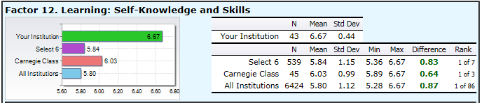
The threshold for the indicator of success on the survey factor signifying that employment as a Resident Assistant enhanced self-knowledge and skills of the student staff member was met. Each survey question gauging this indicator for success documented survey responses with a mean above all the EBI benchmark comparison groups. At this time, no action is needed for this indicator.

4. b. 1
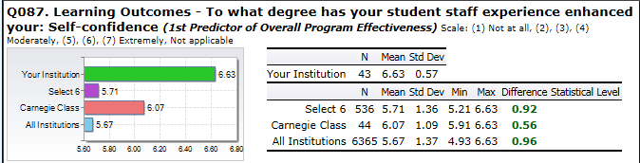

4. b. 2
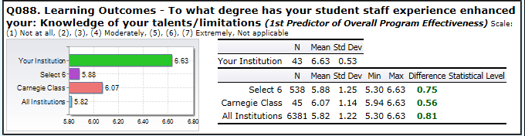

4. b. 3
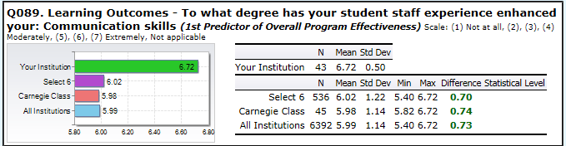

4. b. 4
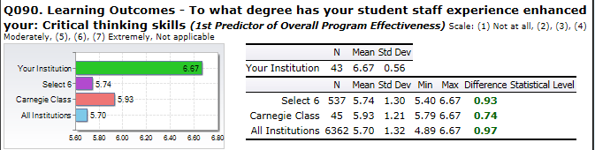

4. b. 5
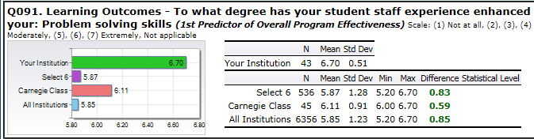

4. c. Employment as a Resident Assistant (RA) improved the student staff member’s personal competence.
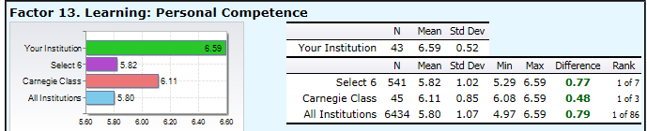
The threshold for the indicator of success on the survey factor signifying that employment as a Resident Assistant improved the student staff member’s personal competence was met. Each survey question gauging this indicator for success documented survey responses with a mean above all the EBI benchmark comparison groups. At this time, no action is needed for this indicator.

4. c. 1
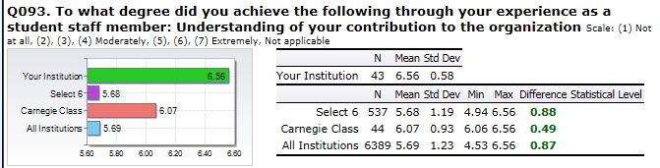

4. c. 2
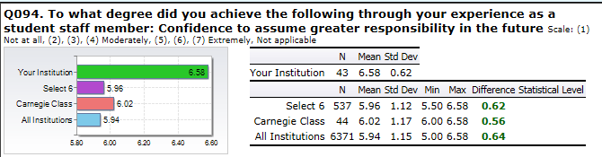

4. c. 3
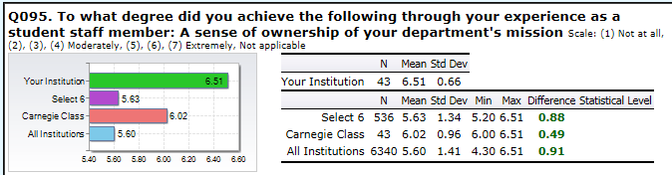

4. c. 4
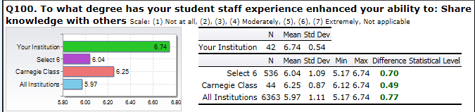

4. d. Employment as a Resident Assistant (RA) enhanced the student staff member’s practical competence.
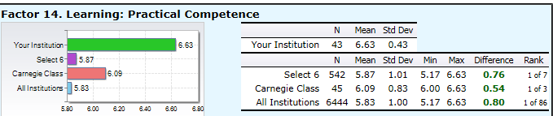
The threshold for the indicator of success on the survey factor signifying that employment as a Resident Assistant improved the student staff member’s practical competence was met. Each survey question gauging this indicator for success documented survey responses with a mean above all the EBI benchmark comparison groups. At this time, no action is needed for this indicator.

4. d. 1
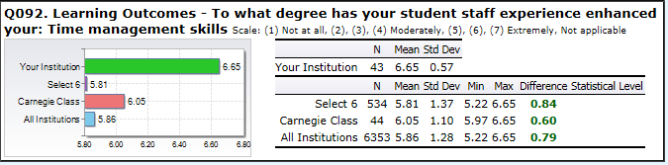

4. d. 2
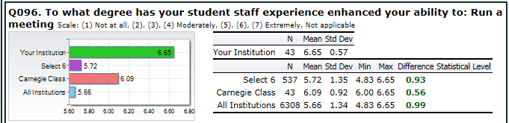

4. d. 3
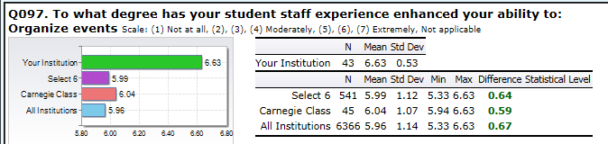

4. d. 4
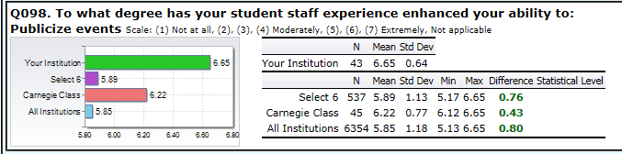

4. d. 5
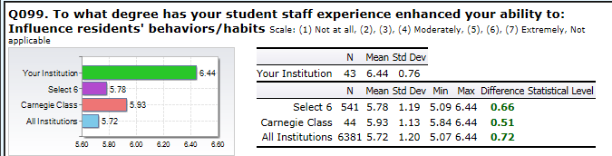

4. e. Employment as a Resident Assistant (RA) enhanced the student staff member’s diverse interactions.
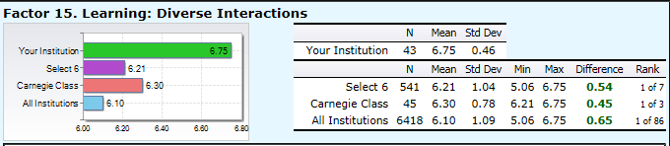
The threshold for the indicator of success on the survey factor signifying that employment as a Resident Assistant enhanced the student staff member’s diverse interactions was met. Each survey question gauging this indicator for success documented survey responses with a mean above all the EBI benchmark comparison groups. At this time, no action is needed for this indicator.

4. e. 1
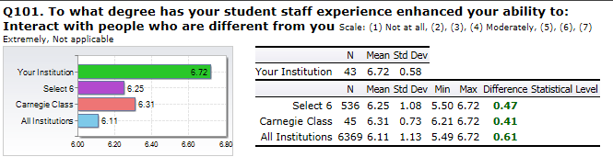

4. e. 2
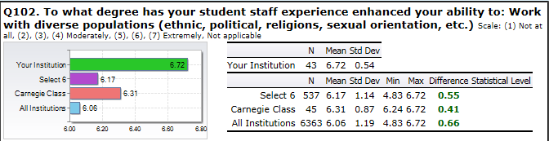

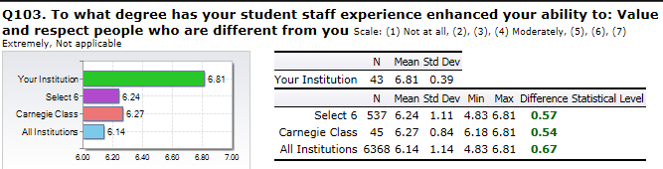

- Provide adequate and satisfactory supervisory support and training for Resident Assistants.

THRESHOLD MET FOR GOAL: 3.00 STRATEGIC GOAL SUPPORTED: ENROLLMENT
The goal of providing Lander University Resident Assistants with adequate supervisory support and training was met for all seven indicators of success. This was the second reporting period the EBI (Educational Benchmarking Inc.) assessment surveys were used to measure this goal. The threshold for each unit indicator was set by comparing Lander University’s results with several different comparison groups (Select 6 Peers, Carnegie Peers, and all EBI participants). By using the same survey for the next reporting period, the ability to compare Lander University’s results over time benefited in establishing new thresholds, identifying patterns, changing thresholds, employing solutions/changes or measuring solutions/changes initiated.

5. a. The Resident Assistant Training provided Resident Assistants (RAs) with beneficial and useful information needed for the effective performance of their job.

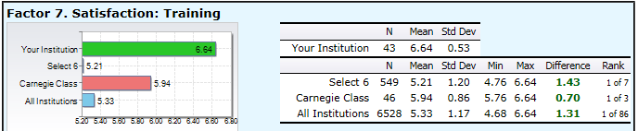
The threshold for the indicator of success on the survey factor demonstrating that the Resident Assistant Training provided Resident Assistants with beneficial and useful information needed for the effective performance of their job was met. Each survey question gauging this indicator for success documented survey responses with a mean above all the EBI benchmark comparison groups. At this time, no action is needed for this indicator.

5. a. 1
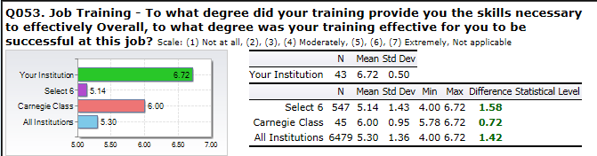

5. a. 2
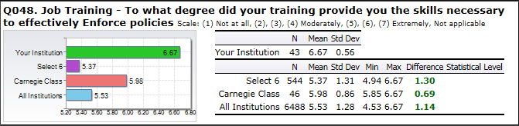

5. a. 3
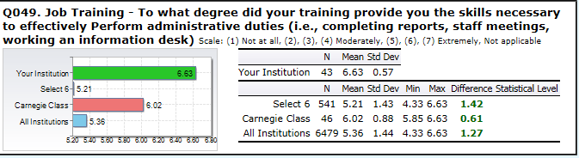

5. a. 4
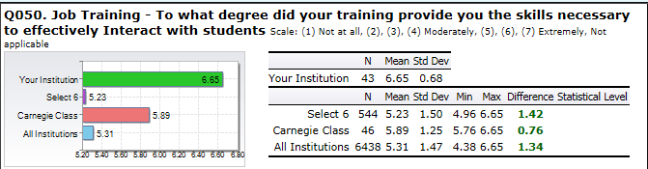

5. a. 5
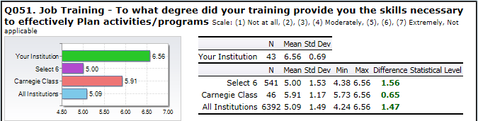

5. a. 6
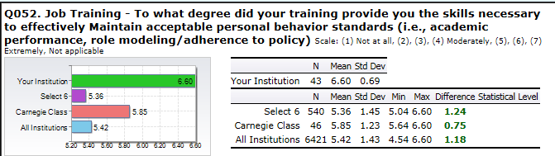

5. b.
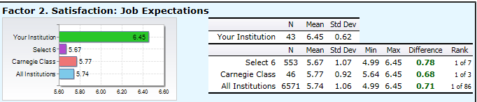
The threshold for the indicator of success on the survey factor demonstrating that clear job expectations were established regarding aspects of the Resident Assistant student staff position was met. Each survey question gauging this indicator for success documented survey responses with a mean above all the EBI benchmark comparison groups. At this time, no action is needed for this indicator.

5. b. 1
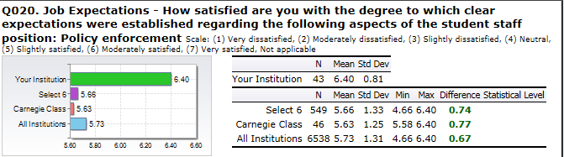

5. b. 2
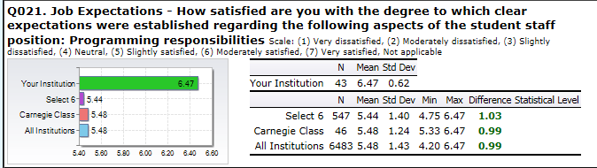

5. b. 3
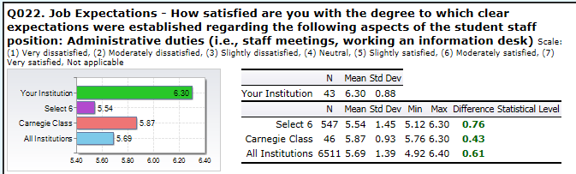

5. b. 4
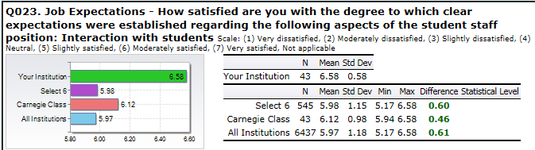

5. b. 5
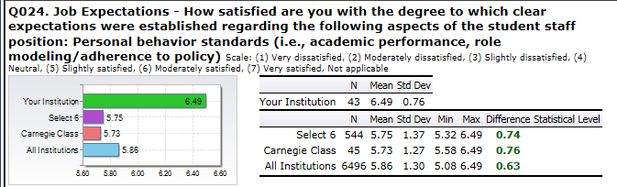

5. c. Resident Assistants are satisfied with their job expectations and compensation.
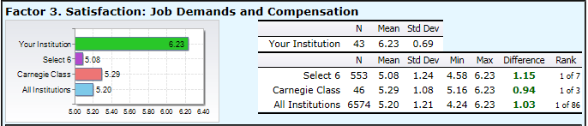
The threshold for the indicator of success on the survey factor demonstrating that Resident Assistants are satisfied with job expectations, demands and compensation was met. Each survey question gauging this indicator for success documented survey responses with a mean above all the EBI benchmark comparison groups. At this time, no action is needed for this indicator.

5. c. 1
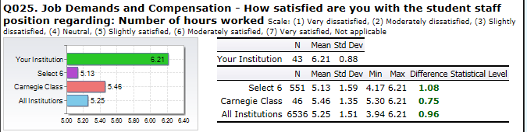

5. c. 2
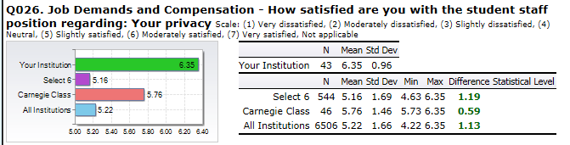

5. c. 3
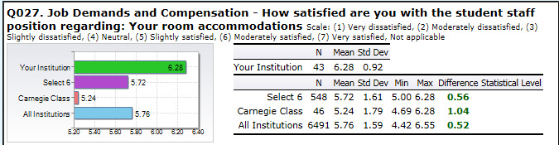

5. c. 4
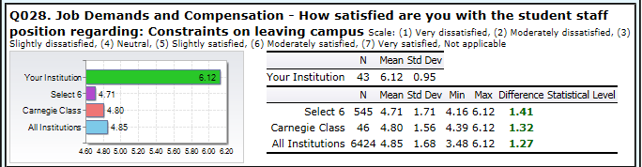

5. c. 5
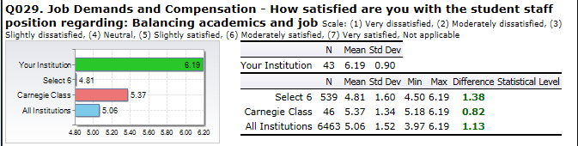

5. c. 6
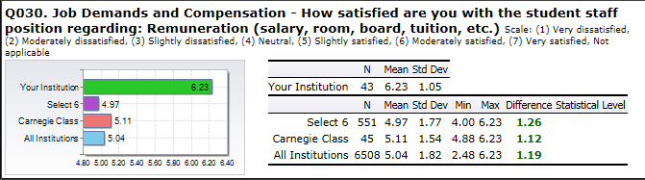

5. d. Resident Assistants are satisfied with their supervisor’s support.
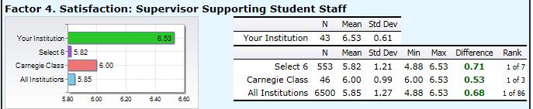
The threshold for this indicator was met. Lander University’s mean was above all of the EBI mean comparison groups. Each survey question gauging this indicator for success documented survey responses with a mean above all the EBI benchmark comparison groups. At this time, no action is needed for this indicator.

5. d. 1
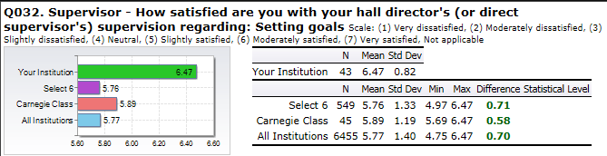

5. d. 2
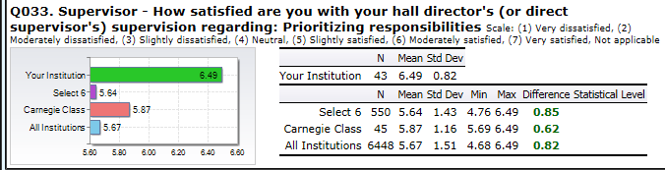

5. d. 3
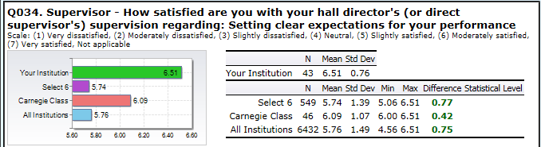

5. d. 4
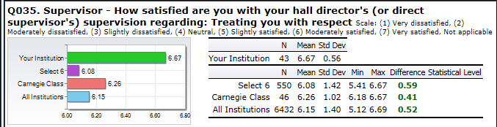

5. d. 5
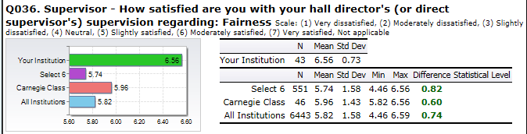

5. d. 6
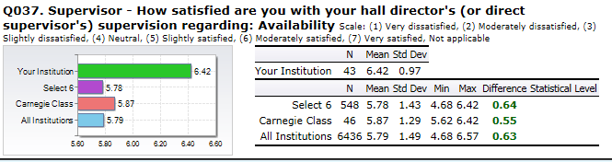

5. d. 7
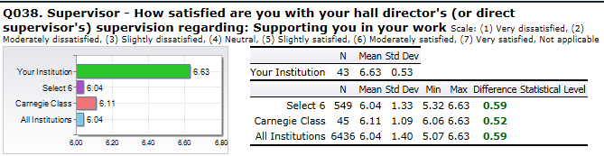

5.e. Resident Assistants are satisfied with their supervisor’s management skills.
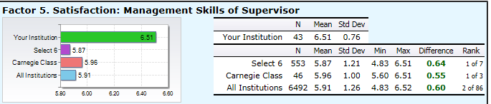
The threshold for the indicator of success on the survey factor demonstrating that Resident Assistants are satisfied with their supervisor’s management skills was met. Each survey question gauging this indicator for success documented survey responses with a mean above all the EBI benchmark comparison groups. At this time, no action is needed for this indicator.

5. e. 1
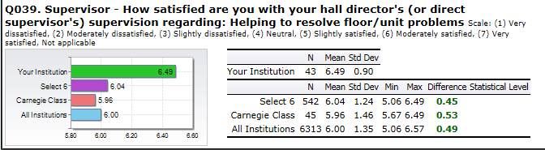

5. e. 2
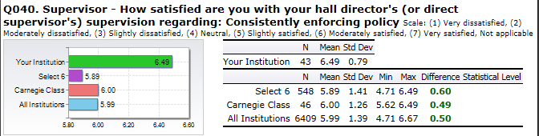

5. e. 3
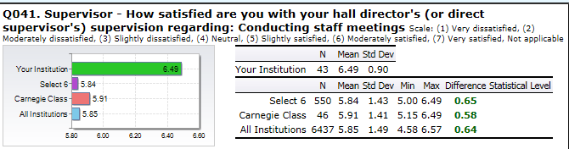

5. e. 4
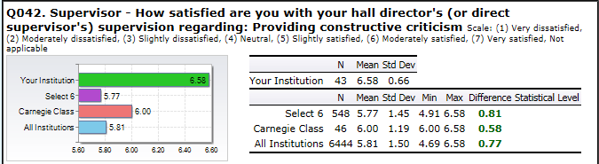

5. f. Resident Assistants are satisfied with the student staff selection process.
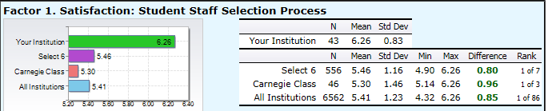
The threshold for the indicator of success on the survey factor demonstrating that Resident Assistants are satisfied with the student staff selection process was met. Each survey question gauging this indicator for success documented survey responses with a mean above all the EBI benchmark comparison groups. At this time, no action is needed for this indicator.

5. f. 1
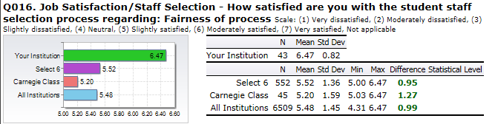

5. f. 2
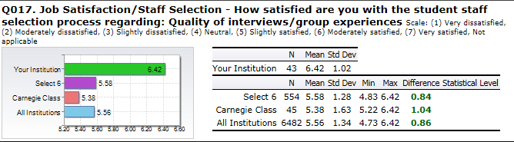

5. f. 3
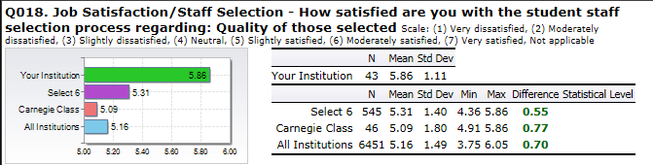

5. f. 4
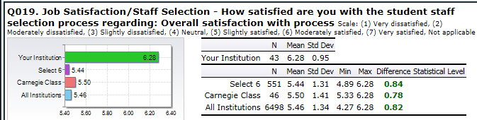

5. g. Overall, Resident Assistants are satisfied with their student staff and academic experience.

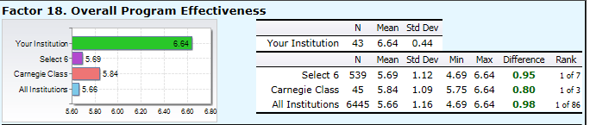
The threshold for the indicator of success on the survey factor demonstrating that overall, Resident Assistants are satisfied with their student staff and academic experience was met. Each survey question gauging this indicator for success documented survey responses with a mean above all the EBI benchmark comparison groups. At this time, no action is needed for this indicator.

5. g. 1
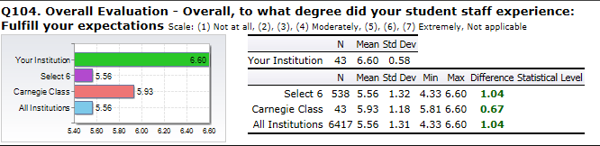

5. g. 2
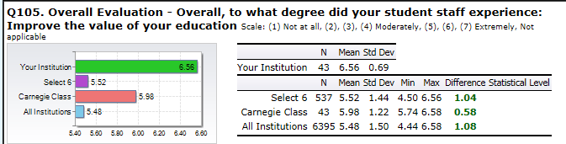

5. g. 3
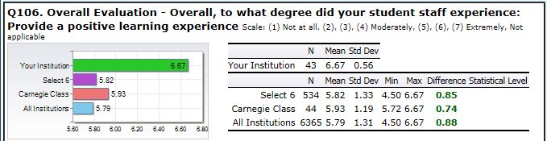

5. g. 4
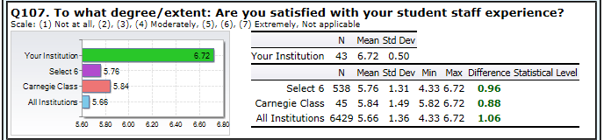

5. g. 5
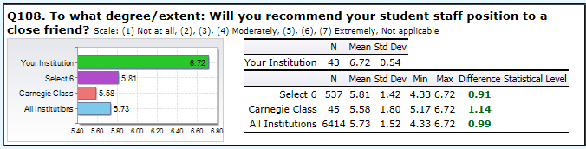

5. g. 6
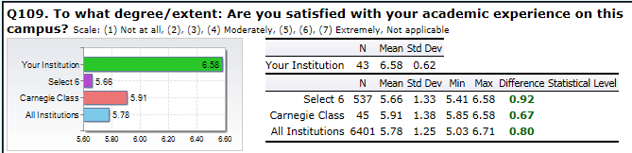

- The Department of Housing and Residence Life is effective in its provision of services to students.
THRESHOLD MET FOR GOAL: 3.00 STRATEGIC GOAL SUPPORTED: ENROLLMENT
The threshold for the indicator of success on the survey factor demonstrating that the Department of Housing & Resident Life was effective in its provisions of services to students was met. This was a new factor or indicator added during this reporting period. Each survey question gauging this indicator for success documented survey responses with a mean above all the EBI benchmark comparison groups. At this time, no action is needed for this indicator.

6. a. Overall, Resident Assistants are satisfied with their student staff and academic experience.
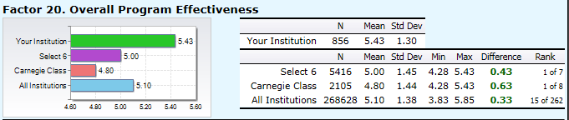
The threshold for the indicator of success on the survey factor demonstrating that the Department of Housing & Resident Life was effective in its provisions of services to students was met. This was a new factor or indicator added during this reporting period. Each survey question gauging this indicator for success documented survey responses with a mean above all the EBI benchmark comparison groups. At this time, no action is needed for this indicator.

6. a. 1
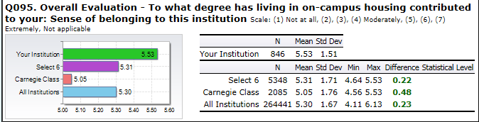

6. a. 2
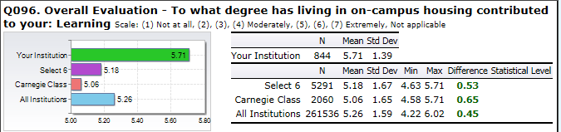

6. a. 3
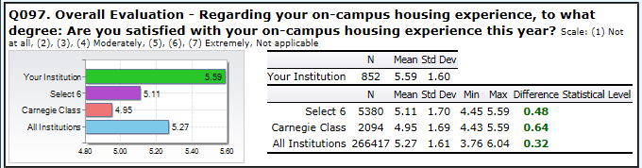

6. a. 4
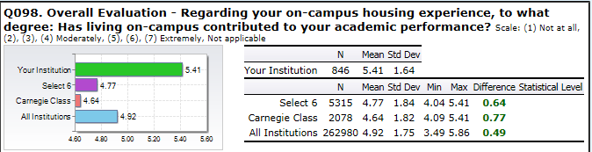

6. a. 5
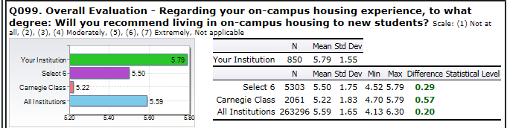

6. a. 6
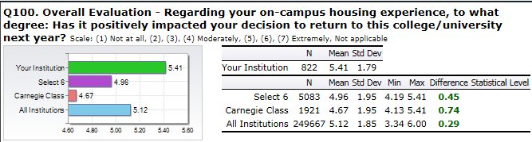

6. a. 7
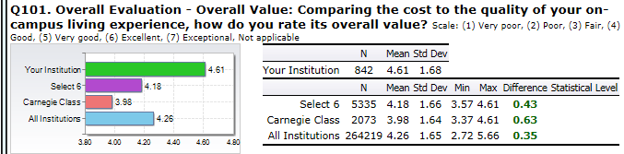

- Provide a quality safe living learning environment for Lander University Resident Students.
THRESHOLD MET FOR GOAL: 3.0 STRATEGIC GOAL SUPPORTED: ENVIRONMENT
The data show that on five of the six unit indicators, the established thresholds were met. Several of these unit indicators will be dropped and new ones focused on for the 2014/2015 reporting period.

7. a Conduct Health & Safety Inspections of the Lander University Residence Hall facilities with Residence Life Staff in regard to maintenance and facility needs and safety and security issues.

Residence Life staff complete an inspection form indicating compliance or requirements needed to remedy non-compliant room conditions. Residence Life Staff completed 538 inspection forms for 538 rooms indicating compliance or requirements needed to remedy non-compliant room conditions. The inspections were conducted on October 20-24, 2014 (Resident assistants followed up on issues) for Fall semester and on February 16-20, 2015 for the Spring semester. Follow-up inspections due to the academic year end were conducted on April 13-17, 2015. All room violations were corrected from the Inspection Orders. Resident Assistants keep a log of violations and report to Residence Life Coordinators any violations not corrected. No Action Needed.

7. b. Conduct Fire Drills in all residence halls with centralized fire alarm systems each semester.

Goal was dropped for this reporting period. Reported in Lander University’s Police Department’s Unit/Program Summary Report.

7. c. Evaluate condition of room at move-in as well as at move-out to determine repair needs, upgrades, etc.

This goal will be dropped for the 2014/2015 reporting period as it has been consistently met and is not a continued measure.

7. d. Establish overall satisfaction of LU living learning environment.

The Skyfactor/EBI Mapworks Benchmark Assessment for Residence Life was purchased and used to assess this goal for this reporting period and is contained in another area of this report – Goal 2.f.. At this time, this indicator will not be reported on.

7. e. Students are satisfied with the safety and security of their residence hall room and building.
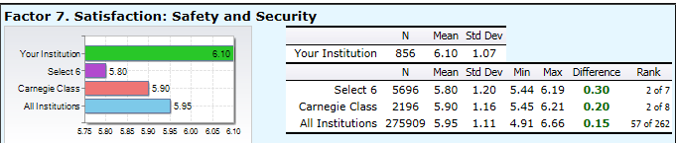
The threshold for the indicator of success on the survey factor demonstrating that Resident Assistants are satisfied with the safety and security of their residence halls and buildings was met. This period showed an improvement on each survey question gauging this indicator when compared to the 2013/2014 survey results.
At this time, no action is needed for this indicator.

7. e. 1
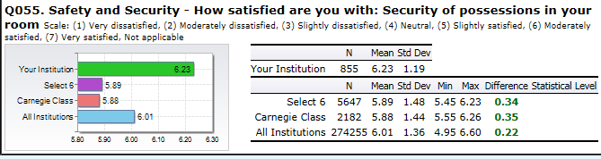

7. e. 2
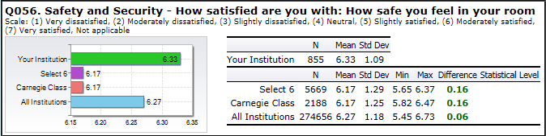

7. e. 3
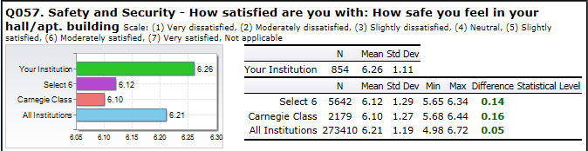

7. e. 4
